Figure legends

Supplement Figure 1. Correlation between Overall Survival (OS) and Progression Free Survival (PFS) for 120 arms below 1.2 (OS observed/estimated) for first-line treatment for patients with advanced NSCLC.

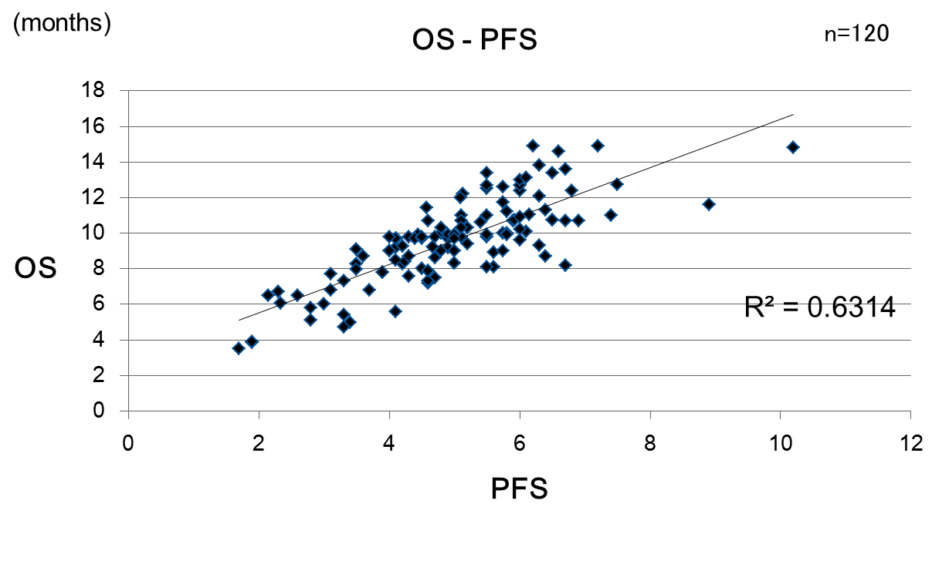
Supplement Figure 1.

