Supplementary information
Hemophagocytic lymphohistiocytosis in adults: Collaborative analysis of 137 cases of a nationwide German registry
Sebastian Birndt¹, Thomas Schenk¹, Babett Heinevetter¹, Frank M. Brunkhorst², Georg Maschmeyer³, Frank Rothmann³, Thomas Weber⁴, Markus Müller⁵, Jens Panse⁶, Olaf Penack⁷, Roland Schroers⁸, Jan Braess⁹, Norbert Frickhofen¹⁰, Stephan Ehl¹¹, Gritta Janka¹², Kai Lehmberg¹², Mathias W. Pletz¹³, Andreas Hochhaus¹, Thomas Ernst¹, Paul La Rosée¹⁴

¹Klinik für Innere Medizin II, Abt. Hämatologie und intern. Onkologie, Universitätsklinikum Jena, Germany;

²Zentrum für klinische Studien, Universitätsklinikum Jena, Germany;
³Klinik für Hämatologie, Onkologie u. Palliativmedizin, Klinikum Ernst von Bergmann, Potsdam, Germany;
⁴Klinik für Hämatologie und Onkologie, Universitätsklinikum Halle (Saale), Germany;
⁵Zentrum für Infektiologie und HIV, Vivantes Auguste-Viktoria-Klinikum, Berlin, Germany;
⁶Klinik für Hämatologie, Onkologie, Hämostaseologie und Stammzelltransplantation, Uniklinik RWTH Aachen, Germany;
⁷ Medizinische Klinik mit Schwerpunkt Hämatologie, Onkologie und Tumorimmunologie, Charité Universitätsmedizin, Berlin, Germany;
⁸Hämatologie und Onkologie, Universitätsklinikum Knappschaftskrankenhaus, Bochum, Germany;
⁹Onkologie und Hämatologie, Krankenhaus Barmherzige Brüder, Regensburg, Germany;
¹⁰Hämatologie, Onkologie und Palliativmedizin, HELIOS Dr. Horst Schmidt Kliniken, Wiesbaden, Germany;
¹¹ Institut für Immundefizienz, Zentrum für Chronische Immundefizienz, Universitätsklinikum Freiburg, Germany;
¹²Pädiatrische Hämatologie und Onkologie, Universitätsklinikum Eppendorf, Hamburg, Germany;
¹³Institut für Infektionsmedizin und Krankenhaushygiene, Universitätsklinikum Jena, Germany;
¹⁴Klinik für Innere Medizin II, Hämatologie, Onkologie, Immunologie, Infektiologie und Palliativmedizin, Schwarzwald-Baar Klinikum, Villingen-Schwenningen, Germany

Supplementary Table 1.

Calculation of the HScore, adapted from Fardet et al.³
Parameter | Number of points (criteria for scoring)
Known underlying immunosuppression* | 0 (no) or 18 (yes)
Temperature (°C) | 0 (<38.4), 33 (38.4 – 39.4), or 49 (>39.4)
Organomegaly | 0 (no), 23 (hepatomegaly or splenomegaly), or 38 (hepatomegaly and splenomegaly)
Type of cytopenias⁺ | 0 (1 lineage), 24 (2 lineages), or 34 (3 lineages)
Ferritin (µg/liter) | 0 (<2,000), 35 (2,000 – 6,000), or 50 (>6,000)
Triglycerides (mmol/liter) | 0 (<1.5), 44 (1.5 – 4), or 64 (>4)
Fibrinogen (g/liter) | 0 (>2.5) or 30 (≤2.5)
Serum aspartate aminotransferase (ASAT) (IU/liter) | 0 (<30) or 19 (≥30)
Hemophagocytosis features on bone marrow aspirate | 0 (no) or 35 (yes)

* Human immunodeficiency virus positive or receiving ling-term immunosuppressive therapy (i.e. glucocorticoids, cyclosporine, azathioprine)

⁺ Defined as a hemoglobin level of ≤9.2 g/dl and/or a leukocyte count of ≤5,000/mm³ and/or a platelet count of ≤110,000/mm³

Supplementary Table 2.
Information on patients with HLH-associated mutations.
Patient | Sex | Age at diagnosis | Triggering disease | Mutated gene
1 | Male | 23 | CMV/EBV co-infection | XIAP (XLP-2)
2 | Male | 19 | EBV/H1N1 infection | SH2D1A (XLP-1)
3 | Female | 43 | NK/T-cell lymphoma | PRF1 (A91V/Q405X compound heterozygous)
4 | Male | 51 | Idiopathic | PRF1 (A91V homozygous)
5 | Female | 24 | EBV infection | RAB27A (Griscelli syndrome type 2)

Abbreviations: EBV, Epstein-Barr virus; CMV, Cytomegalovirus; XLP, X-linked lymphoproliferative disease; XIAP, X-linked inhibitor of apoptosis protein; SH2D1A, SH2 domain-containing protein 1A; PRF, Perforin; RAB27A, Ras-related protein Rab-27A.

Figure legends

Supplementary Figure 1.

Flow chart illustrating the enrollment process and eligibility for data analysis.

Supplementary Figure 2.

Scatter plot illustrating the relationship between HLH-2004 diagnostic criteria and the HScore. Using Pearson´s r, there was a strong positive correlation between number of fulfilled diagnostic criteria and the HScore (r=0.75, p<0.001).

Supplementary Figure 1.

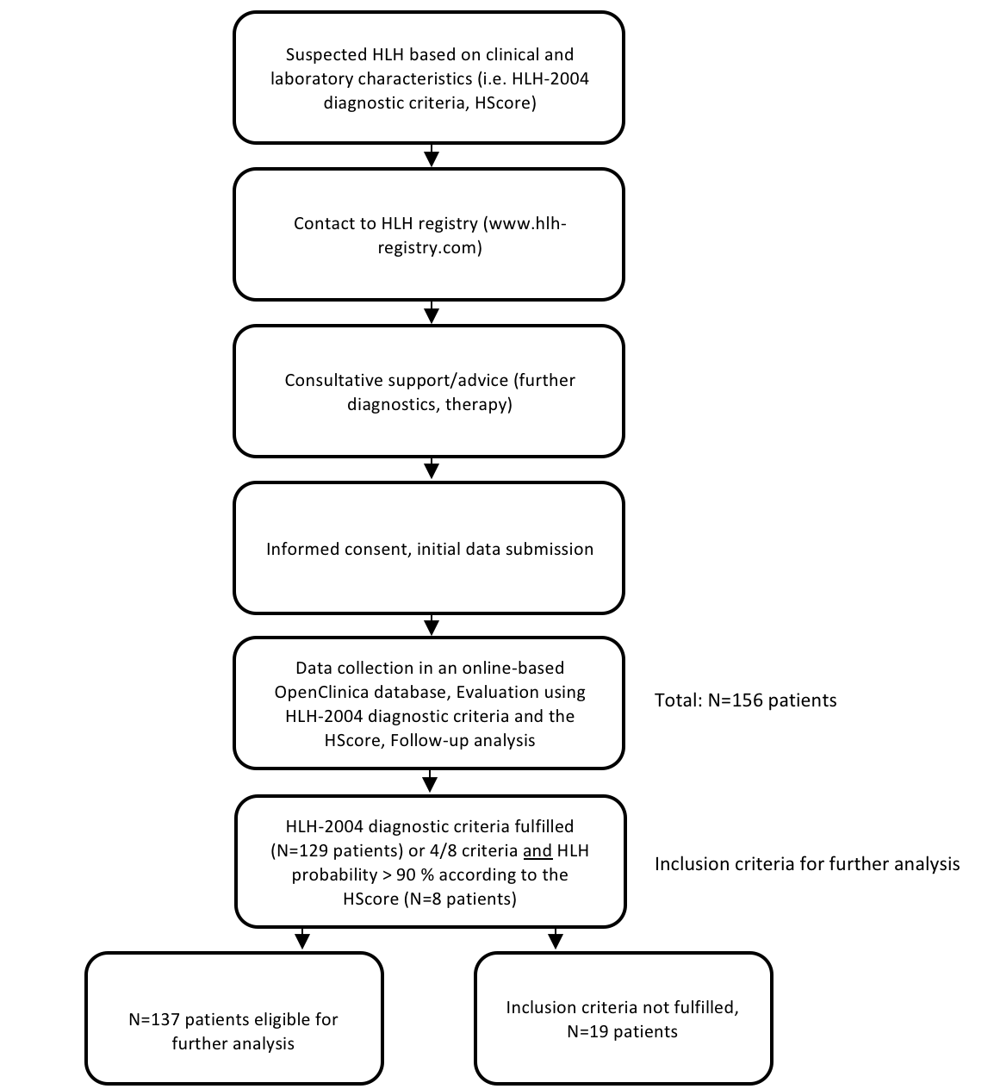

Supplementary Figure 2.

