Supplemental Information

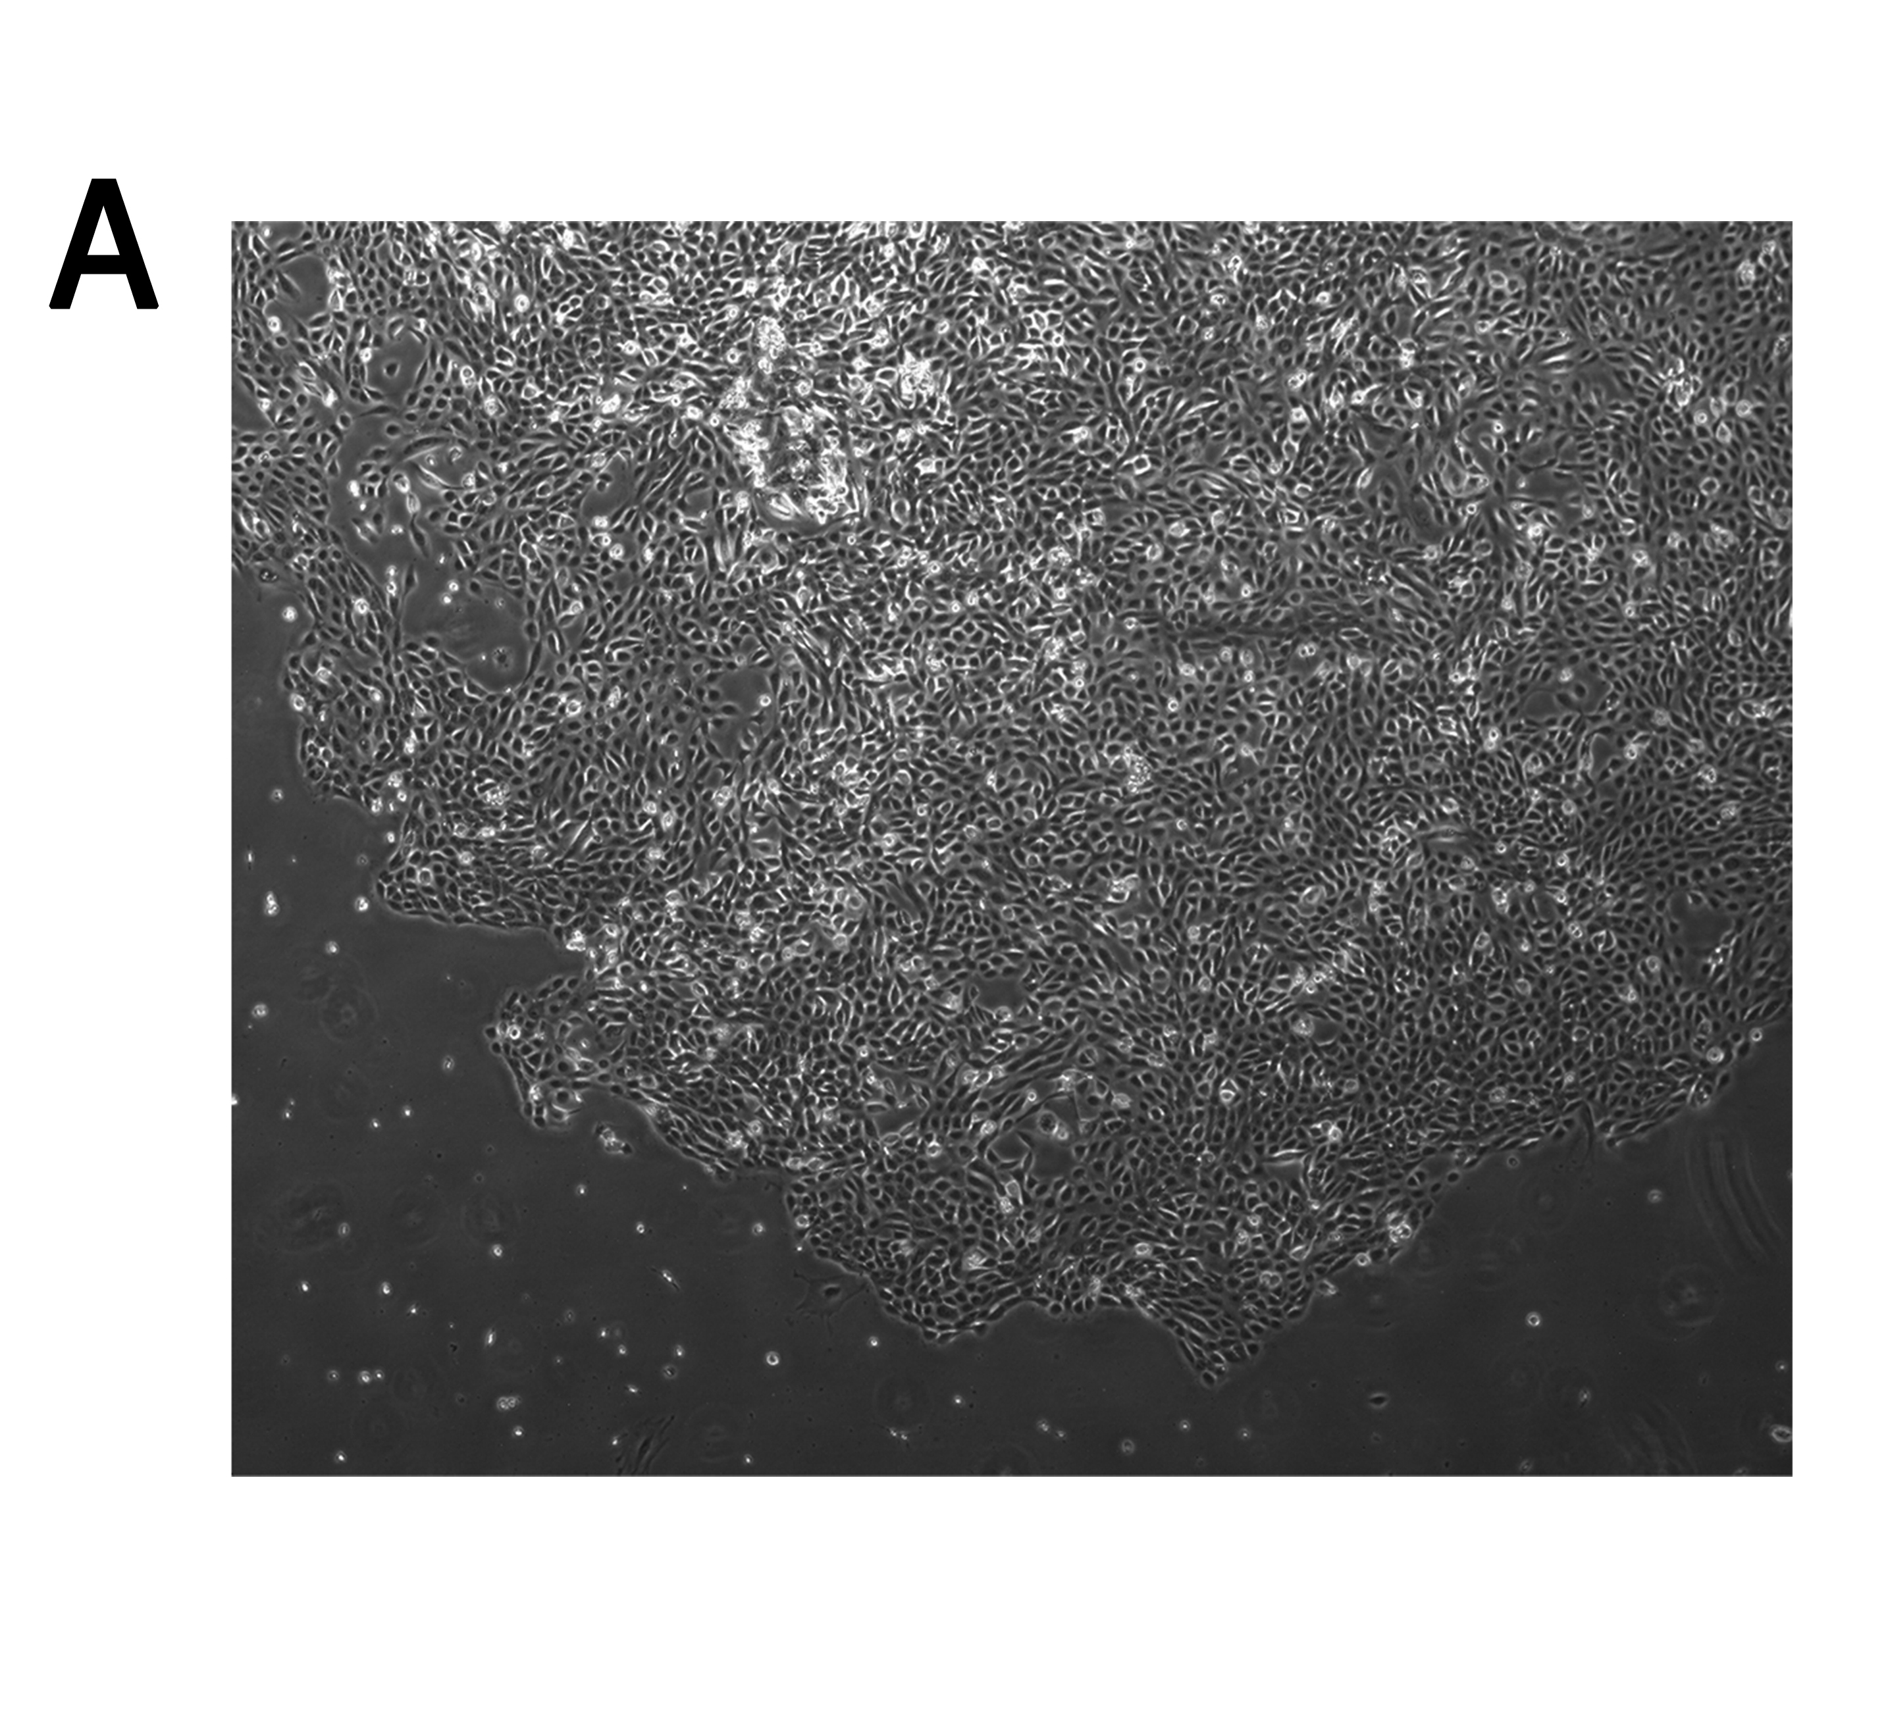

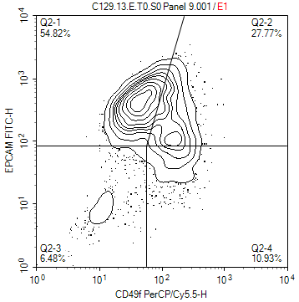
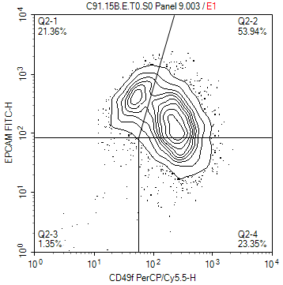
B
C91
C129
CD49f
CD49f
EpCAM
EpCAM

Supplemental Figure 1: Cultured tumor cells isolated from patient biopsies are phenotypically epithelial.
(A) Representative culture of primary cells from a digested tumor biopsy at day 9 of culture. (B) Flow cytometric analysis of the epithelial luminal biomarker EpCAM and the basal/progenitor biomarker CD49f expression level on the tumor primary cells analyzed in Figure 1 at the time of CELx HSF test.

Supplemental Figure 2. FACS analysis of HER2 expression confirms the HER2- status designated by IHC and/or ISH. 114 patient samples were analyzed for Her2 expression using flow cytometry as described in the methods. The mean fluorescence intensity of the samples were compared to three cell lines used as standards in the DAKO HercepTest. (SKBR3, DAKO 3+, MDA175vii 2+, MDA231 0)
114 Patient
Samples
Supplemental Table 1. Characteristics of HCC1954 and BT483 cells

Cell Line | HCC1954 | BT483
HER2 status | HER2+ | HER2-
Celcuity HER2 protein level (MFC*) | 4009 | 441
CCLE HER2 mRNA level (Log2) | 12.6 | 9.6
CCLE HER2 gene copy (Log2) | 3.46 | 0.17
CELx HSF Test results | HSF_{S}- | HSF_{S}+
CELx HSF score (cutoff = 250 units) | 88 | 454
* MFC- Mean Fluorescence Channel

Supplemental Table 2. Breast Cancer Patient Population Characteristics

Characteristic | No. of Patients | %
Total Patients | 114
Age, years
Mean | 58.6
Range | 36-85
Stage
I | 23 | 20
II | 62 | 54
III | 24 | 22
IV | 4 | 4
Histology
DCIS only | 0 | 0
Invasive only | 24 | 21
Invasive Ductal/DCIS mixed | 55 | 48
Lobular/Other | 35 | 31
Lymph Node Status
Metastatic | 56 | 49
Non-Metastatic | 46 | 40
pNX or NA* | 12 | 11
Estrogen Receptor Status
ER+ | 96 | 84
ER- | 18 | 16
HER2 FISH/IHC Scores
Negative/0/1+/FISH not amplified** | 101 | 89
IHC2+/FISH not amplified | 13 | 11

* Information not available
** Some hospitals report only FISH score

Supplemental Table 3. Antibodies used in flow cytometric analysis
Antigen | Conjugate | Clone | Source
CD10 | Allophycocyanin | HL10a | BioLegend
CD49f | PerCP-eFluor710 | eBioGoH3 | eBioScience
Claudin 4 | Phycoerythrin | 382321 | R&D Systems
EPCAM | AlexaFluor488 | MH99 | eBioScience
HER2 | Phycoerythrin | 24D2 | Biolegend
PRG | eFluor660 | KMC912 | eBioScience

