Figure S1 Representative images of MICB+ staining
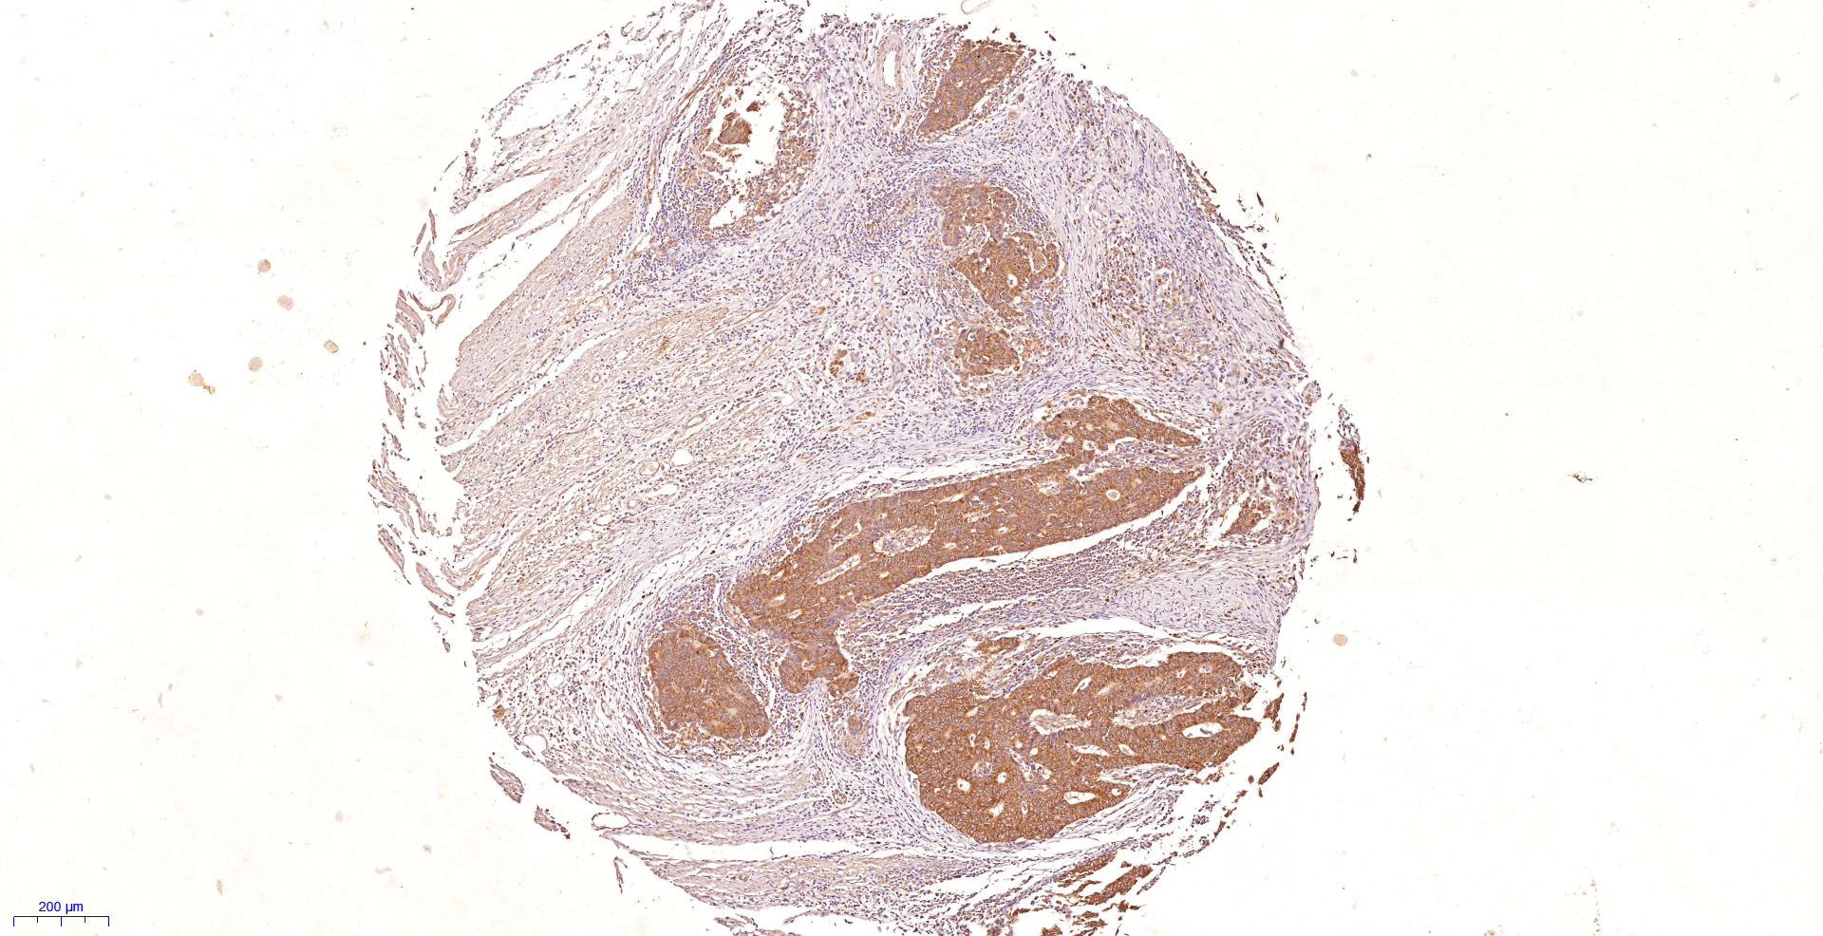
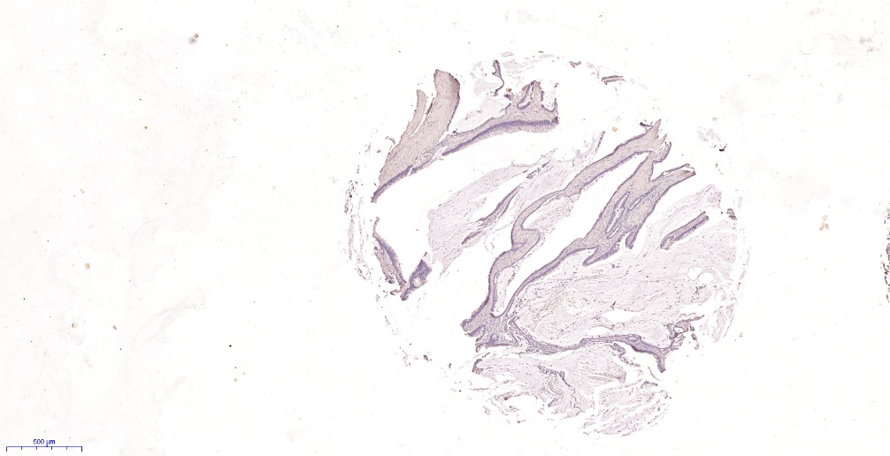
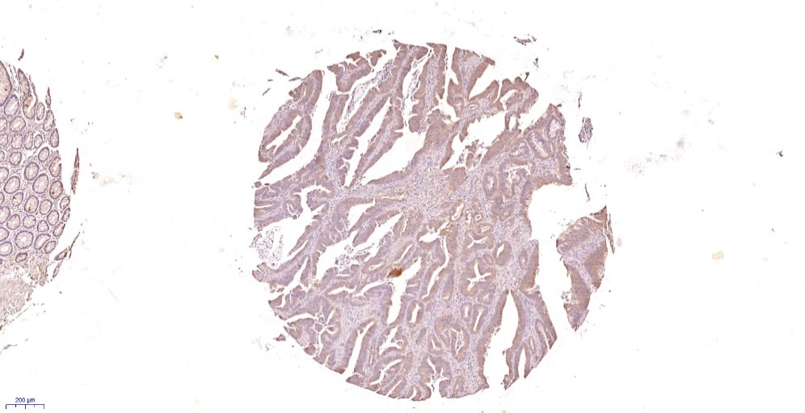
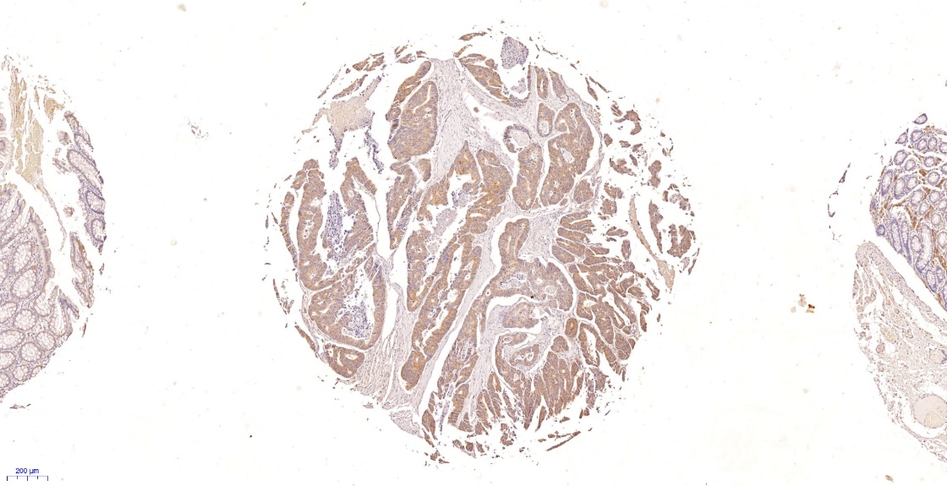
+++
-
+
++
A
B
C
D

Figure S2 A typical image of 400x high power field of MICB+ staining
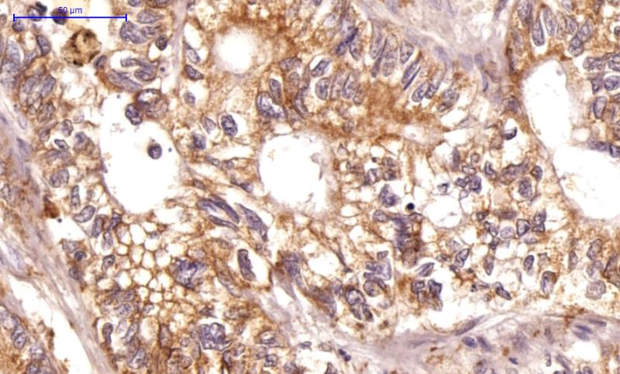

Table S1 Relationship between MICB and clinical characteristics of validation cohort
validation cohort
 |  | MICB
Factors | No (%) | Low (%) | High (%) | P
All patients | 556 | 342 | 214
Age (years) |  |  |  | 0.242
≤60 | 157 (28.2) | 91 (26.6) | 66 (30.8)
>60 | 398 (71.6) | 251 (73.4) | 147 (68.7)
Unknown | 1 (0.2) | 0 (0.2) | 1 (0.5)
Gender |  |  |  | 0.508
Male | 306 (55.0) | 192 (56.1) | 114 (53.3)
Female | 250 (45.0) | 150 (43.9) | 100 (46.7)
Localization |  |  |  | <0.001
Proximal colon | 218 (39.2) | 112 (32.7) | 106 (49.5)
Distal colon | 338 (60.8) | 230 (67.3) | 108 (50.5)
T stage |  |  |  | 0.070
T1/T2 | 55 (9.9) | 31 (9.1) | 24 (11.2)
T3/T4 | 481 (86.5) | 294 (86.0) | 187 (87.4)
Unknown | 20 (3.6) | 17 (5.0) | 3 (1.4)
N stage |  |  |  | 0.075
N0 | 294 (52.9) | 175 (51.2) | 119 (55.6)
N1/N2 | 242 (43.5) | 150 (43.9) | 92 (43.0)
Unknown | 20 (3.6) | 17 (5.0) | 3 (1.4)
M stage |  |  |  | 0.047
M0 | 473 (85.1) | 281 (82.2) | 192 (89.7)
M1 | 61 (11.0) | 44 (12.9) | 17 (7.9)
Unknown | 22 (4.0) | 17 (5.0) | 5 (2.3)
TNM stage |  |  |  | 0.345
I | 32 (5.8) | 18 (5.3) | 14 (6.5)
II | 261 (46.9) | 156 (45.6) | 105 (49.1)
III | 203 (36.5) | 125 (36.5) | 78 (36.4)
IV | 60 (10.8) | 43 (12.6) | 17 (7.9)

Figure S3 Kaplan-Meier analysis of validation cohort
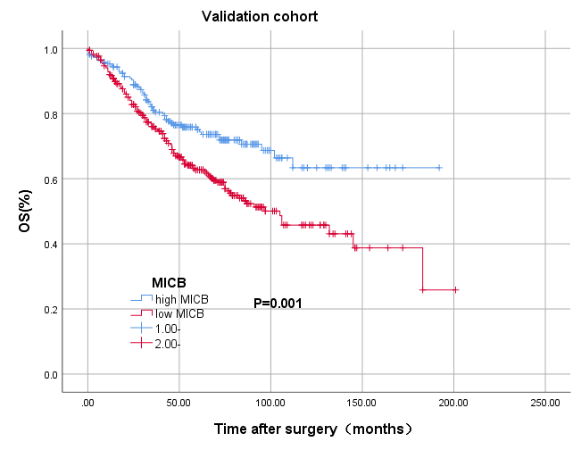

Table S2. Univariate and multivariate Cox regression analysis for overall survival in validation cohort
 | Overall survival
 | Univariate analysis |  | Multivariate analysis
Factors | HR (95% CI) | P | HR (95% CI) | P
Age (years) |  | 0.034 |  | 0.007
≤60 | 1 (reference) |  | 1 (reference)
>60 | 1.450 (1.029 – 2.043) |  | 1.624 (1.145 – 2.304)
Gender |  | 0.076 |  | 0.083
Male | 1 (reference) |  | 1 (reference)
Female | 0.769 (0.575 – 1.028) |  | 0.771 (0.575 – 1.035)
Localization |  | 0.600
Right-sided colon | 1 (reference)
Left-sided colon | 0.925 (0.690 – 1.239)
T stage |  | 0.044 |  | 0.153
T1/T2 | 1 (reference) |  | 1 (reference)
T3/T4 | 1.990 (1.017 – 3.891) |  | 1.635 (0.833 – 3.208)
N stage |  | 0.001 |  | 0.061
N0 | 1 (reference) |  | 1 (reference)
N1/N2 | 1.663 (1.237 – 2.234) |  | 1.351 (0.986 – 1.850)
M stage |  | <0.001 |  | <0.001
M0 | 1 (reference) |  | 1 (reference)
M1 | 5.171 (3.608 – 7.410) |  | 4.603 (3.136 – 6.758)
TNM stage |  | <0.001
I | 1 (reference)
II | 1.787 (0.723 – 4.417)
III | 2.198 (0.886 – 5.454)
IV | 8.901 (3.502 – 22.623)
MICB |  | 0.001 |  | 0.028
Low | 1 (reference) |  | 1 (reference)
High | 0.594 (0.434 – 0.811) |  | 0.699 (0.508 – 0.961)

Figure S4 Kaplan-Meier analysis of stage I and II patients from primary cohort(A) and Kaplan-Meier analysis of stage III and IV patients from primary cohort(B)
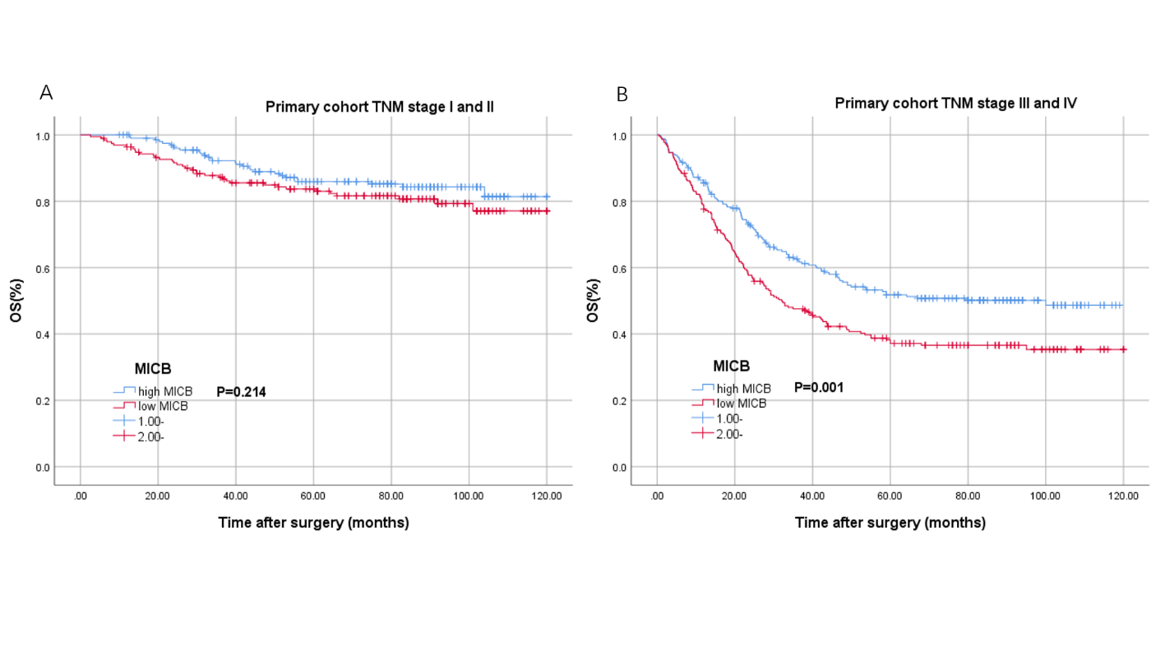
Table S3 Cox regression analyses for OS of stage III and IV patients from primary cohort
 | Overall survival
 | Univariate analysis |  | Multivariate analysis
Factors | HR (95% CI) | P | HR (95% CI) | P
Age (years) |  | 0.416
≤60 | 1 (reference)
>60 | 1.097 (0.858 –1.403)
Gender |  | 0.032 |  | 0.429
Male | 1 (reference) |  | 1 (reference)
Female | 0.756 (0.585 –0.976) |  | 0.899（0.691-1.170）
CEA (ng/ml) |  | <0.001 |  | 0.004
≤ 5 | 1 (reference) |  | 1 (reference)
> 5 | 2.271(1.723-2.993) |  | 1.522 (1.144-2.024)
Tumor location |  | 0.007 |  | 0.156
Right-sided colon | 1 (reference) |  | 1 (reference)
Left-sided colon | 0.958(0.703-1.307) |  | 0.951 (0.685-1.321)
Rectum | 0.652(0.485-0.878) |  | 0.759 (0.560-1.029)
Tumor size |  | 0.032 |  | <0.001
≤4.0cm | 1 (reference) |  | 1 (reference)
>4.0cm | 1.311(1.024-1.678) |  | 1.562 (1.215-2.006)
Primary histological type |  | 0.563
Non-mucinous | 1 (reference)
Mucinous | 1.111(0.777-1.588)
Primary differentiation |  | 0.132
Well/moderate | 1 (reference)
Poor/anaplastic | 1.210(0.944-1.551)
T stage |  | 0.016 |  | 0.461
T1/T2 | 1 (reference) |  | 1 (reference)
T3/T4 | 2.179 (1.158 – 4.101) |  | 1.278(0.665-2.458)
N stage |  | 0.003 |  | 0.003
N0 | 1 (reference) |  | 1 (reference)
N1/N2 | 0.616 (0.446 –0.850) |  | 1.664 (1.184-2.338)
M stage |  | <0.001 |  | <0.001
M0 | 1 (reference) |  | 1 (reference)
M1 | 5.349 (4.060 – 7.048) |  | 5.757 (4.269 – 7.763)
Vascular invasion |  | 0.624
No | 1 (reference)
Yes | 1.102(0.748-1.622)
Nerve invasion |  | 0.441
No | 1 (reference)
Yes | 0.824(0.504-1.348)
MICB |  | 0.001 |  | 0.009
Low | 1 (reference) |  | 1 (reference)
High | 0.666 (0.520 –0.853) |  | 0.716(0.558-0.919)

