Prognostic significance and therapeutic potential of the immune checkpoint VISTA in pancreatic cancer

Zelin Hou^{1#}, Yu Pan^{1#}, Qinglin Fei^{1, 2}, Yali Lin¹, Yuanyuan Zhou³, Ying Liu⁴, Hongdan Guan⁵, Xunbin Yu⁶, Xianchao Lin¹, Fengchun Lu¹, Heguang Huang^{1*}

(Supplementary table S1-S4 and Supplementary figure S1-S2)

Supplementary table S1

Panel 1 | VISTA / PD-1H  Clone D5L5T, CST  Dilution 1:25, overnight, 4°C | CD68  Clone D4B9C, CST  Dilution 1:10000, 1 hour, RT | PD-L1  Clone EPR19759, Abcam  Dilution 1:250, overnight, 4°C | PD-1  Clone NAT105, Abcam  Dilution 1:25, overnight, 4°C | Pan-Cytokeratin  Clone PAN-CK (Cocktail), Abcam  Dilution 1:800, 1 hour, RT | Nuclei staining  DAPI, 1µg/ml, 5 min, RT
Panel 2 | VISTA / PD-1H  Clone D5L5T, CST  Dilution 1:25, overnight, 4°C | CD68  Clone D4B9C, CST  Dilution 1:10000, 1 hour, RT | CD4  Clone EPR6855, Abcam  Dilution 1:100, 1 hour, RT | CD8  Clone EP1150Y, Abcam  Dilution 1:500, 1 hour, RT | Pan-Cytokeratin  Clone PAN-CK (Cocktail), Abcam  Dilution 1:800, 1 hour, RT | Nuclei staining  DAPI, 1µg/ml, 5 min, RT
Panel 3 | VISTA / PD-1H  Clone D5L5T, CST  Dilution 1:25, overnight, 4°C | CD68  Clone D4B9C, CST  Dilution 1:10000, 1 hour, RT | CD3  Clone PS1, Abcam  Dilution 1:100, 1 hour, RT | CD19  Clone EPR5906, Abcam  Dilution 1:500, 1 hour, RT | Pan-Cytokeratin  Clone PAN-CK (Cocktail), Abcam  Dilution 1:800, 1 hour, RT | Nuclei staining  DAPI, 1µg/ml, 5 min, RT
Opal staining | Opal 520 | Opal 540 | Opal 570 | Opal 620 | Opal 650 | DAPI

Table S2. Clinic-pathological characteristics
Cohort description | Cohort #1 | Cohort #2
Total patients | 137 | 86
Gender
Male | 88 | 55
Female | 49 | 31
Age (years)
≥ 65 | 57 | 36
< 65 | 80 | 50
Localization
Head | 88 | 54
Other | 49 | 32
Grading
G1 | 6 | 3
G2 | 102 | 51
G3 | 28 | 29
G4 | 1 | 3
pT-staging
pT1 | 4 | 3
pT2 | 48 | 29
pT3 | 57 | 39
pT4 | 28 | 15
pN-staging
pN0 | 56 | 30
pN1 | 54 | 30
pN2 | 27 | 26
pStage
Ⅰ | 21 | 11
Ⅱ | 63 | 38
Ⅲ | 45 | 30
Ⅳ | 8 | 7
Vascular invasion
Yes | 37 | 25
No | 100 | 61
Diameter (cm)
≥ 4 | 69 | 26
< 4 | 68 | 60
Procedure
PD | 85 | 50
DP | 43 | 27
TP | 9 | 9
Postoperative chemotherapy
Yes | 57 | 39
No | 80 | 47

Table S3. VISTA expression in PDAC tissues
 | TCs |  |  | ICs |  |  | ECs
Cohort | Low | High |  | Low | High |  | Low | High
Cohort #1 (N=137) | 101(73.72%) | 36(26.28%) |  | 82(59.85%) | 55(40.15%) |  | 105(76.64%) | 32(23.36%)
Cohort #1 (N=86) | 65(75.58%) | 21(24.42%) |  | 56(65.12%) | 30(34.88%) |  | 60(69.77%) | 26(30.23%)
Abbreviations: TC, tumor cells; IC, immune cells; ECs, endothelial cells

Table S4. Spearman rank correlation analysis
 |  | VISTA in TCs |  |  | VISTA in ICs |  |  | VISTA in ECs
 |  | r | P |  | r | P |  | r | P
Cohort #1 (N=137) | VISTA in TCs | 1 | - |  | 0.12 | 0.162 |  | 0.219 | 0.01
 | VISTA in ICs | 0.12 | 0.162 |  | 1 | - |  | 0.076 | 0.379
 | VISTA in ECs | 0.219 | 0.01 |  | 0.076 | 0.379 |  | 1 | -
Cohort #2 (N=86) | VISTA in TCs | 1 | - |  | 0.095 | 0.384 |  | 0.333 | 0.002
 | VISTA in ICs | 0.095 | 0.384 |  | 1 | - |  | -0.057 | 0.603
 | VISTA in ECs | 0.333 | 0.002 |  | -0.057 | 0.603 |  | 1 | -
Abbreviations: TC, tumor cells; IC, immune cells; ECs, endothelial cells

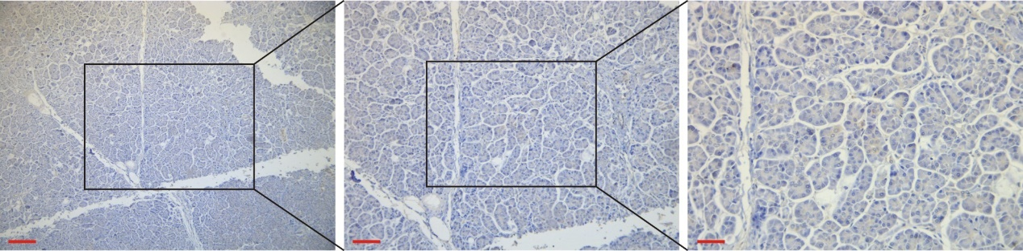
Figure S1. Expression of VISTA in adjacent normal tissues of PDAC patients. Staining with an anti-VISTA in the human PDAC adjacent normal tissue samples. Scale bar = 100 µm (red line at the bottom left)

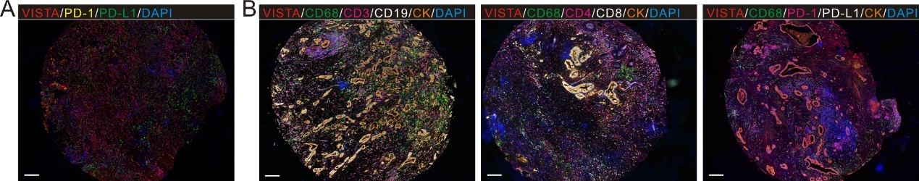
Figure S2. The staining panels of multiplex immunofluorescence. (A) Multiplex immunofluorescence staining image of tonsil control tissue. Scale bars =100 μm. (B) Three different panels of multiplex immunofluorescence in PDAC tumor microenvironment. Scale bars =100 μm.

