Supplementary Material

Supplementary Table S1. MSI-1 siRNA sequences used.
siRNA | sequence
MSI-1 siRNA No 1 | GCUCGACUCCAAAACAAUU
MSI-1 siRNA No 2 | GGACGUGAAGCAAUAUUUU

Supplementary Table S2. qPCR TaqMan probe numbers. All details can be found on the manufacturer’s website (Thermo Fisher Scientific).
Gene | Manufacturer’s ID
18S | hs99999901_s1
Musashi-1 | hs00159291_M1
Notch-1 | hs00413187_M1
Notch-3 | hs01128541_M1
Tdgf1 | hs02339497_g1
Nestin | hs04187831_g1
Nanog | hs02387400_g1

Supplementary Table S3. MSI-1 siRNA sequences used.
Gene | Primary antibody | Secondary antibody
P21 | Rabbit monoclonal IgG  Cell Signalling Technology, Danvers, USA | Goat Anti-Rabbit IgG, H & L Chain Specific Peroxidase Conjugate  Calbiochem, Merck KGaA, Darmstadt
Tubulin | Mouse monoclonal IgG  Sigma-Aldrich, St. Louis, USA | Goat Anti-Mouse IgG, H&L Chain Specific Peroxidase Conjugate  Calbiochem, Merck KGaA, Darmstadt
MSI-1 | Mouse monoclinal IgG  Santa Cruz, Dallas, USA | Goat Anti-Mouse IgG, HRP conjugated  R&D Systems, Minneapolis, USA

Supplementary Fig. S1. MSI-1 expression is downregulated after MSI-1 siRNA transfection, compared to controls. Quantitative polymerase chain reactions (qPCRs) were used for mRNA expression analyses, western blot was used for protein expression analyses. Cells were transfected with a control siRNA and MSI-1siRNA, respectively. Then, measurements were performed as detailed in the Methods section (at least n = 3, * p<0.05, *** p <0.001, error bars indicate s.e.m.).

Supplementary Fig. S2. Mammosphere formation after MSI-1 knockdown, compared to controls. Equal numbers of cells for controls and after MSI-1 knockdown were seeded in stem cell medium. After 7 days, area per sphere was measured and compared between controls and knockdown cells (A). Representative images for controls (left) and knockdown cells (right) in can be found in panel B. Macroscopically, fewer spheres were visible as well (C). Experiments were performed as detailed in the methods section (at least n = 3, ** p <0.01, error bars indicate s.e.m.).
Supplementary Fig. S3. Expression of stem cell markers in MCF-7 cells after MSI-1 knockdown, compared to controls. Cells were transfected with a control siRNA and MSI-1 siRNA, respectively. Then, qPCR measurements were performed as detailed in the Methods section (at least n = 3, * p<0.05, error bars indicate s.e.m.).

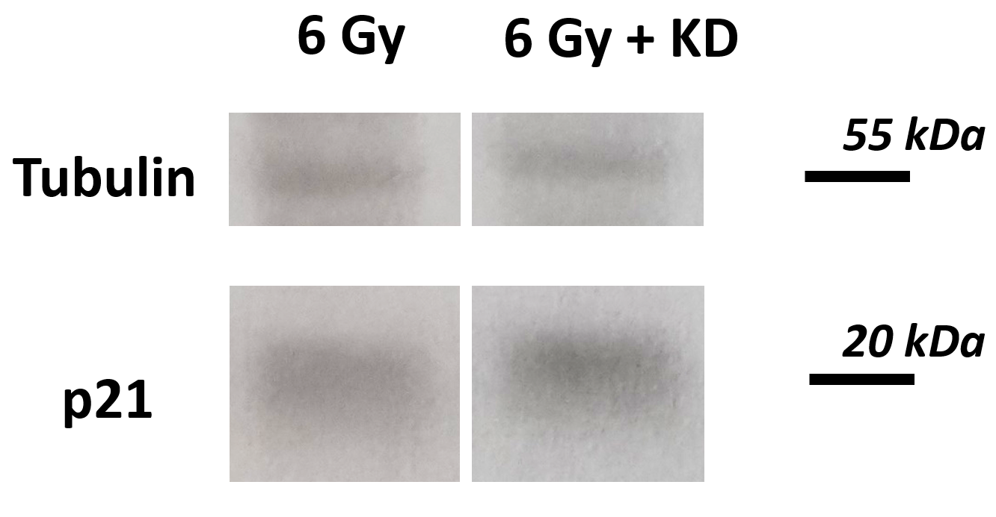
Supplementary Fig. S4. Representative blot: p21 is stronger expressed in MSI-1 knockdown cells after 6 Gy irradiation compared to control siRNA transfected cells after 6 Gy.

Supplementary Fig. S5. Cell viability after MSI-1 knockdown and chemotherapy addition. A: Cell viability is decreased in MSI-1 knockdown cells compared to controls before adding chemotherapy (at least n = 3, ** p<0.01, error bars indicate s.e.m.).. B & C: No additional chemosensitization is seen in MSI-1 knockdown cells after addition of Cisplatin and Doxorubicin.

