Supplementary Figure 1. Proportion of change in health insurance providers
13 respondents had missing information on change in health insurance.

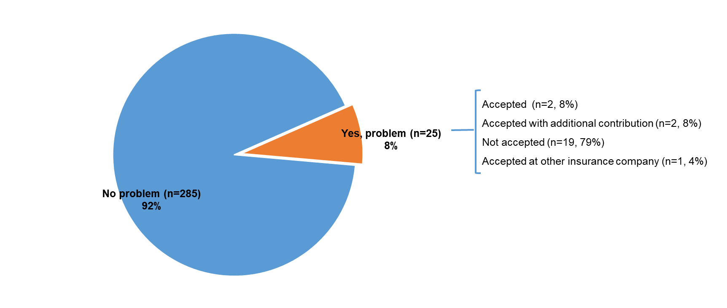

Supplementary Figure 2. Distribution of cancer survivors who bought life insurance after cancer, encountered problems, and how problems were resolved
Survivors who reported how problems were resolved: n=24
Percentages might not add up to 100% due to rounding of decimal
Supplementary Table 1. Factors associated with problems obtaining life insurance (n=25)
 | n | OR_{unadjusted} (95% CI)
Cancer type
Breast | 15 | 1.00
Colorectal | 6 | 1.37 (0.50-3.71)
Prostate | 4 | 0.51 (0.16-1.59)
Sex
Female | 18 | 1.00
Male | 7 | 0.68 (0.27-1.68)
Stage at diagnosis
I | 10 | -
II | 5 | -
III | 3 | -
IV | 0 | -
Low (I &II) | 15 | 1.00
High (III & IV) | 3 | 1.54 (0.42-5.68)
Missing | 7
Age at diagnosis (years)
<55 | 17 | 2.98 (0.87-10.29)
55-64 | 5 | 1.00
≥65 | 3 | 0.36 (0.12-1.10)
Comorbid conditions
None | 8 | 1.00
One | 10 | 0.79 (0.30-2.09)
Two or more | 7 | 0.98 (0.34-2.82)
In a partnered relationship
Yes | 19 | 1.00
No | 6 | 0.89 (0.34-2.31)
Education
< 9 years | 4 | 1.00
10-11years | 8 | 3.24 (0.95-11.11)
≥12 years | 13 | 6.45 (2.03-20.55)
OR: odds ratio; CI: confidence intervals

