SUPPLEMENTARY FIGURES
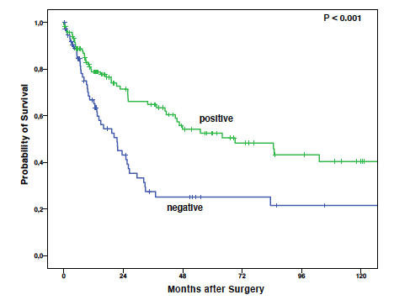
Figure S1: Median survival in patients that underwent primary surgery stratified by negative or positive FBP1 expression.
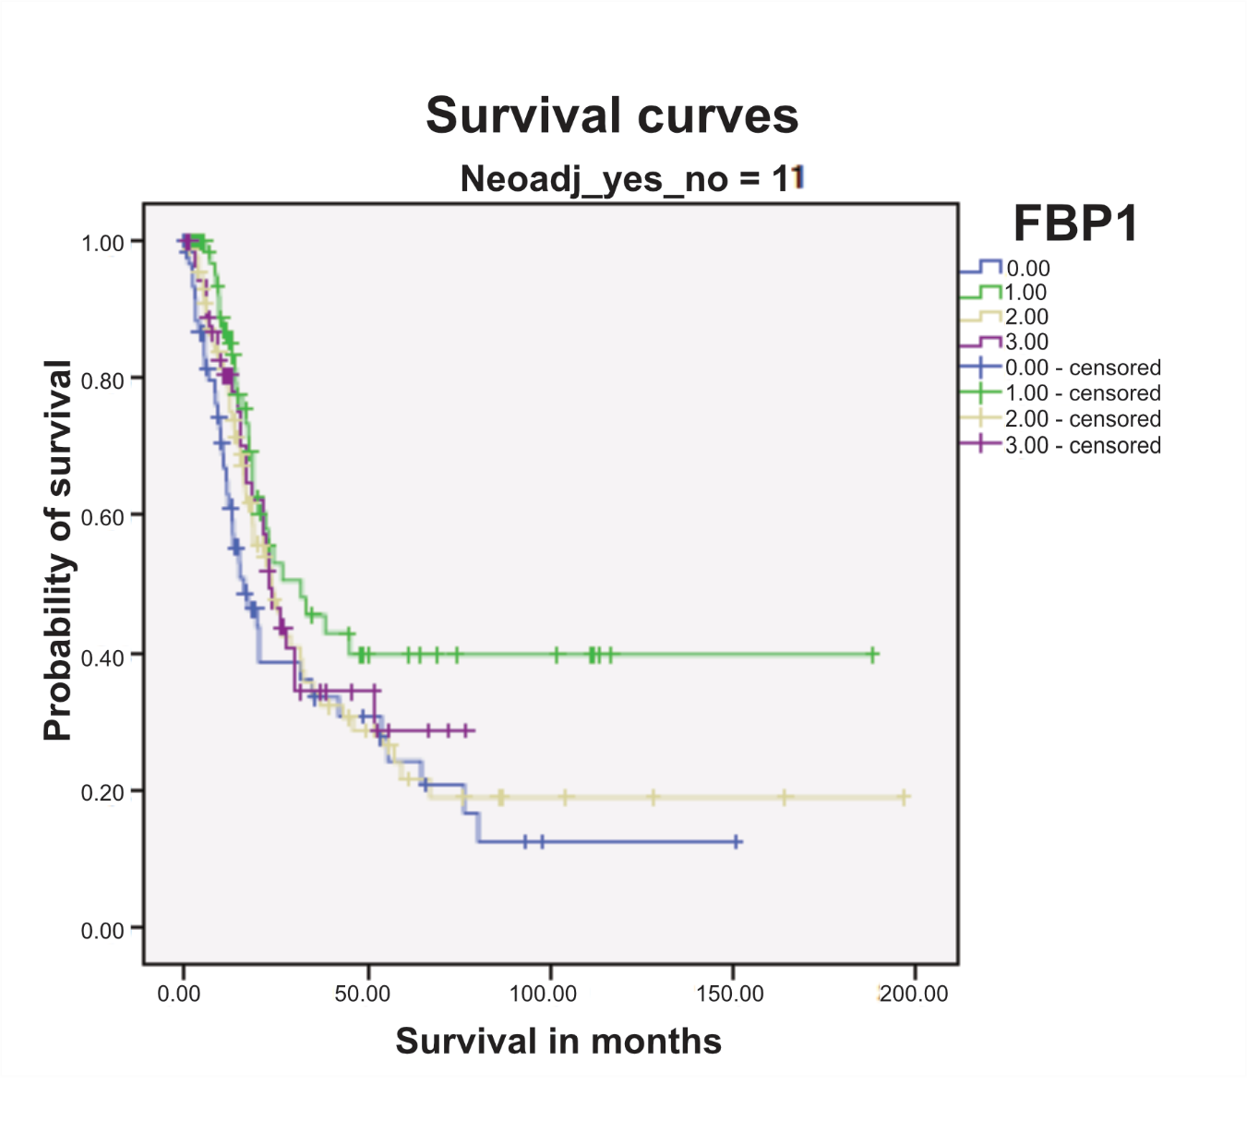
Figure S2: Median survival according to FBP1 expression in patients that underwent neoadjuvant therapy

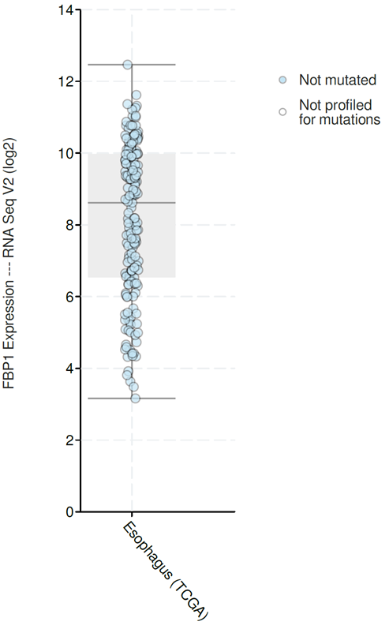
Figure S3: TCGA data for FBP1 expression in esophageal adenocarcinoma

