Supplementary files

Powering single-cell genomics to unravel circulating tumour cells subpopulations in non-small cell lung cancer patients

Emmanuel Acheampong^{1,2}, Michael Morici^{1,2}, Afaf Abed^{1,2,7}, Samantha Bowyer^{3,6,7}, Du-Bois Asante^{1,2}, Weitao Lin^{1,2,5}, Michael Millward^{1,2,6,7}, Elin S Gray^{1,2*}, Aaron B Beasley^{1,2}

Table S1: Antibodies used for immunocytochemistry staining
Antibody | Host Species | Conjugate | Clone | Antigen location | Supplier (CTLG #) | Dilution | Use
CD16 | Mouse | PE | 3G8 | Membrane | BioLegend,San Diego USA, (302008) | 1/50 | WBC identification
CD45 | Mouse | PE | HI30 | Membrane | BioLegend, San Diego, USA (982310) | 1/50 | WBC identification
Cytokeratins | Mouse | FITC | CK3-6H5 | Cytoskeleton | Miltenyi Biotech, Gladbach, Germany (130-118-964) | 1/50 | CTC identification
Cytokeratins | Mouse | AF488 | C11 | Cytoskeleton | Cell Signalling Technology, Denver, USA (4523S) | 1/100 | CTC identification
Cytokeratins | Mouse | AF488 | AE1/AE3 | Cytoskeleton | ThermoFisher Scientific, USA, (53-9003-82) | 1/200 | CTC identification
EpCAM | Mouse | FITC | VU-1D9 | Membrane | ThermoFisher Scientific, USA, (A15755) | 1/100 | CTC identification
Vimentin | Mouse | AF647 | V9 | Cytoskeleton | Abcam, USA, (ab195878) | 1/1000 | CTC identification
N-Cadherin | Mouse | PE | 8C11 | Membrane | BioLegend USA, (350806) | 1/20 | N-cadherin expression
PD-L1 | Rabbit | AF647 | 28-8 | Membrane | Abcam, USA, (ab205921) | 1/400 | PD-L1 expression
PE: phycoerythrin, AF: Alexa Fluor, FITC: Fluorescein isothiocyanate

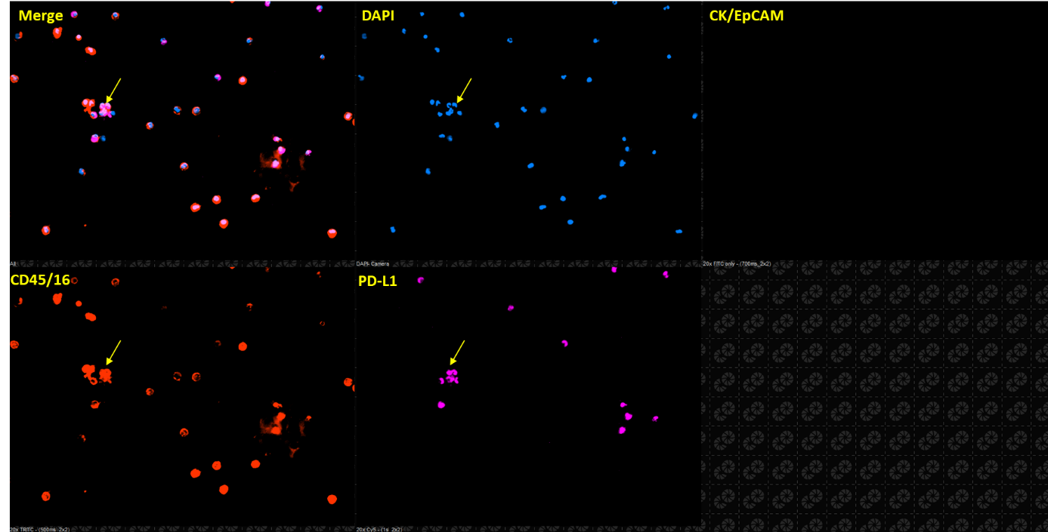
Figure S1: Representative immunofluorescence images of Parsortix-enriched WBC expressing PD-L1. (CK/EpCAM⁻, CD45/16⁺, PD-L1⁺). Cells were stained with DAPI (blue), anti-pCK/EpCAM (green), anti-CD45/16 (red) and anti-PD-L1 antibodies (pink). WBC cells are indicated with yellow arrows. Images were taken using an Eclipse Ti-E inverted fluorescent microscope (magnification X20).

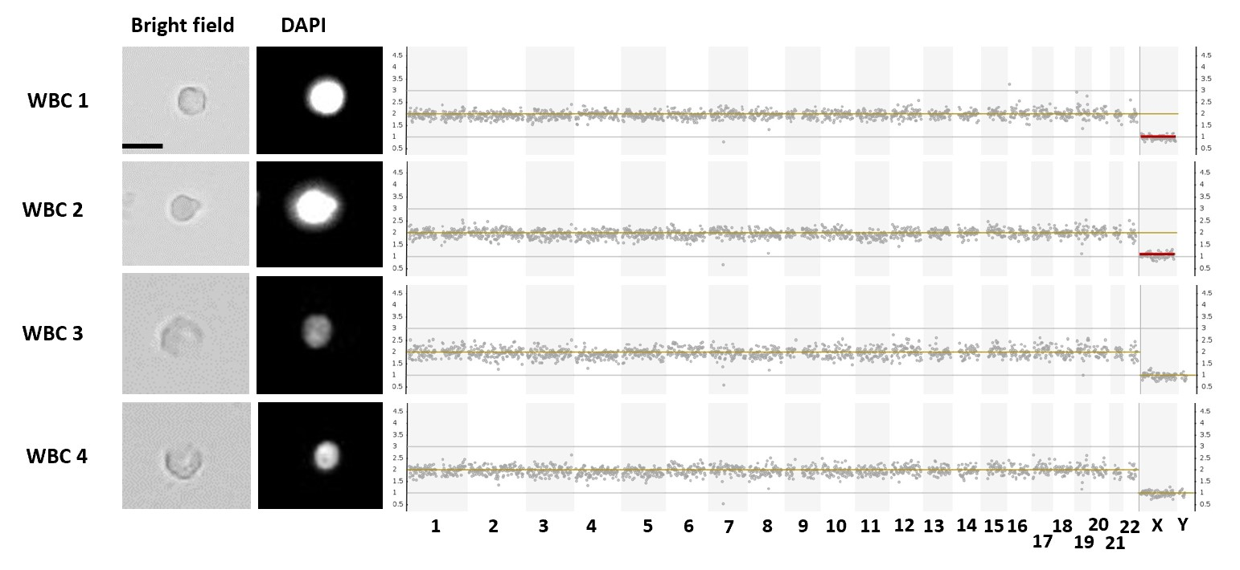
Figure S2: CNA profiles of WBCs used as negative controls. Bright field and DAPI images of WBCs in relation to their genomic profiles obtained from low-pass whole-genome sequencing.

