Supplementary Figures
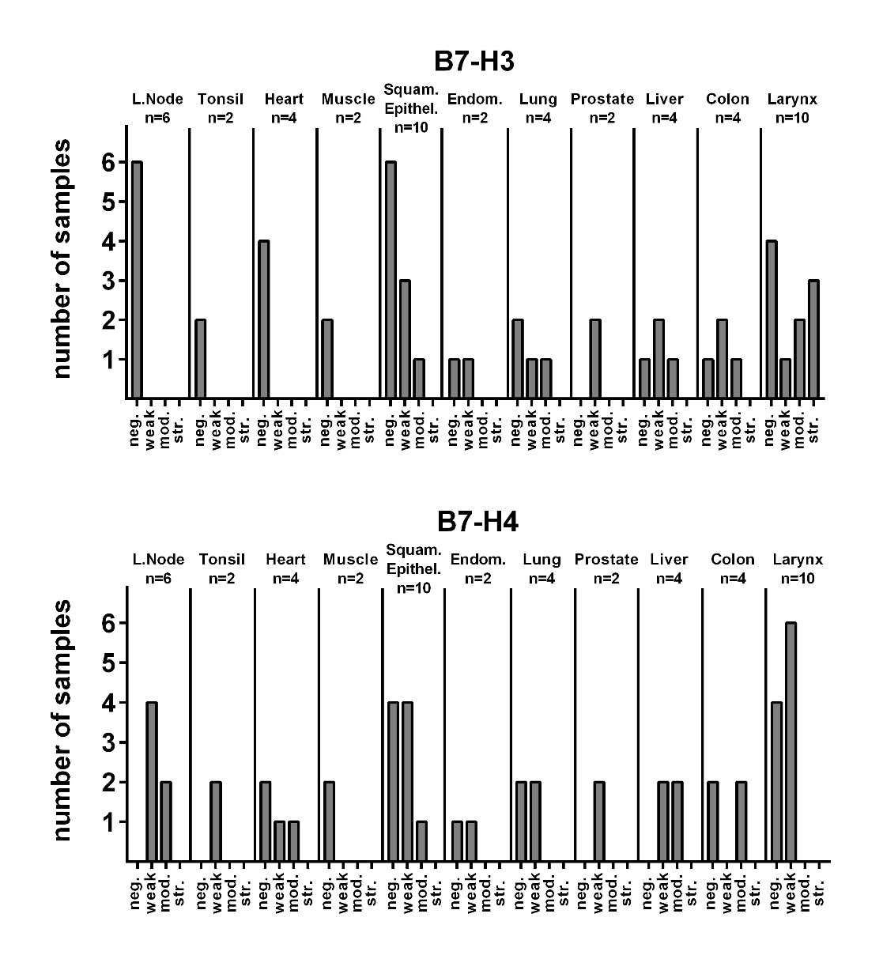

Supplementary Figure 1. Immunohistochemical staining of normal tissue control samples.
Distribution of staining categories in the normal tissue control samples of the TMA in absolute numbers. Staining of normal tissue for B7-H3 is clearly reduced as compared to the HNSCC tumor samples. Note that the mostly small number of samples per tissue type limits accurate conclusions.
neg.: negative; mod.: moderate; str.: strong; Squam.Epithel.: Squamous epithelium; Endom.: Endometrium

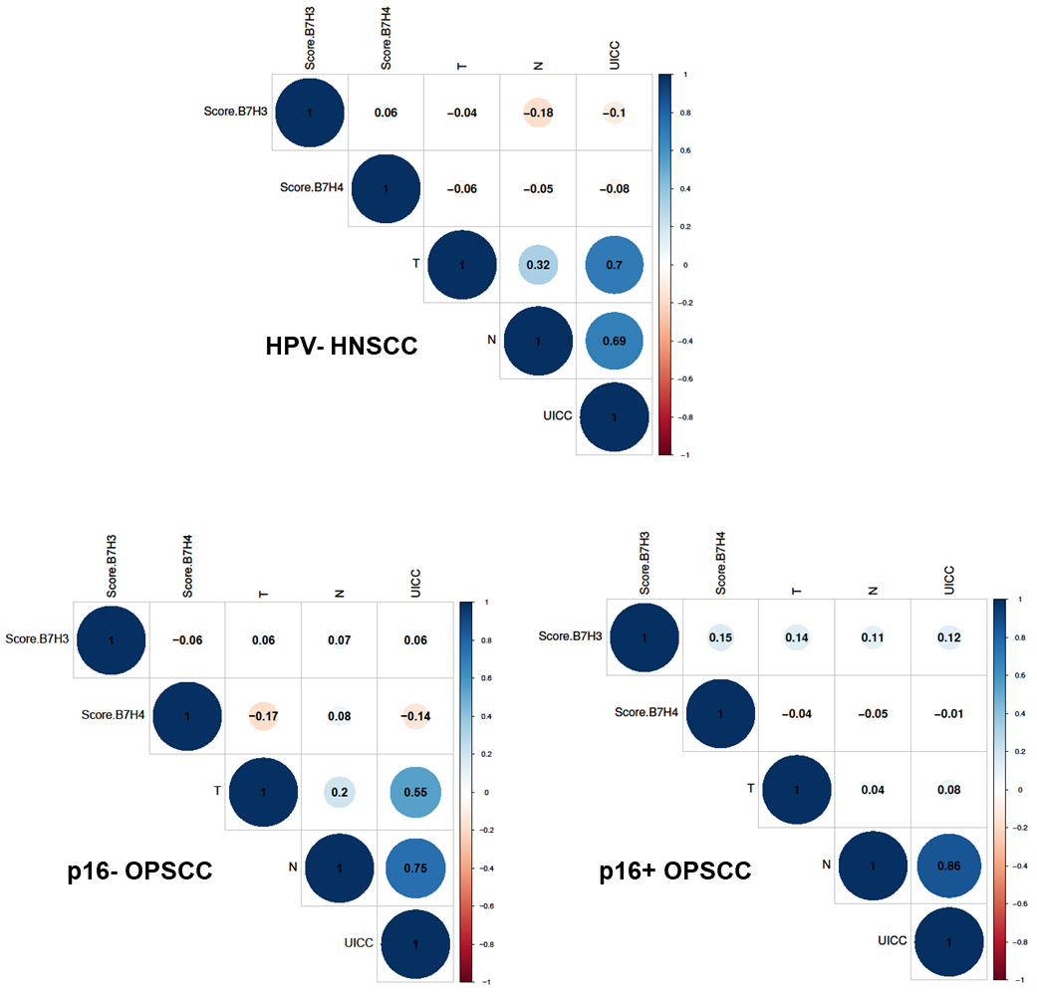

Supplementary Figure 2. Correlation analyses. Correlation analyses of B7-H3 and B7-H4 expression scores with each other and with T-, N- and UICC-stage (7th edition) in HPV- HNSCC and in OPSCC in dependence of the p16 status. As expected, T and N-stage show a clear correlation with UICC-stage (7th edition) in HPV- HNSCC and p16- OPSCC and N-stage with UICC-stage in p16+ OPSCC. B7-H3 and B7-H4 do not demonstrate a clear correlation with each other or T-, or N-stage. Note that faint assoziations are observed between B7-H3 and N-status in HPV- HNSCC and B7-H4 and T-status in p16- OPSCC.

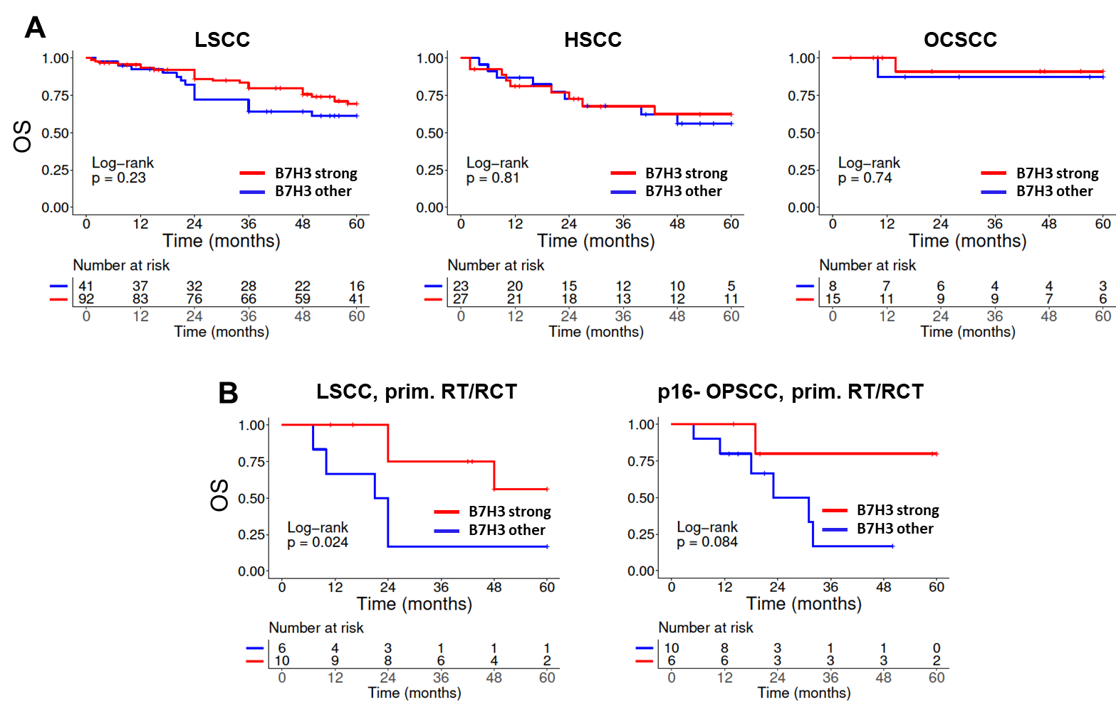

Supplementary Figure 3. Association of overall survival and B7-H3 expression in the indicated subgroups. B7-H3 expression was categorized as either strong or other, which includes all samples scored as negative, weak or moderate.

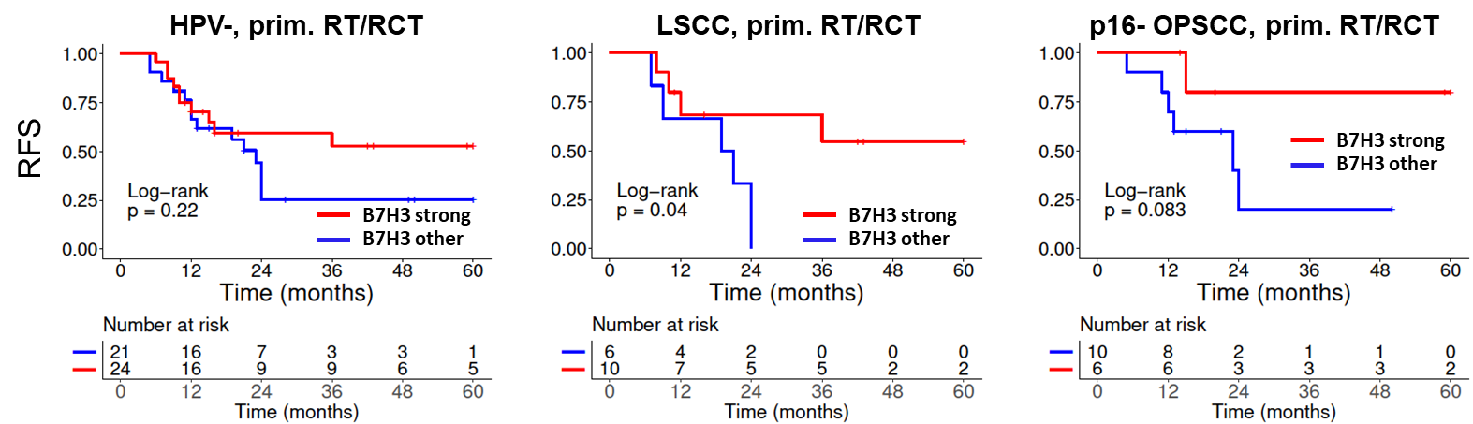

Supplementary Figure 4. Association of recurrence free survival and B7-H3 expression in the indicated patients groups treated with primary RT/RCT. B7-H3 expression was categorized as either strong or other, which includes all samples scored as negative, weak or moderate.

