Figure S2: Naive western blot membrane
a)
c-Met
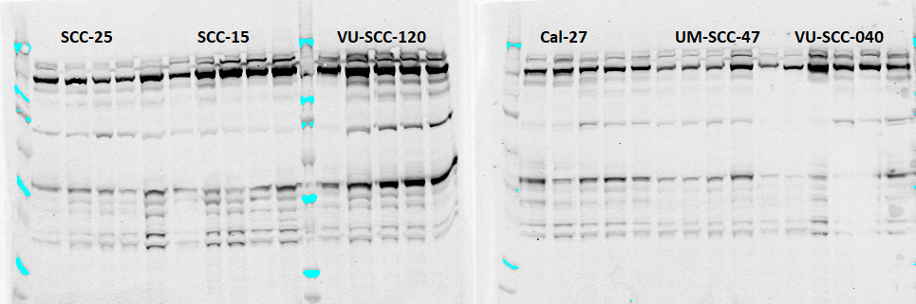
β-actin
b)
VU-SCC-120/p-Met

