Supplementary materials
Figures

SM Figure 1: Patients’ age distribution

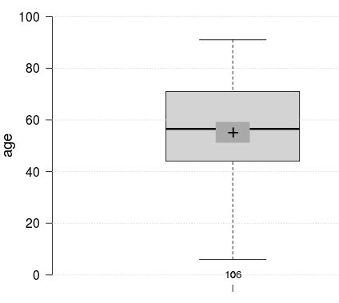

SM Figure 2: Location distribution of sarcomas included 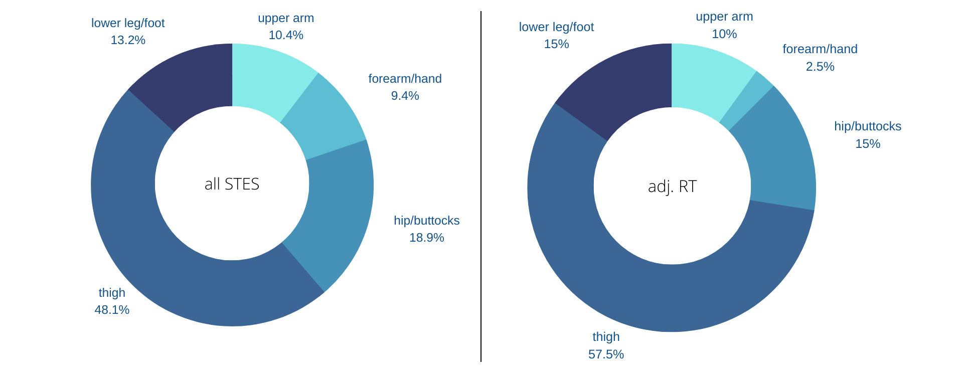

SM Figure 3: Histological distribution of sarcomas included

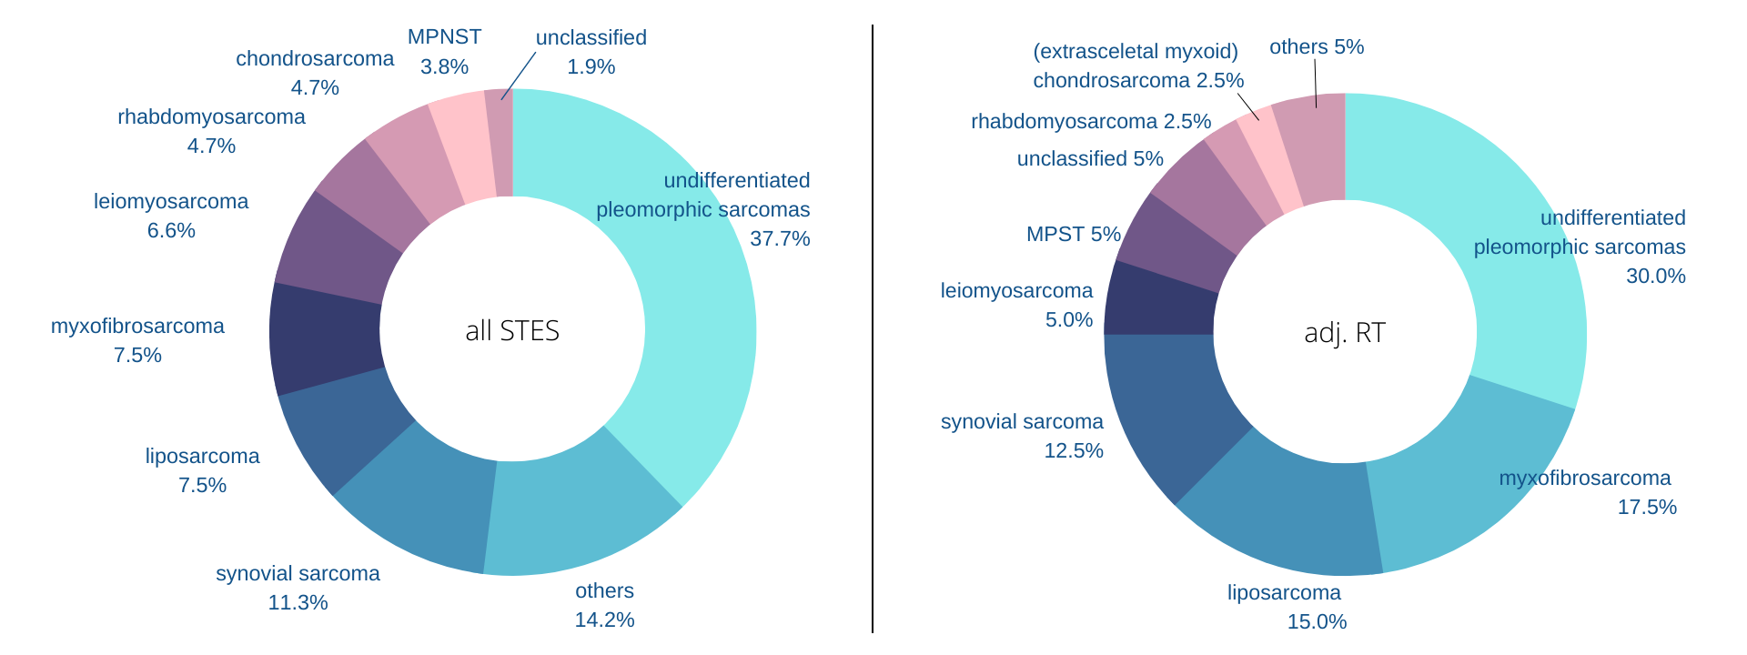

SM Figure 4: MRI of the 56-year-old patient with a synovial sarcoma having received IG-/IMRT RT as an example of the recurrence in relation to the previous irradiation field and its isodoses. This recurrence reaches the 25% isodose (of 60 Gy, see SM Table 1).

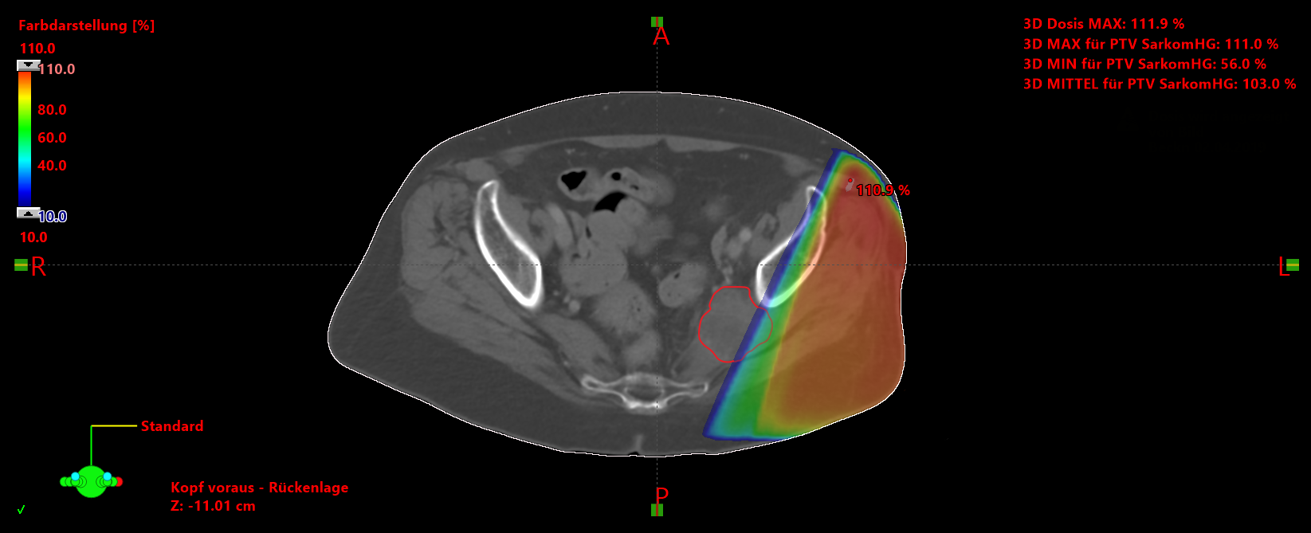

Tables

SM Table 1: Parameters for local recurrence after adj. RT with the distance of the recurrence to the original sarcoma and the isodose of the original irradiation field are given. R = resection status, IG-/IMRT = Image-guided/intensity-modulated radiation therapy, IGRT = Image-guided radiation therapy, IMRT = intensity-modulated radiation therapy, CTV long. = Clinical target volume longitudinal.
Age | Location | Histology | ≥8cm | R | Grade | Dose (Gy) | Technique | PTV Long. |  | Distance | Isodose
28 | thigh | Synovial sarcoma | yes | 1 | 3 | 66 | IG-/IMRT | 3.5 cm | 0 cm |  | 90%
22 | lower leg | other | yes | 1 | 3 | 44.80 | IGRT | 3.5 cm | 0 cm |  | 90%
83 | thigh | Pleomorphic sarcoma | yes | 1 | 2 | 60 | IG-/IMRT | unknown | 0 cm |  | 95%
56 | buttocks/hip | Synovial sarcoma | yes | 0 | 3 | 60 | IG-/IMRT | 3 cm | 3 cm |  | 25%

SM Table 2: surgery complications rates
Wound complications after surgery and VAC | No. | % of n = 92
all wound complications | 27 | 29.3 %
Requiring secondary operations or invasive  procedures for wound care | 23 | 25.0 %
prolonged dressing changes | 7 | 7.6 %
infections within 120 days of surgery | 7 | 7.6 %
use of vacuum-assisted closure | 5 | 5.4 %

