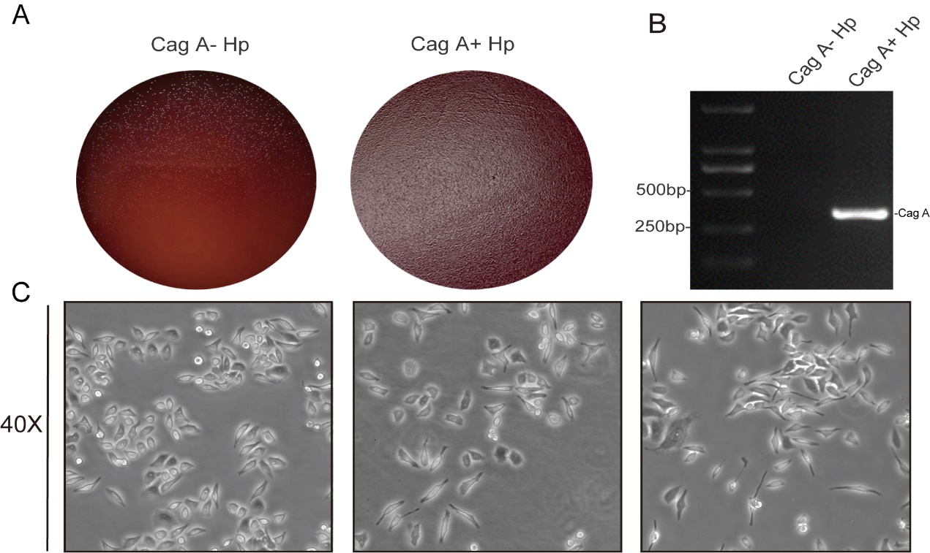

Fig S1 Morphological observation. A Morphological observation of Cag A⁻H. pylori and Cag A⁺H. pylori in Petri dishes, B Identification of Cag A⁻H. pylori and Cag A⁺H. pylori. C From left to right, the morphological changes of GES-1 after chronic infection with Cag A⁻H. pylori and Cag A⁺H. pylori in control group (observed under microscope at 40x).

