Supplementary Material
Supplementary Table S1- S2
Supplementary Fig. S1 – S2

Table S1 Chemotherapy regimens
Neoadjuvant chemotherapy | n %
Total | 505 | 100
No Taxane | 411 | 81.4
Cis + 5-FU or Cap | 222 | 44.0
Ox + 5-FU or Cap | 78 | 15.4
Cis or Ox + 5FU or Cap + Epi | 102 | 20.2
Cis or Ox + Ab | 9 | 1.8
Taxane included | 94 | 18.6
Cis+5FU + Doc or Pac  Ox + 5FU + Doc (FLOT)  FLOT + Ab | 29  62  3 | 5.7  12.3  <1
Cis, cisplatin; Ox, oxaliplatin; 5-FU, 5-fluorouracil; Cap, capecitabine;
Epi, epirubicin; Ab, antibody; Doc, doxetacel; Pac, paclitaxel

Table S2 Association of MSI status with clinicopathological factors in patients treated with or without taxanes
Variable | p valuesª
Variable | platinum/fluoropyrimidine CTx
Variable | without taxane | with taxane
Sex | 0.146 | 0.683
Age | 0.044^{b} | 0.286^{b}
Laurén (intestinal vs. non-intestinal | 0.732 | 0.503
Localisation (proximal vs. non-proximal | 0.159 | 0.008
ypT (ypT0,1,2 vs. 3,4) | 0.477 | 0.091
ypN (negative vs. positive) | 0.360 | 0.310
M status (negative vs. positive) | 0.316 | 0.697
R status ( R0 vs.R1) | 0.695 | 0.448
Response (TRG1 vs. TRG2,3) | 1.000 | 0.167
ª Chi-squared or Fisher's exact tests, ^{b} Mann-Whitney U Test

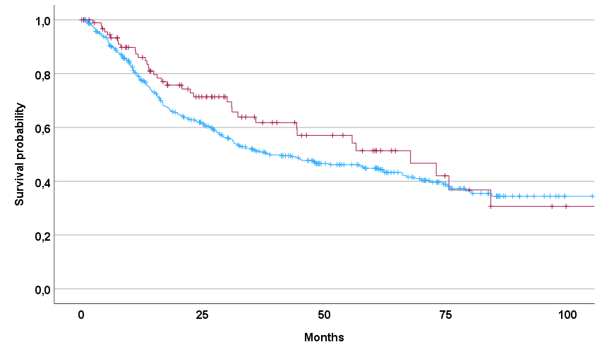
Number at risk
with taxane 94 46 22 8 2
without taxane 411 210 115 50 14
with taxane
without taxane

Fig. S1 Discrimination of patients’ survival by CTx with and without taxane
Kaplan–Meier curves of patients treated with platinum/fluoropyrimidine neoadjuvant CTx with and without taxane are shown; p= 0.179; p of univariable Cox-regression.

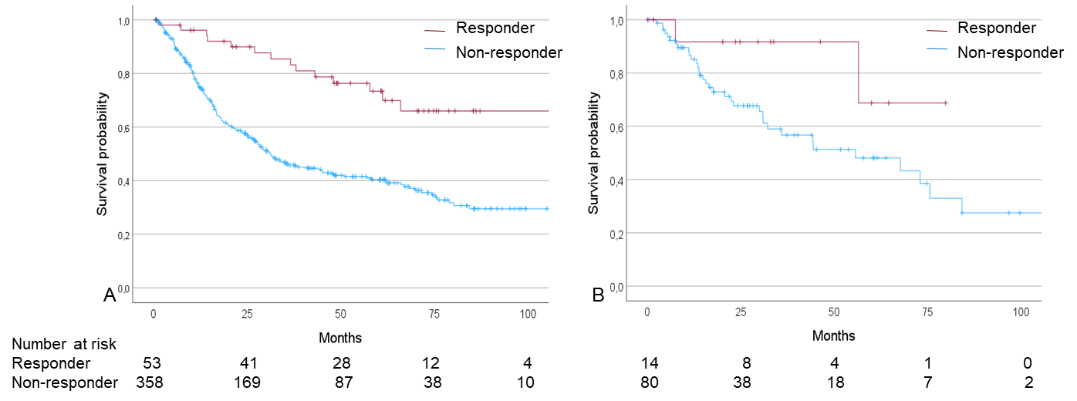

Fig. S2 Discrimination of patients’ survival by response to CTx
Kaplan–Meier curves of responding (TRG1) and non responding (TRG2,3) patients are shown. Patients treated with neoadjuvant CTx A) without taxane, p<0.001; B) with taxane, p=0.105; p of univariable Cox-regression.

