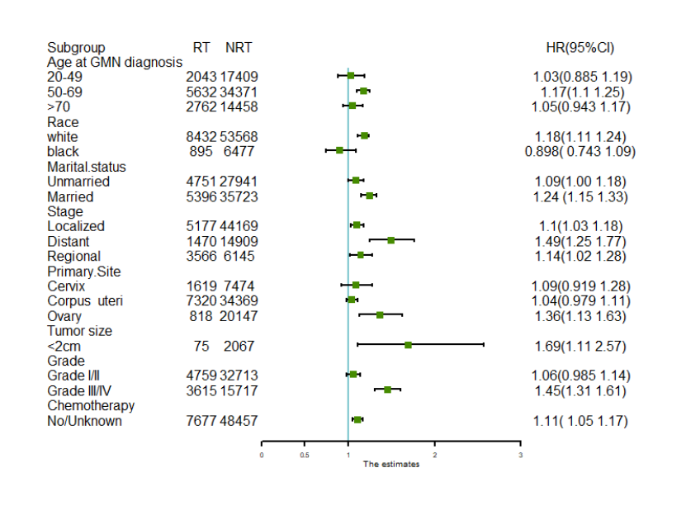

S3Fig.
Subgroup analyses of competing risk regression for the risk of developing secondary primary malignancies (SPMs)

