Fig. S1 Flowchart of inclusion and exclusion criteria used in this study
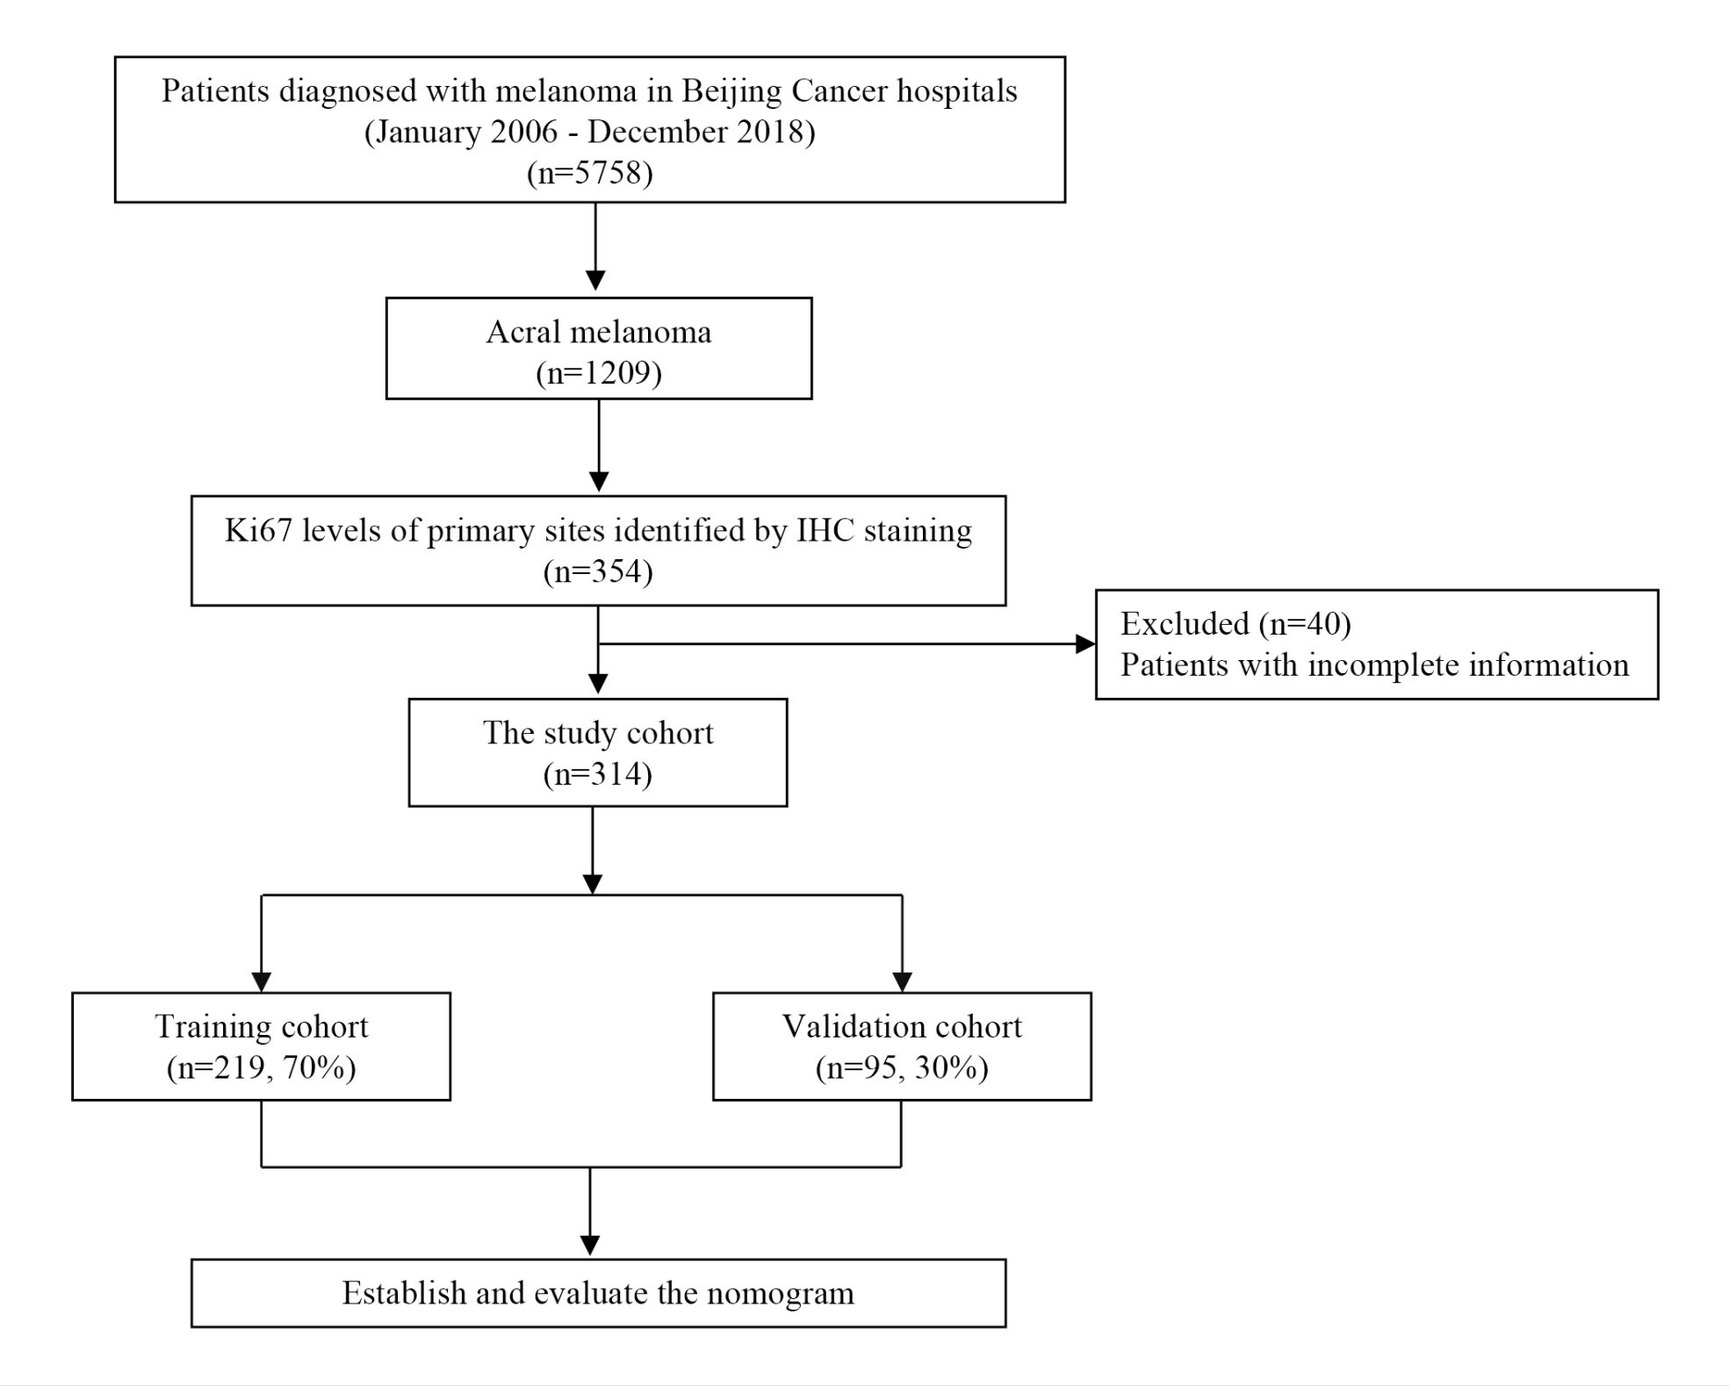

Fig. S2 Calibration curves of the nomogram for predicting overall survival at 1-year, 3-years, 5-years and 8-years in the training cohort (a, c, e, g) and validation cohort (b, d, f, h)
