Supplementary information

Low microsatellite instability – a distinct instability type in gastric cancer?
Meike Kohlruss, Shounak Chakraborty, Alexander Hapfelmeier, Moritz Jesinghaus, Julia Slotta-Huspenina, Alexander Novotny, Leila Sisic, Matthias M. Gaida, Katja Ott, Wilko Weichert, Nicole Pfarr, and Gisela Keller

Supplementary Figures
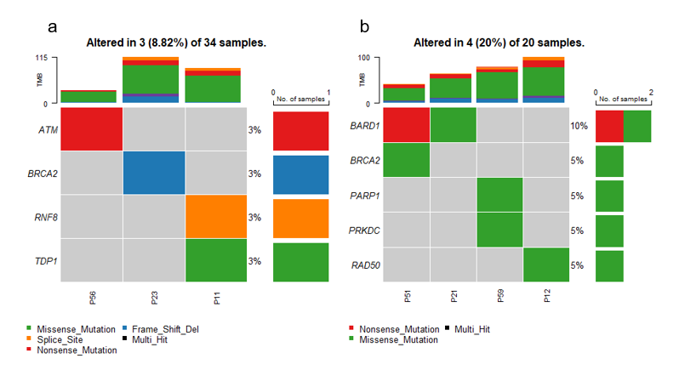

Supplementary Fig. S1 DNA sequence variants in genes of canonical and alternative NHEJ in MSS and MSI-L tumors
Oncoplots of the sequence variants of the genes involved in DNA repair by the canonical and alternative NHEJ pathway are shown a) MSS tumors, b) MSI-L tumors. Bars represent the mutation rate in the respective tumor group. MSS, microsatellite stable; MSI-L, low microsatellite instability; NHEJ, non homologous end joining.

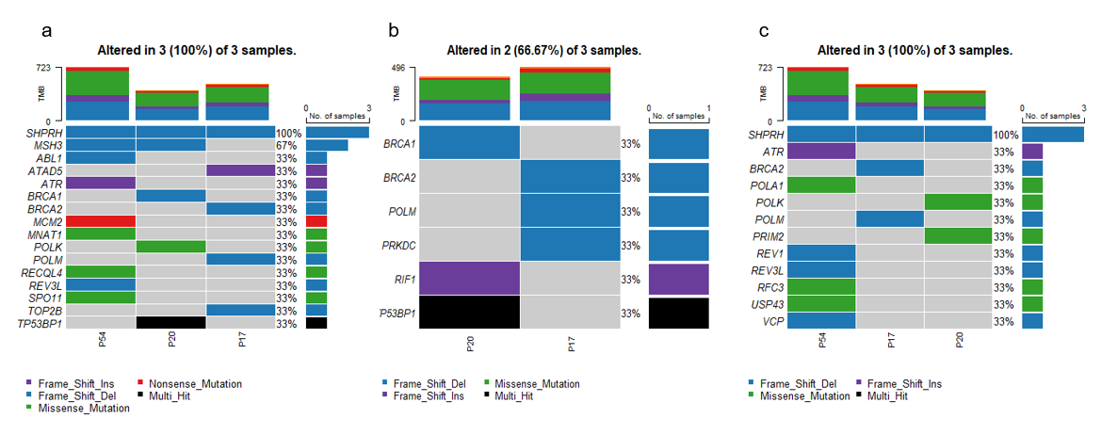
Supplementary Fig. S2 DNA sequence variants in MSI-H tumors
Oncoplots of the DNA sequence variants in the three MSI-H tumors are shown for genes involved in a) HR, b) canonical and alternative NHEJ, c) DNA damage tolerance pathway.
MSI-H, high microsatellite instability; HR, homolgous recombination repair; NHEJ, non homologous end joining.

Supplementary Tables

Supplementary Table S1 Chemotherapy regimens
Neoadjuvant chemotherapy | n %
Total | 28 | 100
Cis + 5-FU or Cap | 12 | 43
Ox + 5-FU or Cap | 5 | 18
Cis or Ox + 5FU or Cap + Epi | 9 | 32
Cis or Ox + Ab | 1 | 4
Cis+5-FU + Doc or Pac | 1 | 4
Cis, cisplatin; Ox, oxaliplatin; 5-FU, 5-fluorouracil; Cap, capecitabine;
Epi, epirubicin; Ab, antibody; Doc, doxetacel; Pac, paclitaxel

Supplementary Table S2 Mutation frequencies of MSS and MSI-L tumors
Pathway | Number of  analysed genes | Number of mutated tumors /  analysed tumors |  | p value*
 |  | MSS  n = 34 (%) | MSI-L  n = 20 (%)
HR | 149 | 10 (29) | 10 (50) | 0.154
Canonical and alternative NHEJ | 60 | 3 (9) | 4 (20) | 0.403
NER | 110 | 6 (18) | 3 (15) | 1.000
Fanconi Anemia | 38 | 4 (12) | 0 (0) | 0.285
DNA synthesis | 121 | 5 (15) | 3 (15) | 1.000
DNA damage tolerance | 98 | 6 (18) | 7 (35) | 0.194
* p value of Fisher exact test; HR, homologous recombination repair; NHEJ, non homologous end joining; NER, nucleotide excision repair;

Supplementary Tables S3 LOH, TAI, LST and HRD score in MSS and MSI-L tumors

Category | Median (range) |  | p value*
Category | MSS n = 32 | MSI-L n = 18 | p value*
LOH** | 0.5 (0-8) | 1.0 (0-6) | 0.991
TAI*** | 22.5 (4-35) | 23.0 (11-39) | 0.606
LST**** | 2.0 (0-8) | 1.0 (0-12) | 0.510
HRD score | 28.5 (4-42) | 27.5 (12-43) | 0.701
* Mann Whitney test: ** LOH: loss of heterozygosity; ***TAI: telomeric allelic imbalance
****LST: large-scale state transition; HRD score; homologous recombination deficiency score.

Supplementary Files

Supplementary File S1. Gene panels selected for the analyses

Supplementary File S2. DNA sequence variants in the HR, NHEJ, Fanconi anemia and DNA damage tolerance pathways

