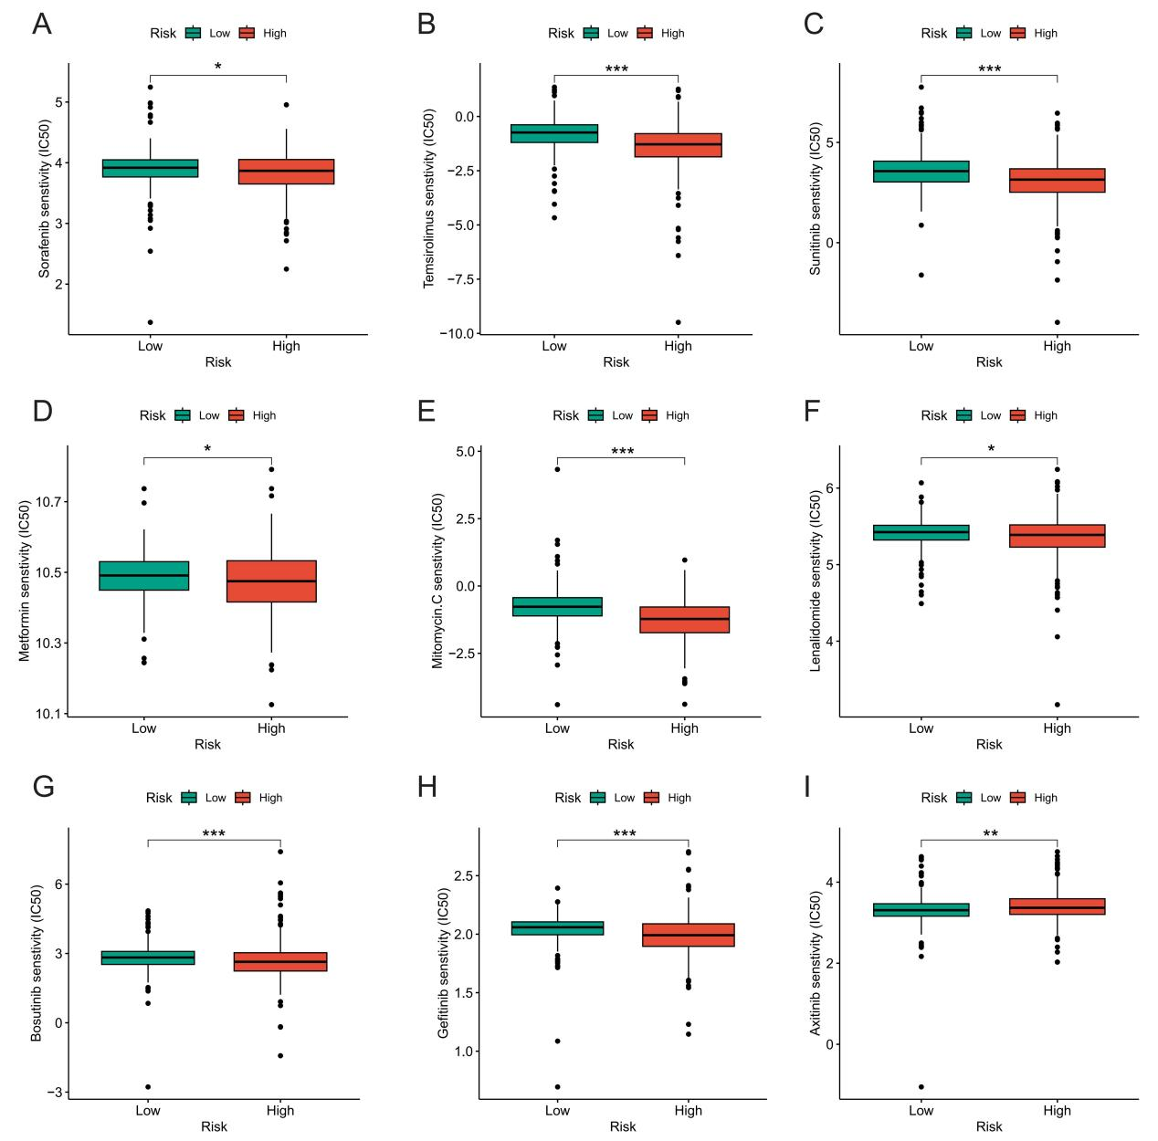
Figure S1. Drug Sensitivity Analysis of NETosis-Related Signature
Sensitivity analysis for (A) Sorafenib, (B) Temsirolimus, (C) Sunitinib, (D) Metformin, (E) Mitomycin C, (F) Lenalidomide, (G) Bosutinib, (H) Gefitinib, and (I) Axitinib between low and high NETosis-related signature groups.

