Supplementary Table 1. Detailed information of antibodies used for Western blot analysis.

 | Concentration | Company
Primary antibodies (catalog number)
Rabbit anti-DCLK1 (ab31704) | 1:1000 | Abcam
Rabbit anti-AKT (C67E7) | 1:1000 | Cell Signaling Technology
Rabbit anti-Phospho-AKT (D25E6) | 1:1000 | Cell Signaling Technology
Rabbit anti-PI3K (19H8) | 1:1000 | Cell Signaling Technology
Rabbit anti-Phospho-PI3K (E3U1H) | 1:1000 | Cell Signaling Technology
Rabbit anti-mTOR (7C10) | 1:1000 | Cell Signaling Technology
Rabbit anti-Phospho-mTOR (D9C2) | 1:1000 | Cell Signaling Technology
Rabbit anti-E-cadherin (20874-1-AP) | 1:1000 | Proteintech
Rabbit anti-N-cadherin (22018-1-AP) | 1:1000 | Proteintech
Rabbit anti-ZO-1 (21773-1-AP) | 1:1000 | Proteintech
Rabbit anti-Snail (13099-1-AP) | 1:1000 | Proteintech
Rabbit anti-Slug (12129-1-AP) | 1:1000 | Proteintech
Rabbit anti-Vimentin (10366-1-AP) | 1:1000 | Proteintech
Rabbit anti-ZEB1 (21544-1-AP) | 1:1000 | Proteintech
Rabbit anti-β-Acitin (20536-1-AP) | 1:1000 | Proteintech
Secondary antibody (catalog number)
HRP-conjugated Affinipure Goat Anti-Rabbit IgG(H+L) (SA00001-2) | 1:10000 | Proteintech

Supplementary Table 2. Detailed information of primers used for RT-PCR.

Genes | Primers | Sequence (5’-3’)
E-cadherin | PCR-F | GTCACTGACACCAACGATAATCCT
 | PCR-R | TTTCAGTGTGGTGATTACGACGTTA
N-cadherin | PCR-F | TCAGGCGTCTGTAGAGGCTT
 | PCR-R | ATGCACATCCTTCGATAAGACTG
Vimentin | PCR-F | CCTGAACCTGAGGGAAACTAA
 | PCR-R | GCAGAAAGGCACTTGAAAGC
ZEB1 | PCR-F | GATGATGAATGCGAGTCAGATGC
 | PCR-R | ACAGCAGTGTCTTGTTGTTGT
Snail | PCR-F | ACTGCAACAAGGAATACCTCAG
 | PCR-R | GCACTGGTACTTCTTGACATCTG

Supplementary Table 3. Clinicopathological information of 49 CCA patients.
Characteristics | Numbers (%)
Numbers of patients | 49
Average age (mean±SD) | 66.08±9.46
Age (years)
<60 | 13 (26.53%)
≥60 | 36 (73.47%)
Gender
Male | 26 (53.06%)
Female | 23 (46.94%)
Tumor site
Intrahepatic bile duct | 16 (32.65%)
Extrahepatic bile duct | 29 (59.18%)
Both | 4 (8.16%)
Histological grade
G1 | 3 (6.12%)
G2 | 27 (55.10%)
G3 | 13 (26.53%)
GX | 6 (12.24%)
Stage
I | 4 (8.16%)
II | 20 (40.82%)
III | 13 (26.53%)
IV | 4 (8.16%)
Missing | 8 (16.33%)

Supplementary Figure 1. DCLK1 activates PI3K/AKT/mTOR pathway in RBE.
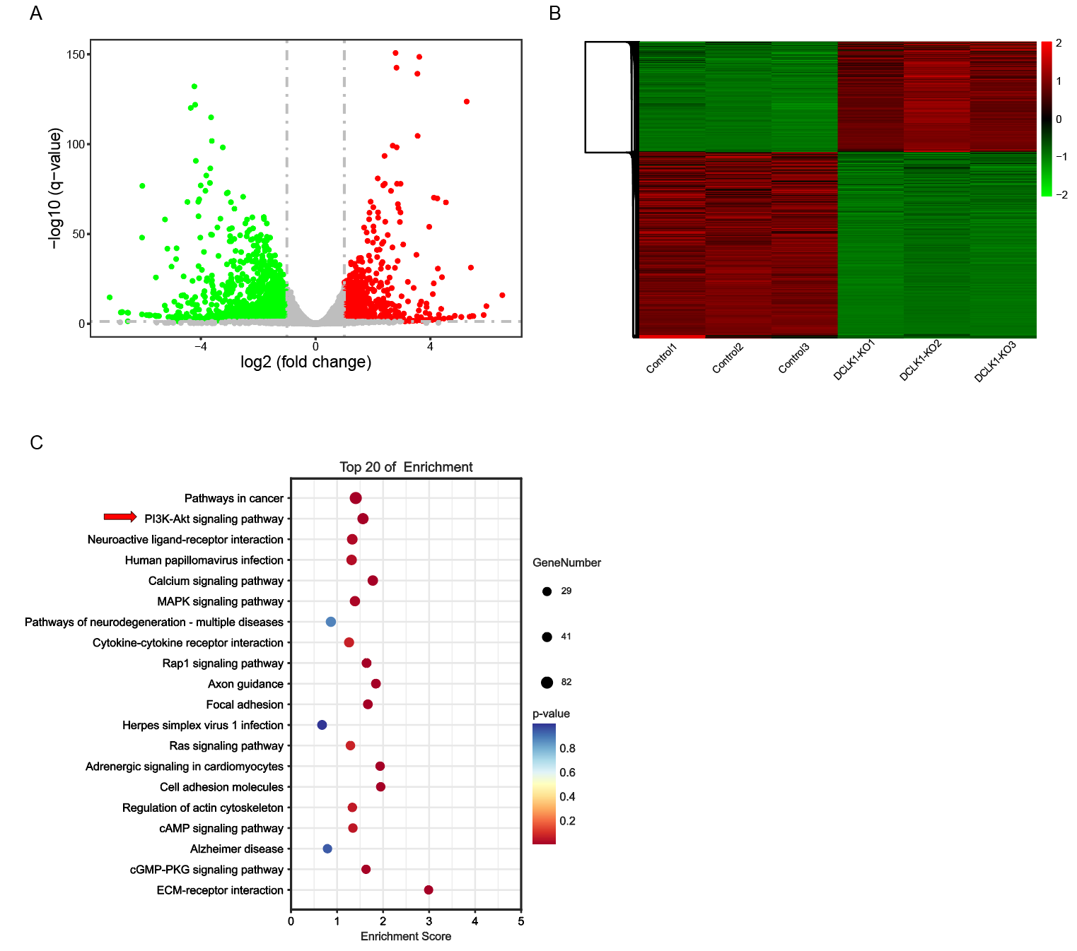
A. Volcano map of Different expressed genes (DEGs) between RBE control and RBE DCLK1-KO; B. Heatmap analysis of RBE control and RBE DCLK1-KO; C. KEGG analysis of DEGs screens the PI3K/AKT pathway as the key pathway related with DCLK1;

