Appendix A
The detailed inclusion and exclusion criteria are as follows:
(1) Inclusion Criteria^{[1]}:
- Patients diagnosed primarily with Hepatocellular Carcinoma (HCC), Intrahepatic Cholangiocarcinoma (ICC), or Combined Hepatocellular Cholangiocarcinoma (cHCC-CCA).
- Age 18 and above, with no gender restrictions.
- Patients with liver space-occupying lesions and this hospitalization includes surgical resection specimens or biopsy specimens that, upon pathological histology and/or cytology examination, are diagnosed as liver cancer, with morphology codes as follows: M81800/3: Combined Hepatocellular Cholangiocarcinoma, M81600/3: Intrahepatic Cholangiocarcinoma, M81700/3: Hepatocellular Carcinoma.
(2) Exclusion Criteria:
- Clearly diagnosed non-primary liver cancers, including liver cysts, liver hemangiomas, etc.
- Patients with confirmed primary liver cancer who have undergone any relevant tumor-related treatments before inclusion in the study.
- Presence of primary malignant tumors in other systems of the body, including leukemia and lymphoma in the hematologic system.
- Presence of diseases such as hemochromatosis, liver cirrhosis, primary biliary cirrhosis, primary sclerosing cholangitis, Budd-Chiari syndrome, schistosomiasis-induced liver fibrosis/cirrhosis, rheumatologic and/or autoimmune diseases.
- Severe heart, brain, lung, or kidney diseases. These exclusion criteria are implemented to ensure the homogeneity and reliability of the study cohort, allowing for a more focused investigation of primary liver cancer cases.

Fig. A1 provides a description of the inclusion and exclusion process for samples.
- 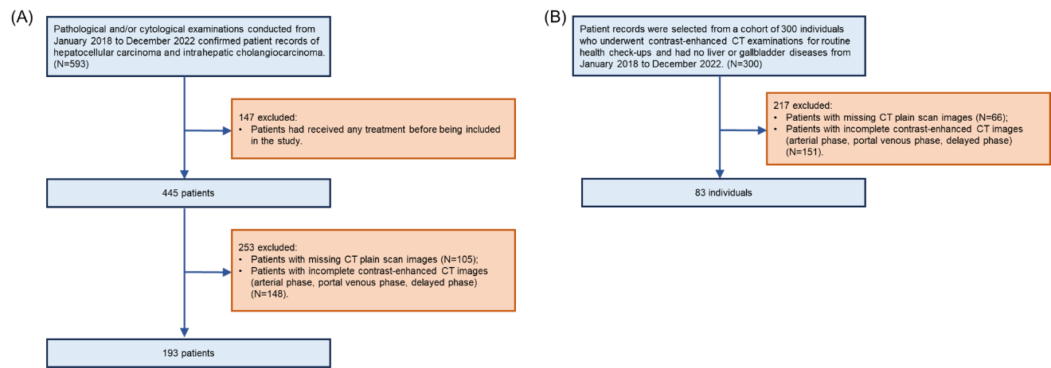
- Fig A1. Subfigure A illustrates the inclusion and exclusion process for HCC or ICC patients, while Subfigure B illustrates the inclusion and exclusion process for normal subjects.

Appendix B

Table B1. Performance test results of H-LSTM model on single-phase CECT Images
Phase | Class | Accuracy | Recall | Precision | F1 | AUROC | AUPRC
P | CN | 0.92(0.85,0.98) | 0.81(0.64,1.00) | 0.93(0.78,1.00) | 0.87(0.75,0.97) | 0.99(0.97,1.00) | 0.97(0.89,1.00)
 | HCC | 0.92(0.85,0.98) | 1.00(1.00,1.00) | 0.82(0.61,0.96) | 0.90(0.76,0.98) | 0.95(0.90,1.00) | 0.90(0.73,0.99)
 | ICC | 0.79(0.69,0.88) | 0.39(0.17,0.60) | 1.00(1.00,1.00) | 0.56(0.29,0.75) | 0.84(0.68,0.96) | 0.85(0.70,0.97)
 | ALL | 0.73(0.62,0.85) | 0.73(0.63,0.82) | 0.92(0.83,0.97) | 0.78(0.67,0.88) | 0.84(0.85,0.99) | 0.74(0.81,0.98)
C1 | CN | 0.85(0.74,0.94) | 0.56(0.31,0.80) | 0.90(0.64,1.00) | 0.69(0.44,0.88) | 0.98(0.93,1.00) | 0.92(0.74,1.00)
 | HCC | 0.91(0.81,0.98) | 0.89(0.73,1.00) | 0.84(0.67,1.00) | 0.86(0.70,0.97) | 0.96(0.90,1.00) | 0.91(0.76,1.00)
 | ICC | 0.79(0.68,0.91) | 0.42(0.19,0.70) | 1.00(1.00,1.00) | 0.59(0.32,0.82) | 0.85(0.71,0.97) | 0.87(0.75,0.98)
 | ALL | 0.62(0.49,0.74) | 0.62(0.50,0.76) | 0.91(0.83,0.98) | 0.72(0.59,0.82) | 0.79(0.88,0.98) | 0.68(0.82,0.98)
C2 | CN | 0.83(0.74,0.92) | 0.44(0.19,0.70) | 1.00(1.00,1.00) | 0.61(0.32,0.82) | 0.99(0.97,1.00) | 0.98(0.92,1.00)
 | HCC | 0.92(0.85,0.98) | 0.94(0.83,1.00) | 0.85(0.71,1.00) | 0.89(0.79,0.97) | 0.97(0.93,1.00) | 0.93(0.84,1.00)
 | ICC | 0.75(0.64,0.87) | 0.32(0.09,0.56) | 1.00(1.00,1.00) | 0.48(0.17,0.72) | 0.88(0.76,0.98) | 0.90(0.76,0.98)
 | ALL | 0.57(0.43,0.70) | 0.57(0.44,0.68) | 0.95(0.89,1.00) | 0.66(0.53,0.78) | 0.77(0.89,0.99) | 0.66(0.87,0.99)
C3 | CN | 0.92(0.87,1.00) | 0.75(0.53,1.00) | 1.00(1.00,1.00) | 0.86(0.70,1.00) | 0.99(0.97,1.00) | 0.98(0.92,1.00)
 | HCC | 0.96(0.91,1.00) | 1.00(1.00,1.00) | 0.90(0.75,1.00) | 0.95(0.86,1.00) | 0.98(0.93,1.00) | 0.95(0.84,1.00)
 | ICC | 0.74(0.64,0.83) | 0.26(0.05,0.48) | 1.00(1.00,1.00) | 0.42(0.10,0.65) | 0.92(0.82,1.00) | 0.93(0.83,1.00)
 | ALL | 0.66(0.51,0.77) | 0.67(0.56,0.77) | 0.97(0.92,1.00) | 0.74(0.61,0.84) | 0.83(0.92,1.00) | 0.75(0.88,1.00)

Table B2. Test Set Performance of the H-LSTM Model Trained Specifically with Single-Phase CECT Images
Phase | Class | Accuracy | Recall | Precision | F1 | AUROC | AUPRC
P | CN | 0.92(0.85,1.00) | 1.00(1.00,1.00) | 0.80(0.63,1.00) | 0.89(0.77,1.00) | 0.98(0.93,1.00) | 0.95(0.86,1.00)
 | HCC | 0.87(0.77,0.96) | 0.78(0.56,0.95) | 0.82(0.68,1.00) | 0.80(0.64,0.94) | 0.94(0.88,1.00) | 0.80(0.65,1.00)
 | ICC | 0.87(0.77,0.96) | 0.72(0.50,0.94) | 0.87(0.67,1.00) | 0.79(0.62,0.94) | 0.84(0.70,0.96) | 0.83(0.65,0.95)
 | ALL | 0.83(0.71,0.92) | 0.83(0.73,0.91) | 0.83(0.72,0.92) | 0.83(0.71,0.91) | 0.87(0.84,0.98) | 0.75(0.77,0.96)
C1 | CN | 0.96(0.91,1.00) | 1.00(1.00,1.00) | 0.89(0.73,1.00) | 0.94(0.85,1.00) | 0.99(0.98,1.00) | 0.98(0.93,1.00)
 | HCC | 0.89(0.81,0.96) | 0.78(0.57,0.96) | 0.88(0.67,1.00) | 0.82(0.67,0.95) | 0.94(0.87,1.00) | 0.83(0.61,1.00)
 | ICC | 0.85(0.75,0.94) | 0.79(0.61,0.94) | 0.79(0.60,1.00) | 0.79(0.61,0.92) | 0.88(0.74,0.98) | 0.86(0.69,0.97)
 | ALL | 0.85(0.75,0.96) | 0.86(0.76,0.96) | 0.85(0.75,0.96) | 0.85(0.75,0.96) | 0.89(0.87,0.99) | 0.78(0.80,0.98)
C2 | CN | 0.94(0.87,1.00) | 0.81(0.56,1.00) | 1.00(1.00,1.00) | 0.90(0.72,1.00) | 1.00(0.98,1.00) | 0.99(0.97,1.00)
 | HCC | 0.91(0.81,0.98) | 0.94(0.82,1.00) | 0.81(0.60,1.00) | 0.87(0.73,0.98) | 0.94(0.87,1.00) | 0.81(0.59,1.00)
 | ICC | 0.87(0.79,0.94) | 0.79(0.61,0.95) | 0.83(0.67,1.00) | 0.81(0.64,0.92) | 0.85(0.73,0.96) | 0.88(0.74,0.97)
 | ALL | 0.85(0.74,0.92) | 0.85(0.74,0.93) | 0.88(0.79,0.94) | 0.86(0.75,0.93) | 0.89(0.86,0.98) | 0.80(0.81,0.98)
C3 | CN | 0.94(0.87,1.00) | 1.00(1.00,1.00) | 0.84(0.67,1.00) | 0.91(0.80,1.00) | 0.99(0.96,1.00) | 0.97(0.89,1.00)
 | HCC | 0.87(0.77,0.96) | 0.89(0.69,1.00) | 0.76(0.58,0.95) | 0.82(0.68,0.95) | 0.95(0.90,0.99) | 0.90(0.77,0.99)
 | ICC | 0.85(0.75,0.91) | 0.58(0.33,0.75) | 1.00(1.00,1.00) | 0.73(0.50,0.86) | 0.88(0.75,0.97) | 0.88(0.77,0.96)
 | ALL | 0.81(0.70,0.91) | 0.82(0.72,0.92) | 0.87(0.79,0.95) | 0.82(0.70,0.92) | 0.87(0.88,0.98) | 0.76(0.84,0.98)

Appendix C

Fig. C1 displays misclassified cases. (a) Misclassification may occur because HCC typically shows significant enhancement during the arterial phase, but some atypically differentiated HCC may also exhibit less pronounced enhancement, similar to ICC during the arterial phase, leading to potential misjudgment. (b) Misclassification might be due to tumor-specific structures (such as the number of blood vessels in the tumor and the degree of tumor differentiation) and cellular factors. The CT enhancement scans of HCC and ICC during the venous and delayed phases can appear similar, increasing the difficulty of differentiation and leading to potential misjudgment. (c) Misclassification might also be attributed to the TCIA public database's HCC-TACE-Seg dataset, mostly comprising CT images collected around the year 2000. The equipment resolution at that time may not sufficiently reveal fine structural details of lesions, impacting the accuracy of diagnosis.
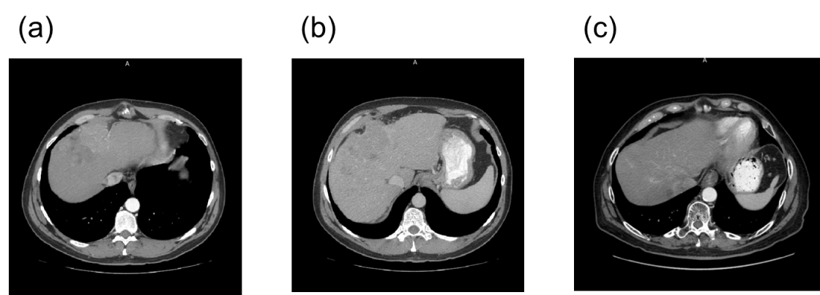
Fig. C1. Display of misclassified cases.

References
[1] BENSON 3RD A B, ABRAMS T A, BEN-JOSEF E, et al. NCCN clinical practice guidelines in oncology: hepatobiliary cancers [J]. Journal of the National Comprehensive Cancer Network: JNCCN, 2009, 7(4): 350-91.

