Supplemental files
Appendix: Image protocols
Before ¹⁸F-FDG administration, all patients underwent a glucose level test, and the blood glucose levels were less than 140 mg/dl. Then, the patients fasted for at least six hours before the injection of ¹⁸F-FDG, and image acquisition was started one hour afterward. During the scanning, the patient was in the head-first supine position, and the scanning range was from the skull base to 1/3 of the femur. After selecting the examination range, CT scanning was performed firstly, followed by PET scanning. The PET image datasets were reconstructed using CT data for attenuation correction.
Appendix: Segmentation information
Nuclear medicine physician A with 10 years of experience and nuclear medicine physician B with 4 years of experience are responsible for data segmentation for hospital A. For hospital B, the nuclear medicine physician B with 4 years of experience is solely responsible for segmentation. Two chief physicians with 20 and 22 years of experience, respectively, reviewing the segmentation results of the two hospitals. Primary tumor volumes of interest (VOIs) for CT were drawn on the lung window (window width: 1600HU; window level: -600HU). To evaluate the robustness and repeatability of handcrafted radiomics features and avoid potential recall bias, random 10 cases from each of the centers were selected, segmented again, and a re-segmentation set was constructed within one week.

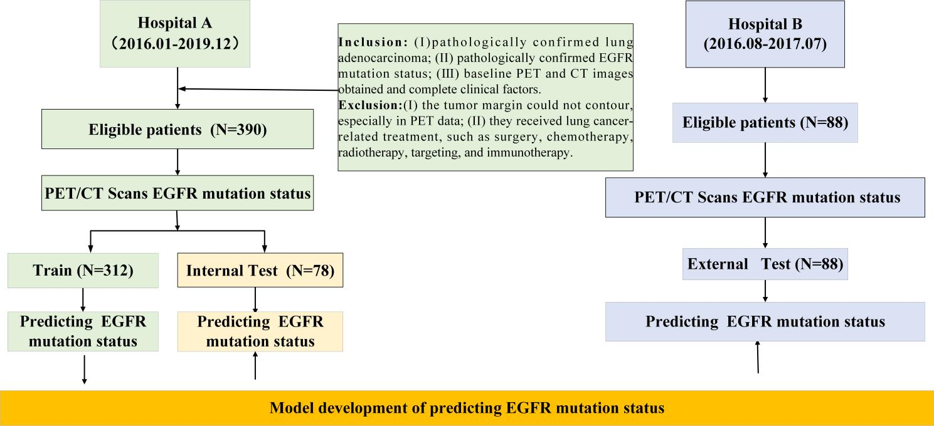

Fig. S1 Data information.

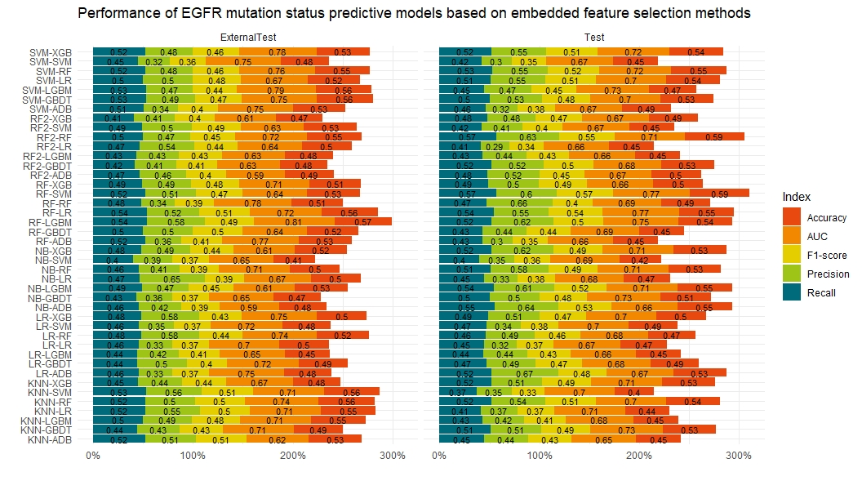
Fig. S2 Model performance of EGFR mutation status predictive models based on embedded feature selection methods.

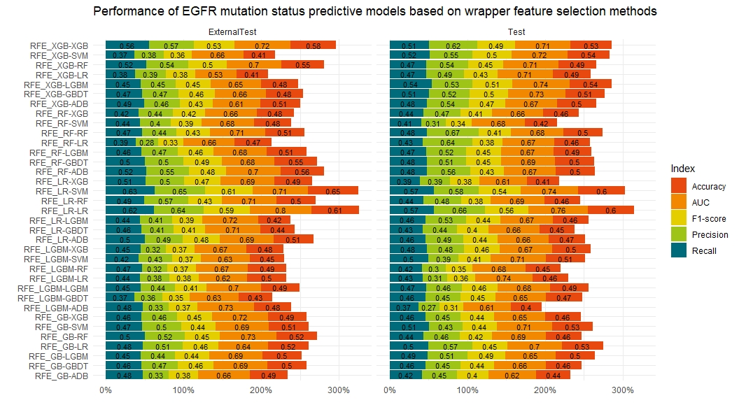
Fig. S3 Model performance of EGFR mutation status predictive models based on wrapper feature selection methods.

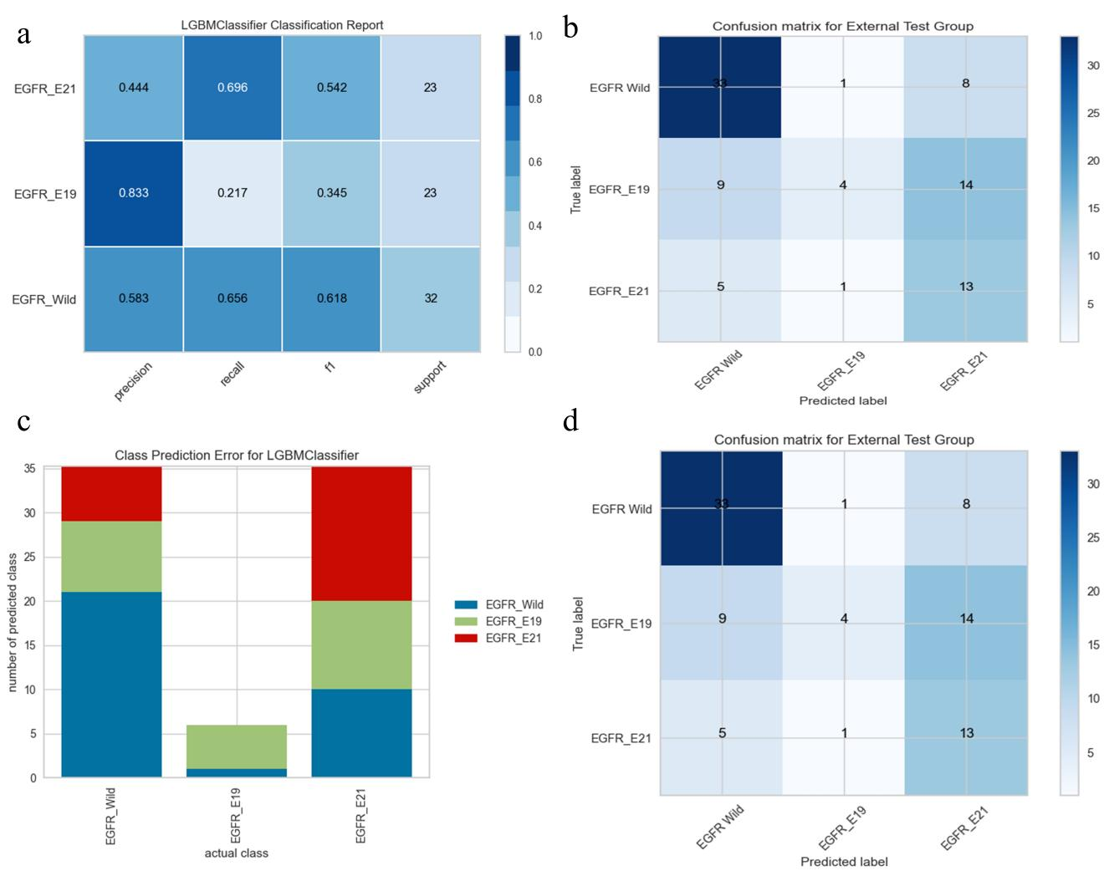
Fig. S4 model visualization results of the optimal model in predicting EGFR mutation status.
a, classification report of the internal test group of optimal predictive model. b, confusion matrix of external test group of optimal predictive model; c, class prediction error in the internal test group of optimal predictive model; d, confusion matrix of the external test group of optimal predictive model.

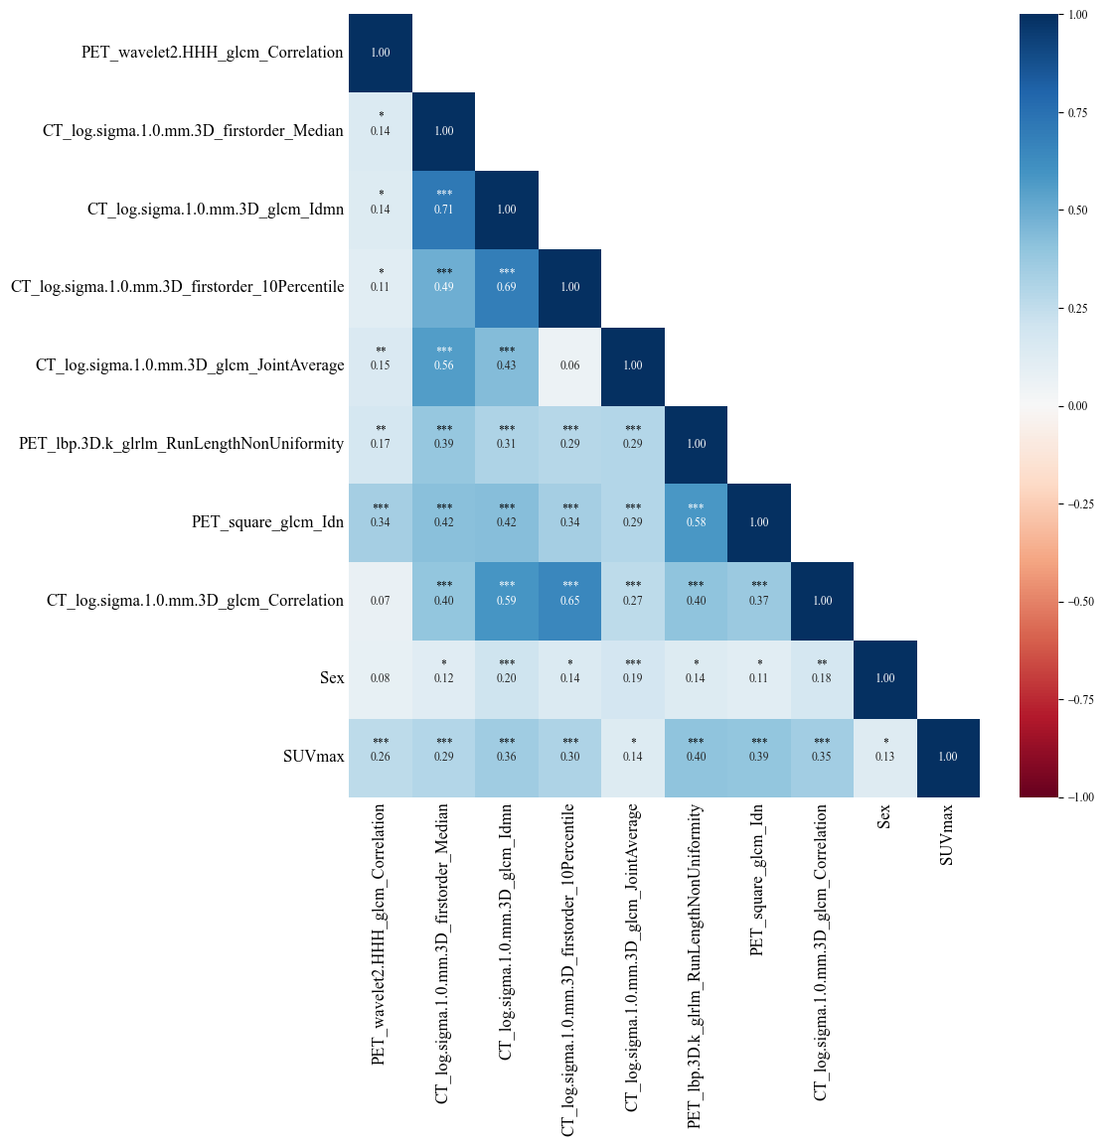
Fig. S5 The correlation heatmap and signification difference information of 8 HRFs and 2 clinical factors of optimal model.

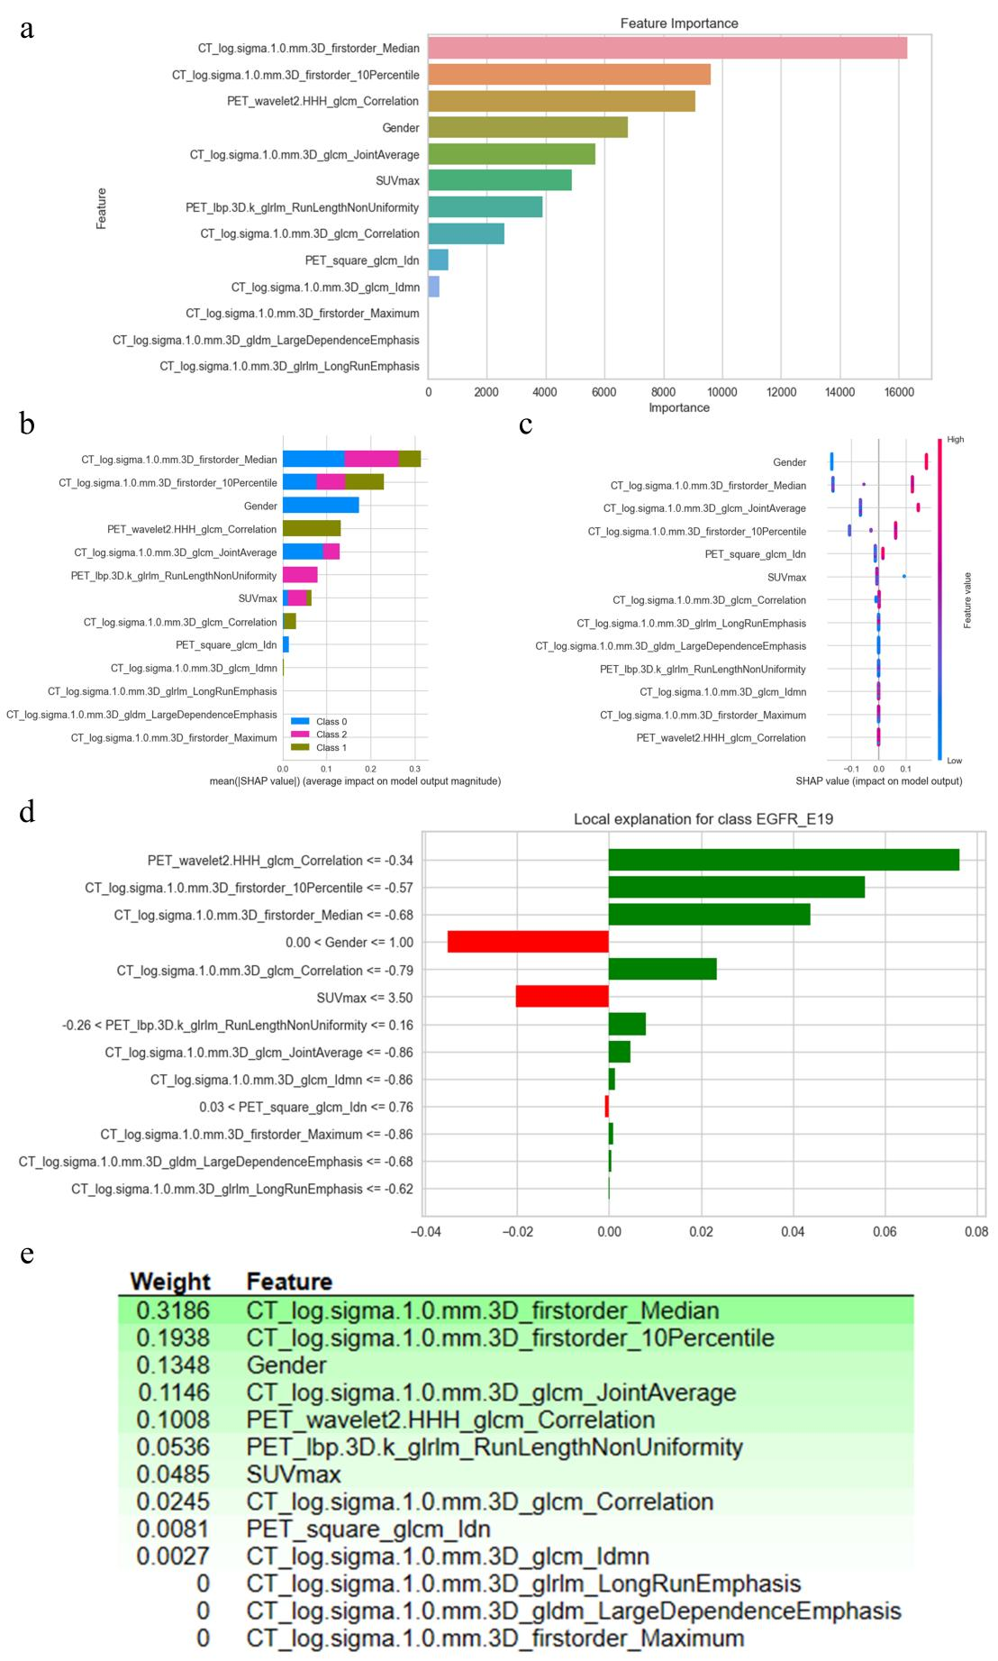
Fig. S6 Model interpretation of initial optimal EGFR mutation status prediction model
a, feature importance of the original initial prediction model; b, mean SHAP value of the initial optimal prediction model; c, SHAP value of the initial optimal prediction model; d, LIME model interpretation; e, ELI5 model interpretation.

Table S1 Scanner information and imaging protocols
Characteristics | Hospital A | Hospital B
Equipment | SIEMENS  Biogragh 16HR | SIEMENS  Biograph mCT-s
Reconstruction | OSEM  (Iterations 4; subsets 8) | PSF+TOF
Tube Voltage (CT) | 120 kV | 120 kV
Tube Current (CT) | 140 mA | Adjusted by CAREDose 4D technology
Slice thickness (PET, mm) | 5.00 | 5.00
Slice thickness (CT, mm) | 5.00 | 3.00
Image size (PET, pixel) | 168*168/192*192/200*200 | 200*200
Image size (CT, pixel) | 512*512 | 512*512
Acquisition time | 2–3 min/bed position | 2 minutes/bed position
Convolution kernel | Gauss 5.00 | Gauss 4.00

Annotations: PSF, point spread function; OSEM, ordered subset expectation maximization; TOF, time of flight; mm, millimeter; GE, General Electric Company.

Table S2 Parameters of params.yaml of CT HRFs and PET HRFs
Parameters | CT | PET
imageType | Original  Wavelet: {start_level: 1; level: 2; wavelet: coif3}  LBP 3D  LoG  Square  SquareRoot  Gradient  Exponential  Logarithm | Original  Wavelet: {start_level: 1; level: 2; wavelet: "coif3"}  LBP 3D  LoG  Square  SquareRoot  Gradient  Exponential  Logarithm
featureClass | shape  firstorder  glcm  glrlm  ngtdm  glszm  gldm | shape  firstorder  glcm  glrlm  ngtdm  glszm  gldm
binWidth | 25 | 128
interpolator | 'sitkBSpline' | 'sitkBSpline'
resampledPixelSpacing | [1, 1, 1] | [1, 1, 1]
geometryTolerance | 0.1 | 0.1
voxelArrayShift | 1000 | 1000
label | 1 | 1

Table S3 List of Extracted Handcrafted Radiomics Features.
Classification (Total number=2380) | Features
First Order Features (18) | Energy TotalEnergy Entropy Minimum 10thpercentile 90thpercentile Maximum Mean Median Interquartile_Range Range Skewness Kurtosis Variance Uniformity  Mean Absolute Deviation (MAD)  Robust Mean Absolute Deviation (rMAD) Root Mean Squared (RMS)
Shape Features (14) | Elongation Flatness LeastAxisLength MajorAxisLength  Maximum2DDiameterColumn Maximum2DDiameterRow VoxelVolume  Maximum2DDiameterSlice Maximum3DDiameter shape_MeshVolume  MinorAxisLength Sphericity SurfaceArea SurfaceVolumeRatio
Textural Features (22+16+16+14+5=73) | 22 features from GLCM:  Autocorrelation Joint Average Cluster Prominence Cluster Shade  Cluster Tendency Contrast Correlation Difference Average  Difference Entropy Difference Variance Joint Energy Joint Entropy  Informational Measure of Correlation (IMC) 1  Informational Measure of Correlation (IMC) 2  Inverse Difference Moment (IDM)  Maximal Correlation Coefficient (MCC)  Inverse Difference Moment Normalized (IDMN)  Inverse Difference (ID) Inverse Variance (IV)  Maximum Probability Sum Entropy Sum of Squares  16 features from GLRLM:  Short Run Emphasis (SRE)  Long Run Emphasis (LRE)  Gray Level Non-Uniformity (GLN)  Gray Level Non-Uniformity Normalized (GLNN)  Run Length Non-Uniformity (RLN)  Run Length Non-Uniformity Normalized (RLNN)  Run Percentage (RP)  Gray Level Variance (GLV)  Run Variance (RV)  Run Entropy (RE)  Low Gray Level Run Emphasis (LGLRE)  High Gray Level Run Emphasis (HGLRE)  Short Run Low Gray Level Emphasis (SRLGLE)  Short Run High Gray Level Emphasis (SRHGLE)  Long Run Low Gray Level Emphasis (LRLGLE)  Long Run High Gray Level Emphasis (LRHGLE)  16 features from GLSZM:  Small Area Emphasis (SAE)  Large Area Emphasis (LAE)  Gray Level Non-Uniformity (GLN)  Gray Level Non-Uniformity Normalized (GLNN)  Size-Zone Non-Uniformity (SZN)  Size-Zone Non-Uniformity Normalized (SZNN)  Zone Percentage (ZP)  Gray Level Variance (GLV)  Zone Variance (ZV)  Zone Entropy (ZE)  Low Gray Level Zone Emphasis (LGLZE)  High Gray Level Zone Emphasis (HGLZE)  Small Area Low Gray Level Emphasis (SALGLE)  Small Area High Gray Level Emphasis (SAHGLE)  Large Area Low Gray Level Emphasis (LALGLE)  Large Area High Gray Level Emphasis (LAHGLE)  14 features from GLDM:  Small Dependence Emphasis (SDE)  Large Dependence Emphasis (LDE)  Gray Level Non-Uniformity (GLN)  Dependence Non-Uniformity (DN)  Dependence Non-Uniformity Normalized (DNN)  Gray Level Variance (GLV)  Dependence Variance (DV)  Dependence Entropy (DE)  Low Gray Level Emphasis (LGLE)  High Gray Level Emphasis (HGLE)  Small Dependence Low Gray Level Emphasis (SDLGLE)  Small Dependence High Gray Level Emphasis (SDHGLE)  Large Dependence Low Gray Level Emphasis (LDLGLE)  Large Dependence High Gray Level Emphasis (LDHGLE)  5 features from NGTDM:  Coarseness Contrast Busyness Complexity Strength
Wavelet features (91*15=1365) | 15 decompositions:  For each decomposition, all of the above features except shape features were computed.
LoG features (91*2) | 2 decompositions:  For each decomposition, all of the above features except shape features were computed.
Square features (91) | 1 decomposition:  For each decomposition, all of the above features except shape features were computed.
SquareRoot features (91) | 1 decomposition:  For each decomposition, all of the above features except shape features were computed.
Local Binary Pattern (3D) features (91*3=273) | 3 decompositions:  For each decomposition, all of the above features except shape features were computed.
Gradient features (91) | 1 decomposition:  For each decomposition, all of the above features except shape features were computed.
Exponential features (91) | 1 decomposition:  For each decomposition, all of the above features except shape features were computed.
Logarithm features (91) | 1 decomposition:  For each decomposition, all of the above features except shape features were computed.

Table S4. Performance of feature selection methods in handcrafted radiomics feature selection
FS methods | Count | Threshold
RF | 8 | 0.4468
LR | 18 | 0.4319
SVM | 12 | 0.4213
KNN | 23 | 0.4213
NB | 15 | 0.4213
RFFI | 9 | 0.01 (Feature importance)
RFE-LGBM | 20 | 0.5989
RFE-XGB | 21 | 0.6497
RFE-GBDT | 20 | 0.5958
RFE-RF | 5 | 0.6197
RFE-LR | 7 | 0.7249

Table S5. Interquartile range of the enrolled radiomic features of the optimal model
Number | Enrolled HRFs | Train | Internal Test | External Test1
F1 | CT_log.sigma.1.0.mm.3D_firstorder_Median | [-0.593-0.667] | [-0.676-0.657] | [-0.521-0.828]
F2 | CT_log.sigma.1.0.mm.3D_glcm_Correlation | [-0.562-0.752] | [-0.792-0.641] | [-0.646-0.856]
F3 | PET_wavelet2.HHH_glcm_Correlation | [-0.311-0.562] | [-0.344-0.465] | [-0.454-0.608]
F4 | CT_log.sigma.1.0.mm.3D_glcm_Idmn | [-0.509-0.828] | [-0.863-0.651] | [-0.428-0.777]
F5 | CT_log.sigma.1.0.mm.3D_firstorder_10Percentile | [-0.559-0.746] | [-0.566-0.397] | [-0.576-0.580]
F6 | CT_log.sigma.1.0.mm.3D_glcm_JointAverage | [-0.540-0.481] | [-0.861-0.515] | [-0.550-0.556]
F7 | PET_lbp.3D.k_glrlm_RunLengthNonUniformity | [-0.521-0.101] | [-0.522-0.157] | [-0.448-0.113]
F8 | PET_square_glcm_Idn | [-0.686-0.708] | [-0.679-0.760] | [-0.547-0.677]

Table S6. The Hyperparameter tuning results of the optimal model based on gridsearchCV
Hyperparameters | candidates | tuning results
Learning Rate | [0.01, 0.03, 0.05, 0.1, 0.2,0.5] | 0.01
n_estimators | [200,500, 800,1000, 1500,2000,3000,5000] | 200
max_depth | [1,2,3,4, 5,6, 8,None] | 1

Table S7. The criteria and maximal radiomic quality score as well as the actural score of this work
Criteria | Points system | Maximal score | Actual score of this work
Image protocol quality - well-documented image protocols (for example, contrast, slice thickness, energy, etc.) and/or usage of public image protocols allow reproducibility/replicability | + 1 (if protocols are well-documented) + 1 (if public protocol is used) | 2 | 2
Multiple segmentations - possible actions are: segmentation by different physicians/algorithms /software, perturbing segmentations by (random) noise, segmentation at different breathing cycles. Analyse feature robustness to segmentation variabilities | 1 | 1 | 1
Phantom study on all scanners - detect inter-scanner differences and vendor-dependent features. Analyse feature robustness to these sources of variability | 1 | 1 | 0
Imaging at multiple time points - collect images of individuals at additional time points. Analyse feature robustness to temporal variabilities (for example, organ movement, organ expansion /shrinkage) | 1 | 1 | 0
Feature reduction or adjustment for multiple testing - decreases the risk of overfitting. Overfitting is inevitable if the number of features exceeds the number of samples. Consider feature robustness when selecting features | − 3 (if neither measure is implemented) + 3 (if either measure is implemented) | 3 | 3
Multivariable analysis with non radiomics features (for example, EGFR mutation) - is expected to provide a more holistic model. Permits correlating /inferencing between radiomics and non radiomics features | 1 | 1 | 1
Detect and discuss biological correlates - demonstration of phenotypic differences (possibly associated with underlying gene–protein expression patterns) deepens understanding of radiomics and biology | 1 | 1 | 1
Cut-off analyses - determine risk groups by either the median, a previously published cut-off or report a continuous risk variable. Reduces the risk of reporting overly optimistic results | 1 | 1 | 1
Discrimination statistics - report discrimination statistics (for example, C-statistic, ROC curve, AUC) and their statistical significance (for example, p-values, confidence intervals). One can also apply resampling method (for example, bootstrapping, cross-validation) | + 1 (if a discrimination statistic and its statistical significance are reported) + 1 (if a resampling method technique is also applied) | 2 | 2
Calibration statistics - report calibration statistics (for example, Calibration-in-the-large/slope, calibration plots) and their statistical significance (for example, P-values, confidence intervals). One can also apply resampling method (for example, bootstrapping, cross-validation) | + 1 (if a calibration statistic and its statistical significance are reported) + 1 (if a resampling method technique is also applied) | 2 | 2
Prospective study registered in a trial database - provides the highest level of evidence supporting the clinical validity and usefulness of the radiomics biomarker | + 7 (for prospective validation of a radiomics signature in an appropriate trial) | 7 | 0
Validation - the validation is performed without retraining and without adaptation of the cut-off value, provides crucial information with regard to credible clinical performance | - 5 (if validation is missing) + 2 (if validation is based on a dataset from the same institute) + 3 (if validation is based on a dataset from another institute) + 4 (if validation is based on two datasets from two distinct institutes) + 4 (if the study validates a previously published signature) + 5 (if validation is based on three or more datasets from distinct institutes) | 5 | 3
Comparison to 'gold standard' - assess the extent to which the model agrees with/is superior to the current 'gold standard' method (for example, TNM-staging for survival prediction). This comparison shows the added value of radiomics | 2 | 2 | 2
Potential clinical utility - report on the current and potential application of the model in a clinical setting (for example, decision curve analysis) | 2 | 2 | 0
Cost-effectiveness analysis - report on the cost-effectiveness of the clinical application (for example, QALYs generated) | 1 | 1 | 0
Open science and data - make code and data publicly available. Open science facilitates knowledge transfer and reproducibility of the study | + 1 (if scans are open source) +1 (if region of interest segmentations are open source) + 1 (if code is open source) + 1 (if radiomics features are calculated on a set of representative ROIs and the calculated features and representative ROIs are open source) | 4 | 2
Total score |  | 36 | 20

Table S8. TRIPOD Checklist: Prediction Model Development and Validation
Section/Topic | Item |  | Checklist Item | Page
Title and abstract
Title | 1 | D; V | Identify the study as developing and/or validating a multivariable prediction model, the target population, and the outcome to be predicted. | Yes
Abstract | 2 | D; V | Provide a summary of objectives, study design, setting, participants, sample size, predictors, outcome, statistical analysis, results, and conclusions. | Yes
Introduction
Background and objectives | 3a | D; V | Explain the medical context (including whether diagnostic or prognostic) and rationale for developing or validating the multivariable prediction model, including references to existing models. | Yes
Background and objectives | 3b | D; V | Specify the objectives, including whether the study describes the development or validation of the model or both. | Yes
Methods
Source of data | 4a | D; V | Describe the study design or source of data (e.g., randomized trial, cohort, or registry data), separately for the development and validation data sets, if applicable. | Yes
Source of data | 4b | D; V | Specify the key study dates, including start of accrual; end of accrual; and, if applicable, end of follow-up. | Yes
Participants | 5a | D; V | Specify key elements of the study setting (e.g., primary care, secondary care, general population) including number and location of centres. | Yes
Participants | 5b | D; V | Describe eligibility criteria for participants. | Yes
Participants | 5c | D; V | Give details of treatments received, if relevant. | Yes
Outcome | 6a | D; V | Clearly define the outcome that is predicted by the prediction model, including how and when assessed. | Yes
Outcome | 6b | D; V | Report any actions to blind assessment of the outcome to be predicted. | Yes
Predictors | 7a | D; V | Clearly define all predictors used in developing or validating the multivariable prediction model, including how and when they were measured. | Yes
Predictors | 7b | D; V | Report any actions to blind assessment of predictors for the outcome and other predictors. | Yes
Sample size | 8 | D; V | Explain how the study size was arrived at. | Yes
Missing data | 9 | D; V | Describe how missing data were handled (e.g., complete-case analysis, single imputation, multiple imputation) with details of any imputation method. | Yes
Statistical analysis methods | 10a | D | Describe how predictors were handled in the analyses. | Yes
Statistical analysis methods | 10b | D | Specify type of model, all model-building procedures (including any predictor selection), and method for internal validation. | Yes
Statistical analysis methods | 10c | V | For validation, describe how the predictions were calculated. | Yes
Statistical analysis methods | 10d | D; V | Specify all measures used to assess model performance and, if relevant, to compare multiple models. | Yes
Statistical analysis methods | 10e | V | Describe any model updating (e.g., recalibration) arising from the validation, if done. | NaN
Risk groups | 11 | D; V | Provide details on how risk groups were created, if done. | NaN
Development vs. validation | 12 | V | For validation, identify any differences from the development data in setting, eligibility criteria, outcome, and predictors. | Yes
Results
Participants | 13a | D; V | Describe the flow of participants through the study, including the number of participants with and without the outcome and, if applicable, a summary of the follow-up time. A diagram may be helpful. | Yes
Participants | 13b | D; V | Describe the characteristics of the participants (basic demographics, clinical features, available predictors), including the number of participants with missing data for predictors and outcome. | Yes
Participants | 13c | V | For validation, show a comparison with the development data of the distribution of important variables (demographics, predictors and outcome). | Yes
Model development | 14a | D | Specify the number of participants and outcome events in each analysis. | Yes
Model development | 14b | D | If done, report the unadjusted association between each candidate predictor and outcome. | Yes
Model specification | 15a | D | Present the full prediction model to allow predictions for individuals (i.e., all regression coefficients, and model intercept or baseline survival at a given time point). | Yes
Model specification | 15b | D | Explain how to the use the prediction model. | Yes
Model performance | 16 | D; V | Report performance measures (with CIs) for the prediction model. | NaN
Model-updating | 17 | V | If done, report the results from any model updating (i.e., model specification, model performance). | NaN
Discussion
Limitations | 18 | D; V | Discuss any limitations of the study (such as nonrepresentative sample, few events per predictor, missing data). | Yes
Interpretation | 19a | V | For validation, discuss the results with reference to performance in the development data, and any other validation data. | Yes
Interpretation | 19b | D; V | Give an overall interpretation of the results, considering objectives, limitations, results from similar studies, and other relevant evidence. | Yes
Implications | 20 | D; V | Discuss the potential clinical use of the model and implications for future research. | Yes
Other information
Supplementary information | 21 | D; V | Provide information about the availability of supplementary resources, such as study protocol, Web calculator, and data sets. | Yes
Funding | 22 | D; V | Give the source of funding and the role of the funders for the present study. | Yes

Abbreviation: TRIPOD: Transparent Reporting of a multivariable prediction model for Individual Prognosis or Diagnosis.

