Sarcoma Ring Trial

Please provide as a multidisciplinary tumor board a recommendation for further management or the next proposed therapy as free text and as a multiple-choice option with multiple selections assuming it is a localized disease and patients with maximal therapy desire and without limiting comorbidities.

Please provide a brief clinical rationale for your decision, e.g., with reference to scientific publications or clinic-specific prior experiences.

Name of completing center:
- Please provide your tumor board recommendation as free text
- Further diagnostics required? | ☐ No
- Further diagnostics required? | ☐ Yes, namely (multiple choices possible):
- Further diagnostics required? | ☐ Repeat imaging |  | ☐ PET-CT
- Further diagnostics required? | ☐ Re-biopsy |  | ☐ Further pathological diagnostics
- Further diagnostics required? | ☐ Reference pathological assessment |  | ☐ Molecular pathology / panel diagnostics
- Further diagnostics required? | Other (free text):
- What are your therapy recommendations at this point without further diagnostics (free text)?
- What are your therapy recommendations at this point without further diagnostics? (multiple choices possible)? | ☐ Resection. If yes, please specify:  ☐ Wide resection with primary wound closure  ☐ Wide resection plus plastic reconstruction  ☐ Wide resection with marginal resection at critical structures (e.g., sciatic nerve)  If yes, which ones:  ☐ Wide resection with resection and if necessary replacement of critical structures (e.g., femoral artery)  If yes, which ones:
☐ Chemotherapy (=CTX)
- Agent:
- Dosage:
- Number of cycles:
☐ Radiotherapy (=RT):
- Type of radiation (Photons, Protons, etc.):
- Dosage per fraction:
- Fractions per day:
- Total dosage:
- Technique:
☐ Deep Regional Hyperthermia (=HT)
☐ Concurrent with chemotherapy
☐ Concurrent with radiation therapy

- Total number of sessions:
- Number of sessions per week:
- Duration per session:
- Target temperature:
☐ Targeted Therapy (=TT)
• Agent:
• Dosage:
• Number of administrations:
 | ☐ Best supportive care
 | ☐ Enrollment in the following trial:
 | ☐ Other therapy recommendation (free text):
- Multimodal Therapy:  If you have recommended multimodal therapy, please provide the planned sequence | E.g. CTX +/- HT – RT - OP – CTX
- What is your rationale for this procedure (free text)?
- How much consensus was reached among all participants in this decision? (on a scale from 1 (lowest) to 10 (highest)) | 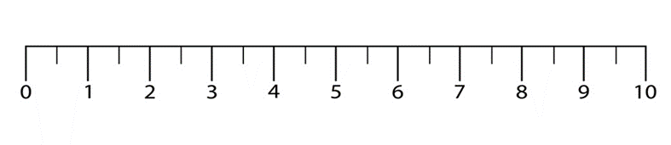
- Best alternative procedure (Free text) ?
- Disciplines present at the tumor board meeting (Multiple choices possible) | ☐ General and visceral surgery | ☐ Orthopedic and trauma surgery
 | ☐ Radiation oncology | ☐ Medical oncology
 | ☐ Pathology | ☐ Neuropathology
 | ☐ Radiology (including neuroradiology) | ☐ Nuclear medicine
 | ☐ Vascular surgery | ☐ Plastic surgery
 | ☐ Neurosurgery | ☐ Gynecology
 | ☐ Otorhinolaryngology | ☐ Oral and maxillofacial surgery
 | ☐ Urology | ☐ Anesthesiology
 | ☐ Psycho-oncology | ☐ Social services

