CYCLOSPORINE PLUS METHOTREXATE VERSUS CYCLOSPORINE ALONE FOR GRAFT-VERSUS-HOST DISEASE PROPHYLAXIS IN PEDIATRIC PATIENTS UNDERGOING HEMATOPOIETIC STEM CELL TRANSPLANTATION FROM HLA-IDENTICAL SIBLINGS
V.Apolito¹, V. Ceolin¹, M. Spadea^{1,2}, R. Vitale² , M.Barone¹, A. Tomatis¹, P. Quarello^{1,2} F.Saglio¹, F. Fagioli^{1,2}
¹Pediatric Onco-Haematology Division, Regina Margherita Children's Hospital, Turin, Italy
²Department of Public Health and Pediatrics,University of Turin, Italy

Supplementary Table 1. Characteristic of patients
 | CSA/MTX (n.) | CSA alone (n.) | P value
Number of patients | 28 | 21
Sex |  |  | 0.22
Male | 21 | 12
Female | 7 | 9
Median age, y (range) | 13.7 (4.1-21.9) | 7.6 (0.5-14.9)
Age |  |  | 0.0013
Younger than 12 years | 11 | 18
12 years and older | 17 | 3
Disease type |  |  | 0.48
Malignant | 21 | 18
Non malignant | 7 | 3
Underlying disease
AML | 5 | 4
MDS | 1 | 2
ALL | 13 | 10
NHL | 1 | 1
CML | 1 | 0
Neuroblastoma | 0 | 1
SCD | 4 | 0
DBA | 2 | 0
SAA | 0 | 1
Talassemia | 1 | 0
Fanconi anemia | 0 | 1
SCID | 0 | 1
Remission status of cancer, n(%)
Active disease | 1 (4.8) | 2 (11.1)
CR1 | 10 (47.6) | 10 (55.6)
CR2 | 8 (38.1) | 5 (27.8)
CR3 | 2 (9.5) | 0
PR | 0 | 1 (5.5)
Source of SC |  |  | 0.03
Peripheral blood | 6 | 0
Bone marrow | 22 | 21
Use of ATG |  |  | 0.0063
Yes | 9 | 0
No | 19 | 21
CMV Status
D+/R+ | 15 | 16
D+/R- | 2 | 3
D-/R+ | 8 | 1
D-/R- | 3 | 1
Conditioning
TBI based | 10 | 10
Busulfan based | 9 | 6
Treosulfan based | 9 | 2
Other | 0 | 3
aGvHD grade I | 1 | 7
aGvHD grade II | 1 | 7
Skin involvement, n (%) | 1 (100) | 7 (100)
Hepatic involvement, n (%) | 0 | 1 (14.3)
aGvHD grade III | 1 | 0
GI and hepatic involvement, n (%) | 1 (100) | 0
aGvHD grade IV | 0 | 1
GI, skin and hepatic involvement | 0 | 1 (100)
SC: Stem cell source; ATG: Antithymocyte globulin, GI: Gastrointestinal

Supplementary Table 2. Multivariate analysis of acute GvHD grade II/IV
Variable | HR | 95% CI | P value
Use of MTX | 0.1 | 0.01 – 0.95 | 0.04
BM as SCS | 0.23 | 0.07 – 7.54 | 0.40
Older than 12 years old | 1.30 | 0.25 – 6.9 | 0.75
Use of ATG | 1.59 | 0.05 – 42.8 | 0.8
Female patients | 3.31 | 0.8 – 13.37 | 0.09
MTX: Methotrexate; BM: Bone Marrow; SCS: Stem cell source; ATG: antithymocite globulin; HR: Hazard ratio; CI: confidence interval

Supplementary Table 3. Multivariate analysis of cGvHD
Variable | HR | 95% CI | P value
Use of MTX | 0.24 | 0.03 – 1.64 | 0.14
BM as SCS | 0.02 | 0.002 – 0.24 | 0.002
Older than 12 years old | 1.87 | 0.33 – 10.58 | 0.48
Use of ATG | 0 | 0.00 - ∞ | 0.97
Female patients | 1.37 | 0.34 – 5.52 | 0.66
MTX: Methotrexate; BM: Bone Marrow; SCS: Stem cell source; ATG: antithymocite globulin; HR: Hazard ratio; CI: confidence interval

Figure S1. Overall survival
P-value=0.56

CSA: Cyclosporine; CSA/MTX: Cyclosporine plus methotrexate
Figure S2. Cumulative incidence of relapse in patients with malignancy
p-value=0.27
CSA: Cyclosporine; CSA/MTX: Cyclosporine plus methotrexate

Figure S3. Cumulative incidence of moderate/severe cGvHD
P-value=0.38
CSA: Cyclosporine; CSA/MTX: Cyclosporine plus methotrexate

Figure S4. Cumulative incidence of aGvHD grade II/IV (excluding patients who received ATG)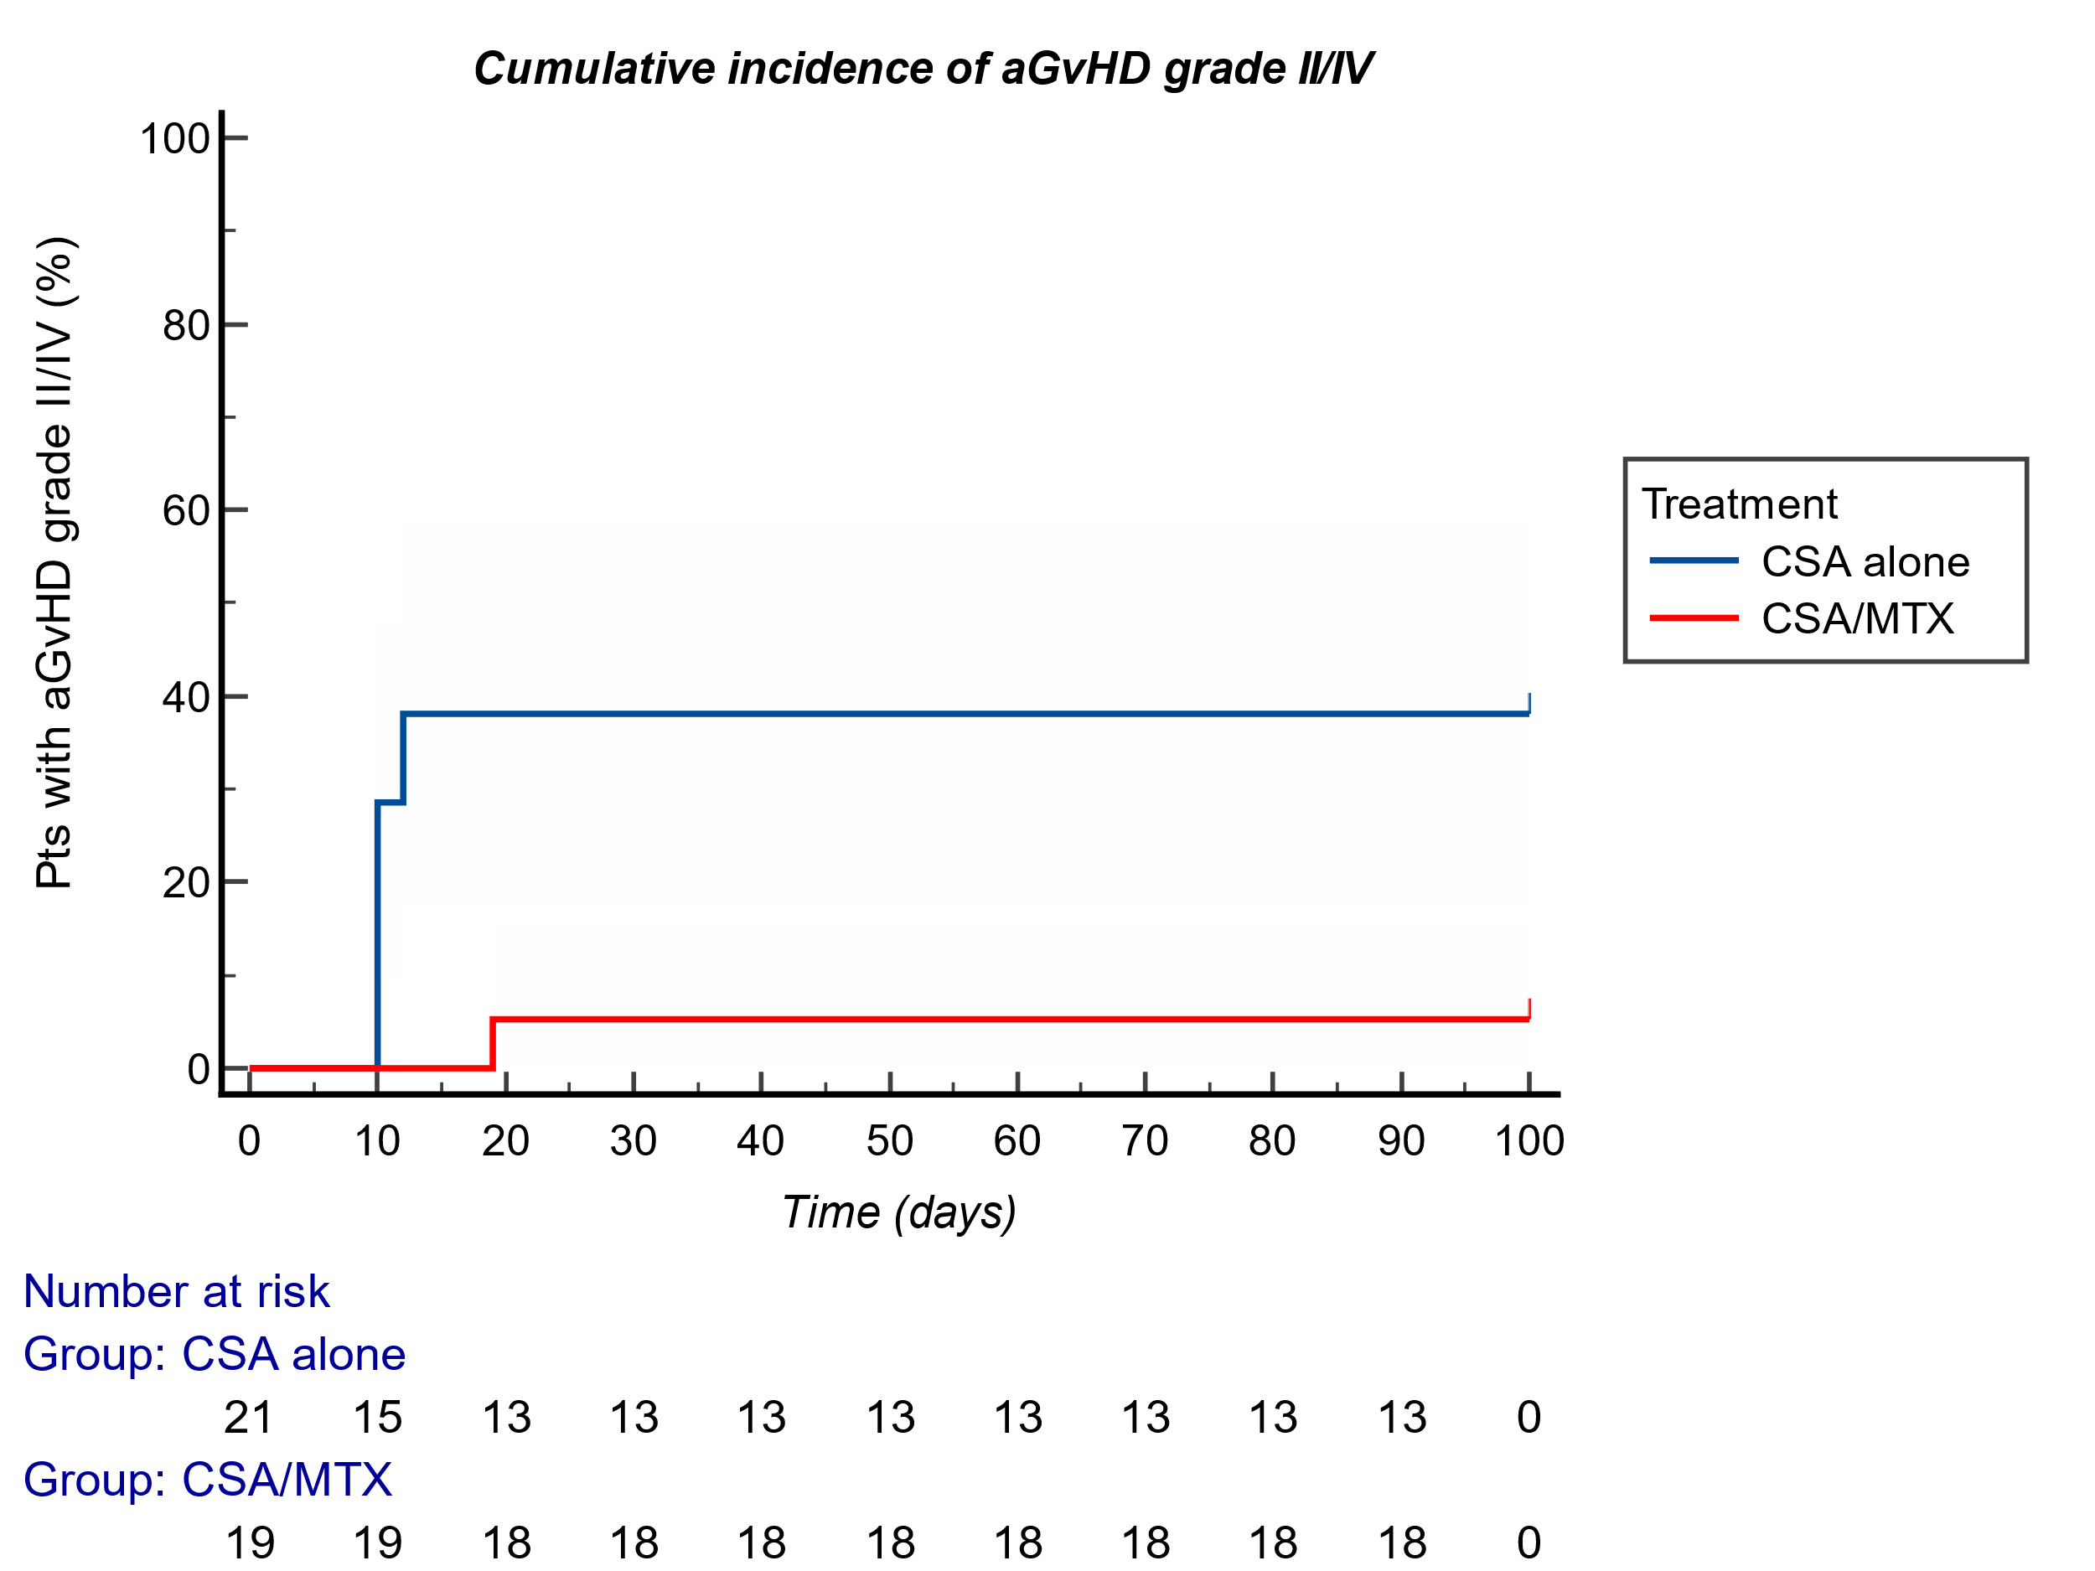
P-value=0.01

Supplementary information
All consecutive patients undergoing BMT from HLA identical sibling at Regina Margherita Children’s Hospital between 2013 and 2023 have been enrolled in this study. Our policy of considering matched-related donors as the first-line choice has remained unchanged over the years. No significant changes were made in terms of conditioning regimens or supportive therapy during the study period (2013-2023). All patients included in the study had an indication for bone marrow transplantation due to their underlying malignant or non-malignant disease, and all had a matched-related donor available.
ATG was used, following the pubblication of “Kröger, Nicolaus et al. “Antilymphocyte Globulin for Prevention of Chronic Graft-versus-Host Disease.” The New England journal of medicine vol. 374,1 (2016): 43-53. doi:10.1056/NEJMoa1506002” in 2016, in 4 patients receiving PBSC as SCS. Two patients in PBSC group did not receive ATG, as they were treated before 2016, so at the time there were no clear evidence available. Five patients in ATG group received bone marrow as stem cell source. All of these 5 had non-malignant disease, so there was no risk of oncological relapse, which may be affected by ATG use. Instead, ATG was used in these patients to reduce the risk of GvHD and promote engraftment.
Discrete data are expressed as frequencies and continuous data as mean or median and interquartile range, as appropriate. Fisher test was used to compare differences between groups. OS was estimated using the Kaplan-Meier method, censoring at the date of the last follow-up. Multivariable analyses were performed by Cox regression, assessing variables that reached statistical significance in univariable analyses. P value <0.05 was considered statistically significant. Statistical analyses were performed using NCSS2023, Graphpad, MedCalc and R. To answer to the peer-review process binary logistic regression was performed after checking for assumption (no multicollinearity assessed with spearman/pearson for continuous variable or Cramer V for nominal variables). Goodness of fit was assessed by Hosmer Lemeshow test and Nagelkerke R square considering significant a p>0.05 and ROC curve prediction on model (AUC>0.7, p<0.05). R egressor will be considered significant with a p<0.05 at Walds test, then HR with condifence interval at 95% will be provived. Set point of significancy was fixed at p<.001. to analyze time-to-event data with competing risks, we used Fine and Gray’s subdistribution hazard model to estimate the cumulative incidence function (CIF) and assess differences between groups. The subdistribution hazard ratios (sHR) and 95% confidence intervals (CI) were estimated, adjusting for covariates. Significancy was set at p<.001. To evaluate the statistical power of Fine and Gray’s competing risks model, we conducted a Monte Carlo simulation using 1,000 repetitions. We used R v 4.4.2 with "Survival" and "cmprk" packages. The goal was to estimate the probability of detecting a significant difference between groups when a true difference exists, considering competing risks. The simulation process involved: 1) Generating time-to-event data using an exponential distribution to mimic survival times. 2) Randomly assigning group membership with equal probability. 3) Simulating event status (event, competing event, or censoring) using predefined probabilities. 4) Applying Fine and Gray’s subdistribution hazard model to estimate the effect of group membership on cumulative incidence. 5) Extracting p-values from each simulated model and calculating the proportion of simulations with p<0.05 for power estimation.

