S4: Meta-analysis data extraction

Meta-analysis data overview

Author | Year | m_int | sd_int | n_int | m_con | sd_con | n_con
Boeryd | 1974 | 34 | 42,16 | 30 | 13 | 42,16 | 32
Hiramoto | 2019 | 7,69 | 2,87 | 5 | 17,56 | 7,22 | 5
Horiguchi | 2000 | 0,27 | 0,57 | 18 | 0,88 | 0,78 | 17
Kikuchi | 1986 | 2,57 | 1,3 | 10 | 4,96 | 1,56 | 10
Law | 2021 | 9,3 | 15,56 | 5 | 81,7 | 62,52 | 5
Ogawa | 1982 | 1,21 | 0,60 | 11 | 2,03 | 0,82 | 10
Ogawa | 1982 | 0,81 | 0,36 | 11 | 1,23 | 0,32 | 10
Ogawa | 1982 | 0,81 | 0,36 | 11 | 1,3 | 0,51 | 10
Yamamotmo | 2017 | 2,72 | 0,42 | 4 | 3,95 | 0,76 | 4

Extracted data for meta-analysis

Author, year | Boeryd, B. et al, 1974
Tumor model | Melanoma (B16)
Outcome measure | Tumor volume
Mean, intervention group | 34
SD, intervention group | Not reported. Formula for calculation standard deviation:  $$sd=\frac{{\overline{x}}_{1}-{\overline{x}}_{2}}{t}*\sqrt{\frac{n_{1}{*n}_{2}}{n_{1}+n_{2}}}$$  $${\overline{x}}_{1}=Mean \left(intervention group\right)$$  $${\overline{x}}_{2}=Mean (control group)$$  $$t=1.96 (for p=0.05)$$  $$n_{1}=Sample size (intervention group)$$  $$n_{2}=Sample size (control group)$$  $$SD=\frac{34-13}{1.96}*\sqrt{\frac{30*32}{30+32}}=42.16$$
Sample size, intervention group | 30
Mean, control group | 13
SD, control group | 42.16
Sample size, control group | 32
Additional information | Concerning SD: Calculations for sd are based on assumption of normal distribution of the sample, in spite of this being unlikely as the performed analysis in the article is nonparametric.

Author, year | Hiramoto, K. et al 2019
Tumor model | Non-melanoma skin cancer
Outcome measure | Tumor size
Mean, intervention group | Reported in figure. Formula for calculating results from figure:  $$Mean=measurement* \frac{Value for reference measure}{reference measure}$$  $$Mean=5.65*\frac{10}{7.35}=7.69$$
SD, intervention group | $$SD=2.11*\frac{10}{7.35}=2.87$$
Sample size, intervention group | 5
Mean, control group | $$Mean=12.91*\frac{10}{7.35}=17.56$$
SD, control group | $$SD=5.31*\frac{10}{7.35}=7.22$$
Sample size, control group | 5
Additional information | Figure and measurements:  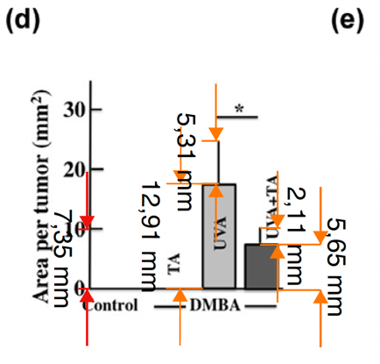

Author, year | Horiguchi, K. et al 2000
Tumor model | Pancreatic ducts carcinoma
Outcome measure | No. of tumors
Mean, intervention group | 0.27
SD, intervention group | 0.57
Sample size, intervention group | 18
Mean, control group | 0.88
SD, control group | 0.78
Sample size, control group | 17
Additional information

Author, year | Kikuchi, Y. et al 1986
Tumor model | Ovarian carcinoma (HR)
Outcome measure | Tumor volume
Mean, intervention group | 2.57
SD, intervention group | 1.3
Sample size, intervention group | 10
Mean, control group | 4.96
SD, control group | 1.56
Sample size, control group | 10
Additional information

Author, year | Law, M. E. et al 2022
Tumor model | Breast tumor (012/LVM2/LR10)
Outcome measure | Tumor volume
Mean, intervention group | 9.3
SD, intervention group | Standard error reported in figure.  $$SE=1.26*\frac{20}{3.62}=6.96$$  Formula for calculating SD from SE:  $$SD=SE*\sqrt{n}$$  $$SD=6.96*\sqrt{5}=15.56$$
Sample size, intervention group | 5
Mean, control group | 81.7
SD, control group | SE reported in figure. Results calculations:  $$SE=5.06*\frac{20}{3.62}=27.96$$  $$SD=27.96*\sqrt{5}=62.52$$
Sample size, control group | 5
Additional information | 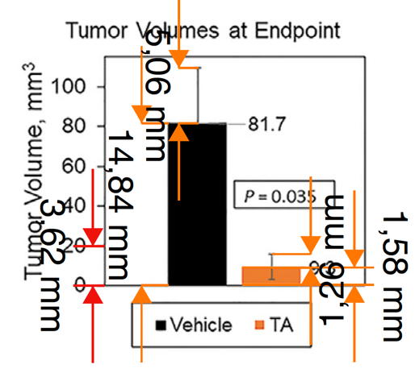  Figure and measurements:

Author, year | Ogawa, H., et al 1982
Tumor model | Ovarian carcinoma (OC-1), Lung squamous carcinoma (QG-56) & Lung adenocarcinoma (PC-12)
Outcome measure | Tumor weight
Ovarian carcinoma (OC-1)
Mean, intervention group | 1.21
SD, intervention group | SE = 0.18  $$SD=0.18*\sqrt{11}=0.6$$
Sample size, intervention group | 11
Mean, control group | 2.03
SD, control group | SE = 0.26  $$SD=0.26*\sqrt{10}=0.82$$
Sample size, control group | 10
Lung squamous carcinoma (QG-56)
Mean, intervention group | 0.81
SD, intervention group | SE = 0.11  $$SD=0.11*\sqrt{11}=0.36$$
Sample size, intervention group | 11
Mean, control group | 1.23
SD, control group | SE = 0.10  $$SD=0.10*\sqrt{10}=0.32$$
Sample size, control group | 10
Lung adenocarcinoma (PC-12)
Mean, intervention group | 0.81
SD, intervention group | SE = 0.11  $$SD=0.11*\sqrt{11}=0.36$$
Sample size, intervention group | 11
Mean, control group | 1.30
SD, control group | SE = 0.16  $$SD=0.16*\sqrt{10}=0.51$$
Sample size, control group | 10

Author, year | Yamamoto, H., et al 2017
Tumor model | Small cell lung carcinoma (SBC-3A)
Outcome measure | Tumor weight
Mean, intervention group | $$Mean=14.68*\frac{1}{5.39}=2.72$$
SD, intervention group | SE reported in figure.  $$SE=1.13*\frac{1}{5.39}=0.21$$  $$SD=0.21*\sqrt{4}=0.42$$
Sample size, intervention group | 4
Mean, control group | $$Mean=21.31*\frac{1}{5.39}=3.95$$
SD, control group | SE reported in figure.  $$SE=2.07*\frac{1}{5.39}=0.38$$  $$SD=0.38*\sqrt{4}=0.76$$
Sample size, control group | 4
Additional information | 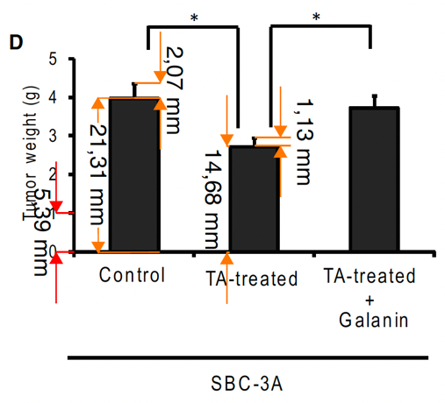  Figure and measurements:

List of included studies

Boeryd, B., Hagmar, B., Johnsson, G., & Ryd, W. (1974). Effects of EACA, AMCHA and guanethidine on metastases induced by intravenously injected tumour cells. Pathologia Europaea, 9(2), 119–123. https://www.embase.com/search/results?subaction=viewrecord&id=L5454222&from=export
Hiramoto, K., Yamate, Y., Sugiyama, D., Matsuda, K., Iizuka, Y., & Yamaguchi, T. (2019). Tranexamic Acid Ameliorates Nonmelanoma Skin Cancer Induced by Long-term Ultraviolet A Irradiation. Photochemistry and Photobiology, 95(2), 612–617. https://doi.org/10.1111/php.13025
Horiguchi, K. (2000). Effects of tranexamic acid and phenyl N-tert-butylnitrone on pancreatic carcinogenesis in hamsters. Journal of Nara Medical Association, 51(6), 436–445. https://www.embase.com/search/results?subaction=viewrecord&id=L32147407&from=export
Kikuchi, Y., Kizawa, I., & Oomori, K. (1986). The inhibitory effect of tranexamic acid on human ovarian carcinoma cell grown in vitro and in vivo. Gynecologic Oncology, 24(2), 183–188. https://doi.org/10.1016/0090-8258(86)90026-0
Law, M. E., Davis, B. J., Ghilardi, A. F., Yaaghubi, E., Dulloo, Z. M., Wang, M., Guryanova, O. A., Heldermon, C. D., Jahn, S. C., Castellano, R. K., & Law, B. K. (2022). Repurposing Tranexamic Acid as an Anticancer Agent. Frontiers in Pharmacology, 12. https://doi.org/10.3389/fphar.2021.792600
Ogawa, H., Sekiguchi, F., & Tanaka, N. (1982). Effect of antifibrinolysis treatment on human cancer in nude mice. Anticancer Research, 2(6), 339–344. https://www.embase.com/search/results?subaction=viewrecord&id=L13135878&from=export
Yamamoto, H., Okada, R., Tanaka, R., Unno, K., & Iguchi, K. (2017). Expression of a urokinase-type plasminogen activator during tumor growth leads to angiogenesis via galanin activation in tumor-bearing mice. FEBS Open Bio, 7(11), 1784–1792. https://doi.org/10.1002/2211-5463.12318

