Table A Distribution of patient and tumor characteristics by sex
 |  | Men |  | Women |  | Total |  | p
 |  | Number | % | Number | % | Number | %
Period of diagnosis | 2000-05 | 608 | 24.2 | 83963 | 27.3 | 84571 | 27.3 | <.001
Period of diagnosis | 2006-11 | 771 | 30.7 | 104845 | 34.1 | 105616 | 34.1 | <.001
Period of diagnosis | 2012-18 | 1131 | 45.1 | 118826 | 38.6 | 119957 | 38.7 | <.001
Age at diagnosis (years) | 0-49 | 186 | 7.4 | 58300 | 19.0 | 58486 | 18.9 | <.001
Age at diagnosis (years) | 50-59 | 351 | 14.0 | 68263 | 22.2 | 68614 | 22.1 | <.001
Age at diagnosis (years) | 60-69 | 764 | 30.4 | 81467 | 26.5 | 82231 | 26.5 | <.001
Age at diagnosis (years) | 70-79 | 839 | 33.4 | 64779 | 21.1 | 65618 | 21.2 | <.001
Age at diagnosis (years) | ≥80 | 370 | 14.7 | 34825 | 11.3 | 35195 | 11.3 | <.001
Side localization ICDO-3 | Left | 1346 | 53.6 | 157780 | 51.3 | 159126 | 51.3 | .030
Side localization ICDO-3 | Right | 1146 | 45.7 | 148241 | 48.2 | 149387 | 48.2 | .030
Side localization ICDO-3 | both sides | 0 | 0.0 | 79 | 0.0 | 79 | 0.0 | .030
Side localization ICDO-3 | n. s.ª | 18 | 0.7 | 1534 | 0.5 | 1552 | 0.5 | .030
Histology classification | Invasive carcinoma | 2480 | 98.8 | 304666 | 99.0 | 307146 | 99.0 | .180
Histology classification | DCIS^{b} | 2 | 0.1 | 449 | 0.1 | 451 | 0.1 | .180
Histology classification | Other malignant neoplasms | 28 | 1.1 | 2519 | 0.8 | 2547 | 0.8 | .180
Stage UICC | 0 | 5 | 0.2 | 3117 | 1.0 | 3122 | 1.0 | <.001
Stage UICC | I | 581 | 23.1 | 116205 | 37.8 | 116786 | 37.7 | <.001
Stage UICC | II | 905 | 36.1 | 107892 | 35.1 | 108797 | 35.1 | <.001
Stage UICC | III | 549 | 21.9 | 39036 | 12.7 | 39585 | 12.8 | <.001
Stage UICC | IV | 248 | 9.9 | 21495 | 7.0 | 21743 | 7.0 | <.001
Stage UICC | X/ n. s. | 222 | 8.8 | 19889 | 6.5 | 20111 | 6.5 | <.001
Grading | G1 | 277 | 11.0 | 42382 | 13.8 | 42659 | 13.8 | <.001
Grading | G2 | 1449 | 57.7 | 166132 | 54.0 | 167581 | 54.0 | <.001
Grading | G3 | 641 | 25.5 | 85969 | 27.9 | 86610 | 27.9 | <.001
Grading | GX/ n. s. | 143 | 5.7 | 13151 | 4.3 | 13294 | 4.3 | <.001
Lymphatic invasion | 0 | 997 | 39.7 | 150113 | 48.8 | 151110 | 48.7 | <.001
Lymphatic invasion | 1 | 811 | 32.3 | 68045 | 22.1 | 68856 | 22.2 | <.001
Lymphatic invasion | X/ n. s. | 702 | 28.0 | 89476 | 29.1 | 90178 | 29.1 | <.001
Venous invasion | 0 | 1536 | 61.2 | 192433 | 62.6 | 193969 | 62.5 | <.001
Venous invasion | 1 | 126 | 5.0 | 10007 | 3.3 | 10133 | 3.3 | <.001
Venous invasion | X/ n. s. | 848 | 33.8 | 105194 | 34.2 | 106042 | 34.2 | <.001
Hormon receptor (HR) status | Positive | 1966 | 78.3 | 214114 | 69.6 | 216080 | 69.7 | <.001
Hormon receptor (HR) status | Negative | 71 | 2.8 | 39190 | 12.7 | 39261 | 12.7 | <.001
Hormon receptor (HR) status | n. s. | 473 | 18.8 | 54330 | 17.7 | 54803 | 17.7 | <.001
HER2 status | Positive | 212 | 8.4 | 36635 | 11.9 | 36847 | 11.9 | <.001
HER2 status | Negative | 1839 | 73.3 | 220292 | 71.6 | 222131 | 71.6 | <.001
HER2 status | n. s. | 459 | 18.3 | 50707 | 16.5 | 51166 | 16.5 | <.001
Ki-67 | Low risk (<25%) | 582 | 23.2 | 69666 | 22.6 | 70248 | 22.7 | .219
Ki-67 | High risk (≥25%) | 347 | 13.8 | 39539 | 12.9 | 39886 | 12.9 | .219
Ki-67 | n.s. | 1581 | 63.0 | 198429 | 64.5 | 200010 | 64.5 | .219
Molecular subtypes | Luminal A | 304 | 12.1 | 43098 | 14.0 | 43402 | 14.0 | <.001
Molecular subtypes | Luminal B | 435 | 17.3 | 30153 | 9.8 | 30588 | 9.9 | <.001
Molecular subtypes | HER2 enriched | 212 | 8.4 | 36635 | 11.9 | 36847 | 11.9 | <.001
Molecular subtypes | Triple negative | 45 | 1.8 | 25590 | 8.3 | 25635 | 8.3 | <.001
Molecular subtypes | n. s. | 1514 | 60.3 | 172158 | 56.0 | 173672 | 56.0 | <.001
Total |  | 2510 | 100.0 | 307634 | 100.0 | 310144 | 100.0
ª N.s.: not specified
b Carcinoma in situ diagnosed after neoadjuvant therapy
Table B Sentinel lymph node biopsy in patients with clinically inconspicious lymph nodes (cN0)
Sentinel lymph node biopsy | male patients |  | female patients |  | total
Sentinel lymph node biopsy | number | % | number | % | Number | %
Performed | 309 | 88.3 | 60884 | 89.8 | 61193 | 89.8
not performed | 41 | 11.7 | 6936 | 10.2 | 6977 | 10.2
Total | 350 | 100.0 | 67820 | 100.0 | 68170 | 100.0

Table C HER2 analysis in male and female patients
HER2 examination | male patients |  | female patients |  | total
HER2 examination | number | % | number | % | number | %
Performed | 2051 | 81.7 | 256927 | 83.5 | 258978 | 83.5
not performed | 459 | 18.3 | 50707 | 16.5 | 51166 | 16.5
Total | 2510 | 100.0 | 307634 | 100.0 | 310144 | 100.0

Table D Surgery performed in male and female patients
Surgery | Male patients |  | Female patients |  | Total
 | number | % | number | % | Number | %
BCT | 261 | 13.9 | 173623 | 72.1 | 173884 | 71.7
Mastectomy | 1566 | 83.3 | 59712 | 24.8 | 61278 | 25.3
Other surgery/ not specified | 51 | 2.7 | 6030 | 2.5 | 6081 | 2.5
No surgery | 3 | 0.2 | 1372 | 0.6 | 1375 | 0.6
Total | 1881 | 100.0 | 240737 | 100.0 | 242618 | 100.0

Table E Multivariable Cox regression with and without adjustment for therapy in patients with respective indication. The collective was restricted to patients in stages I – III with local R0 status after BET or mastectomy. Indication for endocrine therapy was a positive hormone receptor status. Analyses for antibody therapy were only carried out from 2006, since the proportion of testing for HER2 status in previous years was very low. Indication for antibody therapy and antibody and chemotherapy was a positive HER2 status. Indication for chemotherapy was a negative hormone receptor status and/or positive lymph nodes and/or grading G3/4 and/or under 35 years of age.
 |  |  | Without adjustment for therapy |  |  |  | With adjustment for therapy
Therapy | Sex | n (patients with indication) | pª | HR | 95%-CI |  | p | HR | 95%-CI
 |  |  |  |  | Lower limit | Upper limit |  | HR | Lower limit | Upper limit
Endocrine therapy | women | 173,008 |  | Ref^{b} |  |  |  | Ref.
Endocrine therapy | men | 1,543 | < .001 | 1.49 | 1.36 | 1.63 | < .001 | 1.47 | 1.34 | 1.61
Antibody therapy | women | 2,2012 |  | Ref. |  |  |  | Ref.
Antibody therapy | men | 133 | < .001 | 2.45 | 1.85 | 3.25 | < .001 | 2.37 | 1.79 | 3.14
Antibody and chemotherapy | women | 2,2012 |  | Ref. |  |  |  | Ref.
Antibody and chemotherapy | men | 133 | < .001 | 2.45 | 1.85 | 3.25 | < .001 | 2.33 | 1.76 | 3.09
Chemo-therapy | women | 120,269 |  | Ref. |  |  |  | Ref.
Chemo-therapy | men | 1,001 | < .001 | 1.48 | 1.34 | 1.64 | < .001 | 1.49 | 1.35 | 1.65
The p-values in the tables given in the reference category refer to the entire variable.
^{b} Ref.: Reference
Table F Multivariable Cox regression for overall survival in dependence of therapy applied yes vs no separated by sex in patients with respective indication
Therapy | Sex | pª | HR | 95%-CI
 |  |  |  | Lower limit | Upper limit
Endocrine therapy | Women | < .001 | .75 | .73 | .77
Endocrine therapy | Men | < .001 | .71 | .58 | .86
Antibody therapy | Women | < .001 | .63 | .58 | .68
Antibody therapy | Men | .245 | .63 | .29 | 1.37
Chemotherapy | Women | < .001 | .75 | .73 | .77
Chemotherapy | Men | .002 | .70 | .56 | .88
ª The p-values in the tables given in the reference category refer to the entire variable.

Table G Rate of contralateral secondary tumors in the group of 2,467 male patients and 293,127 female patients
 | Male patients |  | Female patients |  | Total
 | number | % | number | % | number | %
Simultanous contralateral secondary tumors | 24 | 1.0 | 6641 | 2.3 | 6665 | 2.3%
Subsequent contralateral secondary tumors | 9 | 0.4 | 5606 | 1.9 | 5615 | 1.9%

Table H Uni- and multivariable logistic regression with OR and multivariable Cox regression with HR men versus women for simultanous and subsequent contralateral secondary tumors
 | Sex | Log-rank pª | Odds Ratio (OR) or Hazard ratio (HR) | 95% CI für HR
 |  |  |  | Lower limit | Upper limit
Univariable logistic regression
Simultanous contralateral secondary tumors | Women | < .001 | Ref.^{b}
Simultanous contralateral secondary tumors | Men | < .001 | .42 | .28 | .63
Subsequent contralateral secondary tumors | Women | < .001 | Ref.
Subsequent contralateral secondary tumors | Men | < .001 | .19 | .10 | .36
Multivariable logistic regression
Simultanous contralateral secondary tumors | Women | < .001 | Ref.
Simultanous contralateral secondary tumors | Men | < .001 | .33 | .22 | .49
Subsequent contralateral secondary tumors | Women | < .001 | Ref.
Subsequent contralateral secondary tumors | Men | < .001 | .24 | .13 | .46
Multivariable Cox regression
Simultanous contralateral secondary tumors | Women | - | - | - | -
Simultanous contralateral secondary tumors | Men | - | - | - | -
Subsequent contralateral secondary tumors | Women | < .001 | Ref.
Subsequent contralateral secondary tumors | Men | .000 | .27 | .14 | .52
ª The p-values in the tables given in the reference category refer to the entire variable.
^{b} Ref.: Reference
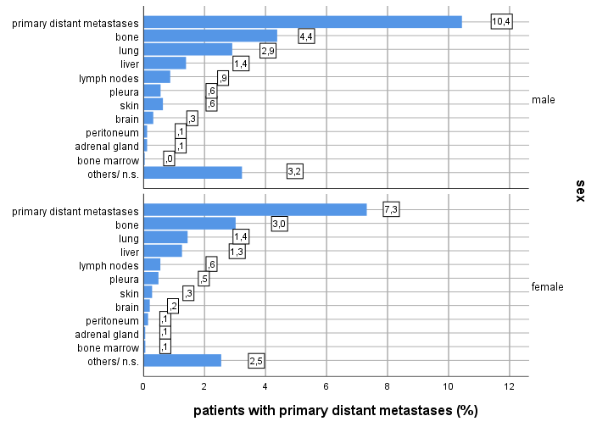
Figure A Primary distant metastases (%) of 2510 male and 307634 female patients (total and by location)
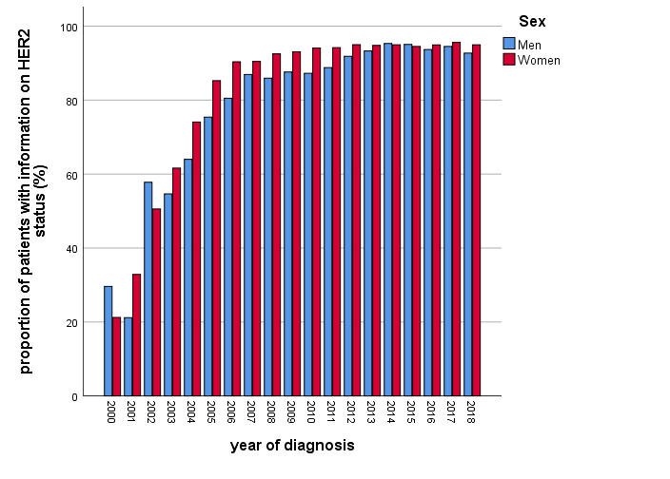
Figure B Proportion of men and women with HER2 testing by year of diagnosis

