Supplementary Data

Supplementary Tables

Supplementary Table S1. Patient clinical characteristics in training, internal validation and external validation datasets
Characteristic | Data_1 |  |  |  | Data_2
Characteristic | Train (n=88) |  | Validation (n=39) |  | Test (n=43)
Characteristic | n (%), Range (Mean) | p-value * | n (%), Range (Mean) | p-value * | n (%), Range (Mean) | p-value *
Age | 43-86; (68) | 0.26 | 46-87; (69) | 0.07 | 45-83 (69) | 0.30
Gender
Male | 62 (70%) | 0.32 | 29 (74%) | 0.16 | 19 (56%) | 0.51
Female | 26 (30%) |  | 10 (26%) |  | 24 (44%)
Overall stage |  | 0.19 |  | 0.001 |  | 0.32
I-II | 73 (83%) |  | 32 (82%) |  | 34 (79%)
III-IV | 15 (17%) |  | 7 (18%) |  | 9 (21%)
T Stage |  | 0.42 |  | 0.10 |  | 0.57
1 | 39 (44%) |  | 20 (51%) |  | 9 (21%)
2 | 34 (39%) |  | 12 (31%) |  | 25 (58%)
3 | 12 (14%) |  | 6 (15%) |  | 7 (16%)
4 | 3 (3%) |  | 1 (3%) |  | 2 (5%)
N Stage |  | 0.03 |  | 0.007 |  | 0.26
0 | 70 (80%) |  | 33 (85%) |  | 30 (70%)
1 | 10 (11%) |  | 5 (13%) |  | 8 (18%)
2 | 8 (9%) |  | 1 (3%) |  | 5 (12%)
M Stage |  | 0.14 |  | 0.02 |  | 0.04
0 | 84 (95%) |  | 38 (97%) |  | 42 (98%)
1 | 4 (5%) |  | 1 (3%) |  | 1 (2%)
Histology
Adenocarcinoma | 65 (74%) | 0.97 | 32 (82%) | 0.03 | 18 (42%) | 0.32
Squamous cell carcinoma | 21 (24%) |  | 6 (15%) |  | 25 (58%)
Not specified | 2 (2%) |  | 1 (3%) |  | 0 (0%)
SUV_{max} | 0.84-35.66; (8.40) | 0.16 | 0.98-22.15; (6.56) | 0.001 | 1.67-27.89; (12.33) | 0.30
Survival status
Dead | 29 (33%) |  | 13 (33%) |  | 16 37%)
Alive | 59 (67%) |  | 26 (67%) |  | 27 (63%)
Categorical variables are presented as n (%), and continuous variables as range (mean).
* The p-value indicates the significance of each feature in univariate Cox analysis.

Supplementary Table S2. Conventional PET features calculated during ROI segmentation.
Feature | Index | Units
Mean uptake value | SUV_{mean} | SUV_{bw}
Minimum uptake value | SUV_{min} | SUV_{bw}
Maximum uptake value | SUV_{max} | SUV_{bw}
Peak value within ROI | SUV_{peak} | SUV_{bw}
Sum of segmented voxel volumes | Volume | ml
Total Lesion Glycolysis | TLG | SUV_{bw}*ml
Standard Deviation of uptake values | SUV_{SD} | SUV_{bw}
Median uptake value | SUV_{median} | SUV_{bw}
Standardized added metabolic activity | SAM | SUV_{bw}*ml

Supplementary Table S3. Radiomic features based on shape, histogram, and texture.
Feature group | Image Type * | Feature Class | Feature Name
Shape-based (2D and 3D) | Original | Shape | Elongation, Flatness, LeastAxisLength, MajorAxisLength, Maximum2DDiameterColumn, Maximum2DdiameterRow, Maximum2DdiameterSlice, Maximum3Ddiameter, MeshVolume, MinorAxisLength, Sphericity, SurfaceArea, SurfaceVolumeRatio, VoxelVolume
First-order statistics (intensity or histogram based) |  | First-order | 10Percentile, 90Percentile, Energy, Entropy InterquartileRange, Kurtosis, Maximum, MeanAbsoluteDeviation, Mean, Median, Minimum, Range, RobustMeanAbsoluteDeviation, RootMeanSquared, Skewness, TotalEnergy, Uniformity, Variance
  Original
  Wavelet (High
  and low pass
  in x,y and
  z directions)
  Log-sigma
  (σ=1.0)
High-order (textural) |  | Gray Level Co-occurrence Matrix  (GLCM) | Autocorrelation, ClusterProminence, ClusterShade, ClusterTendency, Contrast, Correlation, DifferenceAverage, DifferenceEntropy, DifferenceVariance, Id, Idm, Idmn, Idn, Imc1, Imc2, InverseVariance, JointAverage, JointEnergy, JointEntropy, MCC, MaximumProbability, SumAverage, SumEntropy  SumSquares
  Original
  Wavelet (High
  and low pass
  in x,y and
  z directions)
  Log-sigma
  (σ=1.0)
High-order (textural) |  | Gray Level Size Zone Matrix (GLSZM) | GrayLevelNonUniformity, GrayLevelNonUniformityNormalized, GrayLevelVariance, HighGrayLevelZoneEmphasis, LargeAreaEmphasis, LargeAreaHighGrayLevelEmphasis, LargeAreaLowGrayLevelEmphasis, LowGrayLevelZoneEmphasis, SizeZoneNonUniformity, SizeZoneNonUniformityNormalized, SmallAreaEmphasis
High-order (textural) |  | Gray Level Run Length Matrix (GLRLM) | GrayLevelNonUniformity, GrayLevelNonUniformityNormalized, GrayLevelVariance, HighGrayLevelRunEmphasis, LongRunEmphasis, LongRunHighGrayLevelEmphasis, LongRunLowGrayLevelEmphasis, LowGrayLevelRunEmphasis, RunEntropy, RunLengthNonUniformity, RunLengthNonUniformityNormalized, RunPercentage, RunVariance, ShortRunEmphasis, ShortRunHighGrayLevelEmphasis, ShortRunLowGrayLevelEmphasis
High-order (textural) |  | Neighbouring Gray Tone Difference Matrix (NGTDM) | Busyness, Coarseness, Complexity, Contrast, Strength
High-order (textural) |  | Gray Level Dependence Matrix (GLDM) | DependenceEntropy, DependenceNonUniformity, DependenceNonUniformityNormalized, DependenceVariance, GrayLevelNonUniformity  GrayLevelVariance, HighGrayLevelEmphasis, LargeDependenceEmphasis, LargeDependenceHighGrayLevelEmphasis, LargeDependenceLowGrayLevelEmphasis, LowGrayLevelEmphasis, SmallDependenceEmphasis, SmallDependenceHighGrayLevelEmphasis, SmallDependenceLowGrayLevelEmphasis
* Radiomic features were extracted from the original and filtered (wavelet and Laplacian-of-Gaussian (LoG)) images. Wavelet filters were applied as high/low band-pass in the x, y, and z directions. For LoG filtering, we used the sigma value of 1.0.

Supplementary Table S4. Multivariate Cox regression analysis of PET-radiomic features
Feature | P-value | HR* | 95%CI†
original_glrlm_GrayLevelNonUniformity (GLNU) | 0.087 | 1.47 | 0.95-2.30
Wavelet-LLH_glszm_SmallAreaLowGrayLevelEmphasis (SALGLE) | 0.071 | 0.35 | 0.11-1.09
Wavelet-LHH_glcm_InverseVariance (IV) | 0.016 | 0.66 | 0.47-0.93
Wavelet-HLH_ngtdm_Busyness (BN) | 0.006 | 1.83 | 1.19-2.82
Wavelet-HHL_glcm_MCC (MCC) | 0.001 | 2.28 | 1.37-3.80
* HR, hazard ratio
† CI, confidence interval

Supplementary Table S5. Multivariate Cox analysis of clinical risk factors
Feature | P-value | HR* | 95%CI†
Age | 0.119 | 1.42 | 0.91-2.20
Gender (Male) | 0.147 | 2.05 | 0.78-5.40
N-stage | 0.011 | 1.94 | 1.16-3.22
M-stage | 0.046 | 4.10 | 1.03-16.33
* HR, hazard ratio
† CI, confidence interval

Supplementary Table S6. Multivariate Cox regression analysis of
RAD score and clinical factors
Feature | P-value | HR* | 95%CI†
Age | 0.004 | 1.07 | 1.02-1.13
Gender (Male) | 0.011 | 3.85 | 1.37-10.86
N-stage | 0.083 | 1.66 | 0.94-2.93
M-stage | 0.003 | 10.07 | 2.17-46.84
Histology | 0.206 | 1.81 | 0.72-4.55
RAD score | 5.752E-06 | 9.97 | 3.69-26.95
* HR, hazard ratio
† CI, confidence interval

Supplementary Table S7. Results of the t-test comparing gene expression between high and low PET radiomic (RAD) risk cohorts, and Cox univariate survival analysis.
 | Differential expression  between risk groups |  |  | Cox univariate  analysis
Gene | Statistic | P-value | FDR | P-value | CI* | Pathway
TP53 | 1.72 | 9.29E-02 | 0.11 | 5.45E-02 | 0.67 | WP_GLYCOLYSIS_IN_SENESCENCE
EGFR | 2.06 | 4.80E-02 | 0.14 | 3.32E-01 | 0.66 | REACTOME_EGFR_TRANSACTIVATION_BY_GASTRIN
ZC3HC1 | 3.65 | 1.21E-03 | 0.06 | 3.57E-02 | 0.66 | REACTOME_SIGNALING_BY_ALK_IN_CANCER
HIF1A | 3.19 | 2.78E-03 | 0.02 | 2.72E-01 | 0.56 | WP_HIF1A_AND_PPARG_REGULATION_OF_GLYCOLYSIS
LDHA | 2.48 | 1.74E-02 | 0.03 | 5.24E-01 | 0.61 | WP_AEROBIC_GLYCOLYSIS
LDHB | 2.53 | 1.59E-02 | 0.06 | 9.24E-02 | 0.66 | WP_GLYCOLYSIS_AND_GLUCONEOGENESIS
HK1 | 2.80 | 7.96E-03 | 0.02 | 3.75E-01 | 0.64 | WP_AEROBIC_GLYCOLYSIS
GPI | 3.43 | 1.46E-03 | 0.01 | 6.68E-02 | 0.67 | REACTOME_GLUCONEOGENESIS
ALDOA | 4.31 | 1.36E-04 | 0.00 | 1.44E-02 | 0.71 | WP_AEROBIC_GLYCOLYSIS
GAPDH | 1.86 | 7.15E-02 | 0.09 | 5.50E-01 | 0.65 | WP_AEROBIC_GLYCOLYSIS
ENO1 | 2.55 | 1.50E-02 | 0.03 | 6.16E-01 | 0.56 | WP_AEROBIC_GLYCOLYSIS
PKM | 1.88 | 7.11E-02 | 0.09 | 1.26E-01 | 0.65 | WP_AEROBIC_GLYCOLYSIS
PRPS1 | 3.03 | 4.87E-03 | 0.02 | 4.25E-01 | 0.61 | WP_PURINE_METABOLISM
PAICS | 3.69 | 6.91E-04 | 0.03 | 1.12E-02 | 0.77 | KEGG_PURINE_METABOLISM
IMPDH1 | 3.78 | 5.34E-04 | 0.00 | 5.69E-02 | 0.58 | WP_PURINE_METABOLISM
ADSL | 2.94 | 5.95E-03 | 0.02 | 5.92E-01 | 0.44 | WP_PURINE_METABOLISM
PDHA1 | 2.45 | 2.00E-02 | 0.06 | 2.84E-01 | 0.66 | WP_GLYCOLYSIS_AND_GLUCONEOGENESIS
SLC2A1 | 2.39 | 2.25E-02 | 0.03 | 1.38E-01 | 0.60 | WP_AEROBIC_GLYCOLYSIS
G6PD | 2.90 | 6.25E-03 | 0.04 | 2.07E-01 | 0.68 | WP_GLYCOLYSIS_IN_SENESCENCE
COX5A | 2.54 | 1.57E-02 | 0.10 | 3.83E-01 | 0.63 | REACTOME_TP53_REGULATES_METABOLIC_GENES
CYCS | 4.04 | 3.15E-04 | 0.01 | 1.52E-01 | 0.69 | KEGG_P53_SIGNALING_PATHWAY
RAD51 | 2.75 | 1.11E-02 | 0.11 | 6.72E-02 | 0.70 | HALLMARK_DNA_REPAIR
ERCC2 | 3.34 | 2.05E-03 | 0.06 | 2.16E-02 | 0.63 | HALLMARK_DNA_REPAIR
CUL4B | 2.97 | 5.77E-03 | 0.14 | 1.28E-01 | 0.66 | REACTOME_DNA_REPAIR
PSMD12 | 4.08 | 2.20E-04 | 0.00 | 1.43E-02 | 0.71 | REACTOME_G1_S_DNA_DAMAGE_CHECKPOINTS
CHEK1 | 2.38 | 3.02E-02 | 0.08 | 8.83E-03 | 0.74 | REACTOME_CHK1_CHK2_CDS1_CDK1
AKT1S1 | 3.07 | 6.28E-03 | 0.07 | 8.37E-02 | 0.61 | WP_P53_TRANSCRIPTIONAL_GENE_NETWORK
CCNE1 | 2.31 | 3.18E-02 | 011 | 1.66E-01 | 0.63 | REACTOME_G1_S_DNA_DAMAGE_CHECKPOINTS
CCNB1 | 2.19 | 4.19E-02 | 0.07 | 1.58E-02 | 0.68 | REACTOME_INACTIVATION_OF_CYCLIN_B_CDK1_COMPLEX
PLK1 | 3.91 | 6.45E-04 | 0.02 | 3.83E-05 | 0.83 | REACTOME_MITOTIC_G2_G2_M_PHASES
DUSP14 | 3.41 | 1.54E-03 | 0.08 | 1.24E-01 | 0.63 | KEGG_MAPK_SIGNALING_PATHWAY
DUSP7 | 4.00 | 2.72E-04 | 0.05 | 7.26E-04 | 0.67 | WP_MAPK_SIGNALING_PATHWAY
BIRC5 | 2.84 | 9.14E-03 | 0.07 | 2.05E-01 | 0.63 | REACTOME_SUMOYLATION_OF_DNA_REPLICATION_PROTEINS
PCK2 | 3.49 | 1.26E-03 | 0.01 | 2.22E-01 | 0.66 | REACTOME_GLUCONEOGENESIS
VDAC1 | 2.19 | 3.57E-02 | 0.11 | 2.52E-03 | 0.73 | REACTOME_PYRUVATE_METABOLISM
PGK2 | 1.70 | 9.84E-02 | 0.18 | 4.26E-02 | 0.61 | WP_GLYCOLYSIS_AND_GLUCONEOGENESIS
CD44 | 2.03 | 5.15E-02 | 0.22 | 2.21E-02 | 0.65 | HALLMARK_ GLYCOLYSIS
* CI, Concordance Index

Supplementary Table S8. Genes associated with tumorigenesis activity, where more than 70% of patients with gene gain or loss belong to the high PET radiomic (RAD) risk cohort.
Gene | CNV gain/loss | % of patients with CNV gain/loss  among all patients | % of patients with CNV gain/loss  belong high risk cohort | % of patients with CNV gain/loss  belong low risk cohort
TP53 | loss | 50.00 | 80.00 | 20.00
ERCC1 | loss | 25.00 | 80.00 | 20.00
ERCC2 | loss | 25.00 | 80.00 | 20.00
BRCA1 | loss | 20.00 | 87.50 | 12.50
BRCA2 | loos | 52.50 | 80.95 | 19.05
PTEN | loss | 40.00 | 75.00 | 25.00
EGFR | gain | 62.50 | 84.00 | 16.00
HIF1A | gain | 17.50 | 75.00 | 25.00
PDHA1 | gain | 25.00 | 80.00 | 20.00
G6PD | gain | 27.50 | 81.82 | 18.18
RAD51 | gain | 25.00 | 80.00 | 20.00
SLC2A1 | gain | 32.50 | 84.62 | 15.38
CUL4B | gain | 25.00 | 70.00 | 30.00
CCNE1 | gain | 40.00 | 68.75 | 31.25
PLK1 | gain | 22.50 | 77.78 | 22.22
BIRC5 | gain | 42.50 | 82.35 | 17.65
CD44 | gain | 20.00 | 75.00 | 25.00

Supplementary Table S9. Results of the t-test comparing gene expression between high and low semiquantitative (SQ) PET risk cohorts, and Cox univariate survival analysis.
 | Differential expression  between risk groups |  |  | Cox univariate  analysis
Gene | Statistic | P-value | FDR | P-value | CI* | Pathway
EGFR | 2.17 | 3.75E-02 | 0.11 | 3.32E-01 | 0.66 | REACTOME_EGFR_TRANSACTIVATION_BY_GASTRIN
HIF1A | 2.77 | 9.69E-03 | 0.03 | 2.72E-01 | 0.56 | WP_HIF1A_AND_PPARG_REGULATION_OF_GLYCOLYSIS
LDHA | 1.93 | 6.68E-02 | 0.12 | 5.24E-01 | 0.61 | WP_GLYCOLYSIS_IN_SENESCENCE
HK1 | 2.69 | 9.69E-03 | 0.03 | 3.75E-01 | 0.64 | WP_AEROBIC_GLYCOLYSIS
HK2 | 2.57 | 1.92E-02 | 0.08 | 9.39E-01 | 0.47 | WP_GLYCOLYSIS_IN_SENESCENCE
GPI | 1.90 | 7.85E-02 | 0.13 | 6.68E-02 | 0.67 | WP_AEROBIC_GLYCOLYSIS
ALDOA | 1.45 | 1.66E-01 | 0.20 | 1.44E-02 | 0.71 | WP_AEROBIC_GLYCOLYSIS
ALDOC | 3.44 | 1.66E-03 | 0.01 | 4.21E-01 | 0.57 | WP_GLYCOLYSIS_IN_SENESCENCE
GAPDH | 1.74 | 1.03E-01 | 0.14 | 5.50E-01 | 0.65 | WP_AEROBIC_GLYCOLYSIS
ENO1 | 2.19 | 3.59E-02 | 0.08 | 6.16E-01 | 0.56 | WP_GLYCOLYSIS_IN_SENESCENCE
PKM | 2.91 | 7.84E-03 | 0.03 | 1.26E-01 | 0.65 | WP_GLYCOLYSIS_IN_SENESCENCE
PRPS1 | 3.04 | 5.10E-03 | 0.03 | 4.25E-01 | 0.61 | WP_PURINE_METABOLISM
ADSL | 4.58 | 2.07E-05 | 0.00 | 5.92E-01 | 0.44 | WP_PURINE_METABOLISM
GMPS | 3.39 | 2.38E-03 | 0.04 | 5.08E-01 | 0.62 | KEGG_PURINE_METABOLISM
SLC2A1 | 4.65 | 4.19E-05 | 0.00 | 1.38E-01 | 0.60 | WP_AEROBIC_GLYCOLYSIS
BRCA1 | 3.01 | 7.40E-03 | 0.03 | 2.35E-02 | 0.71 | REACTOME_G2_M_CHECKPOINTS
BRCA2 | 1.86 | 7.70E-02 | 0.17 | 3.93E-01 | 0.64 | HALLMARK_G2M_CHECKPOINT
ERCC1 | 2.18 | 4.06E-02 | 0.14 | 8.59E-01 | 0.50 | REACTOME_DNA_DOUBLE_STRAND_BREAK_REPAIR
COX5A | 3.73 | 8.17E-04 | 0.02 | 3.83E-01 | 0.63 | REACTOME_TP53_REGULATES_METABOLIC_GENES
CYCS | 2.63 | 1.62E-02 | 0.07 | 1.52E-01 | 0.69 | WP_DNA_DAMAGE_RESPONSE
RAD51 | 4.09 | 5.75E-04 | 0.01 | 6.72E-02 | 0.70 | WP_DNA_DAMAGE_RESPONSE
CUL4B | 2.65 | 1.88E-02 | 0.11 | 1.28E-01 | 0.66 | REACTOME_DNA_REPAIR
CHEK1 | 2.58 | 2.40E-02 | 0.06 | 8.83E-03 | 0.74 | REACTOME_CHK1_CHK2_CDS1_CDK1
CHEK2 | 5.67 | 2.40E-02 | 0.00 | 5.68E-01 | 0.46 | REACTOME_CHK1_CHK2_CDS1_CDK1
CCNB1 | 2.47 | 2.84E-02 | 0.04 | 1.58E-02 | 0.68 | REACTOME_G2_M_DNA_REPLICATION_CHECKPOINT
CCNB2 | 4.95 | 1.61E-04 | 0.00 | 2.10E-02 | 0.71 | REACTOME_G2_M_DNA_REPLICATION_CHECKPOINT
PLK1 | 2.19 | 4.61E-02 | 0.11 | 3.83E-05 | 0.83 | HALLMARK_G2M_CHECKPOINT
BIRC5 | 4.19 | 3.62E-04 | 0.00 | 2.05E-01 | 0.63 | REACTOME_CELL_CYCLE_CHECKPOINTS
PCK2 | 2.44 | 1.98E-02 | 0.09 | 2.22E-01 | 0.66 | REACTOME_GLUCONEOGENESIS
PGK1 | 3.91 | 4.10E-04 | 0.00 | 4.26E-02 | 0.61 | WP_AEROBIC_GLYCOLYSIS
PIK3CA | 2.65 | 1.27E-02 | 0.05 | 7.63E-01 | 0.58 | BIOCARTA_HER2
PDK1 | 2.43 | 2.02E-02 | 0.17 | 1.68E-01 | 0.57 | HALLMARK_HYPOXIA
RRM1 | 5.14 | 7.99E-06 | 0.00 | 5.89E-02 | 0.71 | KEGG_PYRIMIDINE_METABOLISM
MKI67 | 2.64 | 1.94E-02 | 0.06 | 1.94E-02 | 0.64 | HALLMARK_G2M_CHECKPOINT
SERPINB5 | 2.51 | 1.96E-02 | 0.11 | 7.06E-01 | 0.59 | KEGG_P53_SIGNALING_PATHWAY
EZH2 | 3.50 | 1.28E-03 | 0.01 | 6.03E-01 | 0.60 | HALLMARK_G2M_CHECKPOINT
XRCC6 | 5.05 | 1.07E-05 | 0.00 | 4.35E-01 | 0.67 | REACTOME_DNA_DOUBLE_STRAND_BREAK_REPAIR
CD28 | -1.86 | 9.44E-02 | 0.20 | 5.36E-02 | 0.76 | KEGG_ALLOGRAFT_REJECTION
CD40LG | -2.64 | 3.24E-02 | 0.16 | 6.37E-01 | 0.67 | KEGG_ALLOGRAFT_REJECTION
IL2 | -1.78 | 1.15E-01 | 0.20 | 6.37E-01 | 0.60 | KEGG_ALLOGRAFT_REJECTION
CDKN2A | 1.64 | 1.17E-01 | 0.22 | 8.52E-01 | 0.62 | WP_G1_TO_S_CELL_CYCLE_CONTROL
* CI, Concordance Index

Supplementary Table S10. Genes associated with tumorigenesis activity, where more than 70% of patients with gene gain or loss belong to the high semiquantitative (SQ) PET risk cohort.
Gene | CNV gain/loss | % of patients with CNV gain/loss  among all patients | % of patients with CNV gain/loss  belong high risk cohort | % of patients with CNV gain/loss  belong low risk cohort
CDKN2A | loss | 52.50 | 76.19 | 23.81
ERCC1 | loss | 25.00 | 90.00 | 10.00
ERCC2 | loss | 25.00 | 90.00 | 10.00
BRCA1 | loss | 20.00 | 100.00 | 0.00
BRCA2 | loss | 52.50 | 85.71 | 14.29
PTEN | loss | 40.00 | 75.00 | 25.00
EGFR | gain | 62.50 | 88.00 | 12.00
HIF1A | gain | 17.50 | 85.71 | 14.29
RAD51 | gain | 25.00 | 100.00 | 0.00
CHEK2 | loss | 17.50 | 85.71 | 14.29
SLC2A1 | gain | 32.50 | 92.31 | 7.69
CUL4B | gain | 25.00 | 100.00 | 0.00
BIRC5 | gain | 42.50 | 76.47 | 23.53
HK2 | gain | 40.00 | 81.25 | 18.75
CCNB2 | gain | 25.00 | 100.00 | 0.00
EZH2 | gain | 32.50 | 92.31 | 7.69

Supplementary Table S11. The range and distribution of radiomic features and risk scores across the samples in Data_1.
 | Normalized values |  |  |  |  | Calculated values
Feature | Min | Q1 | Median | Q3 | Max | Min |  | Q1 |  | Median |  | Q3 |  | Max
GLNU | -0.74 | -0.59 | -0.38 | 0.11 | 4.01 | 2.67 |  | 7.25 |  | 13.70 |  | 28.73 |  | 147.38
SALGLE | -0.74 | -0.57 | -0.35 | 0.26 | 5.62 | 0.0002 |  | 0.006 |  | 0.01 |  | 0.03 |  | 0.20
IV | -4.43 | -0.59 | 0.15 | 0.70 | 2.30 | 0.28 |  | 0.42 |  | 0.45 |  | 0.47 |  | 0.53
BN | -0.45 | -0.40 | -0.29 | -0.12 | 7.82 | 0.21 |  | 1.09 |  | 2.96 |  | 6.12 |  | 149.23
MCC | -2.15 | -0.80 | 0.04 | 0.61 | 3.31 | 0.10 |  | 0.26 |  | 0.36 |  | 0.43 |  | 0.75
Risk score | Risk values
RAD* Score | -5.24 | -0.40 | 0.22 | 0.99 | 3.44
SQ† Score | -0.21 | -0.14 | -0.04 | 0.11 | 0.84
CLIN‡ Score | -0.89 | 0.46 | 0.77 | 1.12 | 2.09
NOM§ Score | 4.27 | 6.66 | 7.48 | 8.71 | 10.83
* RAD: Radiomic model
† SQ: Semiquantitative model
‡ CLIN: Clinical model
§ NOM: Nomogram

Supplementary Figures

Supplementary Figure S1. Funnel graph showing subject exclusion. Step 1: excluded cases with missing or poor-quality PET scans. Step 2: excluded cases lacking clinical or survival data. Final cohort includes subjects meeting both criteria.

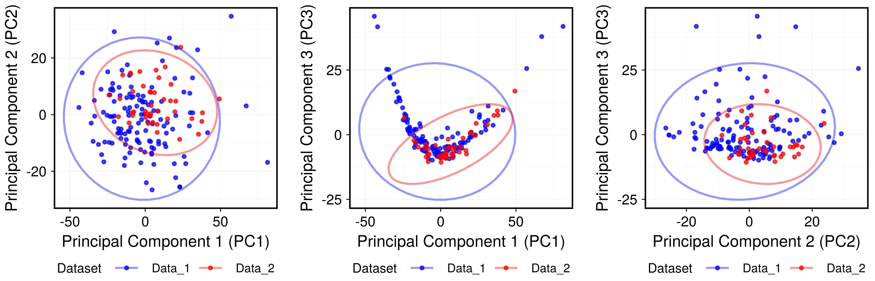
Supplementary Figure S2. Representation of the first three components from principal component analysis (PCA) of PET radiomic features, used to assess congruency of Data1 and Data2. The difference between the datasets was tested using the MANOVA test. Although the p-value was significant (p < 0.05), the partial eta-squared value was 0.04, which is generally considered a small effect. This is especially relevant here, as the PCA plots visually demonstrate consistent overlaps between the datasets.

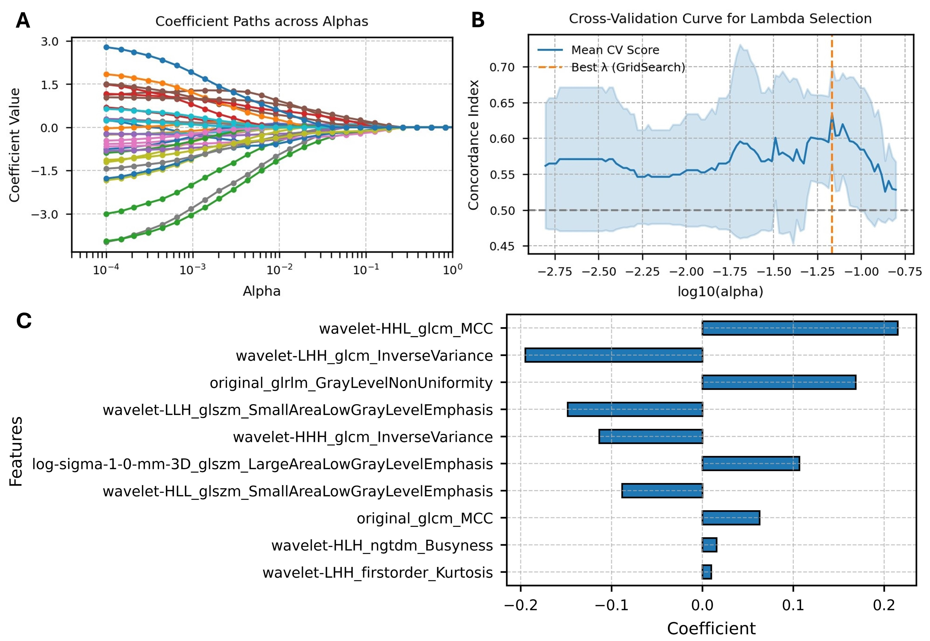
Supplementary Figure S3. (A) Regularization paths of ffeature coefficients across a sequence of λ (lambda) values using Coxnet with LASSO (l1_ratio=0.9). (B) Cross-validation results for selecting the optimal λ in Coxnet LASSO. The mean concordance index (C-index) with standard deviation is plotted against λ on a logarithmic scale. The vertical dashed line indicates the λ value that yielded the highest average performance. (C) Feature coefficients from the best-performing Coxnet LASSO model selected via cross-validation.

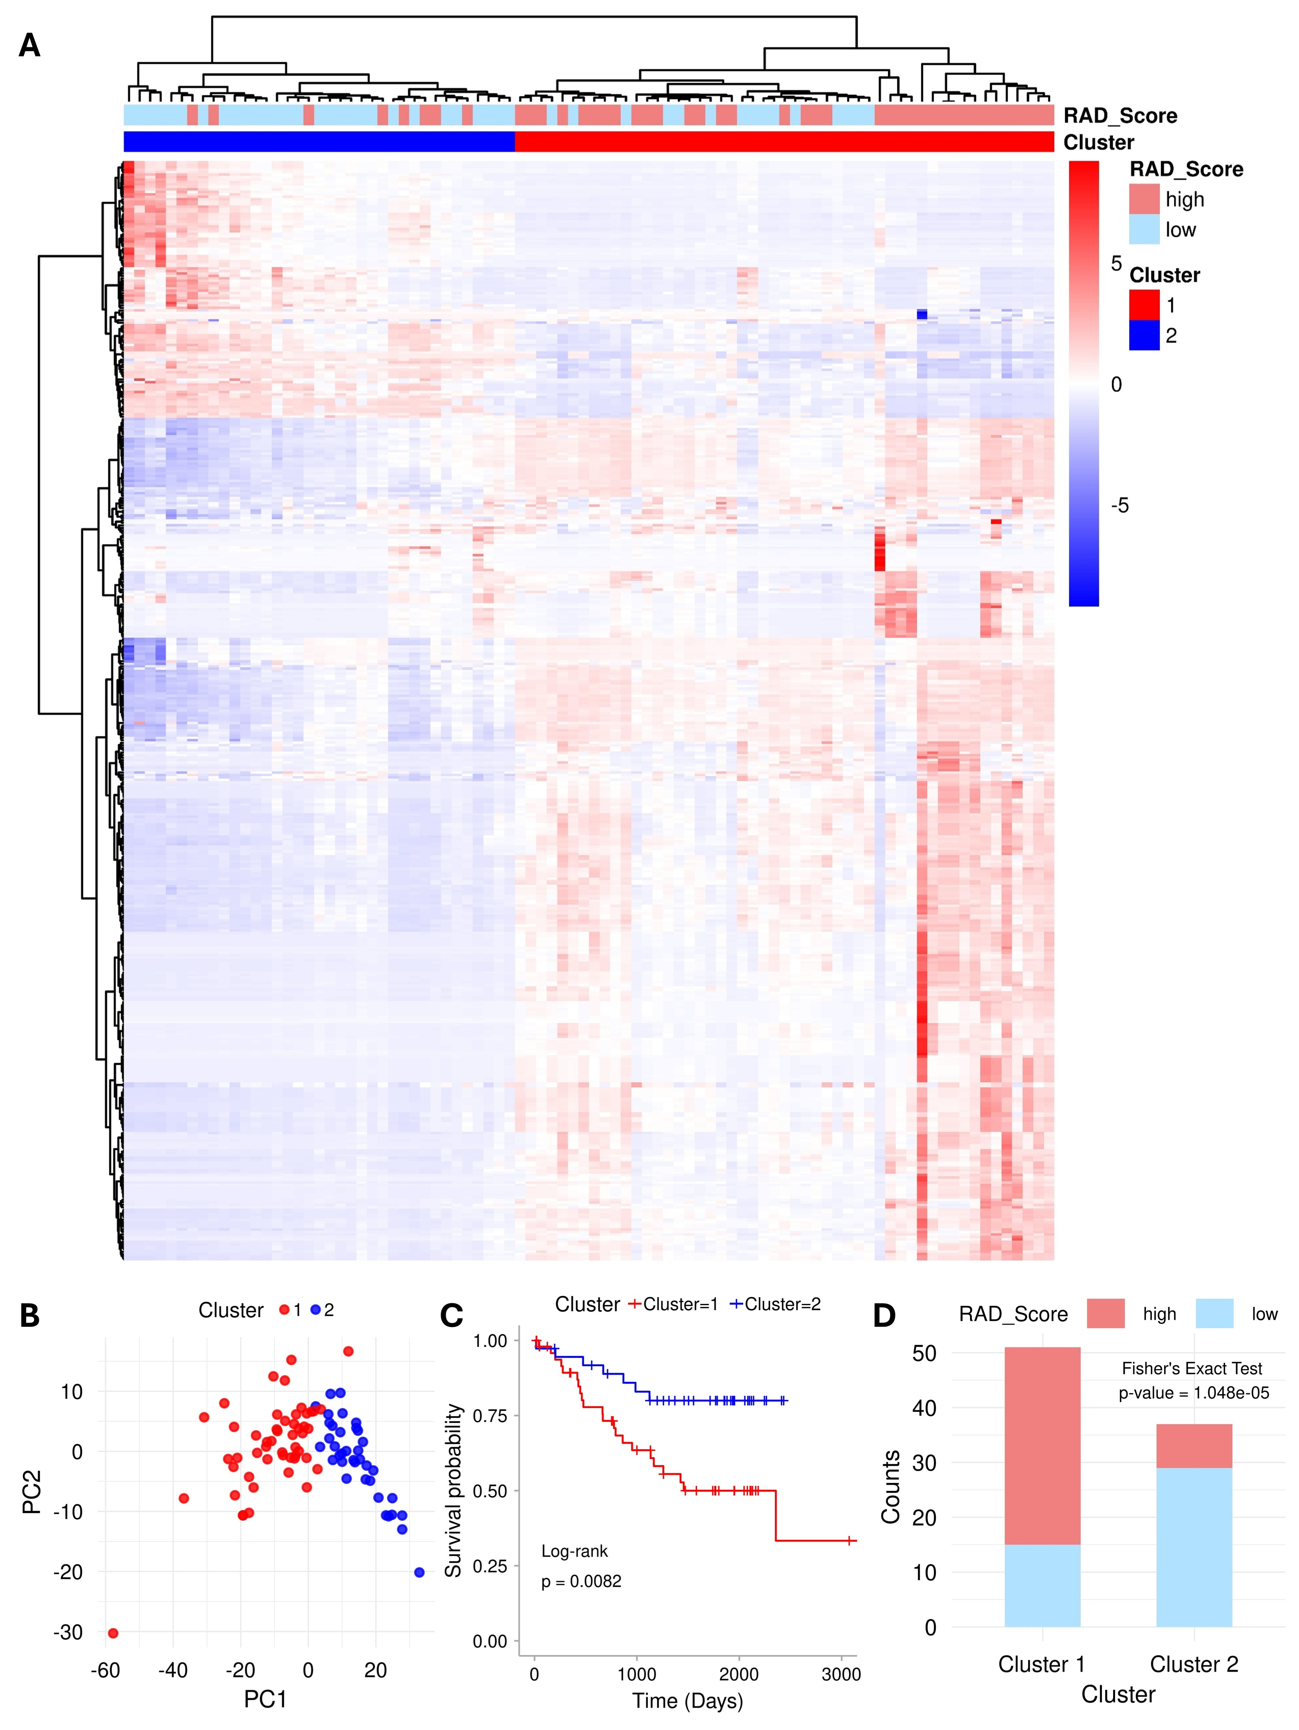

Supplementary Figure S4. Clustering-based analysis of radiomic features. (A) Heatmap showing the unsupervised clustering of patients (columns) based on 445 radiomic features (rows), revealing two distinct clusters. (B) PCA plot illustrates clear separation between the two clusters in component space. (C) KM survival curves demonstrating significantly different overall survival between the identified clusters (log-rank test, p < 0.01). (D) Association between RAD-score–based risk groups and clustering results, assessed using Fisher’s Exact Test (p = 0.00001).
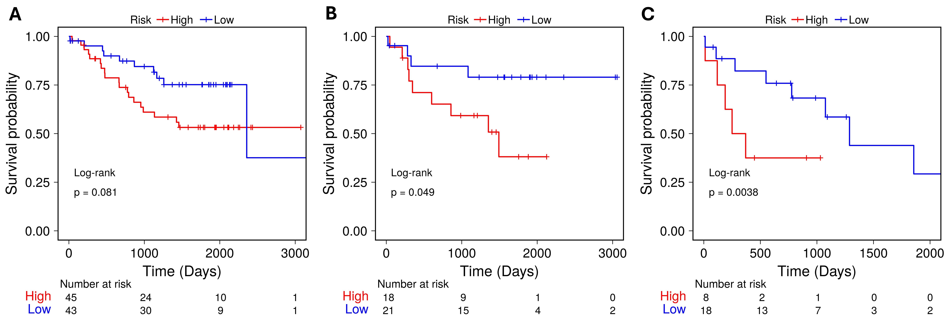
Supplementary Figure S5. Kaplan-Meier (KM) plots of the clinical model in: (A) train, (B) validation, and (C) test data.

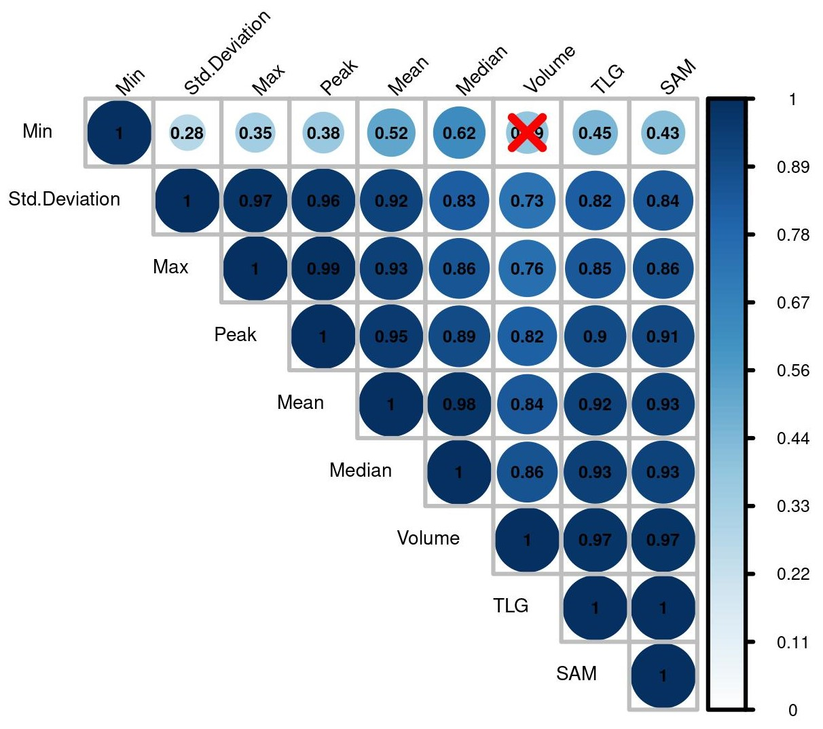
Supplementary Figure S6. Pearson correlation assessment of semiquantitative (SQ) PET features. The red cross mark indicates insignificant correlations.

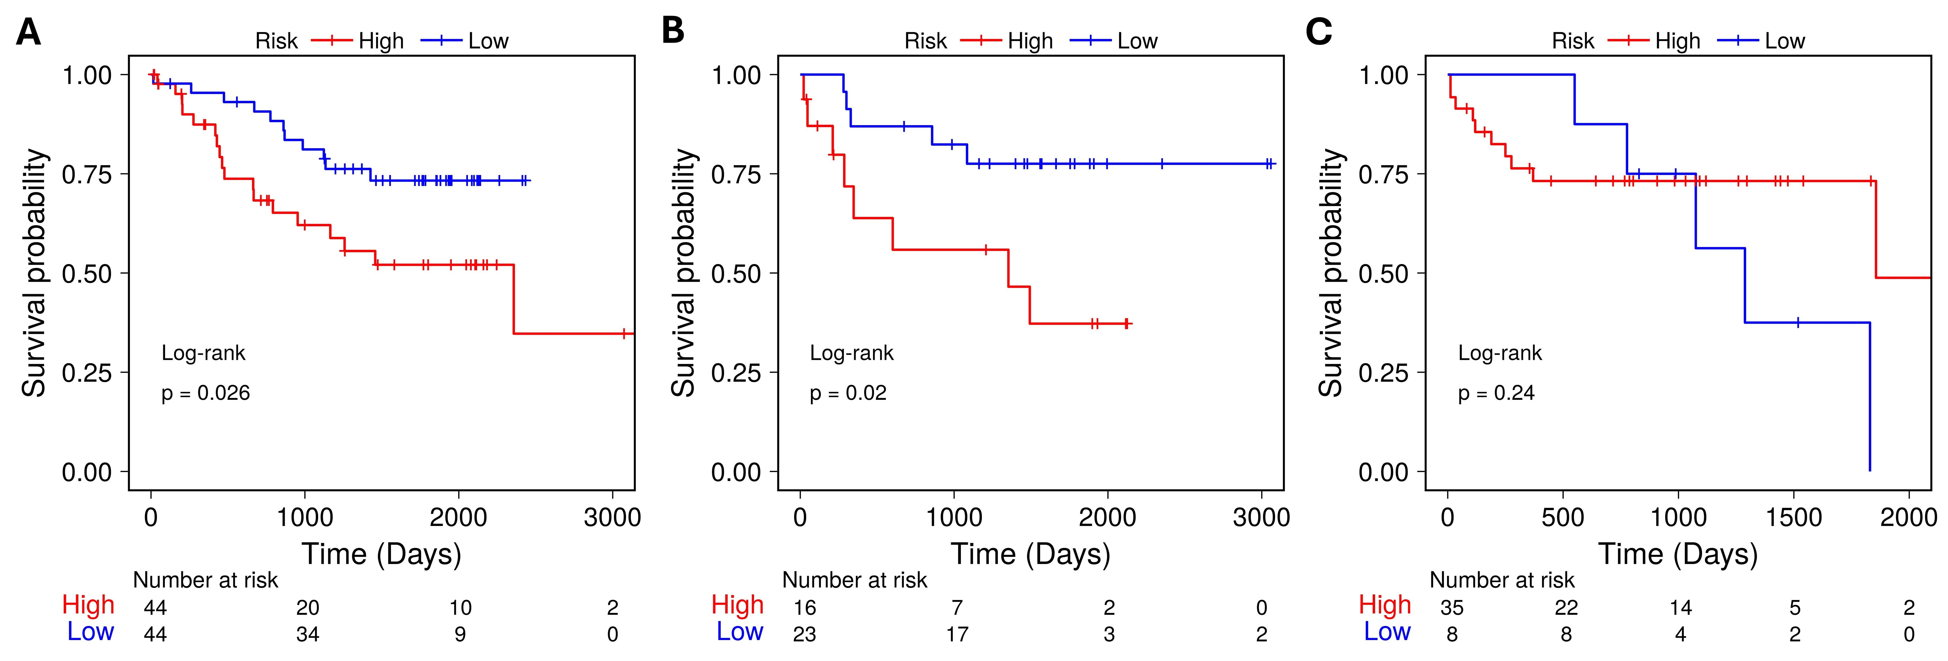
Supplementary Figure 7. Kaplan-Meier (KM) plots of the PET semiquantitative model in: (A) train, (B) validation, and (C) test data. The conventional model included one feature, SUVmax (P-value: 0.160; HR: 1.22; 95%CI: 0.92-1.62).

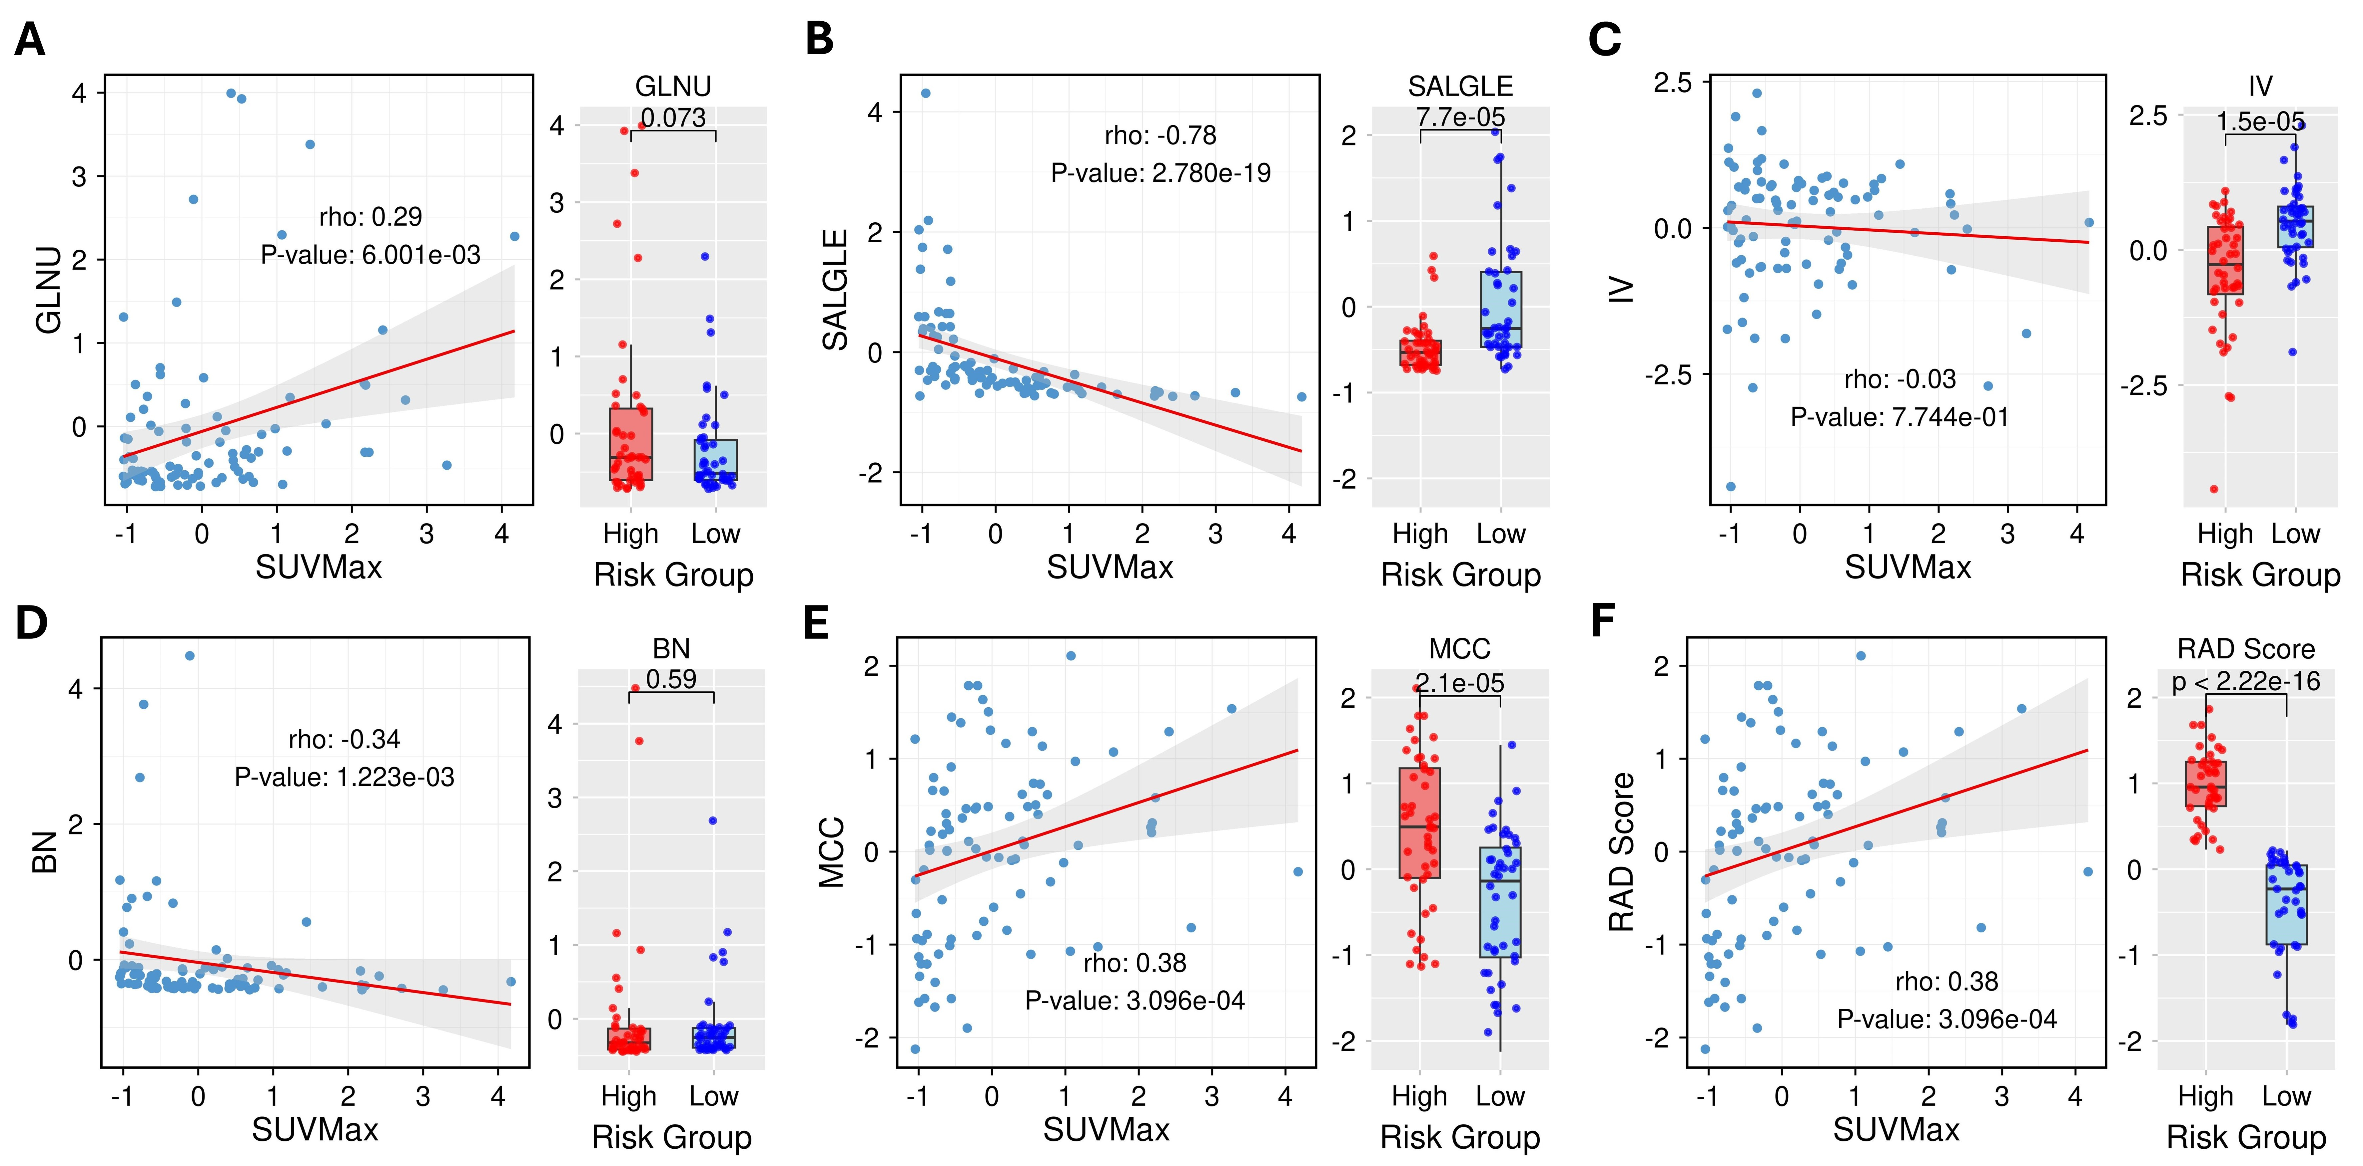
Supplementary Figure S8. Correlation and difference assessments between maximum standardized uptake value (SUV_{max}) or SQ score (
$\text{SQ score}= (\text{SUVmax) }×\left(0.20\right)$) and (A-E) five radiomic features included in the PET radiomic model, as well as (F) the radiomic risk (RAD) score. Difference assessments include comparisons of RAD score and radiomic features between high- and low-risk groups based on the semiquantitative (SQ) score. Radiomic features: original_glrlm_GrayLevelNonUniformity (GLNU), SmallAreaLowGrayLevelEmpasis (SALGLE), Wavelet_LHH_glcm_InverseVariance (IV), wavelet-HLH_ngtdm_Busyness (BN), and wavelet-HHL_glcm_MCC (MCC).

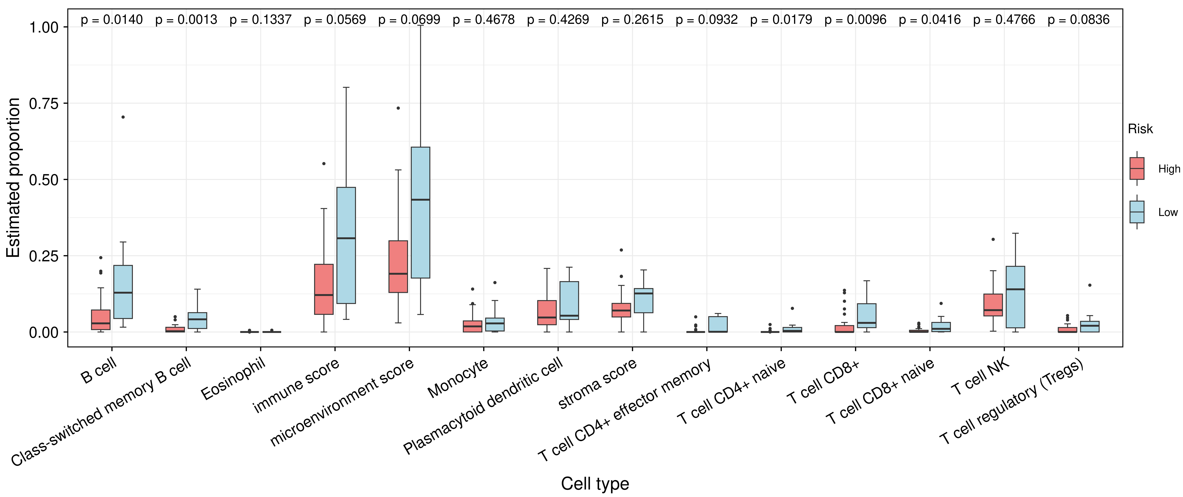
Supplementary Figure S9. Inferred immune cell infiltration levels within the tumor microenvironment across high- and low-risk cohorts as derived from xCell in R. Statistical significance was assessed using Wilcoxon signed-rank test.
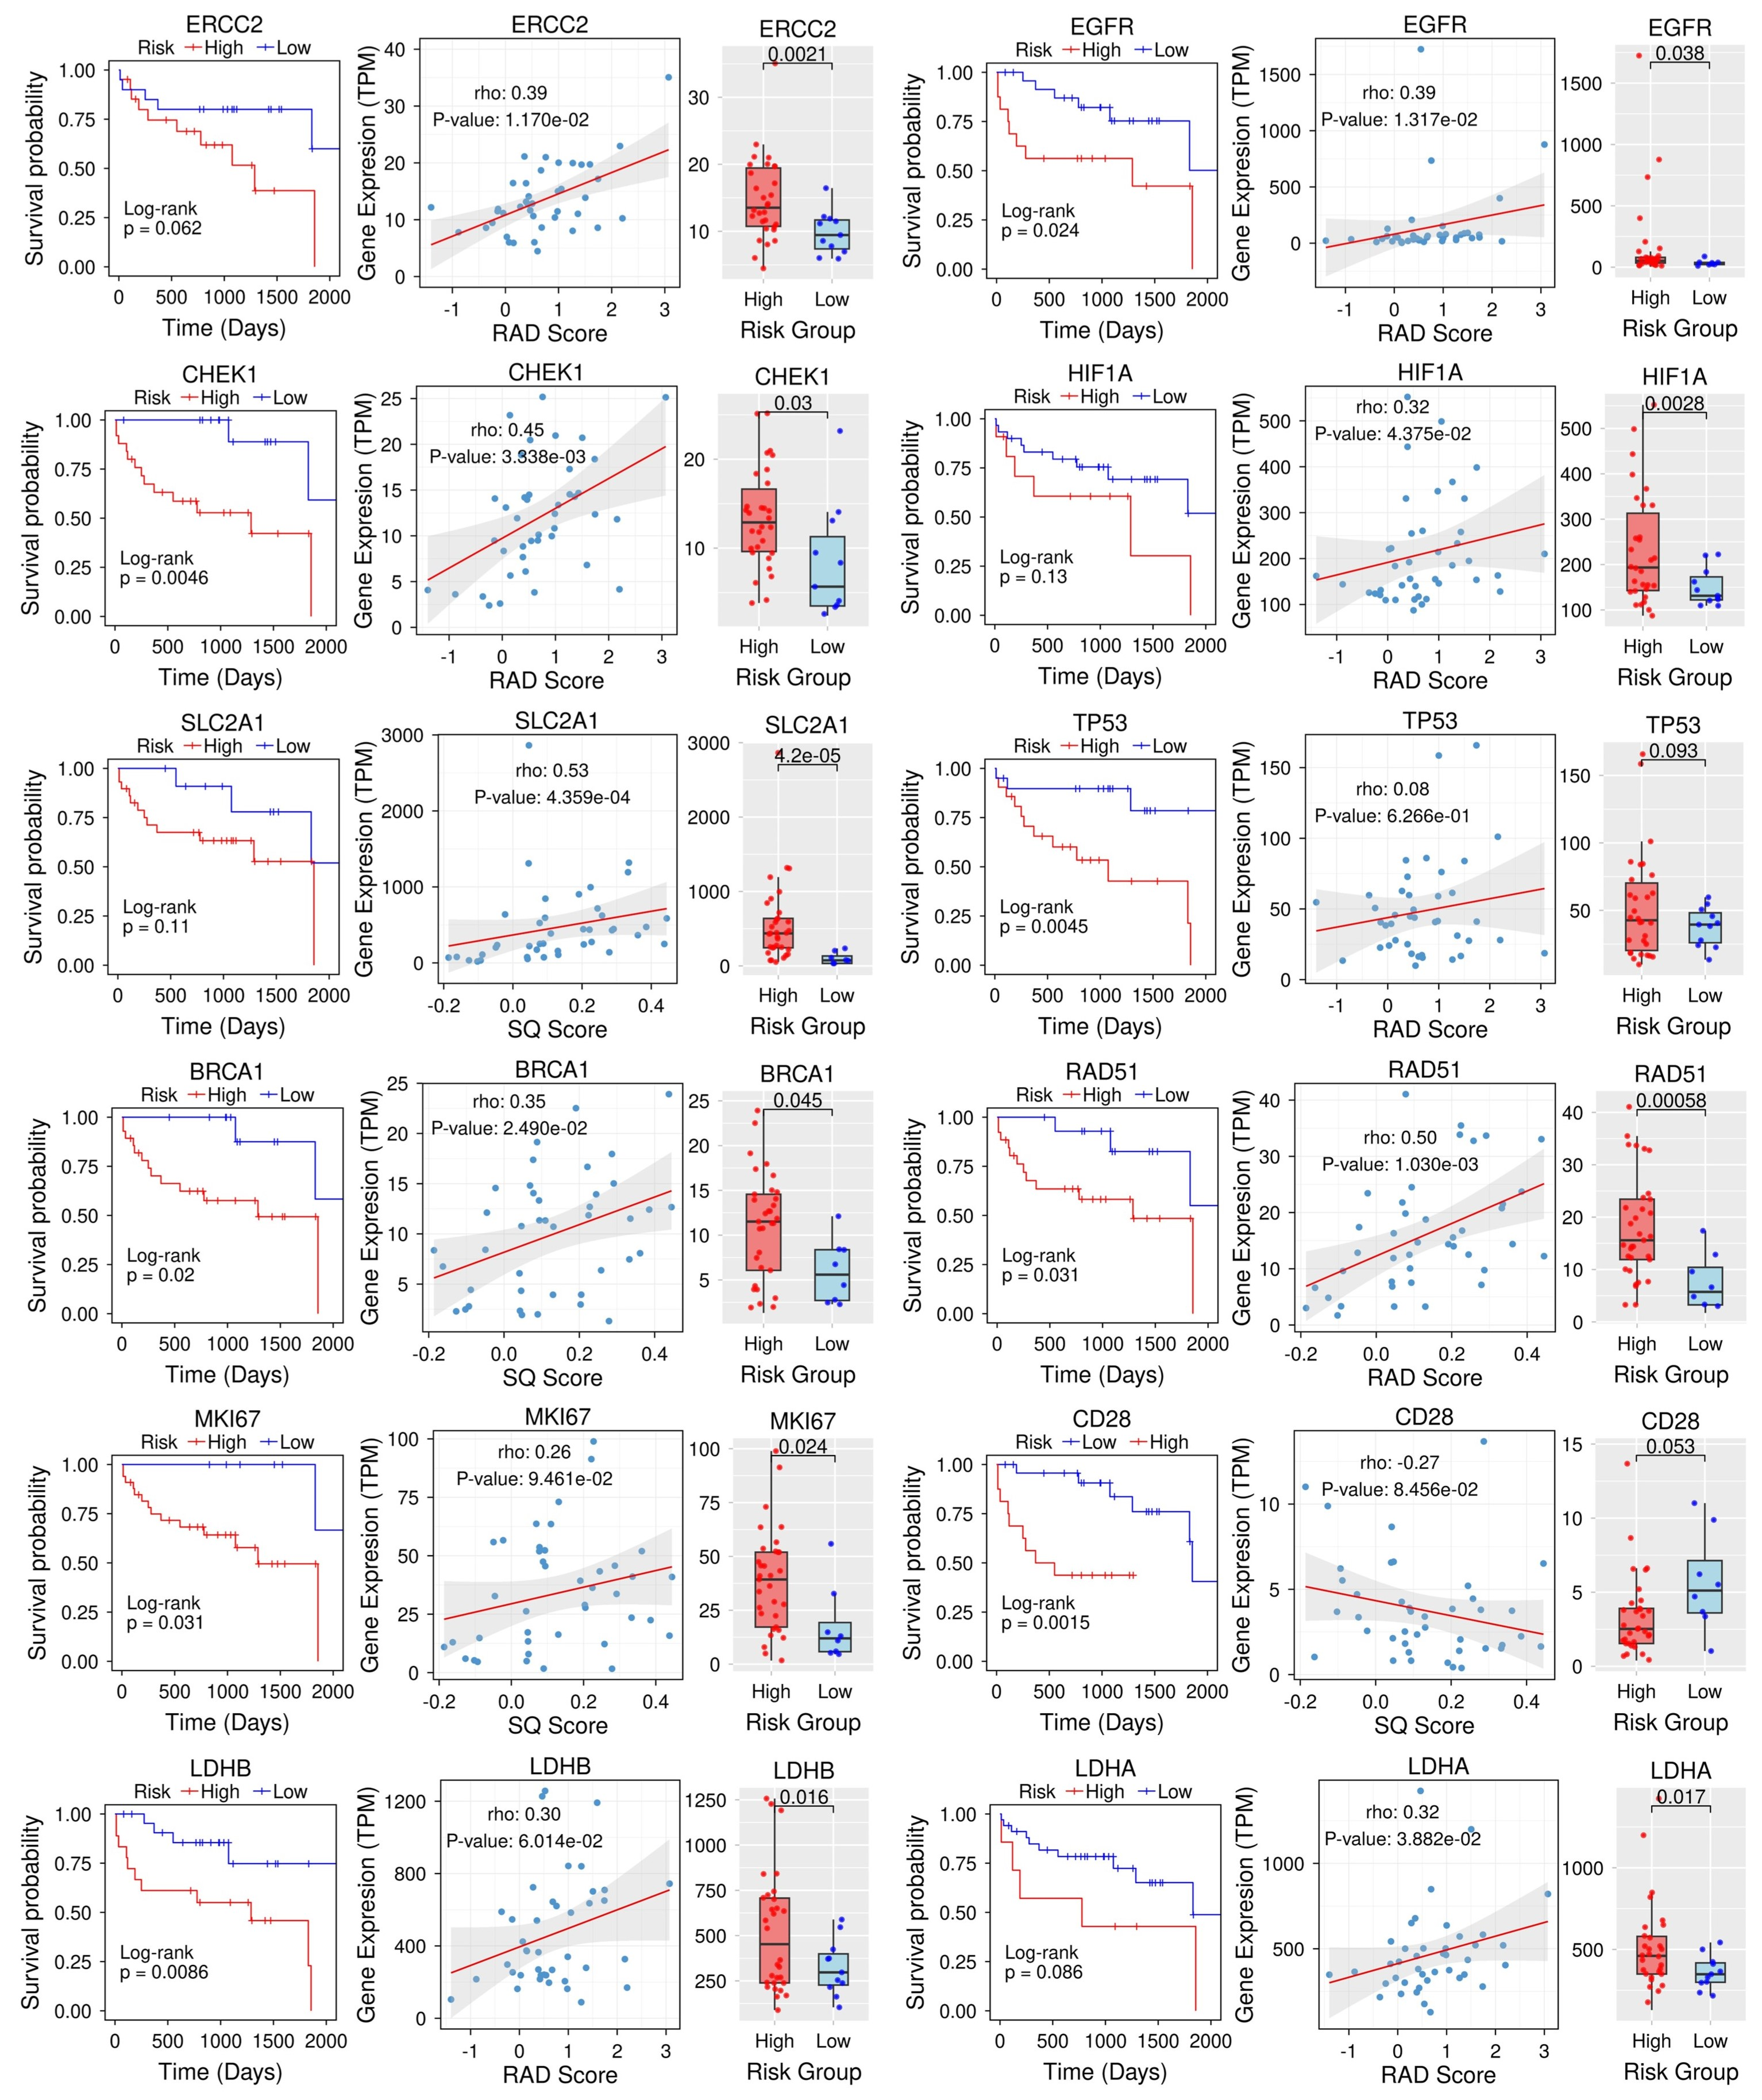
Supplementary Figure S10. Integrated analysis of genes associated with PET radiomic (RAD) and PET semiquantitative (SQ) risk scores in the external validation cohort (TCGA, Data_2). For each gene, (i) correlation analysis was performed to assess the association between gene expression levels and RAD/SQ scores, (ii) differential expression was evaluated between high- and low-risk cohorts (defined by RAD and SQ score thresholds) using the Wilcoxon rank-sum test, and (iii) prognostic significance was determined via Kaplan-Meier (KM) survival analysis stratified by gene expression levels. Genes shown are those significantly associated with at least one metric.

