Supplementary table 1 Change in patients’ management following the ⁶⁸Ga-FAPI-04 PET/CT scan
Impact on management | Patient | Type of cancer | Indication | Extra FAPI PET/CT scan results | Management before FAPI | Management after FAPI
low impact | No.22 | Gastric Ca | Restaging | Recurrent AT | Surgery | Expanded Surgery
medium impact | No.10 | SMC | Initial staging | PM negative | Chemo + Surgery | Surgery
 | No.16 | Gastric Ca | Restaging | extra AP LN | Chemo | Chemo Change
 | No.27 | Colorectal Ca | Restaging | Diffuse PM | Chemo + RT | Chemo Change
 | No.36 | Gastric Ca | Restaging | Diffuse PM | Chemo | Chemo Change
 | No.40 | Gastric Ca | Restaging | Pericardial metastasis | Chemo | Chemo Change
 | No.57 | AC | Initial staging | AP LN | Chemo | Chemo Change
high impact | No.1 | Colorectal Ca | Restaging | Diffuse BM | Chemo + RT | Palliative care
 | No.4 | Colorectal Ca | Restaging | Diffuse PM | Surgery | Palliative care
 | No.5 | Colorectal Ca | Restaging | AP LN + extra AP LN | Surgery | Chemo
 | No.7 | Colorectal Ca | Restaging | Diffuse PM + AP LN | Surgery | Palliative care
 | No.12 | Gastric Ca | Restaging | AP LN + extra AP LN + Diffuse BM | Surveillance | Palliative care
 | No.19 | Gastric Ca | Restaging | AP LN | Surgery | Chemo
 | No.31 | Colorectal Ca | Restaging | Diffuse PM + Recurrent AT | Chemo | Palliative care
 | No.47 | Gastric Ca | Restaging | Diffuse PM | Surgery | Chemo
 | No.54 | Colorectal Ca | Restaging | PM negative | Chemo | Surgery
 | No.56 | Colorectal Ca | Restaging | Isolated PM | Chemo | Surgery
FAPI, Fibroblast-activated protein specific inhibitor; Ca, cancer; AC, appendiceal cancer; SMC: small intestinal cancer；AT, anastomotic tumor; AP, abdominopelvic; LN, lymph nodes; PM, peritoneal metastasis; BM, bone metastasis; RT, radiotherapy
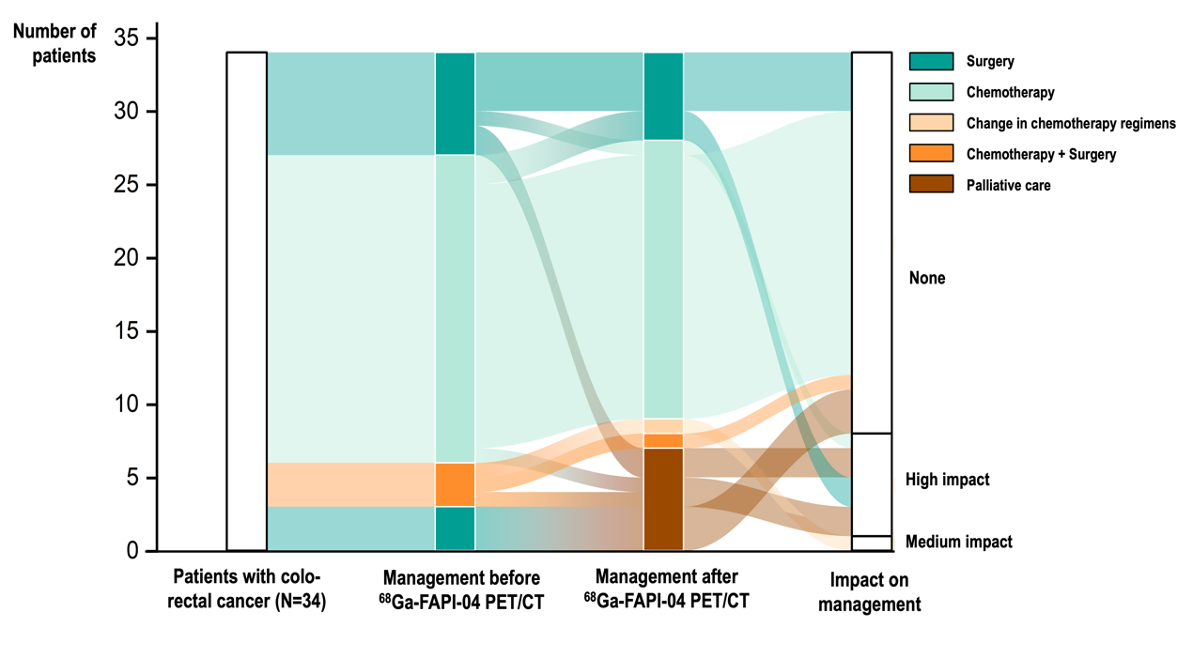Supplementary Fig. 1. Changes in management among patients with colorectal cancer following ⁶⁸Ga-FAPI-04 PET/CT scans (N = 34).
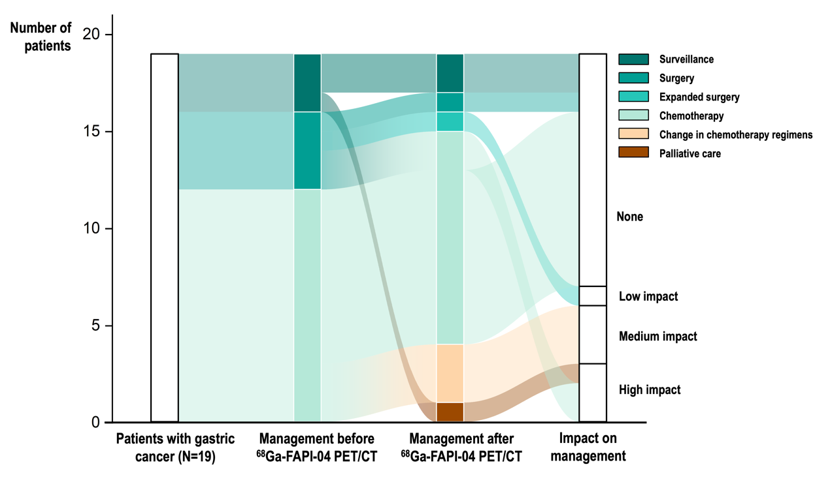Supplementary Fig. 2. Changes in management among patients with gastric cancer following ⁶⁸Ga-FAPI-04 PET/CT scans (N = 19).

