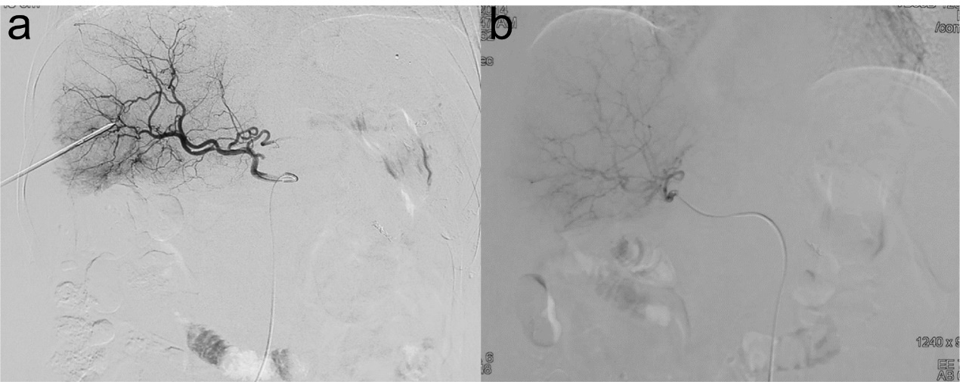

Supplemental figure 1 Comparison of angiography before (a) and after (b) simultaneous ablation of right lobe lesions in an elderly woman with pancreatic neuroendocrine tumor with liver metastasis more than 2 months age

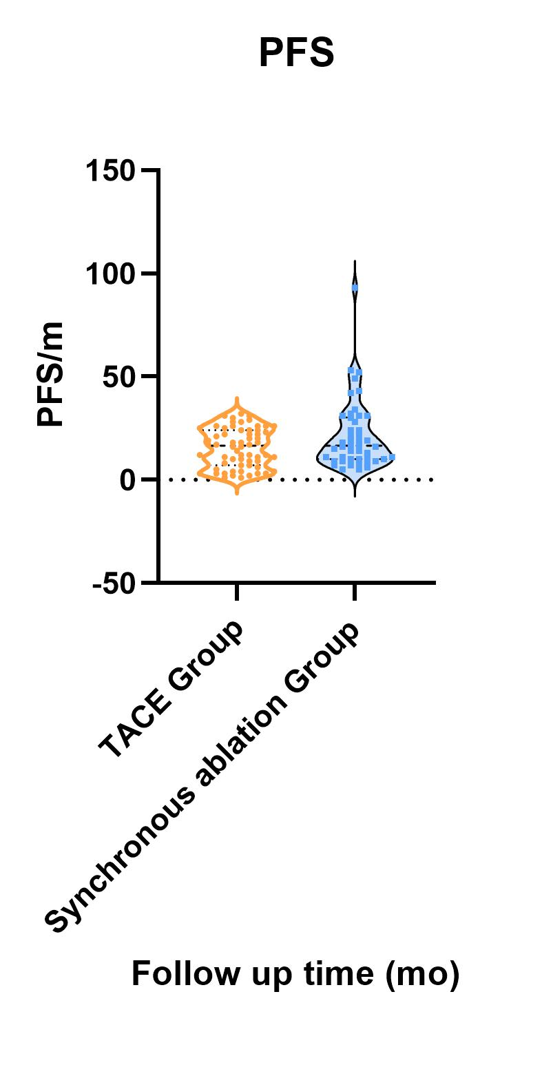

Supplemental figure2.Violin diagram of progression-free survival (PFS) in NET patients

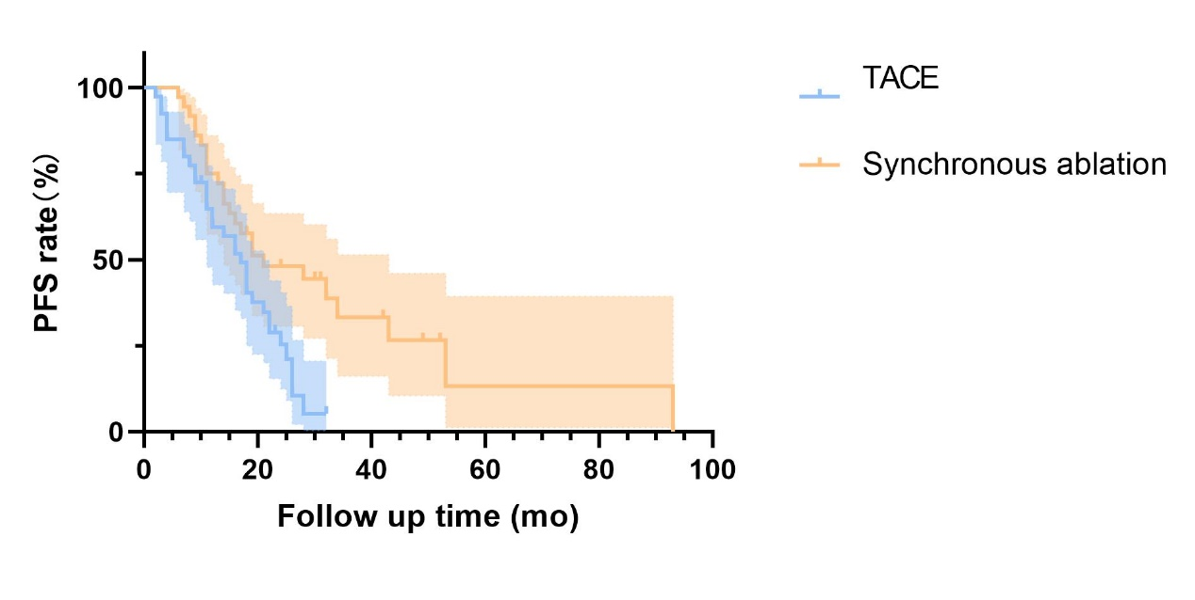
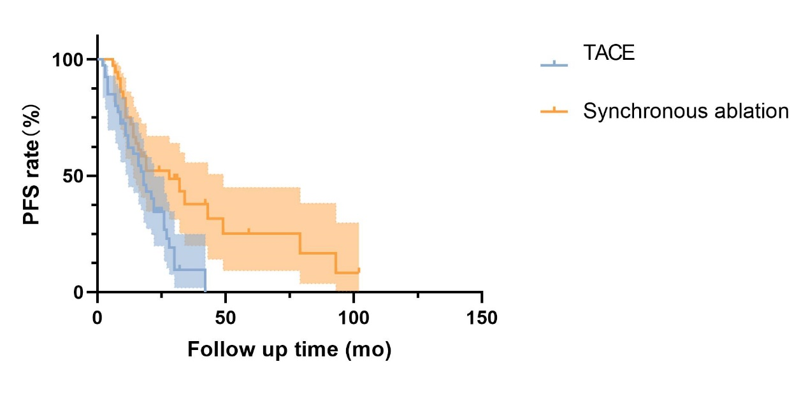 Supplemental figure 3 Kaplan-Meier curves of PFS in WHO G1/2 patients receiving different treatments.

