Title: Prediction Models for Different Types of Leukemia: A Systematic Review and Critical Appraisal
Journal: Journal of Cancer Research and Clinical Oncology
Author name(s): Yingzi Yang^{1,2*}, Ayizhati Tuerxun^{1,2*}, Xinqi Cai^{1,2*}, Xinyu Chen^{1,2}, Zhuoya Zhao^{1,2}, Yang Zhao^{1,2}, Zinuo Lin^{1,2}, Shengfeng Wang^{1,2}
(*These authors contributed equally to this work.)
Author affiliation(s): ¹Department of Epidemiology and Biostatistics, School of Public Health, Peking University, Beijing, China; ²Key Laboratory of Epidemiology of Major Diseases (Peking University), Ministry of Education, Beijing, China
Corresponding Author: Shengfeng Wang, M.D.
Corresponding author email address: shengfeng1984@126.com
ORCID: 0000-0001-9397-0409
Supplementary file (Word):
eTable 1 TRIPOD-SRMA Checklist 3
eTable 2 Key Items for Framing Aim, Search Strategy, and Study Inclusion and Exclusion Criteria for Systematic Review, Following PICOTS Guidance 6
eTable 3 Literature Search Strategy 7
eTable 4 Characteristics of Reviewed Prediction Models of Leukemia 11
eTable 5 Characteristics of the Included Prediction Models 13
eTable 6 Summary of Study Characteristics and Performance Metrics for the Included Prediction Models 20
eTable 7 Prediction Models for Major Leukemia Subtypes with External Validation or Large Development Samples 24
eFig. 1 Risk of Bias for Prediction models of Leukemia (n=148) 27
eFig. 2-1 Risk of Bias for Prediction models of Acute Myeloid Leukemia (n=61) 28
eFig. 2-2 Risk of Bias for Prediction models of Chronic Myeloid Leukemia (n=22) 29
eFig. 2-3 Risk of Bias for Prediction models of Chronic Lymphocytic Leukemia (n=21) 30
eFig. 3-1 Risk of Bias for Signaling Questions of Prediction models of Leukemia (n=148) 31
eFig. 3-2 Risk of Bias for Signaling Questions of Prediction models of Acute Myeloid Leukemia (n=61) 32
eFig. 3-3 Risk of Bias for Signaling Questions of Prediction models of Chronic Myeloid Leukemia (n=22) 33
eFig. 3-4 Risk of Bias for Signaling Questions of Prediction models of Chronic Lymphocytic Leukemia (n=21) 34
Reference 35

eTable 1 TRIPOD-SRMA Checklist
Section and topic | Item  No | Checklist item | Page
Title
Title | 1 | Identify the report as a systematic review or meta-analysis (or both) of diagnostic or prognostic model studies. Specify the target population and outcome(s) predicted as relevant to the review question. | 1
Abstract
Abstract | 2 | See the TRIPOD-SRMA Checklist for Abstracts. | 2
Introduction
Rationale | 3 | Describe the rationale for the review in the context of existing knowledge. | 3-5
Objectives | 4 | Provide an explicit statement of the objective(s) being addressed with reference to: target population, index and comparator models (as relevant), outcome(s), time (prediction horizon and intended moment of using the model), and setting. | 5
Methods
Study eligibility  criteria | 5 | Specify study characteristics used as eligibility criteria, including any prediction models of specific interest, and whether development or validation studies (or both) were eligible. | 6
Information  sources | 6 | Specify all databases, registers, websites, organisations, reference lists and other sources searched or consulted to identify studies. Specify the date when each source was last searched or consulted. | 5-6
Search strategy | 7 | Present the full search strategies for all databases, registers and websites, including any filters and limits used. | 5-6  eTable 3
Study selection  process | 8 | Specify the methods used to decide whether a study met the inclusion criteria of the review, including how many reviewers screened each record and each report retrieved, whether they worked independently, and if applicable, details of automation tools used in the process. | 5-6  eTable 2  Fig. 1
Data collection  process | 9 | Specify the methods used to collect data from study reports, including how many reviewers collected data from each report, whether they worked independently, any processes for obtaining or confirming data from study investigators, and if applicable, details of automation tools used in the process. | 6-7
Data Items | 10a | List and define all items for which data were sought from each study. | 6-7
Data Items | 10b | State the model performance measures that were sought (e.g., measures of calibration, discrimination, overall model fit, clinical utility). | 7
Data Items | 10c | Describe how any desired but unreported data items (items 10a, 10b) were handled (e.g., contacted authors, calculated from other reported information). | 7
Risk of bias and  applicability  assessment | 11 | Specify the methods used to assess risk of bias in the included studies and their applicability to the review question. This should be done separately for each model development and validation. Include details of any tool(s) used, how many reviewers assessed each study and whether they worked independently. | 7
Synthesis  methods | 12a | Describe any methods for synthesising estimates of performance measures for each model. If meta-analysis was carried out, describe the methods used, including any transformations of data prior to pooling, how any heterogeneity in model performance was quantified and handled, and software package(s) used. | 7
Synthesis  methods | 12b | Describe any methods used to explore possible causes of heterogeneity in model performance (e.g., subgroup analysis, meta-regression), including whether or not they were planned. | Not applicable
Synthesis  methods | 12c | Describe any sensitivity analyses conducted to assess robustness of the synthesised results. | Not applicable
Certainty  assessment | 13 | Describe any methods used to assess certainty (or confidence) in the body of evidence for a prediction model. | Not applicable
Results
Study selection | 14 | Describe the results of the search and selection process, from the number of records identified in the search to the number of studies and models included in the review, ideally using a flow diagram. | 8
Study and model characteristics | 15 | Present study characteristics and model details extracted (as per Item 10a), and cite the study reports. | 9-16  eTable 5  eeTable 1
Risk of bias and  applicability | 16 | Present results of risk of bias and applicability assessment. This should be done separately for each model development and validation in each included study. | 17-18  eeTable 6
Results of model  performance in  individual studies | 17 | Present performance estimates and confidence intervals for each model and all evaluations, including whether they relate to the internal or external validation performance. If internal, give details of the method. | 16-17  eeTable 5
Results of syntheses | 18a | Present the results of any synthesis of model performance, together with details of which study estimates contributed. If meta-analysis was carried out, then for each model and performance measure, present summary results, confidence/credible intervals and measures of heterogeneity. Forest plots may be useful. | Not applicable
Results of syntheses | 18b | For each model, present results of all investigations of possible causes of heterogeneity in model performance. | Not applicable
Results of syntheses | 18c | Present results of all sensitivity analyses conducted to assess the robustness of the synthesised results. | Not applicable
Certainty of evidence | 19 | Present any assessments of certainty (or confidence) in the body of evidence for each prediction model of interest. | Not applicable
Discussion
Summary of  evidence | 20 | Summarise the main findings including the strengths and limitations of the evidence. | 18-19
Limitations | 21 | Discuss the strengths and limitations of the review process. | 32-33
Implications | 22 | Discuss implications of the results in the context of other evidence and for practice, policy, and future research. | 25-28
Other information
Registration and  protocol | 23a | Provide registration information for the review, including register name and registration number, or state that the review was not registered. | 5
Registration and  protocol | 23b | Indicate where the review protocol can be accessed, or state that a protocol was not prepared. | 5
Registration and  protocol | 23c | Describe and explain any amendments to information provided at registration or in the protocol. | Not applicable
Support | 24 | Describe sources of financial or non-financial support for the review, and the role of the funders or sponsors in the review. | 40
Competing interests | 25 | Declare any competing interests of review authors. | 40
Availability of  data, code, and  other materials | 26 | Report which of the following are publicly available and where they can be found: template data collection forms; data extracted from included studies; data used for all analyses; analytic code; any other materials used in the review. | 40
This checklist appears in appendix 2 of Snell KIE, Levis B, Damen JAA, et al. Transparent reporting of multivariable prediction models for individual prognosis or diagnosis: checklist for systematic reviews and meta-analyses (TRIPOD-SRMA). BMJ 2023;381:e073538. doi:10.1136/bmj-2022-073538.

eTable 2 Key Items for Framing Aim, Search Strategy, and Study Inclusion and Exclusion Criteria for Systematic Review, Following PICOTS Guidance
Item | Definition
Population | Not limited
Intervention | Any diagnostic or prognostic model to predict any possible diagnostic or clinical outcome in all disease process of leukemia
Control | Not applicable
Outcomes | Any diagnostic or clinical outcome reported by diagnostic or prognostic models
Timing | Not limited
Setting | Inpatient, outpatient or community, etc.

eTable 3 Literature Search Strategy

eTable 3-1 Search strategy in PubMed
Date: 20230807
Steps | Search query | Results
#1 | leukemia* OR leukaemia* OR Leukemia[Mesh] OR Leukemias OR Leucocythaemia OR Leucocythaemias OR Leucocythemia OR Leucocythemias(1-3) | 377,857
#2 | "predictive model*"[Title/Abstract] or "prediction model*"[Title/Abstract] or "predictive rule*"[Title/Abstract] or "prediction rule*"[Title/Abstract] or "predictive equation"[Title/Abstract] or "prediction equation"[Title/Abstract] or "prediction system"[Title/Abstract] or "mathematical model*"[Title/Abstract] or "diagnostic model*"[Title/Abstract] or "prognostic model*"[Title/Abstract](4) | 146,062
#3 | "risk score*"[Title/Abstract] or "risk model*"[Title/Abstract] or "risk prediction"[Title/Abstract] or "risk calculator"[Title/Abstract] or "risk index"[Title/Abstract] or "decision model*"[Title/Abstract] or "decision rule"[Title/Abstract] or "decision curve"[Title/Abstract](5) | 76,294
#4 | "nomogram"[Title/Abstract] or "scoring system"[Title/Abstract] or "discrimination"[Title/Abstract] or "calibration"[Title/Abstract](6) | 276,725
#5 | #2 OR #3 OR #4 | 460,433
#6 | #1 AND #5 | 3,750
#7 | #1 AND #5 AND (humans[Filter]) | 3,134

eTable 3-2 Search strategy in Embase
Date: 20230807
Steps | Search query | Results
#1 | leukemia* OR leukaemia* OR Leukemia OR Leukemias OR Leucocythaemia OR Leucocythaemias OR Leucocythemia OR Leucocythemias:ab,kw,ti | 589,114
#2 | 'predictive model*' OR 'prediction model*' OR 'predictive rule*' OR 'prediction rule*' OR 'predictive equation'/exp OR 'predictive equation' OR 'prediction equation' OR 'prediction system' OR 'mathematical model*' OR 'diagnostic model*' OR 'prognostic model*':ab,kw,ti | 289,811
#3 | 'risk score*' OR 'risk model*' OR 'risk prediction'/exp OR 'risk prediction' OR 'risk calculator'/exp OR 'risk calculator' OR 'risk index'/exp OR 'risk index' OR 'decision model*' OR 'decision rule' OR 'decision curve':ab,kw,ti | 127,055
#4 | 'nomogram'/exp OR 'nomogram' OR 'scoring system'/exp OR 'scoring system' OR 'discrimination'/exp OR 'discrimination' OR 'calibration':ab,kw,ti | 683,628
#5 | #2 OR #3 OR #4 | 1,030,992
#6 | #1 AND #5 | 12,197
#7 | #6 AND 'human'/de | 11,178

eTable 3-3 Search strategy in Cochrane library
Date: 20230807
Steps | Search query | Results
#1 | (Leukemia):ti,ab,kw | 16,267
#2 | leukemia* or leukaemia* OR Leukemia OR Leukemias OR Leucocythaemia OR Leucocythaemias OR Leucocythemia OR Leucocythemias | 17,495
#3 | (predictive model*):ti,ab,kw OR (prediction model*):ti,ab,kw OR (predictive rule*):ti,ab,kw OR (prediction rule*):ti,ab,kw OR (predictive equation):ti,ab,kw | 28,988
#4 | (prediction equation):ti,ab,kw OR (prediction system):ti,ab,kw OR (mathematical model*):ti,ab,kw OR (diagnostic model*):ti,ab,kw OR (prognostic model*):ti,ab,kw | 33,265
#5 | (risk score*):ti,ab,kw OR (risk model*):ti,ab,kw OR (risk prediction):ti,ab,kw OR (risk calculator):ti,ab,kw OR (risk index):ti,ab,kw | 150,820
#6 | (decision model*):ti,ab,kw OR (decision rule):ti,ab,kw OR (decision curve):ti,ab,kw OR (nomogram):ti,ab,kw OR (scoring system):ti,ab,kw | 76,094
#7 | (discrimination):ti,ab,kw OR (calibration):ti,ab,kw | 17,618
#8 | #1 OR #2 | 17,495
#9 | #3 OR #4 OR #5 OR #6 OR #7 | 250,550
#10 | #8 AND #9 in Trials | 2836
#11 | #8 AND #9 AND Humans in Trials | 2414

eTable 3-4 Search strategy in Web of science
Date: 20230807
Steps | Search query | Results
#1 | TS=(leukemia* OR leukaemia* OR Leukemia OR Leukemias OR Leucocythaemia OR Leucocythaemias OR Leucocythemia OR Leucocythemias) | 401,133
#2 | TS=("predictive model*" or "prediction model*" or "predictive rule*" or "prediction rule*" or "predictive equation" or "prediction equation" or "prediction system" or "mathematical model*" or "diagnostic model*" or "prognostic model*") | 503,005
#3 | TS=("risk score*" or "risk model*" or "risk prediction" or "risk calculator" or "risk index" or "decision model*" or "decision rule" or "decision curve") | 122,929
#4 | ((TI=("nomogram" or "scoring system" or "discrimination" or "calibration")) OR AB=("nomogram" or "scoring system" or "discrimination" or "calibration")) | 588,041
#5 | #4 OR #3 OR #2 | 1,164,919
#6 | #1 AND #5 | 4,855
#7 | #6 NOT TS=(mice or mouse) | 4,698

eTable 4 Characteristics of Reviewed Prediction Models of Leukemia
 | No (%) or M (IQR)
Country
United States | 37(25.0)
China | 34(23.0)
Germany | 17(11.5)
Spain | 11(7.4)
France | 7(4.6)
Italy | 7(4.6)
Japan | 6(4.1)
Korea | 6(4.1)
Israel | 4(2.7)
India | 3(2.0)
Netherlands | 2(1.4)
Switzerland | 2(1.4)
United Kingdom | 2(1.4)
Others | 10(6.8)
Publication year
2023 | 8(5.4)
2022 | 29(19.6)
2021 | 11(7.4)
2020 | 9(6.1)
2019 | 11(7.4)
1980-2018 | 80(54.1)
Type of model
Prognostic model | 142(95.9)
Diagnostic model | 6(4.1)
Type of prediction model study
Development only | 85(57.4)
Development and external validation | 59(39.9)
External validation only | 4(2.7)
Study design
Cohort study | 142(95.9)
Case-control study | 5(3.4)
Randomized controlled trial | 1(0.7)
Sample sizeª
development | 412(213-909)
No of events (development) | 100(46-287)
external validation | 306(131-680)
No of events (external validation) | 160.5(29-355)
Target setting
Inpatients | 147(99.3)
Community | 1(0.7)
Outpatient | 0(0.0)
Target population
AML | 61(41.2)
CML | 22(14.9)
CLL | 21(14.2)
ALL | 18(12.2)
AL | 11(7.3)
Leukemia | 4(2.7)
AML and ALL | 3(2.0)
APL | 3(2.0)
Others^{b} | 5(3.5)
Prediction outcome
Survival | 100(67.6)
Diagnosis | 12(8.1)
Death | 8(5.4)
Remission | 5(3.4)
Time to First Treatment | 5(3.4)
Infection | 4(2.7)
Others^{c} | 14(9.4)
a A total of 147, 67, 51 and 20 models were included in the calculation of each sample size, respectively, because 1, 81, 97 and 128 models could not be calculated or lack of information.
b Others included MDS (n=2), AML, ALL and MDS (n=1), AML, ALL and healthy (n=1).
c Others included bleeding (n=2), GVHD (n=2), tumor lysis syndrome (n=2), other complications (n=8).
Abbreviations: AML, acute myeloid leukemia; CLL, chronic lymphocytic leukemia; CML, chronic myelogenous leukemia; ALL, acute lymphocytic leukemia; AL, acute leukemia; APL, acute promyelocytic leukemia; MDS, myelodysplastic syndromes; GVHD, graft-versus-host disease.

eTable 5 Characteristics of the Included Prediction Models
First author | Country | Year | Setting | Population | Outcome(time horizon) | Sample size  (development) | No of events  (development) | Sample size  (external validation) | No of events  (external validation) | Type of prediction model study | Type of model
Tomoyasu Jo(7) | Japan | 2022 | inpatients | ALL | CE2 for CD3+ | 108 | NI | NI | NI | D | prognostic
Meng-Zhu Shen(8) | China | 2022 | inpatients | AL | GVHD | 470 | 33 | NI | NI | D | prognostic
Adrienne A. Phillips(9) | USA | 2010 | inpatient,  outpatient  and database | ALL | 300-week survival | 89 | 1 | NI | NI | D | prognostic
Armin Rashidi(10) | USA | 2014 | inpatients | AML | 60-month survival | 118 | 3 | NI | NI | D | prognostic
Jie Liu(11) | China | 2022 | inpatients | Leukemia | cell types | 4451 | 2 | NI | NI | D | diagnostic
Laura Boldú(12) | Spain | 2021 | inpatients | AL | diagnosis | 16450 | 12407 | 381 | NI | D,V | diagnostic
Stefano Molica(13) | Italy | 2005 | inpatients | CLL | 120-month  survival | 1138 | NI | NI | NI | D | prognostic
Jared A. Cohen(14) | Italy | 2020 | inpatients | CLL | survival | 478 | NI | 1401 | NI | D,V | prognostic
Theis H. Terwey(15) | Germany | 2010 | inpatients | ALL | 1/2/5-year survival | 151 | NI | NI | NI | V | prognostic
Philipp G. Hemmati(16) | Germany | 2011 | inpatients | AML | 1/3/5-year survival | 214 | NI | NI | NI | V | prognostic
Michael Lauseker(17) | Germany | 2014 | inpatients | CML | 5-year remission | 1271 | NI | NI | NI | D | prognostic
Hossein Bonakchi(18) | Iran | 2022 | inpatients | ALL | 5-year survival | 393 | NI | NI | NI | D | prognostic
Istemi Serin(19) | Turkey | 2022 | inpatients | AML | 5-year survival | 158 | NI | NI | NI | V | prognostic
P Chevallier(20) | France | 2011 | inpatients | AML | 2-year survival | 138 | NI | NI | NI | D | prognostic
TORSTEN HAFERLACH(21) | Germany | 2004 | inpatients | AML | 3-year survival | 321 | 233 | 680 | 374 | D,V | prognostic
Joerg Hasford(22) | Germany | 1998 | inpatients | CML | 10-year survival | 981 | NI | 1303 | NI | D,V | prognostic
Yun-yan He(23) | China | 2022 | inpatients | ALL | 1/2/3-year survival | 1187 | NI | 506 | NI | D | prognostic
Hajime Senjo(24) | Japan | 2020 | inpatients | AML | 2-year survival | 174 | NI | NI | NI | V | prognostic
Christoph Rollig(25) | Germany | 2010 | inpatients | AML | 3-year survival | 909 | NI | NI | NI | D,V | prognostic
Qian Zhang(26) | China | 2023 | inpatients | ALL | 3-year survival | 324 | NI | NI | NI | D | prognostic
Xiaoming Liu(27) | China | 2022 | inpatients | ALL | 80-month survival | 90 | NI | NI | NI | D | prognostic
Xiao-Lin Yuan(28) | China | 2023 | inpatients | AML | 1-year diagnosis | 414 | 93 | 110 | NI | D,V | prognostic
Meng-Zhu Shen(29) | China | 2022 | inpatients | AL | 100-day or 1-year infection | 289 | NI | NI | NI | D | prognostic
Shay Perek(30) | Israel | 2022 | inpatients | AML | 1-year diagnosis | 632 | 64 | NI | NI | D | prognostic
Dae-Young Kim(31) | Korea | 2011 | inpatients | AML | 5-year survival | 142 | 91 | NI | NI | D | prognostic
Anthony R. Mato(32) | USA | 2006 | inpatients | AML | 8-day TLS | 194 | 19 | NI | NI | D | prognostic
Xiao-Shuai Zhang(33) | China | 2022 | inpatients | CML | 1/3/5-year survival | 1364 | NI | NI | NI | D | prognostic
Min Yang(34) | China | 2021 | inpatients | AML | 3-year survival | 254 | NI | 75 | NI | D,V | prognostic
M. J. KEATING(35) | USA | 1982 | inpatients | AL | survival | 325 | 100 | NI | NI | D | prognostic
Yigang Tang(36) | China | 2022 | inpatients | AML | 1/3/5-year survival | 417 | NI | 653 | NI | D,V | prognostic
Juan M. Bergua(37) | Spain | 2016 | inpatients | AML | 5-year survival | 259 | NI | NI | NI | D | prognostic
Francis J. Giles(38) | USA | 2003 | inpatients | CLL | 6/12/18-month survival | 90 | NI | NI | NI | D | prognostic
Alfonso Quintás-Cardama(39) | USA | 2014 | inpatients | MDS | 1-year survival | 1436 | NI | NI | NI | D | prognostic
Philippe Armand(40) | USA | 2008 | inpatients | AML, ALL  and MDS | 5-year survival | 445 | NI | NI | NI | D | prognostic
Nico Gagelmann(41) | France | 2021 | inpatients | CML | 5-year survival | 240 | NI | NI | NI | D | prognostic
Anjali Advani(42) | USA | 2009 | inpatients | ALL | 1/2/5-year survival | 77 | NI | NI | NI | D | prognostic
Albin Österroos(43) | Sweden | 2022 | inpatients | AML | 30-day death | 301 | 59 | 129 | 24 | D,V | prognostic
Le-Qing Cao(44) | China | 2021 | inpatients | ALL | 5-year diagnosis | 477 | NI | NI | NI | D | prognostic
M. K. PALMER(45) | USA | 1980 | inpatients | ALL | 5-year remission | 209 | NI | NI | NI | D | prognostic
Emilie Bérard(46) | France | 2022 | inpatients | AML | 5-year survival | 636 | NI | 563 | NI | D,V | prognostic
David Valcarcel(47) | Spain | 2012 | inpatients | AML | 42-day death | 570 | 63 | 209 | 37 | D,V | prognostic
Michele Malagola(48) | Italy | 2011 | inpatients | AML | 5-year survival | 337 | NI | 193 | NI | D,V | prognostic
Emma J. Verwaaijen(49) | Netherlands | 2021 | inpatients | ALL | 1-year bone  fragility | 249 | 60 | 99 | 27 | D,V | prognostic
Paola Lecca(50) | Italy | 2016 | database | CML | lifetime diagnosis | NI | NI | NI | NI | D,V | prognostic
Marta Solans(51) | Spain | 2018 | inpatients | CLL | diagnosis | 1974 | 369 | NI | NI | D | prognostic
Ping Cai(52) | China | 2020 | inpatients | APL | 30-day death | 570 | 43 | NI | NI | D | prognostic
Pradeep Kumar Das(53) | India | 2022 | inpatients | AML, ALL  and healthy | diagnosis | 448 | 219 | 300 | 150 | D,V | diagnostic
Roni Shouval(54) | Israel | 2017 | inpatients | AL | 2-year survival | 3140 | NI | NI | NI | D | prognostic
The International  CLL-IPI working group(55) | Germany | 2016 | inpatients | CLL | 5-year survival | 3472 | 462 | 1254 | NI | D,V | prognostic
MM Patnaik(56) | France | 2014 | inpatients | CML | 200-month survival | 466 | NI | NI | NI | D | prognostic
Govind Babu Kanakaset(57) | India | 2017 | inpatients | CML | 5-year survival | 371 | NI | NI | NI | D | prognostic
Jingjing Pan(58) | China | 2022 | inpatients | AML | 1/3/5-year survival | 151 | NI | 1054 | NI | D,V | prognostic
Tycho Baumann(59) | Spain | 2014 | inpatients | CLL | survival | 949 | NI | NI | NI | D | prognostic
Heng Li(60) | China | 2017 | inpatients | CLL | TTFT | 406 | NI | NI | NI | D | prognostic
Jose F. Falantes(61) | Spain | 2013 | inpatients | AML | 2-year survival | 332 | 100 | NI | NI | D | prognostic
Friederike Pastore(62) | Germany | 2014 | inpatients | AML | 5-year survival | 669 | NI | 529 | NI | D,V | prognostic
Mohamed L. Sorror(63) | USA | 2007 | inpatients | AML | 2-year survival | 577 | NI | NI | NI | D | prognostic
Utz Krug(64) | Germany | 2010 | inpatients | AML | 60-day death | 1406 | 332 | 801 | 171 | D,V | prognostic
Fan Zhou(65) | China | 2019 | inpatients | AML | 1-year survival | 170 | NI | NI | NI | D | prognostic
Fu Li(66) | China | 2022 | inpatients | AML | survival | 97 | NI | 306 | NI | D,V | prognostic
Celalettin Ustun(67) | USA | 2018 | inpatients | AML | 2-year survival | 247 | 89 | NI | NI | D | prognostic
Piyanuch Kongtim(68) | USA | 2019 | inpatients | AML | survival | 944 | NI | NI | NI | D | prognostic
Ting-Ting Ma(69) | China | 2020 | inpatients | AML | 1/2/3-year survival | 412 | NI | 238 | NI | D,V | prognostic
Jun Li(70) | China | 2022 | inpatients | AML | survival | 597 | NI | 189 | NI | D,V | prognostic
Esperanza Such(71) | Spain | 2013 | inpatients | CML | survival | 558 | NI | 274 | NI | D,V | prognostic
Cong Wei(72) | China | 2022 | inpatients | AML | 5-year survival | 221 | NI | 579 | NI | D,V | prognostic
Pau Montesinos(73) | Spain | 2006 | inpatients | AML | 3-day TLS | 614 | 101 | NI | NI | D | prognostic
Yingmei Zhang(74) | China | 2018 | inpatients | APL | 30-day death | 275 | 58 | 89 | 12 | D,V | prognostic
Yinjun Lou(75) | China | 2017 | inpatients | APL | 30-day death | 526 | 38 | NI | NI | D | prognostic
Ling Ma(76) | China | 2023 | inpatients | ALL | 5-year survival | 1460 | NI | NI | NI | D | prognostic
Florian Huemer(77) | Austria | 2018 | inpatients | CML | TTFT | 55 | NI | 65 | NI | D,V | prognostic
Jinman Zhong(78) | China | 2021 | inpatients | AML | 1/3/5-year survival | 293 | NI | 307 | NI | D,V | prognostic
Ljubomir Buturovic(79) | USA | 2018 | inpatients | AML and ALL | 5-year survival | 733 | 287 | 522 | NI | D,V | prognostic
SUNG J. CHUNGG(80) | USA | 1991 | inpatients | AML | survival | 33 | NI | NI | NI | D | prognostic
Hangseok Choi(81) | Korea | 2013 | inpatients | AML | survival | 118 | NI | NI | NI | D,V | prognostic
Silvia Park(82) | Korea | 2018 | inpatients | AML | survival | 104 | 45 | NI | NI | D | prognostic
Jinghua Wang(83) | China | 2022 | inpatients | AML | 1/3/5-year survival | 151 | NI | 259 | NI | D,V | prognostic
Jingxian Gu(84) | China | 2022 | inpatients | ALL | 28-day remission | 286 | NI | NI | NI | D | prognostic
Jian-Ying Zhou(85) | China | 2023 | inpatients | CML | 3-year survival | 119 | NI | 99 | NI | D,V | prognostic
Roni Shouval(86) | Israel | 2019 | inpatients | AML | 1/3/5-year survival | 956 | NI | NI | NI | D | prognostic
Frederik Damm(87) | Germany | 2011 | inpatients | AML | survival | 275 | NI | 131 | NI | D,V | prognostic
Adalgisa Condoluci(88) | Switzerland | 2020 | inpatients | CLL | 1/5-year TTFT | 333 | NI | NI | NI | D,V | prognostic
Blanca Molina(89) | Spain | 2019 | inpatients | Leukemia | 3-month diagnosis | 353 | 104 | 90 | NI | D,V | prognostic
Rangit R. Vallapuredd(90) | USA | 2019 | inpatients | Leukemia | 5-year diagnosis | 1306 | 1157 | NI | NI | D | diagnostic
Bernice L. Z. Oh(91) | Singapore | 2022 | inpatients | ALL | infection | 2068 | 136 | NI | NI | D | prognostic
Shenrui Bai(92) | China | 2023 | inpatients | AML | 5-year survival | 214 | NI | NI | NI | D,V | prognostic
Jennifer R. Brown(93) | USA | 2013 | inpatients | CLL | 5-year survival | 76 | 46 | NI | NI | D | prognostic
Roni Shouval(94) | Israel | 2015 | inpatients | AL | 100-day survival | 28236 | 3936 | NI | NI | D,V | prognostic
Rudi Agius(95) | Denmark | 2020 | inpatients | CLL | 3-month or 2-year infection | 4149 | 501 | 365 | 220 | D,V | prognostic
Sara Arabyarmohammadi(96) | USA | 2022 | inpatients | AML | 5-year diagnosis | 92 | 44 | NI | NI | D | prognostic
Kyoko Fuse(97) | Japan | 2019 | inpatients | AL | 1-year diagnosis | 217 | 163 | NI | NI | D | prognostic
Shigeki Hirabayashi(98) | Japan | 2021 | inpatients | AML | 1/3/5-year survival | 3052 | NI | 762 | NI | D,V | prognostic
Menachem Bitan(99) | USA | 2017 | inpatients | AML and ALL | 1/2/3/4-year survival | 1886 | NI | NI | NI | D | prognostic
Farshid Dayyani(100) | USA | 2011 | inpatients | Leukemia | death | 118 | 90 | NI | NI | D | prognostic
Diva Baggio(101) | Australia | 2021 | inpatients | CML | 10-year cardiovascular events | 88 | 10 | NI | NI | D | prognostic
Jurjen Versluis(102) | USA | 2022 | inpatients | AML | 14-160 days bleeding | 341 | 20 | 143 | 14 | D,V | prognostic
Inhye E. Ahn(103) | USA | 2020 | inpatients | CLL | 3-year survival | 720 | NI | 84 | NI | D,V | prognostic
Markus Pfi rrmann(104) | Germany | 2012 | inpatients | AML | survival | 452 | 256 | 407 | NI | D,V | prognostic
TERRY L. SMITH(105) | USA | 1982 | inpatients | AL | remission | 300 | 181 | 107 | 64 | D,V | prognostic
Koji Sasaki(106) | USA | 2022 | inpatients | AML | 2/5-year survival | 2790 | 2154 | 938 | 729 | D,V | prognostic
Koji Sasaki(107) | USA | 2023 | inpatients | AML | 1/3-year survival | 1462 | 555 | NI | NI | D | prognostic
Moshe C. Ornstein(108) | USA | 2014 | inpatients | AML | survival | 58 | 46 | NI | NI | D | prognostic
Krzysztof Madry(109) | Poland | 2019 | inpatients | AML, CML  and MDS | infection | 232 | 143 | NI | NI | D | diagnostic
A. Heinecke(110) | Germany | 1990 | inpatients | AML | remission | 501 | 245 | 419 | 283 | D,V | prognostic
Xiao-shuai Zhang(111) | China | 2022 | inpatients | CML | 1/3/5-yearmolecular responses | 1369 | 264 | NI | NI | D | prognostic
Xiaoya Yun(112) | China | 2021 | inpatients | CLL | 5-year survival | 150 | NI | NI | NI | D | prognostic
Francesco Onida(113) | USA | 2016 | inpatients | CML | 10-year survival | 213 | 46 | 51 | 35 | D,V | prognostic
P.R.E.JOHNSON(114) | UK | 1993 | inpatients | AML | survival | 104 | 60 | NI | NI | D | prognostic
Hiroo Katsuya(115) | Japan | 2012 | inpatients | AL | survival | 807 | 641 | NI | NI | D | prognostic
Manuela A. Hoechstett(116) | Germany | 2020 | inpatients | CLL | survival | 539 | 531 | NI | NI | D | prognostic
Sung-Soo Park(117) | Korea | 2018 | inpatients | AML | 4-year survival | 78 | 22 | NI | NI | D | prognostic
Jacob D Soumerai(118) | USA | 2019 | inpatients | CLL | survival | 969 | 257 | 1506 | 483 | D,V | prognostic
Irena Djunic(119) | Serbia | 2012 | inpatients | AML | survival | 102 | NI | NI | NI | D | prognostic
Haesook T. Kim(120) | USA | 2019 | inpatients | CLL | 4-year survival | 606 | 349 | NI | NI | D | prognostic
Raphael Itzykson(121) | France | 2013 | inpatients | CML | survival | 312 | 134 | 165 | NI | D,V | prognostic
DONG HWAN KIM(122) | korea | 2006 | inpatients | AML | survival | 199 | 117 | NI | NI | D | prognostic
A Gratwohl(123) | Switzerland | 1998 | inpatients | CML | 5-year survival | 3142 | 1220 | NI | NI | D | prognostic
N-C Gorin(124) | France | 2003 | inpatients | ALL | survival | 414 | NI | NI | NI | D | prognostic
Xiao-Lin Yuan(28) | China | 2023 | inpatients | AML | 1-year GVHD | 414 | 93 | 110 | 13 | D,V | prognostic
H Kim(125) | Korea | 2006 | inpatients | AL | bleeding | 792 | 419 | NI | NI | D,V | prognostic
F Sto¨lzel(126) | Germany | 2011 | inpatients | AML | survival | 305 | 52 | 195 | 40 | D,V | prognostic
Weerapat Owattanapani(127) | Thailand | 2023 | inpatients | AL | thrombosis | 261 | 60 | NI | NI | D | prognostic
Margriet Oosterveld(128) | Netherlands | 2015 | inpatients | AML | survival | 692 | 472 | 844 | 428 | D,V | prognostic
Binbin Lai(129) | China | 2022 | inpatients | AML | survival | 171 | NI | 403 | NI | D,V | prognostic
Xiangyu Gao(130) | China | 2020 | inpatients | ALL | 3/5-year death | 1119 | NI | 197 | NI | D,V | prognostic
Xiaoning Wang(131) | China | 2023 | inpatients | AML | survival | 536 | NI | NI | NI | D | prognostic
Claudia Haferlach(132) | Germany | 2010 | inpatients | CLL | survival | 482 | NI | NI | NI | D | prognostic
Chunli Zhang(133) | China | 2021 | inpatients | AML | survival | 228 | NI | NI | NI | D | prognostic
Yanis Tazi(134) | USA | 2022 | inpatients | AML | survival | 2113 | NI | NI | NI | D | prognostic
William G. Wierda(135) | USA | 2007 | inpatients | CLL | 5/10-year survival | 1561 | NI | NI | NI | D | prognostic
William G. Wierda(136) | USA | 2011 | inpatients | CLL | 2/4-year TTFT | 930 | 869 | NI | NI | D | prognostic
Yu Kang(137) | USA | 2019 | inpatients | AML and ALL | HF | 450 | 40 | NI | NI | D | prognostic
Jacob D. Soumerai(118) | USA | 2019 | inpatients | CLL | survival | 969 | 257 | 1506 | 483 | D,V | prognostic
Francisco Cervantes(138) | Spain | 1982 | inpatients | CML | survival | 121 | 52 | NI | NI | D | prognostic
M Gentile(139) | Italy | 2016 | inpatients | CLL | survival | 480 | NI | 428 | 298 | D,V | prognostic
Esperanza Such(140) | Spain | 2011 | inpatients | CML | 5-year survival | 414 | NI | NI | NI | D | prognostic
Markus Pfirrmann(141) | Germany | 2015 | inpatients | CML | 8-year survival | 2290 | 2082 | 1120 | NI | D,V | prognostic
Joerg Hasford(142) | Germany | 2011 | inpatients | CML | cytogenetic response | 1223 | NI | NI | NI | D | prognostic
Fortunato Morabito(143) | Italy | 2009 | inpatients | CLL | TTFT | 262 | 67 | NI | NI | D | prognostic
Keith Wheatley(144) | UK | 2009 | inpatients | AML | 1-year survival | 1071 | 161 | 1412 | 222 | D,V | prognostic
Peter Greenberg(145) | USA | 1997 | inpatients | AML | survival | 816 | NI | NI | NI | D | prognostic
Hagop M. Kantarjian(146) | USA | 1985 | inpatients | CML | survival | 303 | NI | NI | NI | D | prognostic
Laurene Fenwarth(147) | France | 2021 | inpatients | AML | 5-year survival | 656 | NI | NI | NI | D | prognostic
Francesco Onida(113) | USA | 2002 | inpatients | CML | 10-year survival | 213 | NI | NI | NI | D | prognostic
Hagop Kantarjian(148) | USA | 2008 | inpatients | MDS | survival | 1915 | NI | NI | NI | D,V | prognostic
SANTE TUR(149) | Italy | 1981 | inpatients | CML | survival | 255 | NI | 153 | NI | D,V | prognostic
Takeshi Inukai(150) | Japan | 2011 | inpatients | ALL | survival | 91 | NI | NI | NI | D | prognostic
Dinesh Chandra(151) | India | 2021 | inpatients | ALL | diagnosis | 120 | 29 | NI | NI | D | diagnostic
Abbreviations: AML, acute myeloid leukemia; CLL, chronic lymphocytic leukemia; CML, chronic myelogenous leukemia; ALL, acute lymphocytic leukemia; AL, acute leukemia; APL, acute promyelocytic leukemia; MDS, myelodysplastic syndromes; CE2, collection efficiency 2; GVHD, graft-versus-host disease; TTFT, time to first treatment; TLS, tumor lysis syndrome; HF, heart failure; NI, no information; D, development only; V, external validation only; D,V, development with external validation.

eTable 6 Summary of Study Characteristics and Performance Metrics for the Included Prediction Models
Population | Outcome | Time horizon | Number of models | AUC Reported | AUC and 95%CI Reported | C-statistic Reported | C-statistic and 95%CI Reported
AL | survival | NI | 2 | 0 | 0 | 0 | 0
AL | bleeding | NI | 1 | 0 | 0 | 0 | 0
AL | diagnosis | 1-year | 1 | 1 | 0 | 0 | 0
AL | diagnosis | NI | 1 | 0 | 0 | 0 | 0
AL | GVHD | NI | 1 | 1 | 0 | 0 | 0
AL | infection | 100-day or 1-year | 1 | 1 | 0 | 0 | 0
AL | remission | NI | 1 | 0 | 0 | 0 | 0
AL | survival | 100-day | 1 | 1 | 0 | 0 | 0
AL | survival | 2-year | 1 | 1 | 1 | 1 | 1
AL | thrombosis | NI | 1 | 1 | 1 | 0 | 0
ALL | survival | 1/2/5-year | 2 | 0 | 0 | 0 | 0
ALL | survival | 5-year | 2 | 0 | 0 | 0 | 0
ALL | survival | NI | 2 | 0 | 0 | 0 | 0
ALL | bone fragility | 1-year | 1 | 1 | 1 | 0 | 0
ALL | CE2 for CD3+ | NI | 1 | 0 | 0 | 0 | 0
ALL | death | 3/5-year | 1 | 1 | 0 | 0 | 0
ALL | diagnosis | 5-year | 1 | 0 | 0 | 0 | 0
ALL | diagnosis | NI | 1 | 1 | 0 | 0 | 0
ALL | infection | NI | 1 | 1 | 1 | 0 | 0
ALL | remission | 28-day | 1 | 1 | 1 | 0 | 0
ALL | remission | 5-year | 1 | 0 | 0 | 0 | 0
ALL | survival | 1/2/3-year | 1 | 1 | 0 | 1 | 1
ALL | survival | 300-week | 1 | 0 | 0 | 0 | 0
ALL | survival | 3-year | 1 | 0 | 0 | 0 | 0
ALL | survival | 80-month | 1 | 0 | 0 | 0 | 0
AML | survival | NI | 19 | 5 | 1 | 2 | 2
AML | survival | 5-year | 9 | 3 | 1 | 4 | 1
AML | survival | 1/3/5-year | 7 | 5 | 2 | 2 | 1
AML | survival | 2-year | 5 | 1 | 0 | 1 | 0
AML | survival | 3-year | 3 | 1 | 0 | 1 | 1
AML | survival | 1-year | 2 | 0 | 0 | 0 | 0
AML | diagnosis | 1-year | 2 | 2 | 1 | 1 | 0
AML | TLS | 3-day | 1 | 0 | 0 | 0 | 0
AML | TLS | 8-day | 1 | 1 | 0 | 0 | 0
AML | survival | 1/2/3-year | 1 | 1 | 1 | 1 | 1
AML | survival | 1/3-year | 1 | 0 | 0 | 1 | 0
AML | survival | 2/5-year | 1 | 0 | 0 | 1 | 0
AML | survival | 4-year | 1 | 0 | 0 | 0 | 0
AML | survival | 60-month | 1 | 0 | 0 | 0 | 0
AML | remission | NI | 1 | 0 | 0 | 0 | 0
AML | GVHD | 1-year | 1 | 1 | 0 | 0 | 0
AML | diagnosis | 5-year | 1 | 1 | 0 | 0 | 0
AML | death | 30-day | 1 | 1 | 1 | 0 | 0
AML | death | 42-day | 1 | 0 | 0 | 0 | 0
AML | death | 60-day | 1 | 1 | 0 | 0 | 0
AML | bleeding | 14-160 days | 1 | 0 | 0 | 0 | 0
AML and ALL | HF | NI | 1 | 0 | 0 | 0 | 0
AML and ALL | survival | 1/2/3/4-year | 1 | 0 | 0 | 0 | 0
AML and ALL | survival | 5-year | 1 | 0 | 0 | 0 | 0
AML, ALL and healthy | diagnosis | NI | 1 | 1 | 0 | 0 | 0
AML, ALL and MDS | survival | 5-year | 1 | 0 | 0 | 1 | 0
AML, CML and MDS | infection | NI | 1 | 0 | 0 | 0 | 0
APL | death | 30-day | 3 | 3 | 3 | 0 | 0
CLL | survival | NI | 7 | 0 | 0 | 5 | 3
CLL | survival | 5-year | 3 | 1 | 1 | 1 | 1
CLL | TTFT | NI | 2 | 1 | 0 | 0 | 0
CLL | diagnosis | NI | 1 | 0 | 0 | 0 | 0
CLL | infection | 3-month or 2-year | 1 | 1 | 1 | 0 | 0
CLL | survival | 120-month | 1 | 0 | 0 | 0 | 0
CLL | survival | 3-year | 1 | 0 | 0 | 1 | 0
CLL | survival | 4-year | 1 | 0 | 0 | 0 | 0
CLL | survival | 5/10-year | 1 | 0 | 0 | 0 | 0
CLL | survival | 6/12/18-month | 1 | 0 | 0 | 0 | 0
CLL | TTFT | 1/5-year | 1 | 0 | 0 | 1 | 0
CLL | TTFT | 2/4-year | 1 | 0 | 0 | 0 | 0
CML | survival | NI | 5 | 0 | 0 | 0 | 0
CML | survival | 5-year | 4 | 0 | 0 | 1 | 1
CML | survival | 10-year | 3 | 0 | 0 | 0 | 0
CML | cardiovascular events | 10-year | 1 | 0 | 0 | 0 | 0
CML | cytogenetic response | NI | 1 | 0 | 0 | 0 | 0
CML | diagnosis | lifetime | 1 | 0 | 0 | 0 | 0
CML | molecular responses | 1/3/5-year | 1 | 1 | 1 | 1 | 1
CML | remission | 5-year | 1 | 0 | 0 | 0 | 0
CML | survival | 1/3/5-year | 1 | 1 | 1 | 0 | 0
CML | survival | 200-month | 1 | 0 | 0 | 0 | 0
CML | survival | 3-year | 1 | 1 | 1 | 0 | 0
CML | survival | 8-year | 1 | 0 | 0 | 0 | 0
CML | TTFT | NI | 1 | 0 | 0 | 0 | 0
Leukemia | cell types | NI | 1 | 0 | 0 | 0 | 0
Leukemia | death | NI | 1 | 0 | 0 | 0 | 0
Leukemia | diagnosis | 3-month | 1 | 0 | 0 | 0 | 0
Leukemia | diagnosis | 5-year | 1 | 1 | 0 | 0 | 0
MDS | survival | 1-year | 1 | 0 | 0 | 0 | 0
MDS | survival | NI | 1 | 0 | 0 | 0 | 0
Abbreviations: AML, acute myeloid leukemia; CLL, chronic lymphocytic leukemia; CML, chronic myelogenous leukemia; ALL, acute lymphocytic leukemia; AL, acute leukemia; APL, acute promyelocytic leukemia; MDS, myelodysplastic syndromes; CE2, collection efficiency 2; GVHD, graft-versus-host disease; TTFT, time to first treatment; TLS, tumor lysis syndrome; HF, heart failure; NI, no information; AUC, area under receiver operating characteristic curve.

eTable 7 Prediction Models for Major Leukemia Subtypes with External Validation or Large Development Samples
 | Jun Li(70)  (2022) |  | Yingmei Zhang(74)  (2018) |  | Xiangyu Gao(130)  (2020) |  | M Pfirrmann(141)  (2015) |  | The International CLL-IPI working group(55) (2016) |  | Laura Boldú(12)  (2021)
Study population | AML |  | APL |  | ALL |  | CML |  | CLL |  | AL
Clinical setting | Inpatients |  | Inpatients |  | Inpatients |  | Inpatients |  | Inpatients |  | Inpatients
Outcome | Overall survival |  | Death (30 days) |  | Death (3 or 5 years) |  | Survival (8-year) |  | Survival (5-year) |  | Diagnosis
Sample size
Development | 597 |  | 275 |  | 1119 |  | 2290 |  | 3472 |  | 16450
External validation | 189 |  | 89 |  | 197 |  | 1120 |  | 1254 |  | 12407
EPV | 85.5 |  | 7.3 |  | 81.4 |  | 520.5 |  | 92.4 |  | N/A
No. candidate predictors | 14 |  | 10 |  | 12 |  | 8 |  | 27 |  | N/A
Included predictors | Age at diagnosis (y),−7∕del(7q)or−5∕del(5q),CBF fusion gene,FLT3-ITD/NPM1 status, CEBPA biallelic mutation,WT1 mutation (n=6) |  | De novo/Relapse, Age, WBC, Serum Fibrinogen, Creatinine, Uric Acid, Aspartate Aminotransferase, Albumin (n=8) |  | Age,gender,WBC,CNSL,BMR,CNSR,BCR_ABL1,Diagnostic Status, BMA29,MRD29,DNA index (n=11) |  | Age, Spleen size below costal margin, Blasts in peripheral blood, Platelet count(n=4) |  | TP53 status, IGHV mutational status,serum β₂-microglobulin concentration,clinical stage,age(n=5) |  | N/A
Time of using the model | Before allo-HSCT |  | Time of diagnosis |  | Time of diagnosis |  | Time of diagnosis |  | Time of diagnosis |  | Time of diagnosis
Modelling method | Cox proportional-hazards regression |  | Logistic regression |  | Multiple linear regression |  | Cox proportional-hazards regression |  | Cox proportional-hazards regression |  | Neural network
External validation | Geographical validation |  | External validation in same center, new patients and later period |  | Different setting validation |  | Geographical validation |  | Different setting validation |  | Different setting validation
Discrimination
C index | 0.68(0.64-0.71) |  | NI |  | 0.83ª |  | NI |  | 0.723(0.684-0.752) |  | NI
AUC | 0.72ª |  | 0.82(0.79-0.84) |  | 0.86ª |  | NI |  | NI |  | 1.0
Calibration | Calibration plot |  | Calibration slope: 0.817(0.693-0.937) |  | NI |  | NI |  | NI |  | NI
Model Presentation | Risk score, web-based dynamic calculator |  | Risk score |  | The Nomogram prediction model |  | Risk score |  | Risk score |  | End-to-end image classification system
Risk of bias | Unclear  (unclear ROB in the analysis domain) |  | Unclear  (unclear ROB in the analysis domain) |  | Unclear  (unclear ROB in the predictors,outcome,analysis domain) |  | High  (high ROB in the predictors,analysis domain) |  | High  (high ROB in the analysis domain) |  | High  (high ROB in the analysis domain)
Cited Articles^{b} | 2 |  | 6 |  | 2 |  | 216 |  | 519 |  | 70
Precautions for use | ①Applicability: Only for AML patients planned for allo-HSCT.  ②Performance: Limited discrimination (C-index 0.68); use cautiously for high-risk decisions.  ③Predictors: Genetic markers (e.g., FLT3-ITD, NPM1)  ④ROB: Unclear ROB in the analysis domain |  | ①Outcome: Predicts only 30-day mortality, not long-term survival.  ②Sample Size: Relatively small development and validation samples may affect stability.  ③Calibration: Limited calibration information (only slope reported).  ④Predictors: common lab tests  ⑤ROB: Unclear ROB in the analysis domain |  | ①Predictors: Includes genetic and MRD markers; confirm local test availability.  ②Outcome: Predicts only 3 years or 5 years mortality  ③ROB: Unclear ROB in predictors and outcome definition. |  | ①ROB: High ROB in predictors and analysis domain; reliability is concerning.  ②Performance: No discrimination and calibration metrics reported  ③Predictors: Uses readily available clinical variables, suitable for basic settings |  | ①ROB: High ROB in the analysis domain.  ②Predictors: Includes molecular markers (TP53, IGHV); ensure test availability.  ③Performance: No calibration metrics reported |  | ①Interpretability: Neural network is a "black box"; difficult to understand predictions.  ②Performance: Perfect AUC (1.0) suggests potential overfitting; generalizability is questionable  ③ROB: High ROB in the analysis domain
a Not reported 95% CI.
b As of August 20, 2025.
Abbreviations: AML,acute myeloid leukemia; APL,acute promyelocytic leukemia; ALL,acute lymphoblastic leukemia; CML,chronic myeloid leukemia;CLL,chronic lymphocytic leukemia;AL,acute leukemia;WBC, white blood cell; CNSL, central nervous system leukemia;BMR, bone marrow relapse;CNSR, central nervous system relapse; BCR-ABL1,breakpoint cluster region – abelson leukemia virus 1;BMA29 ,bone marrow morphology on day 29;MRD29,minimal residual disease on day 29;FLT3-ITD, FMS-like tyrosine kinase 3-tyrosine kinase domain;NPM1, nucleophosmin1;CEBPA, biallelic CCAAT enhancer binding protein alpha; WT1,Wilms Tumor 1;TP53,tumor protein P53;IGHV,immunoglobulin heavy-chain variable region;CBF, core binding factor;allo-HSCT, allogeneic hematopoietic stem cell transplantation;EPV,events per variable;C index,Concordance index;AUC,Area Under the ROC Curve;NI, no information;N/A,not applicable.

eFig. 1 Risk of Bias for Prediction models of Leukemia (n=148)
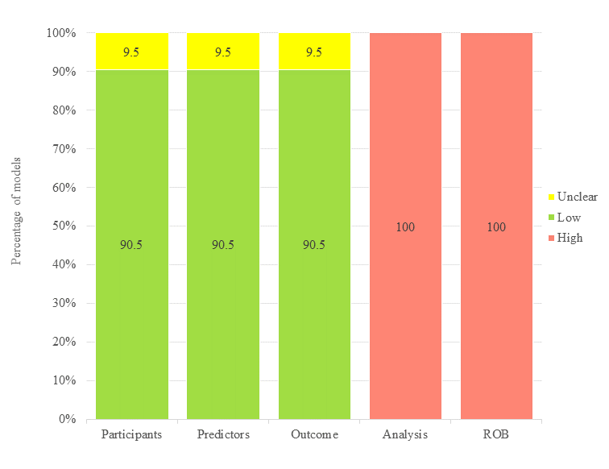

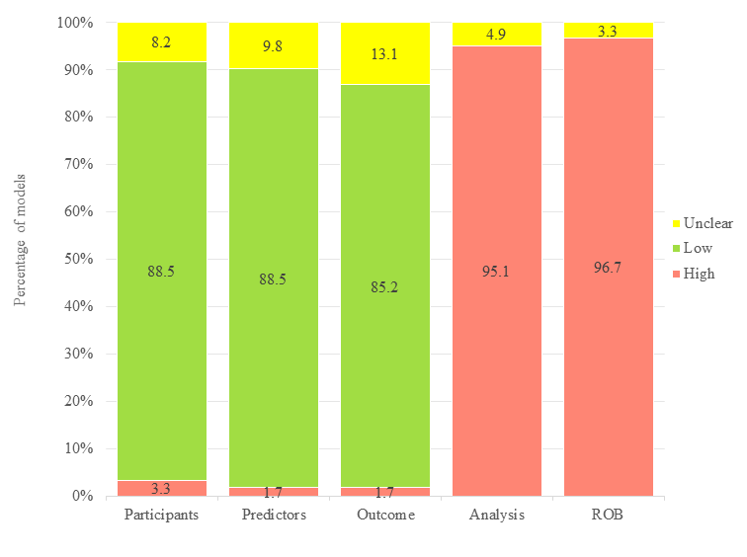
eFig. 2-1 Risk of Bias for Prediction models of Acute Myeloid Leukemia (n=61)

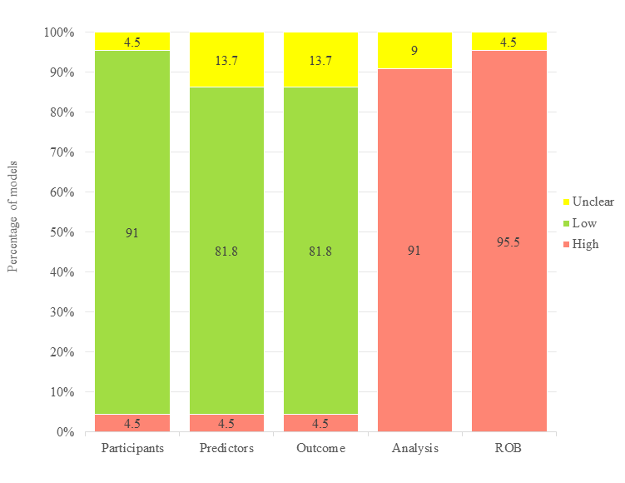
eFig. 2-2 Risk of Bias for Prediction models of Chronic Myeloid Leukemia (n=22)

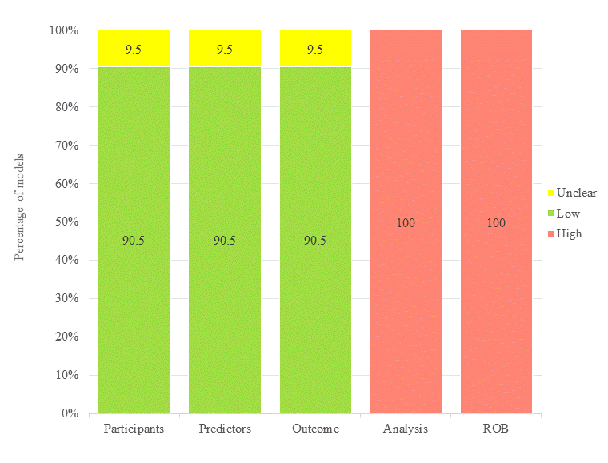
eFig. 2-3 Risk of Bias for Prediction models of Chronic Lymphocytic Leukemia (n=21)

eFig. 3-1 Risk of Bias for Signaling Questions of Prediction models of Leukemia (n=148)
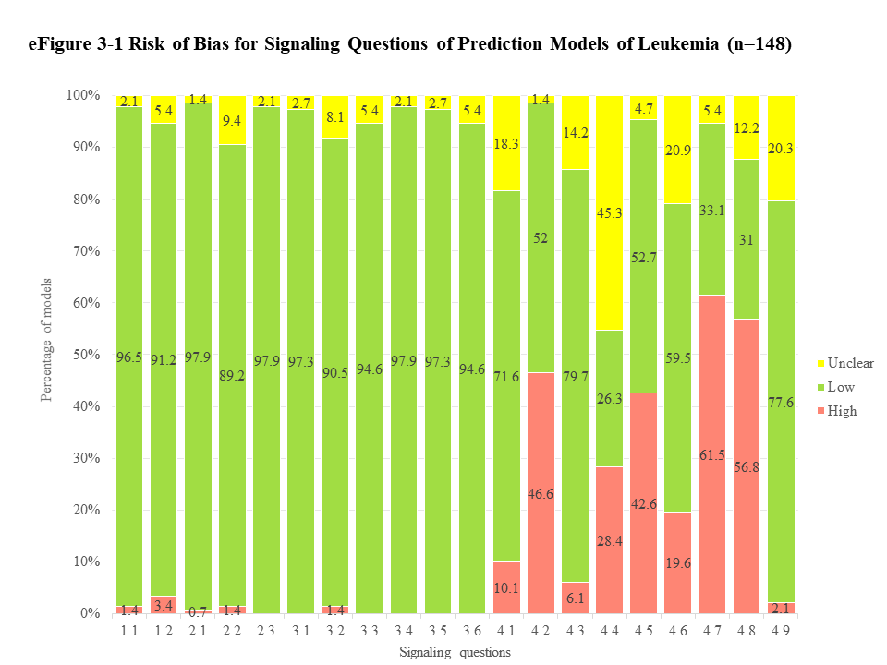

eFig. 3-2 Risk of Bias for Signaling Questions of Prediction models of Acute Myeloid Leukemia (n=61)
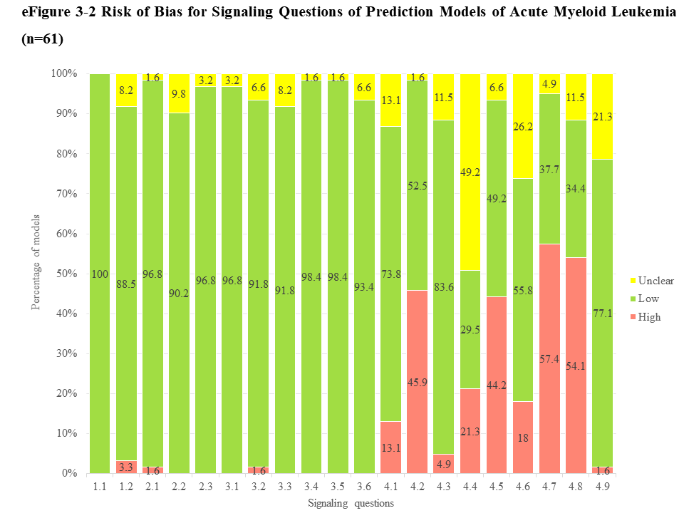

eFig. 3-3 Risk of Bias for Signaling Questions of Prediction models of Chronic Myeloid Leukemia (n=22)
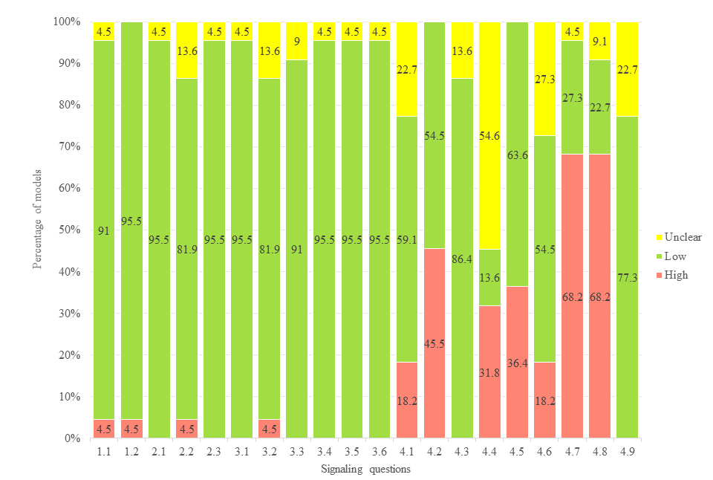

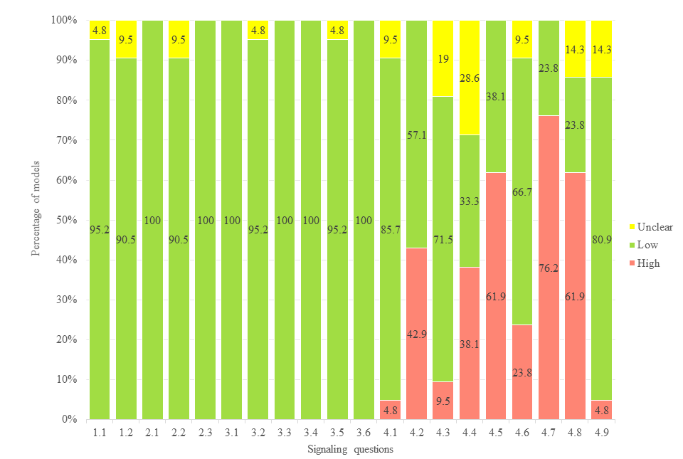
eFig. 3-4 Risk of Bias for Signaling Questions of Prediction models of Chronic Lymphocytic Leukemia (n=21)

Reference
1. Clarke RT, Van den Bruel A, Bankhead C, Mitchell CD, Phillips B, Thompson MJ. Clinical presentation of childhood leukaemia: a systematic review and meta-analysis. Arch Dis Child. 2016;101(10):894-901.
2. Van Maele-Fabry G, Lantin AC, Hoet P, Lison D. Residential exposure to pesticides and childhood leukaemia: a systematic review and meta-analysis. Environ Int. 2011;37(1):280-91.
3. Zhang X, Wang Y, Guo Q, Diao Y, Liu H, Song G, et al. Prognostic role of microRNA-155 in patients with leukemia: A meta-analysis. Clin Chim Acta. 2018;483:6-13.
4. Wynants L, Van Calster B, Collins GS, Riley RD, Heinze G, Schuit E, et al. Prediction models for diagnosis and prognosis of covid-19: systematic review and critical appraisal. Bmj. 2020;369:m1328.
5. Harrison H, Thompson RE, Lin Z, Rossi SH, Stewart GD, Griffin SJ, et al. Risk Prediction Models for Kidney Cancer: A Systematic Review. Eur Urol Focus. 2021;7(6):1380-90.
6. Singh P, Adderley NJ, Hazlehurst J, Price M, Tahrani AA, Nirantharakumar K, et al. Prognostic Models for Predicting Remission of Diabetes Following Bariatric Surgery: A Systematic Review and Meta-analysis. Diabetes Care. 2021;44(11):2626-41.
7. Jo T, Yoshihara S, Hada A, Arai Y, Kitawaki T, Ikemoto J, et al. A Clinically Applicable Prediction Model to Improve T Cell Collection in Chimeric Antigen Receptor T Cell Therapy. Transplant Cell Ther. 2022;28(7):365.e1-.e7.
8. Shen MZ, Hong SD, Lou R, Chen RZ, Zhang XH, Xu LP, et al. A comprehensive model to predict severe acute graft-versus-host disease in acute leukemia patients after haploidentical hematopoietic stem cell transplantation. Exp Hematol Oncol. 2022;11(1):25.
9. Phillips AA, Shapira I, Willim RD, Sanmugarajah J, Solomon WB, Horwitz SM, et al. A critical analysis of prognostic factors in North American patients with human T-cell lymphotropic virus type-1-associated adult T-cell leukemia/lymphoma: a multicenter clinicopathologic experience and new prognostic score. Cancer. 2010;116(14):3438-46.
10. Rashidi A, Cashen AF. A cytogenetic model predicts relapse risk and survival in patients with acute myeloid leukemia undergoing hematopoietic stem cell transplantation in morphologic complete remission. Leuk Res. 2015;39(1):77-81.
11. Liu J, Yuan R, Li Y, Zhou L, Zhang Z, Yang J, et al. A deep learning method and device for bone marrow imaging cell detection. Ann Transl Med. 2022;10(4):208.
12. Boldú L, Merino A, Acevedo A, Molina A, Rodellar J. A deep learning model (ALNet) for the diagnosis of acute leukaemia lineage using peripheral blood cell images. Comput Methods Programs Biomed. 2021;202:105999.
13. Molica S, Mauro FR, Callea V, Gentile M, Giannarelli D, Lopez M, et al. A gender-based score system predicts the clinical outcome of patients with early B-cell chronic lymphocytic leukemia. Leuk Lymphoma. 2005;46(4):553-60.
14. Cohen JA, Rossi FM, Zucchetto A, Bomben R, Terzi-di-Bergamo L, Rabe KG, et al. A laboratory-based scoring system predicts early treatment in Rai 0 chronic lymphocytic leukemia. Haematologica. 2020;105(6):1613-20.
15. Terwey TH, Hemmati PG, Martus P, Dietz E, Vuong LG, Massenkeil G, et al. A modified EBMT risk score and the hematopoietic cell transplantation-specific comorbidity index for pre-transplant risk assessment in adult acute lymphoblastic leukemia. Haematologica. 2010;95(5):810-8.
16. Hemmati PG, Terwey TH, le Coutre P, Vuong LG, Massenkeil G, Dörken B, et al. A modified EBMT risk score predicts the outcome of patients with acute myeloid leukemia receiving allogeneic stem cell transplants. Eur J Haematol. 2011;86(4):305-16.
17. Lauseker M, Hasford J, Hoffmann VS, Müller MC, Hehlmann R, Pfirrmann M. A multi-state model approach for prediction in chronic myeloid leukaemia. Ann Hematol. 2015;94(6):919-27.
18. Bonakchi H, Dehaghi BK, Hosseini-Baharanchi FS, Parkhideh S, Farhangi H, Baghestani AR. A New and Cost-Effective Approach to Risk Stratification for Children with Precursor B-Cell Acute Lymphoblastic Leukemia Based on Competing Outcomes. Iran J Pediatr. 2022;32(4):13.
19. Serin I, Orhan B, Sonmez D, Cinli TA, Goze H, Serin H, et al. A new approach in acute myeloid leukemia (AML): Samatya-predicting score. Leuk Res Rep. 2022;17:100293.
20. Chevallier P, Labopin M, Turlure P, Prebet T, Pigneux A, Hunault M, et al. A new Leukemia Prognostic Scoring System for refractory/relapsed adult acute myelogeneous leukaemia patients: a GOELAMS study. Leukemia. 2011;25(6):939-44.
21. Haferlach T, Kern W, Schoch C, Schnittger S, Sauerland MC, Heinecke A, et al. A new prognostic score for patients with acute myeloid leukemia based on cytogenetics and early blast clearance in trials of the German AML Cooperative Group. Haematologica. 2004;89(4):408-18.
22. Hasford J, Pfirrmann M, Hehlmann R, Allan NC, Baccarani M, Kluin-Nelemans JC, et al. A new prognostic score for survival of patients with chronic myeloid leukemia treated with interferon alfa. Writing Committee for the Collaborative CML Prognostic Factors Project Group. J Natl Cancer Inst. 1998;90(11):850-8.
23. He YY, Wu XJ, Zhou DH, Yang LH, Mai HR, Wan WQ, et al. A Nomogram for Predicting Event-Free Survival in Childhood Acute Lymphoblastic Leukemia: A Multicenter Retrospective Study. Front Oncol. 2022;12:854798.
24. Senjo H, Onozawa M, Hidaka D, Yokoyama S, Yamamoto S, Tsutsumi Y, et al. A novel nutritional index "simplified CONUT" and the disease risk index independently stratify prognosis of elderly patients with acute myeloid leukemia. Sci Rep. 2020;10(1):19400.
25. Röllig C, Thiede C, Gramatzki M, Aulitzky W, Bodenstein H, Bornhäuser M, et al. A novel prognostic model in elderly patients with acute myeloid leukemia: results of 909 patients entered into the prospective AML96 trial. Blood. 2010;116(6):971-8.
26. Zhang Q, Huang MJ, Wang HY, Wu Y, Chen YZ. A novel prognostic nomogram for adult acute lymphoblastic leukemia: a comprehensive analysis of 321 patients. Ann Hematol. 2023;102(7):1825-35.
27. Liu X, Zou Y, Zhang L, Guo Y, Chen Y, Yang W, et al. A Novel Risk Defining System for Pediatric T-Cell Acute Lymphoblastic Leukemia From CCCG-ALL-2015 Group. Front Oncol. 2022;12:841179.
28. Yuan XL, Lai XY, Wu YB, Yang LX, Shi JM, Liu LZ, et al. A novel risk model for predicting early relapse in acute myeloid leukemia patients undergoing allogeneic hematopoietic stem-cell transplantation. Bone Marrow Transplant. 2023;58(7):801-10.
29. Shen MZ, Hong SD, Wang J, Zhang XH, Xu LP, Wang Y, et al. A Predicted Model for Refractory/Recurrent Cytomegalovirus Infection in Acute Leukemia Patients After Haploidentical Hematopoietic Stem Cell Transplantation. Front Cell Infect Microbiol. 2022;12:862526.
30. Perek S, Khatib A, Izhaki N, Khalaila AS, Brenner B, Horowitz NA. A prediction model for central venous catheter-related thrombosis in patients with newly-diagnosed acute myeloid leukemia: A derivation cohort analysis. Eur J Intern Med. 2022;101:68-75.
31. Kim DY, Lee JH, Sym SJ, Yun SC, Lee JH, Kim SD, et al. A prediction model for complete remission upon reinduction for patients with acute myeloid leukemia after failure of anthracycline and cytarabine standard chemotherapy. Ann Hematol. 2011;90(11):1283-91.
32. Mato AR, Riccio BE, Qin L, Heitjan DF, Carroll M, Loren A, et al. A predictive model for the detection of tumor lysis syndrome during AML induction therapy. Leuk Lymphoma. 2006;47(5):877-83.
33. Zhang XS, Gale RP, Zhang MJ, Huang XJ, Jiang Q. A predictive scoring system for therapy-failure in persons with chronic myeloid leukemia receiving initial imatinib therapy. Leukemia. 2022;36(5):1336-42.
34. Yang M, Zhao B, Wang J, Zhang Y, Hu C, Liu L, et al. A Predictor Combining Clinical and Genetic Factors for AML1-ETO Leukemia Patients. Front Oncol. 2021;11:783114.
35. Keating MJ, Smith TL, Gehan EA, McCredie KB, Bodey GP, Freireich EJ. A prognostic factor analysis for use in development of predictive models for response in adult acute leukemia. Cancer. 1982;50(3):457-65.
36. Tang Y, Xiao S, Wang Z, Liang Y, Xing Y, Wu J, et al. A Prognostic Model for Acute Myeloid Leukemia Based on IL-2/STAT5 Pathway-Related Genes. Front Oncol. 2022;12:785899.
37. Bergua JM, Montesinos P, Martinez-Cuadrón D, Fernández-Abellán P, Serrano J, Sayas MJ, et al. A prognostic model for survival after salvage treatment with FLAG-Ida +/- gemtuzumab-ozogamicine in adult patients with refractory/relapsed acute myeloid leukaemia. Br J Haematol. 2016;174(5):700-10.
38. Giles FJ, Bekele BN, O'Brien S, Cortes JE, Verstovsek S, Balerdi M, et al. A prognostic model for survival in chronic lymphocytic leukaemia based on p53 expression. Br J Haematol. 2003;121(4):578-85.
39. Quintás-Cardama A, Daver N, Kim H, Dinardo C, Jabbour E, Kadia T, et al. A prognostic model of therapy-related myelodysplastic syndrome for predicting survival and transformation to acute myeloid leukemia. Clin Lymphoma Myeloma Leuk. 2014;14(5):401-10.
40. Armand P, Kim HT, Cutler CS, Ho VT, Koreth J, Ritz J, et al. A prognostic score for patients with acute leukemia or myelodysplastic syndromes undergoing allogeneic stem cell transplantation. Biol Blood Marrow Transplant. 2008;14(1):28-35.
41. Gagelmann N, Badbaran A, Beelen DW, Salit RB, Stölzel F, Rautenberg C, et al. A prognostic score including mutation profile and clinical features for patients with CMML undergoing stem cell transplantation. Blood Adv. 2021;5(6):1760-9.
42. Advani A, Jin T, Bolwell B, Copelan E, Sekeres M, Sobecks R, et al. A prognostic scoring system for adult patients less than 60 years of age with acute lymphoblastic leukemia in first relapse. Leuk Lymphoma. 2009;50(7):1126-31.
43. Österroos A, Maia T, Eriksson A, Jädersten M, Lazarevic V, Wennström L, et al. A risk score based on real-world data to predict early death in acute promyelocytic leukemia. Haematologica. 2022;107(7):1528-37.
44. Cao LQ, Zhou Y, Liu YR, Xu LP, Zhang XH, Wang Y, et al. A risk score system for stratifying the risk of relapse in B cell acute lymphocytic leukemia patients after allogenic stem cell transplantation. Chin Med J (Engl). 2021;134(10):1199-208.
45. Palmer MK, Hann IM, Jones PM, Evans DI. A score at diagnosis for predicting length of remission in childhood acute lymphoblastic leukaemia. Br J Cancer. 1980;42(6):841-9.
46. Bérard E, Röllig C, Bertoli S, Pigneux A, Tavitian S, Kramer M, et al. A scoring system for AML patients aged 70 years or older, eligible for intensive chemotherapy: a study based on a large European data set using the DATAML, SAL, and PETHEMA registries. Blood Cancer J. 2022;12(7):107.
47. Valcárcel D, Montesinos P, Sánchez-Ortega I, Brunet S, Esteve J, Martínez-Cuadrón D, et al. A scoring system to predict the risk of death during induction with anthracycline plus cytarabine-based chemotherapy in patients with de novo acute myeloid leukemia. Cancer. 2012;118(2):410-7.
48. Malagola M, Skert C, Vignetti M, Piciocchi A, Martinelli G, Alimena G, et al. A simple prognostic scoring system for newly diagnosed cytogenetically normal acute myeloid leukemia: retrospective analysis of 530 patients. Leuk Lymphoma. 2011;52(12):2329-35.
49. Verwaaijen EJ, Ma J, de Groot-Kruseman HA, Pieters R, van der Sluis IM, van Atteveld JE, et al. A Validated Risk Prediction Model for Bone Fragility in Children With Acute Lymphoblastic Leukemia. J Bone Miner Res. 2021;36(12):2290-9.
50. Lecca P, Sorio C. Accurate prediction of the age incidence of chronic myeloid leukemia with an improved two-mutation mathematical model. Integr Biol (Camb). 2016;8(12):1261-75.
51. Solans M, Castelló A, Benavente Y, Marcos-Gragera R, Amiano P, Gracia-Lavedan E, et al. Adherence to the Western, Prudent, and Mediterranean dietary patterns and chronic lymphocytic leukemia in the MCC-Spain study. Haematologica. 2018;103(11):1881-8.
52. Cai P, Wu Q, Wang Y, Yang X, Zhang X, Chen S. An effective early death scoring system for predicting early death risk in de novo acute promyelocytic leukemia. Leuk Lymphoma. 2020;61(8):1989-95.
53. Das PK, Sahoo B, Meher S. An Efficient Detection and Classification of Acute Leukemia Using Transfer Learning and Orthogonal Softmax Layer-Based Model. IEEE/ACM Trans Comput Biol Bioinform. 2023;20(3):1817-28.
54. Shouval R, Ruggeri A, Labopin M, Mohty M, Sanz G, Michel G, et al. An Integrative Scoring System for Survival Prediction Following Umbilical Cord Blood Transplantation in Acute Leukemia. Clin Cancer Res. 2017;23(21):6478-86.
55. An international prognostic index for patients with chronic lymphocytic leukaemia (CLL-IPI): a meta-analysis of individual patient data. Lancet Oncol. 2016;17(6):779-90.
56. Patnaik MM, Itzykson R, Lasho TL, Kosmider O, Finke CM, Hanson CA, et al. ASXL1 and SETBP1 mutations and their prognostic contribution in chronic myelomonocytic leukemia: a two-center study of 466 patients. Leukemia. 2014;28(11):2206-12.
57. Kanakasetty GB, Thanky AH, Kuntegowdanahalli L, Dasappa L, Jacob L, Mallekavu SB, et al. Can the Use of Bone Marrow Parameters Improve the Efficacy of Risk Prediction Scores in Chronic Myeloid Leukemia in Imatinib Era? Clin Lymphoma Myeloma Leuk. 2017;17(6):375-81.
58. Pan J, Jiang Y, Li C, Jin T, Yu K, Jin Z. Characteristics of Pyroptosis-Related Subtypes and Novel Scoring Tool for the Prognosis and Chemotherapy Response in Acute Myeloid Leukemia. Front Oncol. 2022;12:898236.
59. Baumann T, Delgado J, Santacruz R, Martínez-Trillos A, Royo C, Navarro A, et al. Chronic lymphocytic leukemia in the elderly: clinico-biological features, outcomes, and proposal of a prognostic model. Haematologica. 2014;99(10):1599-604.
60. Li H, Yi SH, Xiong WJ, Liu HM, Lyu R, Wang TY, et al. Chronic Lymphocytic Leukemia Prognostic Index: A New Integrated Scoring System to Predict the Time to First Treatment in Chinese Patients with Chronic Lymphocytic Leukemia. Chin Med J (Engl). 2017;130(2):135-42.
61. Falantes JF, Calderón C, Márquez Malaver FJ, Alonso D, Martín Noya A, Carrillo E, et al. Clinical prognostic factors for survival and risk of progression to acute myeloid leukemia in patients with myelodysplastic syndromes with < 10% marrow blasts and non-unfavorable cytogenetic categories. Clin Lymphoma Myeloma Leuk. 2013;13(2):144-52.
62. Pastore F, Dufour A, Benthaus T, Metzeler KH, Maharry KS, Schneider S, et al. Combined molecular and clinical prognostic index for relapse and survival in cytogenetically normal acute myeloid leukemia. J Clin Oncol. 2014;32(15):1586-94.
63. Sorror ML, Sandmaier BM, Storer BE, Maris MB, Baron F, Maloney DG, et al. Comorbidity and disease status based risk stratification of outcomes among patients with acute myeloid leukemia or myelodysplasia receiving allogeneic hematopoietic cell transplantation. J Clin Oncol. 2007;25(27):4246-54.
64. Krug U, Röllig C, Koschmieder A, Heinecke A, Sauerland MC, Schaich M, et al. Complete remission and early death after intensive chemotherapy in patients aged 60 years or older with acute myeloid leukaemia: a web-based application for prediction of outcomes. Lancet. 2010;376(9757):2000-8.
65. Zhou F, Zhou F, Du M, Liu L, Guo T, Xia L, et al. Comprehensive prognostic scoring systems could improve the prognosis of adult acute myeloid leukemia patients. Int J Hematol. 2019;110(5):575-83.
66. Li F, Cai J, Liu J, Yu SC, Zhang X, Su Y, et al. Construction of a solid Cox model for AML patients based on multiomics bioinformatic analysis. Front Oncol. 2022;12:925615.
67. Ustun C, Morgan E, Moodie EEM, Pullarkat S, Yeung C, Broesby-Olsen S, et al. Core-binding factor acute myeloid leukemia with t(8;21): Risk factors and a novel scoring system (I-CBFit). Cancer Med. 2018;7(9):4447-55.
68. Kongtim P, Hasan O, Perez JMR, Varma A, Chen J, Rondon G, et al. Development and validation of a novel disease risk model for patients with AML receiving allogeneic hematopoietic cell transplantation. J Clin Oncol. 2019;37(15):1.
69. Ma TT, Lin XJ, Cheng WY, Xue Q, Wang SY, Liu FJ, et al. Development and validation of a prognostic model for adult patients with acute myeloid leukaemia. EBioMedicine. 2020;62:103126.
70. Li J, Liu L, Zhang R, Wan Y, Gong X, Zhang L, et al. Development and validation of a prognostic scoring model to risk stratify childhood acute myeloid leukaemia. Br J Haematol. 2022;198(6):1041-50.
71. Such E, Germing U, Malcovati L, Cervera J, Kuendgen A, Della Porta MG, et al. Development and validation of a prognostic scoring system for patients with chronic myelomonocytic leukemia. Blood. 2013;121(15):3005-15.
72. Wei C, Ding L, Luo Q, Li X, Zeng X, Kong D, et al. Development and Validation of an Individualized Metabolism-Related Prognostic Model for Adult Acute Myeloid Leukemia Patients. Front Oncol. 2022;12:829007.
73. Mato AR, Riccio BE, Qin L, Heitjan DF, Carroll M, Loren A, et al. A predictive model for the detection of tumor lysis syndrome during AML induction therapy. Leuk Lymphoma. 2006;47(5):877-83.
74. Zhang Y, Hou W, Wang P, Hou J, HuiyuanYang, Zhao H, et al. Development of a risk grading system to identify patients with acute promyelocytic leukemia at high risk of early death. Cancer Manag Res. 2018;10:3619-27.
75. Lou Y, Ma Y, Sun J, Suo S, Tong H, Qian W, et al. Effectivity of a modified Sanz risk model for early death prediction in patients with newly diagnosed acute promyelocytic leukemia. Ann Hematol. 2017;96(11):1793-800.
76. Ma L, Xu LP, Wang Y, Zhang XH, Chen H, Chen YH, et al. Effects of isolated central nervous system involvement evaluated by multiparameter flow cytometry prior to allografting on outcomes of patients with acute lymphoblastic leukemia. Front Oncol. 2023;13:1166990.
77. Huemer F, Weiss L, Faber V, Neureiter D, Egle A, Geissler K, et al. Establishment and validation of a novel risk model for estimating time to first treatment in 120 patients with chronic myelomonocytic leukaemia. Wien Klin Wochenschr. 2018;130(3-4):115-25.
78. Zhong J, Wu H, Bu X, Li W, Cai S, Du M, et al. Establishment of Prognosis Model in Acute Myeloid Leukemia Based on Hypoxia Microenvironment, and Exploration of Hypoxia-Related Mechanisms. Front Genet. 2021;12:727392.
79. Buturovic L, Shelton J, Spellman SR, Wang T, Friedman L, Loftus D, et al. Evaluation of a Machine Learning-Based Prognostic Model for Unrelated Hematopoietic Cell Transplantation Donor Selection. Biol Blood Marrow Transplant. 2018;24(6):1299-306.
80. Chung SJ. Formula predicting survival in patients with acute myelogenous leukemia. Int J Biomed Comput. 1991;29(3-4):283-93.
81. Choi H, Jung C, Sohn SK, Kim S, Kim HJ, Kim YK, et al. Genome-wide genotype-based risk model for survival in acute myeloid leukaemia patients with normal karyotype. Br J Haematol. 2013;163(1):62-71.
82. Park S, Choi H, Kim HJ, Ahn JS, Kim HJ, Kim SH, et al. Genome-wide genotype-based risk model for survival in core binding factor acute myeloid leukemia patients. Ann Hematol. 2018;97(6):955-65.
83. Wang J, Zhuo Z, Wang Y, Yang S, Chen J, Wang Y, et al. Identification and Validation of a Prognostic Risk-Scoring Model Based on Ferroptosis-Associated Cluster in Acute Myeloid Leukemia. Front Cell Dev Biol. 2021;9:800267.
84. Gu J, Liu S, Cui W, Dai H, Cui Q, Yin J, et al. Identification of the Predictive Models for the Treatment Response of Refractory/Relapsed B-Cell ALL Patients Receiving CAR-T Therapy. Front Immunol. 2022;13:858590.
85. Zhou JY, Wang S, Yuan HL, Xu YJ, Huang XB, Gao SJ, et al. Impact of a novel prognostic model on allogeneic hematopoietic stem cell transplantation outcomes in patients with CMML. Am J Hematol. 2023;98(9):1394-406.
86. Shouval R, Labopin M, Gorin NC, Bomze D, Houhou M, Blaise D, et al. Individualized prediction of leukemia-free survival after autologous stem cell transplantation in acute myeloid leukemia. Cancer. 2019;125(20):3566-73.
87. Damm F, Heuser M, Morgan M, Wagner K, Görlich K, Grosshennig A, et al. Integrative prognostic risk score in acute myeloid leukemia with normal karyotype. Blood. 2011;117(17):4561-8.
88. Condoluci A, Terzi di Bergamo L, Langerbeins P, Hoechstetter MA, Herling CD, De Paoli L, et al. International prognostic score for asymptomatic early-stage chronic lymphocytic leukemia. Blood. 2020;135(21):1859-69.
89. Molina B, Gonzalez Vicent M, Herrero B, Deltoro N, Ruiz J, Perez Martinez A, et al. Kinetics and Risk Factors of Relapse after Allogeneic Stem Cell Transplantation in Children with Leukemia: A Long-Term Follow-Up Single-Center Study. Biol Blood Marrow Transplant. 2019;25(1):100-6.
90. Vallapureddy RR, Mudireddy M, Penna D, Lasho TL, Finke CM, Hanson CA, et al. Leukemic transformation among 1306 patients with primary myelofibrosis: risk factors and development of a predictive model. Blood Cancer J. 2019;9(2):12.
91. Oh BLZ, Fan L, Lee SHR, Foo KM, Chiew KH, Seeto ZZL, et al. Life-threatening infections during treatment for acute lymphoblastic leukemia on the Malaysia-Singapore 2003 and 2010 clinical trials: A risk prediction model. Asia Pac J Clin Oncol. 2022;18(5):e456-e68.
92. Bai S, Wang H, Shao R, Fu B, Lu S, Wang J, et al. Lipid profile as a novel prognostic predictor for patients with acute myeloid leukemia. Front Oncol. 2023;13:950732.
93. Brown JR, Kim HT, Armand P, Cutler C, Fisher DC, Ho V, et al. Long-term follow-up of reduced-intensity allogeneic stem cell transplantation for chronic lymphocytic leukemia: prognostic model to predict outcome. Leukemia. 2013;27(2):362-9.
94. Shouval R, Labopin M, Bondi O, Mishan-Shamay H, Shimoni A, Ciceri F, et al. Prediction of Allogeneic Hematopoietic Stem-Cell Transplantation Mortality 100 Days After Transplantation Using a Machine Learning Algorithm: A European Group for Blood and Marrow Transplantation Acute Leukemia Working Party Retrospective Data Mining Study. J Clin Oncol. 2015;33(28):3144-51.
95. Agius R, Brieghel C, Andersen MA, Pearson AT, Ledergerber B, Cozzi-Lepri A, et al. Machine learning can identify newly diagnosed patients with CLL at high risk of infection. Nat Commun. 2020;11(1):363.
96. Arabyarmohammadi S, Leo P, Viswanathan VS, Janowczyk A, Corredor G, Fu P, et al. Machine Learning to Predict Risk of Relapse Using Cytologic Image Markers in Patients With Acute Myeloid Leukemia Posthematopoietic Cell Transplantation. JCO Clin Cancer Inform. 2022;6:e2100156.
97. Fuse K, Uemura S, Tamura S, Suwabe T, Katagiri T, Tanaka T, et al. Patient-based prediction algorithm of relapse after allo-HSCT for acute Leukemia and its usefulness in the decision-making process using a machine learning approach. Cancer Med. 2019;8(11):5058-67.
98. Hirabayashi S, Uozumi R, Kondo T, Arai Y, Kawata T, Uchida N, et al. Personalized prediction of overall survival in patients with AML in non-complete remission undergoing allo-HCT. Cancer Med. 2021;10(13):4250-68.
99. Bitan M, Ahn KW, Millard HR, Pulsipher MA, Abdel-Azim H, Auletta JJ, et al. Personalized Prognostic Risk Score for Long-Term Survival for Children with Acute Leukemia after Allogeneic Transplantation. Biol Blood Marrow Transplant. 2017;23(9):1523-30.
100. Dayyani F, Mougalian SS, Naqvi K, Shan J, Ravandi F, Cortes J, et al. Prediction model for mortality after intracranial hemorrhage in patients with leukemia. Am J Hematol. 2011;86(7):546-9.
101. Baggio D, Tan S, Porch K, Shortt J, Ko B. Prediction of cardiovascular events in patients with chronic myeloid leukaemia using baseline risk factors and coronary artery calcium scoring. Intern Med J. 2021;51(10):1736-40.
102. Versluis J, Pandey M, Flamand Y, Haydu JE, Belizaire R, Faber M, et al. Prediction of life-threatening and disabling bleeding in patients with AML receiving intensive induction chemotherapy. Blood Adv. 2022;6(9):2835-46.
103. Ahn IE, Tian X, Ipe D, Cheng M, Albitar M, Tsao LC, et al. Prediction of Outcome in Patients With Chronic Lymphocytic Leukemia Treated With Ibrutinib: Development and Validation of a Four-Factor Prognostic Model. J Clin Oncol. 2021;39(6):576-85.
104. Pfirrmann M, Ehninger G, Thiede C, Bornhäuser M, Kramer M, Röllig C, et al. Prediction of post-remission survival in acute myeloid leukaemia: a post-hoc analysis of the AML96 trial. Lancet Oncol. 2012;13(2):207-14.
105. Smith TL, Gehan EA, Keating MJ, Freireich EJ. Prediction of remission in adult acute leukemia: development and testing of predictive models. Cancer. 1982;50(3):466-72.
106. Sasaki K, Ravandi F, Kadia T, DiNardo C, Borthakur G, Short N, et al. Prediction of survival with intensive chemotherapy in acute myeloid leukemia. Am J Hematol. 2022;97(7):865-76.
107. Sasaki K, Ravandi F, Kadia TM, Borthakur G, Short NJ, Jain N, et al. Prediction of survival with lower intensity therapy among older patients with acute myeloid leukemia. Cancer. 2023;129(7):1017-29.
108. Ornstein MC, Mukherjee S, Mohan S, Elson P, Tiu RV, Saunthararajah Y, et al. Predictive factors for latency period and a prognostic model for survival in patients with therapy-related acute myeloid leukemia. Am J Hematol. 2014;89(2):168-73.
109. Mądry K, Lis K, Biecek P, Młynarczyk M, Rytel J, Górka M, et al. Predictive Model for Infection Risk in Myelodysplastic Syndromes, Acute Myeloid Leukemia, and Chronic Myelomonocytic Leukemia Patients Treated With Azacitidine; Azacitidine Infection Risk Model: The Polish Adult Leukemia Group Study. Clin Lymphoma Myeloma Leuk. 2019;19(5):264-74.e4.
110. Heinecke A, Sauerland MC, Büchner T. Predictive models for achievement of complete remission and duration of first remission in adult acute myeloid leukemia. Haematol Blood Transfus. 1990;33:285-9.
111. Zhang XS, Gale RP, Li ZY, Zhang MY, Huang XJ, Jiang Q. Predictive scoring systems for molecular responses in persons with chronic phase chronic myeloid leukemia receiving initial imatinib therapy. Leukemia. 2022;36(8):2042-9.
112. Yun X, Sun X, Hu X, Zhang H, Yin Z, Zhang X, et al. Prognostic and Therapeutic Value of Apolipoprotein A and a New Risk Scoring System Based on Apolipoprotein A and Adenosine Deaminase in Chronic Lymphocytic Leukemia. Front Oncol. 2021;11:698572.
113. Onida F, Kantarjian HM, Smith TL, Ball G, Keating MJ, Estey EH, et al. Prognostic factors and scoring systems in chronic myelomonocytic leukemia: a retrospective analysis of 213 patients. Blood. 2002;99(3):840-9.
114. Johnson PR, Hunt LP, Yin JA. Prognostic factors in elderly patients with acute myeloid leukaemia: development of a model to predict survival. Br J Haematol. 1993;85(2):300-6.
115. Katsuya H, Yamanaka T, Ishitsuka K, Utsunomiya A, Sasaki H, Hanada S, et al. Prognostic index for acute- and lymphoma-type adult T-cell leukemia/lymphoma. J Clin Oncol. 2012;30(14):1635-40.
116. Hoechstetter MA, Busch R, Eichhorst B, Bühler A, Winkler D, Bahlo J, et al. Prognostic model for newly diagnosed CLL patients in Binet stage A: results of the multicenter, prospective CLL1 trial of the German CLL study group. Leukemia. 2020;34(4):1038-51.
117. Park SS, Kim HJ, Min KI, Min GJ, Jeon YW, Yoon JH, et al. Prognostic Prediction Model for Second Allogeneic Stem-Cell Transplantation in Patients With Relapsed Acute Myeloid Leukemia: Single-Center Report. Clin Lymphoma Myeloma Leuk. 2018;18(4):e167-e82.
118. Soumerai JD, Ni A, Darif M, Londhe A, Xing G, Mun Y, et al. Prognostic risk score for patients with relapsed or refractory chronic lymphocytic leukaemia treated with targeted therapies or chemoimmunotherapy: a retrospective, pooled cohort study with external validations. Lancet Haematol. 2019;6(7):e366-e74.
119. Djunic I, Suvajdzic-Vukovic N, Virijevic M, Novkovic A, Colovic N, Vidovic A, et al. Prognostic risk score for the survival of elderly patients with acute myeloid leukaemia comprising comorbidities. Med Oncol. 2013;30(1):394.
120. Kim HT, Ahn KW, Hu ZH, Davids MS, Volpe VO, Antin JH, et al. Prognostic Score and Cytogenetic Risk Classification for Chronic Lymphocytic Leukemia Patients: Center for International Blood and Marrow Transplant Research Report. Clin Cancer Res. 2019;25(16):5143-55.
121. Itzykson R, Kosmider O, Renneville A, Gelsi-Boyer V, Meggendorfer M, Morabito M, et al. Prognostic score including gene mutations in chronic myelomonocytic leukemia. J Clin Oncol. 2013;31(19):2428-36.
122. Kim DH, Lee NY, Baek JH, Kim JG, Sohn SK, Suh JS, et al. Prognostic scoring model based on multi-drug resistance status and cytogenetics in adult patients with acute myeloid leukemia. Leuk Lymphoma. 2006;47(3):461-7.
123. Gratwohl A, Hermans J, Goldman JM, Arcese W, Carreras E, Devergie A, et al. Risk assessment for patients with chronic myeloid leukaemia before allogeneic blood or marrow transplantation. Chronic Leukemia Working Party of the European Group for Blood and Marrow Transplantation. Lancet. 1998;352(9134):1087-92.
124. Gorin NC, Labopin M, Polge E, Cordonnier C, Jouet JP, Michallet M, et al. Risk assessment in adult acute lymphoblastic leukaemia before early haemopoietic stem cell transplantation with a geno-identical donor: an easy clinical prognostic score to identify patients who benefit most from allogeneic haemopoietic stem cell transplantation. Leukemia. 2003;17(8):1596-9.
125. Kim H, Lee JH, Choi SJ, Lee JH, Seol M, Lee YS, et al. Risk score model for fatal intracranial hemorrhage in acute leukemia. Leukemia. 2006;20(5):770-6.
126. Stölzel F, Pfirrmann M, Aulitzky WE, Kaufmann M, Bodenstein H, Bornhäuser M, et al. Risk stratification using a new prognostic score for patients with secondary acute myeloid leukemia: results of the prospective AML96 trial. Leukemia. 2011;25(3):420-8.
127. Owattanapanich W, Rungjirajittranon T, Jantataeme A, Kungwankiattichai S, Ruchutrakool T. Simplified predictive scores for thrombosis and bleeding complications in newly diagnosed acute leukemia patients. Thromb J. 2023;21(1):65.
128. Oosterveld M, Suciu S, Muus P, Germing U, Delforge M, Belhabri A, et al. Specific scoring systems to predict survival of patients with high-risk myelodysplastic syndrome (MDS) and de novo acute myeloid leukemia (AML) after intensive antileukemic treatment based on results of the EORTC-GIMEMA AML-10 and intergroup CRIANT studies. Ann Hematol. 2015;94(1):23-34.
129. Lai B, Lai Y, Zhang Y, Zhou M, OuYang G. Survival prediction in acute myeloid leukemia using gene expression profiling. BMC Med Inform Decis Mak. 2022;22(1):57.
130. Gao X, Liu W. The establishment and evaluation of a new model for the prediction of Children B-ALL based on TARGET: A SQUIRE-compliant study. Medicine (Baltimore). 2020;99(19):e20115.
131. Wang X, Wang J, Wei S, Zhao J, Xin B, Li G, et al. The latest edition of WHO and ELN guidance and a new risk model for Chinese acute myeloid leukemia patients. Front Med (Lausanne). 2023;10:1165445.
132. Haferlach C, Dicker F, Weiss T, Schnittger S, Beck C, Grote-Metke A, et al. Toward a comprehensive prognostic scoring system in chronic lymphocytic leukemia based on a combination of genetic parameters. Genes Chromosomes Cancer. 2010;49(9):851-9.
133. Zhang C, Wan W, Zhang S, Wang J, Feng R, Li J, et al. Treatment patterns and a prognostic scoring system for elderly acute myeloid leukemia patients: a retrospective multicenter cohort study in China. Cancer Biol Med. 2021;19(6):871-83.
134. Tazi Y, Arango-Ossa JE, Zhou Y, Bernard E, Thomas I, Gilkes A, et al. Unified classification and risk-stratification in Acute Myeloid Leukemia. Nat Commun. 2022;13(1):4622.
135. Wierda WG, O'Brien S, Wang X, Faderl S, Ferrajoli A, Do KA, et al. Prognostic nomogram and index for overall survival in previously untreated patients with chronic lymphocytic leukemia. Blood. 2007;109(11):4679-85.
136. Wierda WG, O'Brien S, Wang X, Faderl S, Ferrajoli A, Do KA, et al. Multivariable model for time to first treatment in patients with chronic lymphocytic leukemia. J Clin Oncol. 2011;29(31):4088-95.
137. Kang Y, Assuncao BL, Denduluri S, McCurdy S, Luger S, Lefebvre B, et al. Symptomatic Heart Failure in Acute Leukemia Patients Treated With Anthracyclines. JACC CardioOncol. 2019;1(2):208-17.
138. Cervantes F, Rozman C. A multivariate analysis of prognostic factors in chronic myeloid leukemia. Blood. 1982;60(6):1298-304.
139. Gentile M, Shanafelt TD, Cutrona G, Molica S, Tripepi G, Alvarez I, et al. A progression-risk score to predict treatment-free survival for early stage chronic lymphocytic leukemia patients. Leukemia. 2016;30(6):1440-3.
140. Such E, Cervera J, Costa D, Solé F, Vallespí T, Luño E, et al. Cytogenetic risk stratification in chronic myelomonocytic leukemia. Haematologica. 2011;96(3):375-83.
141. Pfirrmann M, Baccarani M, Saussele S, Guilhot J, Cervantes F, Ossenkoppele G, et al. Prognosis of long-term survival considering disease-specific death in patients with chronic myeloid leukemia. Leukemia. 2016;30(1):48-56.
142. Hasford J, Baccarani M, Hoffmann V, Guilhot J, Saussele S, Rosti G, et al. Predicting complete cytogenetic response and subsequent progression-free survival in 2060 patients with CML on imatinib treatment: the EUTOS score. Blood. 2011;118(3):686-92.
143. Morabito F, Cutrona G, Gentile M, Matis S, Todoerti K, Colombo M, et al. Definition of progression risk based on combinations of cellular and molecular markers in patients with Binet stage A chronic lymphocytic leukaemia. Br J Haematol. 2009;146(1):44-53.
144. Wheatley K, Brookes CL, Howman AJ, Goldstone AH, Milligan DW, Prentice AG, et al. Prognostic factor analysis of the survival of elderly patients with AML in the MRC AML11 and LRF AML14 trials. Br J Haematol. 2009;145(5):598-605.
145. Greenberg P, Cox C, LeBeau MM, Fenaux P, Morel P, Sanz G, et al. International scoring system for evaluating prognosis in myelodysplastic syndromes. Blood. 1997;89(6):2079-88.
146. Kantarjian HM, Smith TL, McCredie KB, Keating MJ, Walters RS, Talpaz M, et al. Chronic myelogenous leukemia: a multivariate analysis of the associations of patient characteristics and therapy with survival. Blood. 1985;66(6):1326-35.
147. Fenwarth L, Thomas X, de Botton S, Duployez N, Bourhis JH, Lesieur A, et al. A personalized approach to guide allogeneic stem cell transplantation in younger adults with acute myeloid leukemia. Blood. 2021;137(4):524-32.
148. Kantarjian H, O'Brien S, Ravandi F, Cortes J, Shan J, Bennett JM, et al. Proposal for a new risk model in myelodysplastic syndrome that accounts for events not considered in the original International Prognostic Scoring System. Cancer. 2008;113(6):1351-61.
149. Tura S, Baccarani M, Corbelli G. Staging of chronic myeloid leukaemia. Br J Haematol. 1981;47(1):105-19.
150. Inukai T, Kiyokawa N, Campana D, Coustan-Smith E, Kikuchi A, Kobayashi M, et al. Clinical significance of early T-cell precursor acute lymphoblastic leukaemia: results of the Tokyo Children's Cancer Study Group Study L99-15. Br J Haematol. 2012;156(3):358-65.
151. Chandra D, Singh MK, Gupta R, Rahman K, Yadav DD, Sarkar MK, et al. Clinicopathological and immunophenotypic features of early T cell precursor acute lymphoblastic leukaemia: A flow cytometry score for the initial diagnosis. Int J Lab Hematol. 2021;43(6):1417-23.

