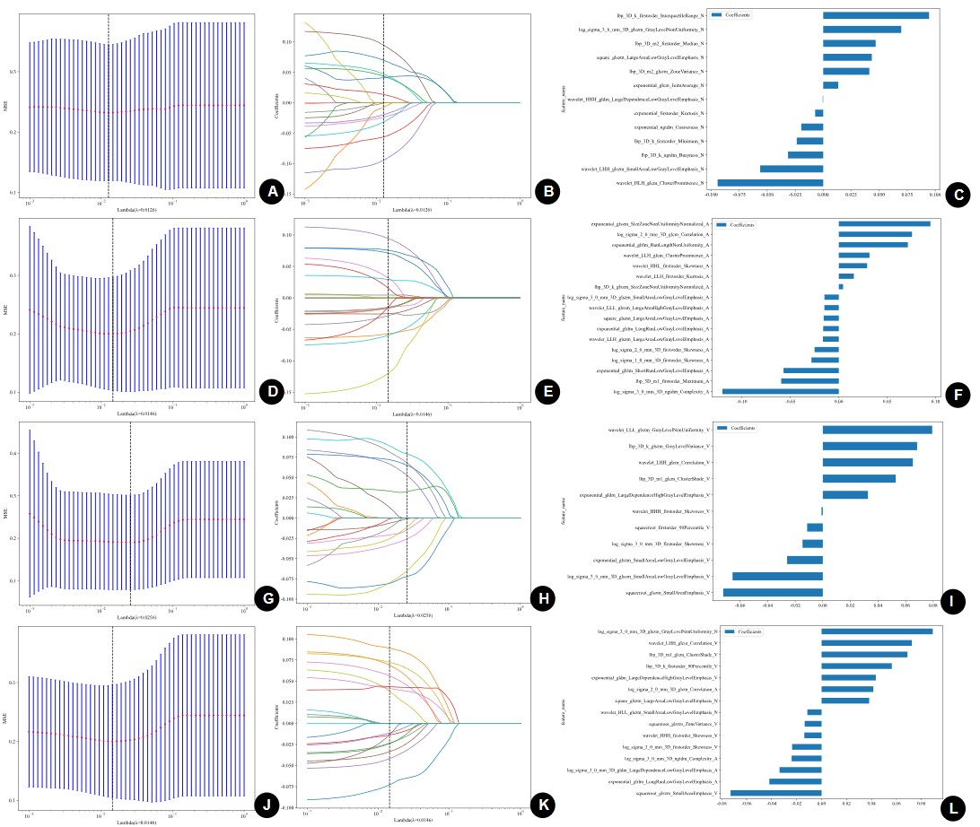
Online Resource 1. Radiomics feature selection using the LASSO algorithm for different CT image sets.
LASSO regression was used to select the most informative radiomics features from different CT image sets. Panels A, D, G, and J show the mean squared error plots generated by 10-fold cross-validation for the non-contrast, arterial-phase, venous-phase, and combined three-phase image sets, respectively. Panels B, E, H, and K show the corresponding LASSO coefficient profiles of radiomics features, with the vertical dashed line indicating the optimal λ value. Panels C, F, I, and L present the coefficients of the selected features with nonzero weights for each image set.

Online Resource 2 Diagnostic performance of radiomics models based on different CT phases in the training and test sets
 |  | LR |  |  |  | SVM
Group |  | AUC | Accuracy | Sensitivity | Specificity | AUC | Accuracy | Sensitivity | Specificity
N  Training set |  | 0.772 | 0.754 | 0.657 | 0.800 | 0.780 | 0.792 | 0.627 | 0.871
N  Test set |  | 0.725 | 0.678 | 0.781 | 0.621 | 0.735 | 0.656 | 0.937 | 0.500
A  Training set |  | 0.809 | 0.773 | 0.716 | 0.800 | 0.792 | 0.754 | 0.672 | 0.793
A  Test set |  | 0.724 | 0.633 | 0.875 | 0.500 | 0.749 | 0.722 | 0.812 | 0.672
V  Training set |  | 0.833 | 0.729 | 0.881 | 0.657 | 0.823 | 0.749 | 0.776 | 0.736
V  Test set |  | 0.709 | 0.733 | 0.500 | 0.862 | 0.709 | 0.733 | 0.500 | 0.862
A_V_N Training set |  | 0.829 | 0.831 | 0.627 | 0.929 | 0.814 | 0.778 | 0.731 | 0.800
A_V_N  Test set |  | 0.759 | 0.778 | 0.656 | 0.845 | 0.812 | 0.722 | 0.844 | 0.655
 |  | RF |  |  |  | NB
Group |  | AUC | Accuracy | Sensitivity | Specificity | AUC | Accuracy | Sensitivity | Specificity
N  Training set |  | 0.795 | 0.792 | 0.687 | 0.843 | 0.708 | 0.652 | 0.761 | 0.600
N  Test set |  | 0.700 | 0.700 | 0.656 | 0.724 | 0.704 | 0.611 | 1.000 | 0.397
A  Training set |  | 0.795 | 0.763 | 0.672 | 0.807 | 0.770 | 0.734 | 0.642 | 0.779
A  Test set |  | 0.566 | 0.511 | 0.750 | 0.379 | 0.650 | 0.622 | 0.844 | 0.500
V  Training set |  | 0.778 | 0.758 | 0.612 | 0.829 | 0.830 | 0.807 | 0.642 | 0.886
V  Test set |  | 0.640 | 0.678 | 0.437 | 0.810 | 0.616 | 0.700 | 0.437 | 0.845
A_V_N  Training set |  | 0.884 | 0.807 | 0.851 | 0.786 | 0.829 | 0.812 | 0.627 | 0.900
A_V_N  Test set |  | 0.672 | 0.744 | 0.437 | 0.914 | 0.794 | 0.733 | 0.812 | 0.690

 |  | KNN
Group |  | AUC | Accuracy | Sensitivity | Specificity
N  Training set |  | 0.863 | 0.783 | 0.836 | 0.757
N  Test set |  | 0.646 | 0.644 | 0.625 | 0.655
A  Training set |  | 0.877 | 0..773 | 0.881 | 0.721
A  Test set |  | 0.699 | 0.722 | 0.469 | 0.862
V  Training set |  | 0.867 | 0.792 | 0.836 | 0.757
V  Test set |  | 0.624 | 0.622 | 0.656 | 0.603
A_V_N  Training set |  | 0.891 | 0.816 | 0.776 | 0.836
A_V_N  Test set |  | 0.728 | 0.689 | 0.656 | 0.707
N = non-contrast CT; A = arterial-phase CT; V = venous-phase CT; A_V_N = combined non-contrast, arterial-phase, and venous-phase CT.

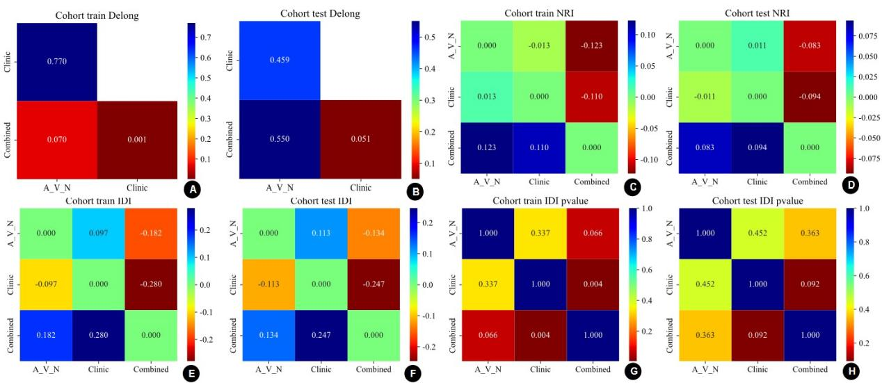

Online Resource 3. Pairwise comparison and incremental value assessment of the radiomics, clinical, and combined models.
Panels A and B show the heatmaps of DeLong test P values for pairwise comparisons of the AUCs among the radiomics model (A_V_N), clinical model, and combined model in the training and test sets, respectively. Panels C and D show the heatmaps of net reclassification improvement (NRI) values in the training and test sets, respectively. Panels E and F show the heatmaps of integrated discrimination improvement (IDI) values in the training and test sets, respectively. Panels G and H show the heatmaps of P values for pairwise comparisons of IDI in the training and test sets, respectively. A two-sided P value < 0.05 was considered statistically significant.

