Supplementary Information
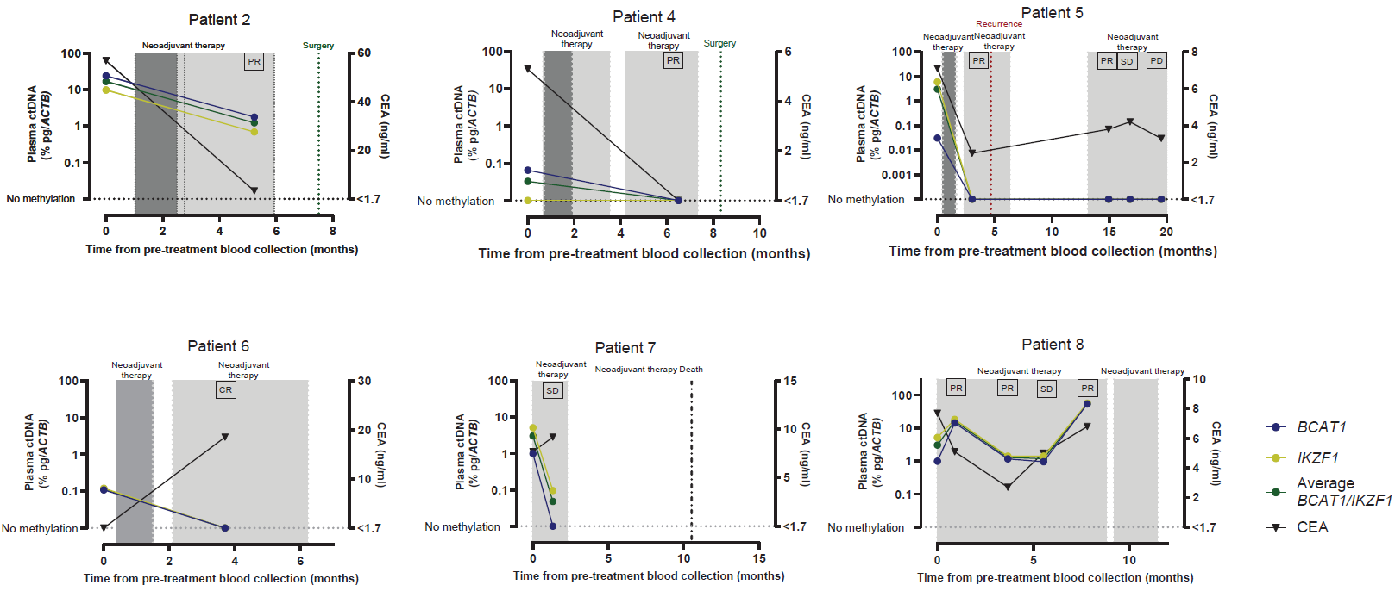

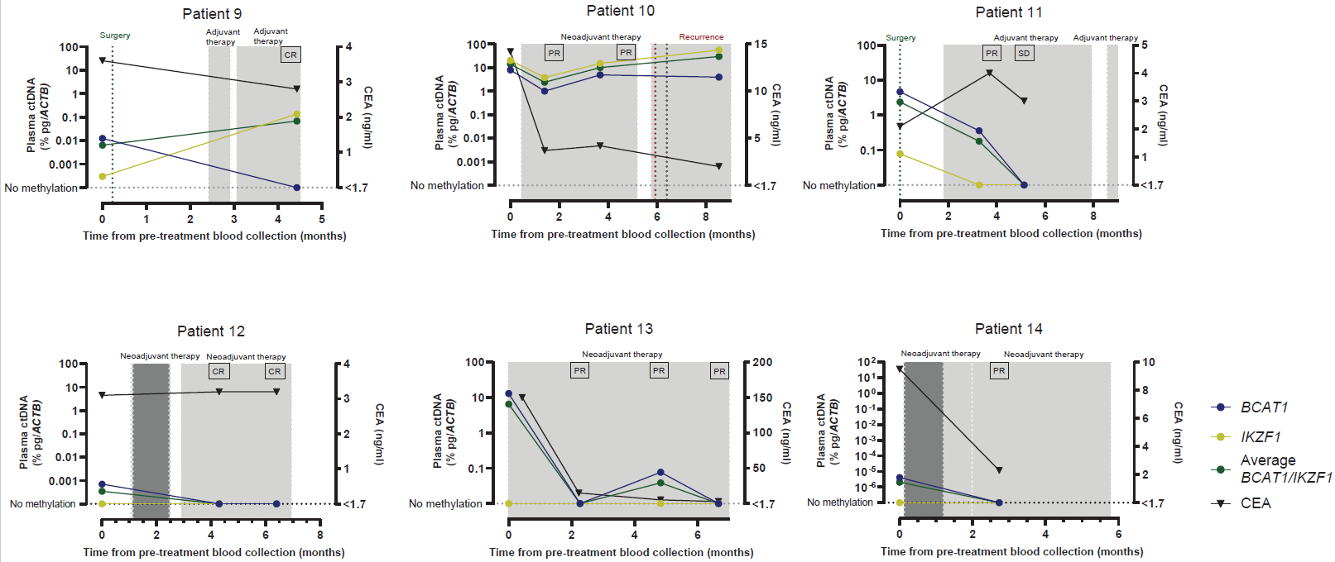

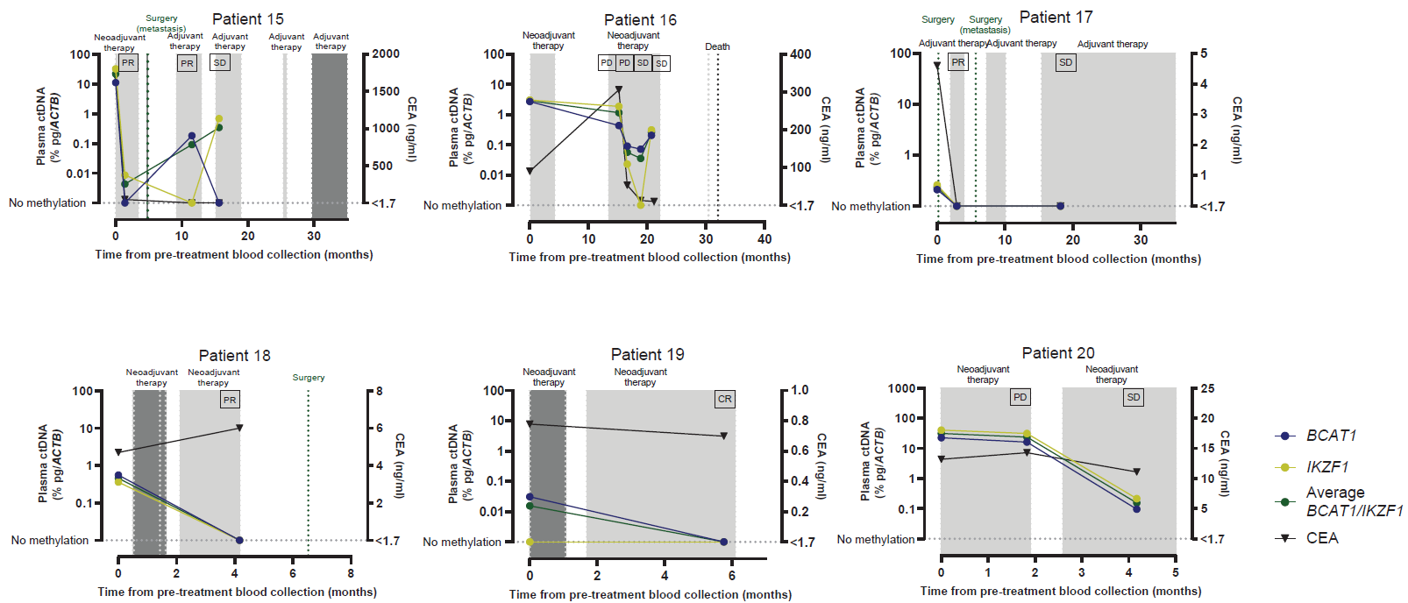

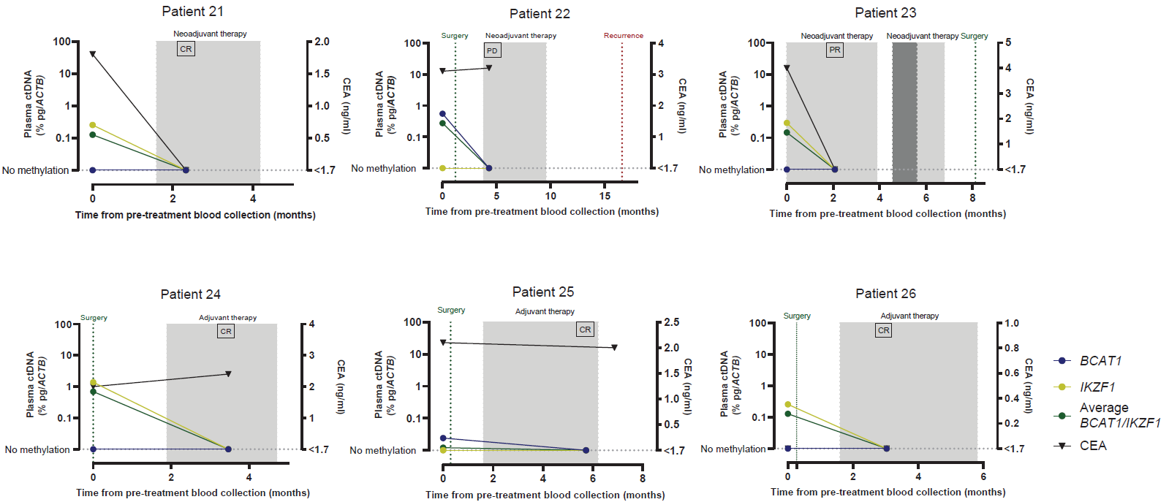

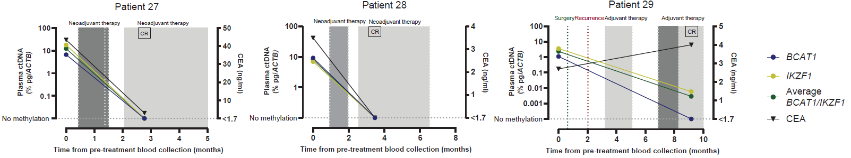

Supplementary Figure 1. Individual patient methylated BCAT1 ctDNA levels, methylated IKZF1 ctDNA levels, average methylated BCAT1/IKZF1 ctDNA levels and CEA levels across each patient’s treatment. Methylated BCAT1=dark blue circle, methylated IKZF1=yellow circle, average methylated BCAT1/IKZF1=green circle, black triangle=CEA. Periods of chemotherapy ± targeted therapy and targeted therapy only are shaded in light grey and periods of radiotherapy are shaded in dark grey. Surgery is represented by a green dotted line, recurrence is represented by a red dotted line and death is represented by a black dotted line. Treatment response status is indicated above each ctDNA blood collection point (CR=complete response, PR=partial response, SD=stable disease and PD=progressive disease.

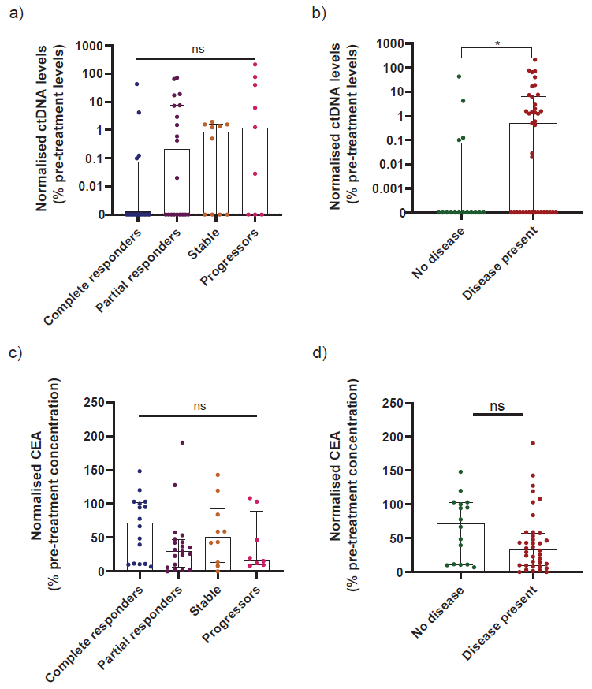
Supplementary Figure 2. a) ctDNA levels during treatment in complete responders, partial responders, stable patients and progressors (normalised to pre-treatment levels, expressed as a percentage). b) ctDNA levels during treatment in patients with disease present vs. no disease (normalised to pre-treatment levels). c) CEA levels during treatment in complete responders, partial responders, stable patients and progressors (normalised to pre-treatment levels). d) CEA levels during treatment in patients with disease present vs. no disease (normalised to pre-treatment levels).

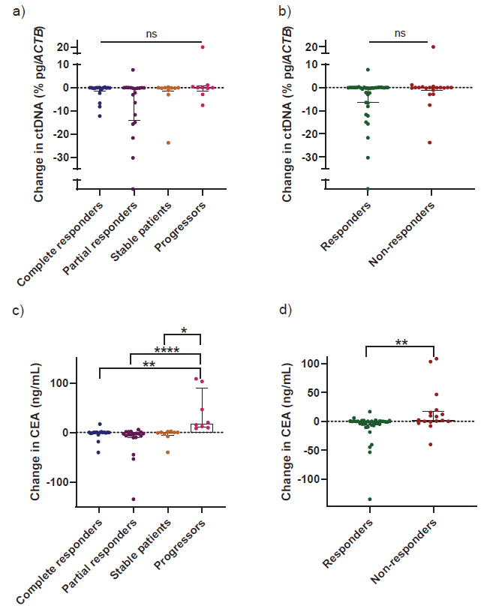Supplementary Figure 3. Change in ctDNA and CEA levels between consecutive bloods. a) Change in ctDNA levels, compared between complete responders, partial responders, stable patients and progressors (% pg/ACTB). b) % Change in ctDNA levels, compared between responders and non-responders (% pg/ACTB). c) % Change in CEA levels, compared between complete responders, partial responders, stable patients and progressors (ng/mL). d) % Change in CEA levels, compared between responders and non-responders (ng/mL). Kruskal-Wallis tests were used for comparisons between complete responders, partial responders, stable patients and progressors, with post-hoc Dunn’s test for multiple pairwise comparisons. Mann-Whitney U tests were used for comparisons between responders and non-responders. *p<0.05, **p<0.01, ****p<0.0001

