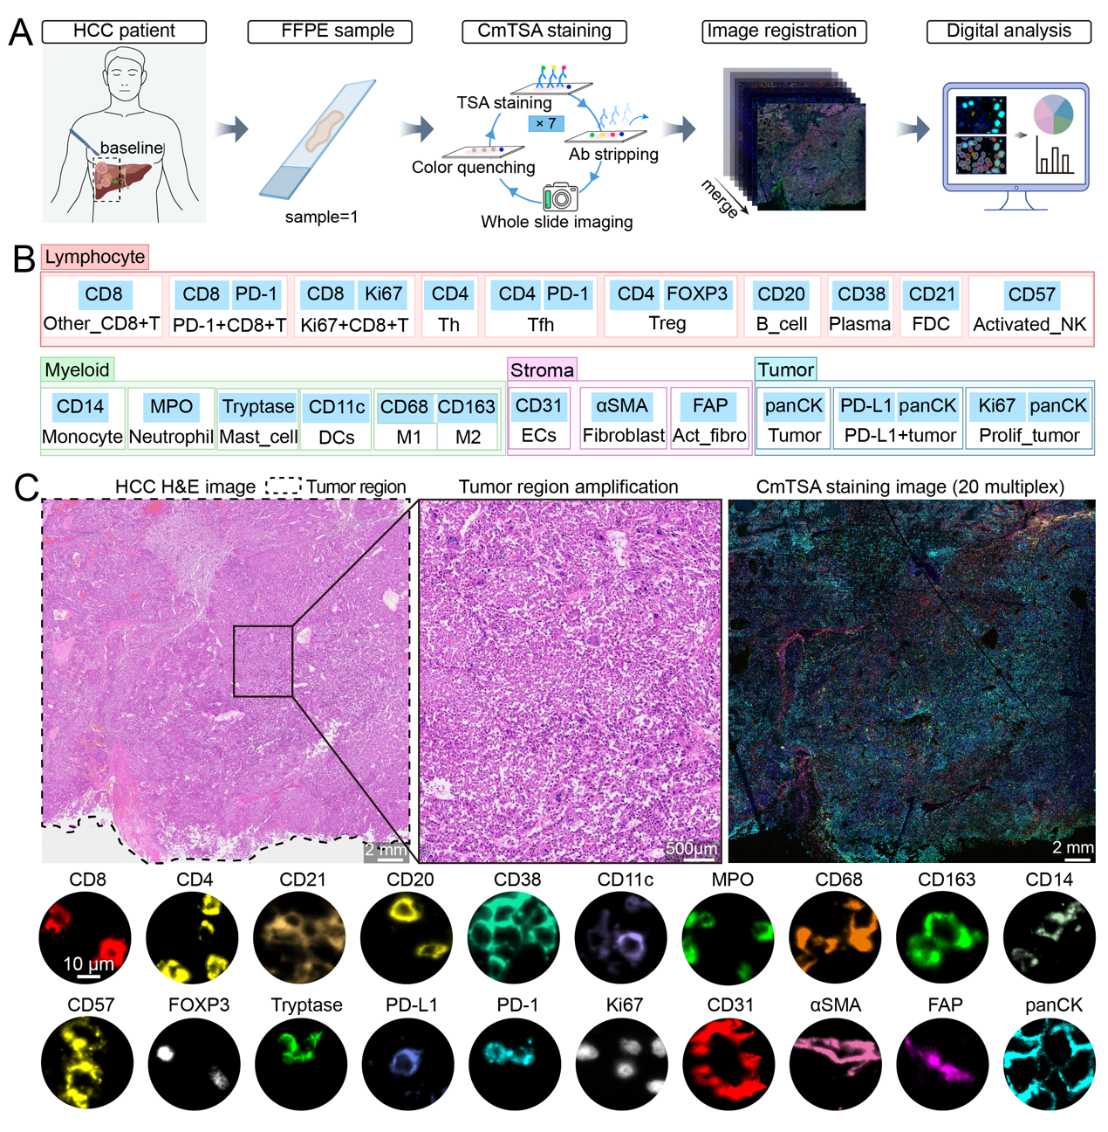
Figure S1. Schematic overview of the CmTSA imaging workflow and the representative staining results.
A. Schematic workflow of CmTSA staining, including sequential TSA labeling, imaging, and digital analysis.
B. Panel of 20 biomarkers categorized into lymphocyte, myeloid, stroma, and tumor cell subsets.
C. Representative H&E and CmTSA images of the primary HCC tissue, showing the expression patterns of all 20 biomarkers at the tumor region.

MATERIALS AND METHODS
Cyclic multiplexed Tyramide Signal Amplification (CmTSA) and analysis strategy
- Clinical sample collection
Human FFPE tissue sample from surgically resected primary HCC patient were collected from the Department of Pathology, West China Hospital, Sichuan University. Valid tissue samples were obtained from patients in the course of clinical treatment, and written informed consent was acquired from this patient.
H&E sample collection
Staining and image acquisition were completed by the Department of Pathology, West China Hospital, Sichuan University.
- Antibody infromations
Table 1. Antibody informations
Antibody | Brand | Catalog# | Dilution rate
CD20 | HUABIO | IRS003 | 1:100
CD21 | HUABIO | IRS019 | 1:100
CD38 | HUABIO | IRS006 | 1:100
CD4 | HUABIO | IRS005 | 1:100
CD8 | Immunoway | YM6938 | 1:500
CD57 | HUABIO | IRS027 | 1:100
FOXP3 | abcam | ab20034 | 1:800
PD1 | ZSGB-BIO | ZM-0381 | 1:800
CD11c | HUABIO | IRS001 | 1:100
CD14 | HUABIO | IRS015 | 1:100
CD163 | HUABIO | IRS002 | 1:100
CD68 | HUABIO | IRS004 | 1:100
MPO | HUABIO | IRS085 | 1:100
Trypatse | HUABIO | IRS041 | 1:100
CD31 | HUABIO | IRS023 | 1:100
FAP | zenbio | R381838 | 1:1000
aSMA | HUABIO | IRS012 | 1:100
Ki67 | HUABIO | IRS057 | 1:100
panCK | HUABIO | IRS010 | 1:100
PDL1 | abcam | ab279294 | 1:1000

- CmTSA workflow
CmTSA staining
CmTSA staining was performed on formalin-fixed paraffin-embedded (FFPE) sections. Briefly, after deparaffinization and antigen retrieval, background fluorescence was quenched using IRISKit® HyperView Quench Buffer (#MH900102) in the LUMINIRIS Fluorescence Quenching System (#MH030101). Multiplex immunolabeling was conducted with the IRISKit™ HyperView mTSA Kit (#MH900206), using primary antibodies, HRP-conjugated secondary antibodies, and cyclic fluorophore-conjugated tyramides (480/550/630). Antibody stripping was performed after each round. DAPI counterstaining was applied, and whole-slide images were acquired on an Evident VS200 scanner. Multi-round images were registered via DAPI landmarks using IRRISSin software for final super-multiplexed data integration. Detailed methodological protocols for CmTSA staining are documented in our team’s paper “Integrative spatial profiling pipeline for determining TME architectures in archival clinical specimens using CmTSA superplex technology”^{[1]}.
Pathologist-Guided Tumor Region Delineation and ROI Selection
Under the supervision of a pathologist, tumor and adjacent non-tumor regions were identified and delineated on the CmTSA whole-slide images based on the corresponding hematoxylin and eosin (H&E)-stained sections and histomorphological features. Representative regions of interest (ROIs) were selected according to the spatial distribution patterns of tumor cells, immune cells, and stromal components for subsequent visualization and analysis.
Cell segmentation and positive threshold setting
Single-cell segmentation was first performed in QuPath (v0.5.1) using the StarDist-2D model^{[2]}. This process generated individual cell boundaries and extracted mean fluorescence intensity for each marker across distinct cellular compartments (nucleus, cytoplasm, membrane, and whole cell). Subsequently, channel-specific positive thresholds were established on a 0–255 intensity scale based on the actual staining characteristics of each marker. Cells were categorized as positive or negative by comparing their measured intensity against the defined threshold. Finally, the spatial coordinates of each segmented cell were retrieved to support spatial analysis between different cell populations.
Cell Type Identification and Spatial Projection Mapping
Given that individual antigen markers are not uniquely expressed in single cell lineages, precise cellular phenotyping relies on combinatorial marker profiling. Here, a rigorous cell classification strategy was established based on cell lineage-specific biomarkers, cellular abundance characteristics, and actual staining performance, ensuring accurate and reproducible identification of diverse cell subtypes. Combined with the acquired single-cell spatial coordinate information, the classified cell phenotypes were spatially mapped point-by-point to generate a final cell type distribution map for subsequent analysis.
Quantitative Statistical Analysis
All quantitative statistical analyses were conducted using R software (version 4.3.1). Based on the single-cell phenotypic data obtained from whole tumor microenvironments and screened representative ROIs, we systematically quantified the composition of diverse cellular subsets and calculated the relative proportion of each cell population. Data sorting, statistical computation and visualization were implemented with mainstream R packages, including ggplot2, dplyr, readr, tidyr and scales.

Reference
- Xiao C, Zhou R, Chen Q, et al. Integrative spatial profiling pipeline for determining TME architectures in archival clinical specimens using CmTSA superplex technology. Cell Discov. 2026;12(1):16.
- Uwe Schmidt, Martin Weigert, Coleman Broaddus, et al. Cell Detection with Star-convex Polygons. International Conference on Medical Image Computing and Computer-Assisted Intervention (MICCAI), Granada, Spain, September 2018.

