Supplementary Materials
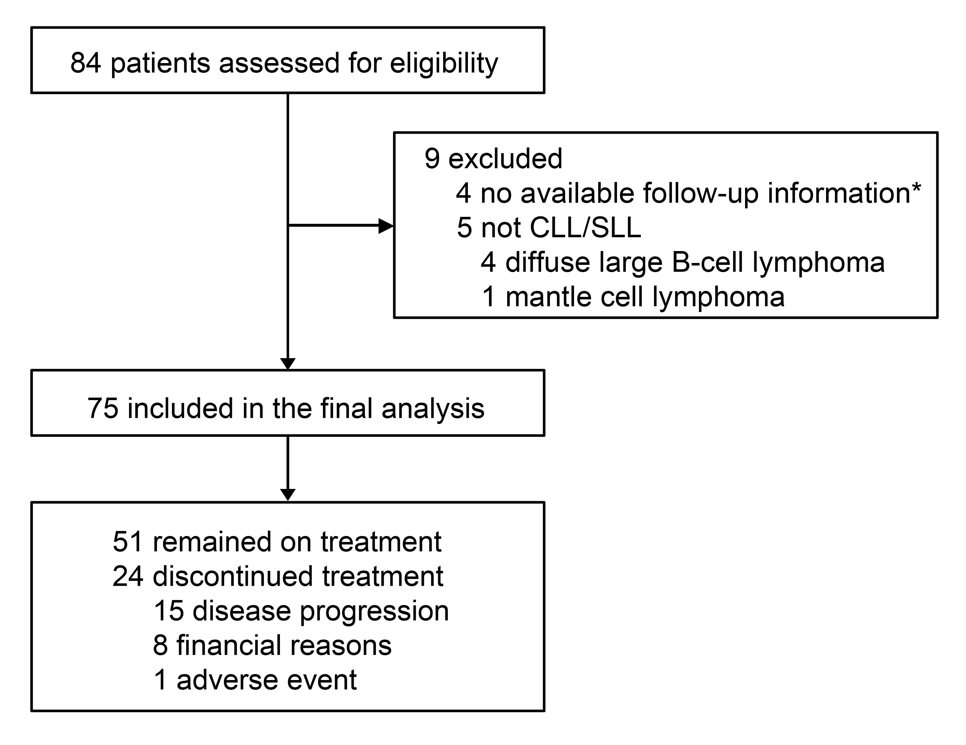
Figure S1. Patient screening and disposition
CLL, chronic lymphocytic leukemia; SLL, small lymphocytic lymphoma.
*None of the four patients without available follow-up information had documented orelabrutinib use before loss to follow-up.
Figure S2. Kaplan-Meier curves of PFS in the different subgroups
PFS by (A) age; (B) comorbidity; (C) IGHV status; (D) del(17p).
PFS, progression-free survival; IGHV, immunoglobulin heavy-chain variable region; del(17p), deletion of the short arm of chromosome 17; CI, confidence interval; NR, not reached.

Figure S3. Kaplan-Meier curves of OS in the different subgroups
OS by (A) age; (B) ECOG performance status; (C) comorbidity; (D) IGHV mutation status; (E) TP53 mutation status; (F) del(17p) status.
OS, overall survival; ECOG, Eastern Cooperative Oncology Group; IGHV, immunoglobulin heavy-chain variable region; TP53, tumor protein p53; del(17p), deletion of the short arm of chromosome 17; CI, confidence interval; NE, not estimated; NR, not reached.

