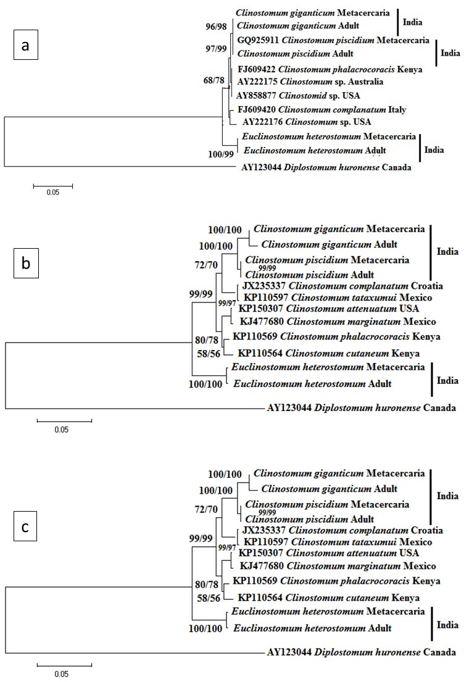

Supplementary Figure. Phylogenetic tree depicting relationships between taxa found in the present study and those found elsewhere inferred from 28S (a), ITS-1 (b) and ITS-2 (c) rRNA gene sequence data. NJ and ML tree from the phylogenetic analysis of 28S (a), ITS-1 (b) and ITS-2 (c) rRNA gene sequence dataset of both metacercariae and adults of Clinostomum species (C. giganticum and C. piscidium) and E. heterostomum using members of the family Clinostomidae). Numbers preceding the taxa are GenBank accession numbers for their28S, ITS-1 and ITS-2 rRNA gene sequences. Numbers at the internodes are NJ bootstrap values (above) and ML bootstrap values (below). Diplistomum huronense (AY123044) was employed as an outgroup.

