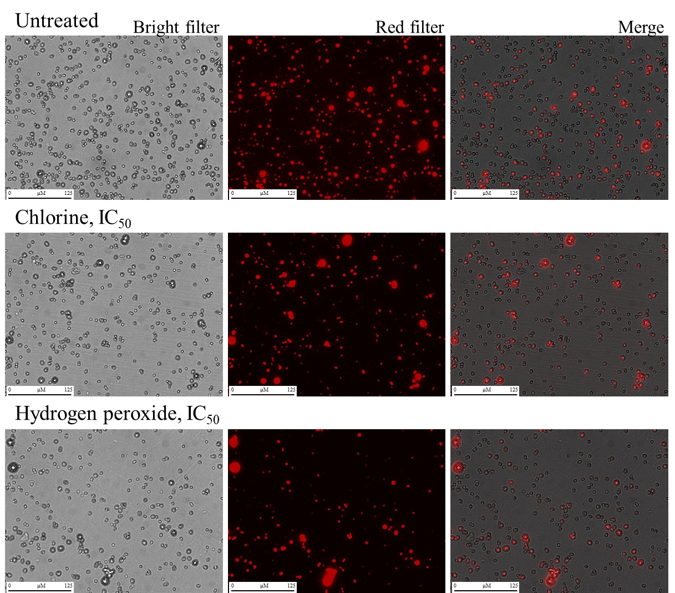
Figure S1. Representative microscopic images of Blastocystis ST4 WR1 untreated (control) and treated at IC₅₀ concentrations of chlorine and hydrogen peroxide for 24 h, and stained with MitoTrackerTM Red CMXRos.
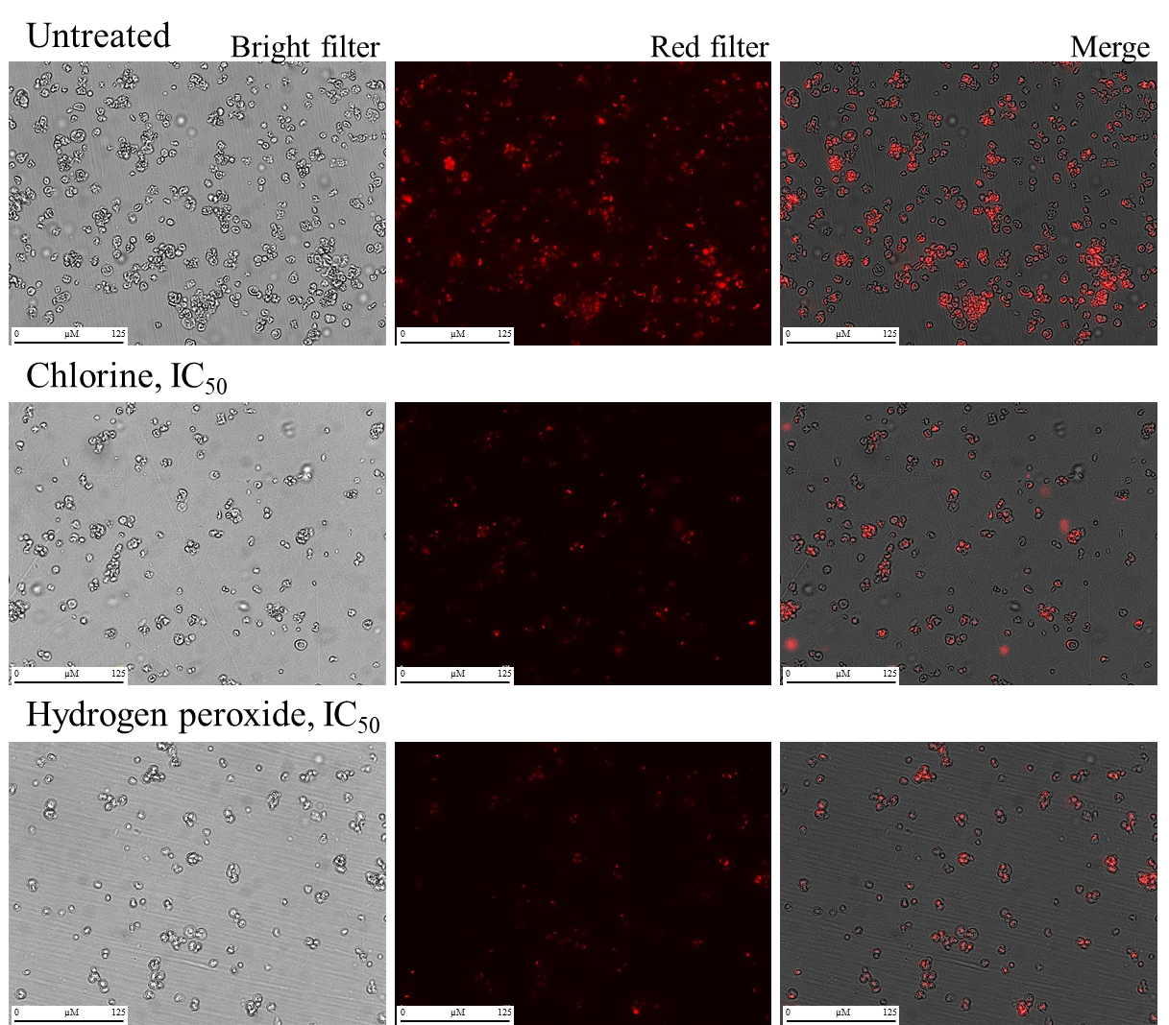
Figure S2. Representative microscopic images of Blastocystis ST7 H untreated (control) and treated at IC₅₀ concentrations of chlorine and hydrogen peroxide for 24 h, and stained with MitoTrackerTM Red CMXRos.
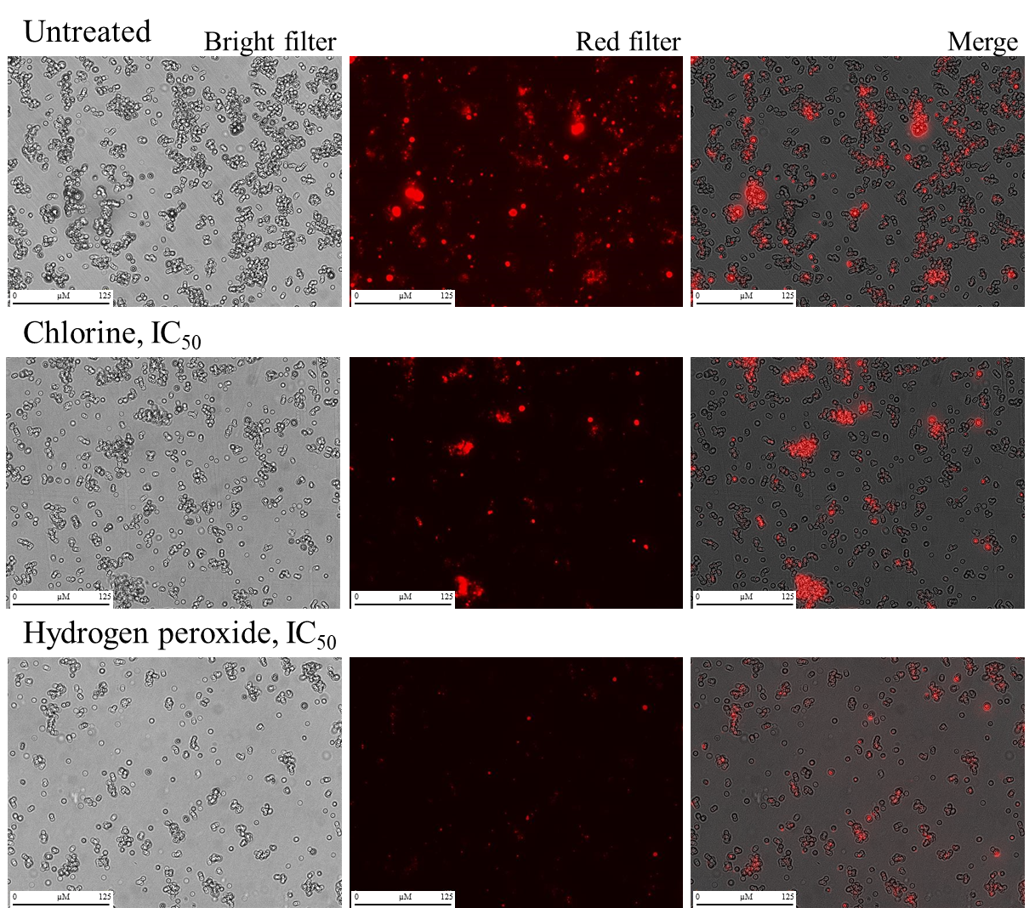
Figure S3. Representative microscopic images of Blastocystis ST7 B untreated (control) and treated at IC₅₀ concentrations of chlorine and hydrogen peroxide for 24 h, and stained with MitoTrackerTM Red CMXRos.

Table S1: Number of Blastocystis cells obtained through the JuLi system software (see Figure S4) that were used to calculate the cell viability.
Sample | Count | Total cells vs untreated | Active cells vs untreated
Untreated
Total cells (Bright) | 874 | 100% | -
Active cells (Red) | 723 (83%) | - | 100%
Chlorine, IC₅₀
Total cells (Bright) | 327 | 37% | -
Active cells (Red) | 211 (64%) | - | 29%
Hydrogen peroxide, IC₅₀
Total cells (Bright) | 308 | 35% | -
Active cells (Red) | 213 (69%) | - | 29%
In brackets, percentage of active cells

Figure S4. Representative microscopic images of Blastocystis ST4 B untreated (control) and treated at IC₅₀ concentrations of chlorine and hydrogen peroxide for 24 h, and stained with MitoTrackerTM Red CMXRos. Arrows show cells that have been selected as inactive (e.g. potential cysts).

