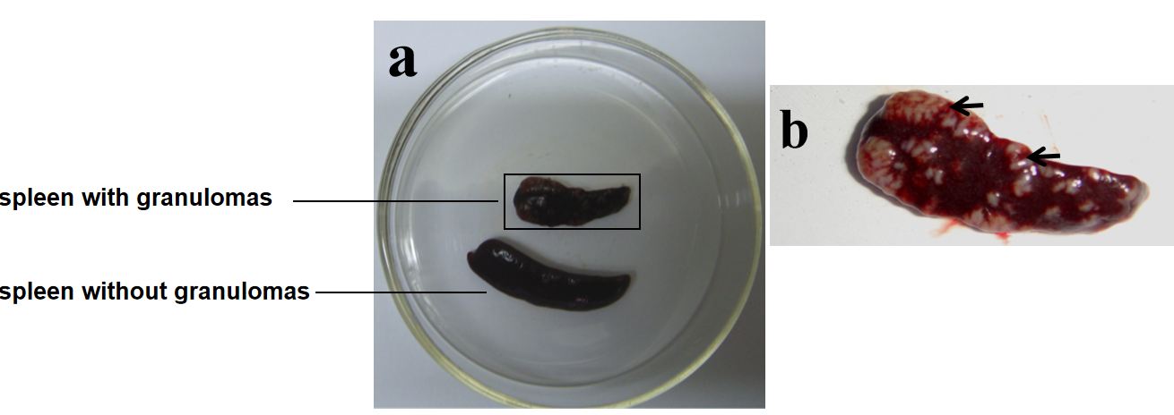

a, Spleens from mice infected with S. japonicum for 16 weeks, area in black rectangle was showed in b, with black arrows indicate splenic granulomas

