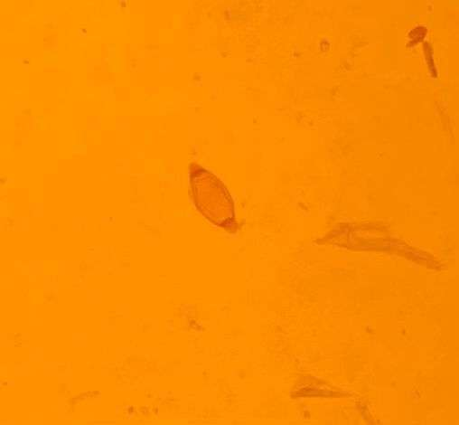
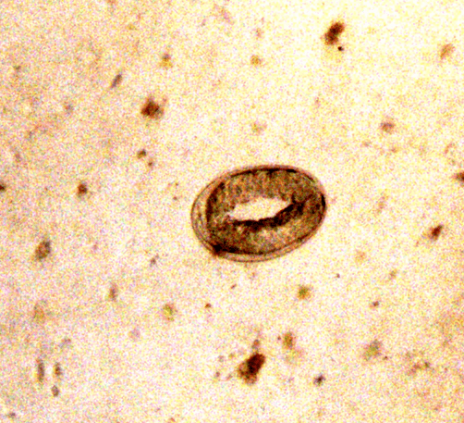
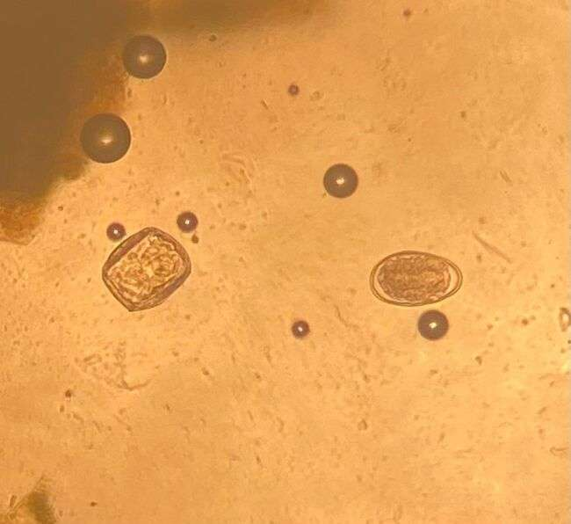
D:Moniezia spp egg
A :Strongyloides spp egg
B :Larvated Strongyloides spp egg

E :Trichuris spp egg

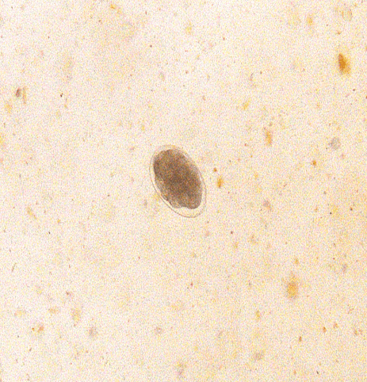

F: Haemonchus spp egg

Supplementary Figure S1: Micrographs of helminth eggs identified from faecal samples from lambs reared on communal farms of the KSD local municipality

