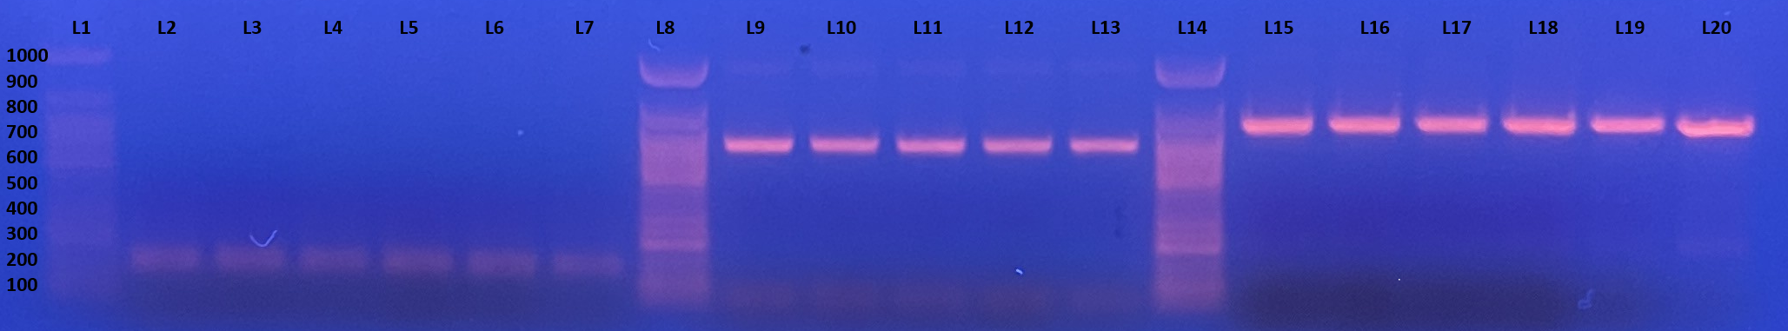
Supplementary 1. Agarose gel electrophoresis image of PCR amplicons obtained from kdr mutation screenings (Lanes L1, L8, and L14 represent the 100 bp DNA ladder used as a molecular size marker. Lanes L2–L7 show PCR products amplified from domain I of the vgsc gene targeting the V410L point mutation. Lanes L9–L13 correspond to PCR amplicons from domain II, used for detection of the S989P, I1011M/V, L1014F, and V1016G/I mutations. Lanes L15–L20 display PCR products amplified from domain III for analysis of the T1520I and F1534C mutations.

