Figure S1: Change in the distribution of the number of phenotypes (Zoomed in to 1 – 4 phenotypes). The fraction of genes in the GWAS catalog (Y-axis) associated with a given number of phenotypes (X-axis). Color gradient indicates year that the data was available from (red = 2005 to blue = 2017).

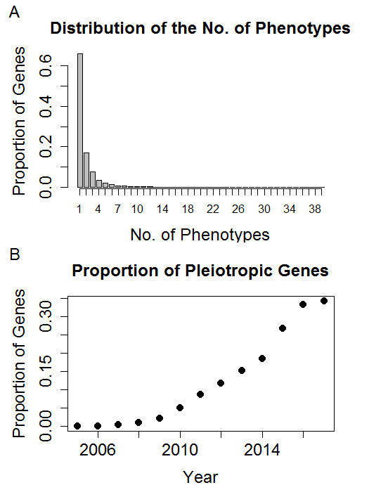

Figure S2: Distribution of the number of phenotypes each gene is associated with in the GWAS catalog (p-value <5e-8). A) Histogram showing the proportion of genes that associate with phenotypes in the GWAS catalog (y-axis) and the number of phenotypes with which they associate (x-axis). B) The proportion of genes associated with 2 or more phenotypes (y-axis) for each year (x-axis).

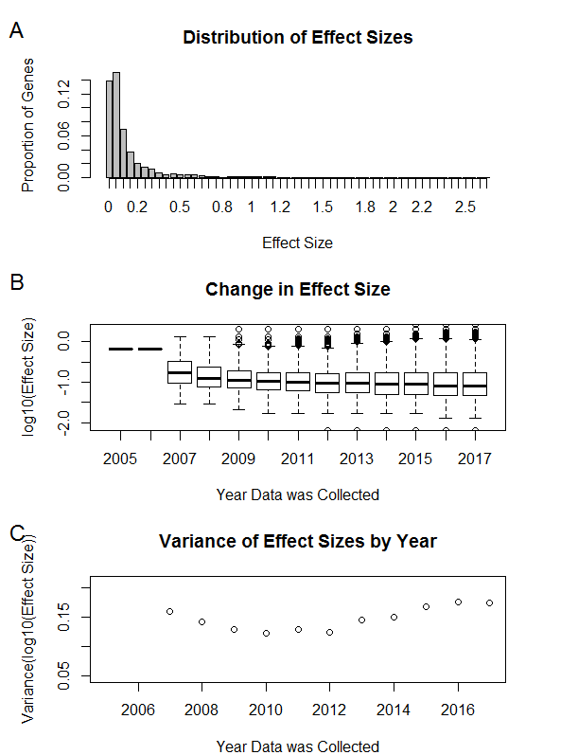
Figure S3: Distribution of effect sizes in the GWAS catalog (p-value <5e-8). A) Histogram showing the proportion of genes in the GWAS catalog (y-axis) with a given effect size (x-axis). B) Boxplot of log₁₀(Effect Sizes) (y-axis) for each year from 2005 – 2017 (x-axis). C) Variance of log₁₀(Effect Sizes) (y-axis) for each year from 2005 – 2017 (x-axis)

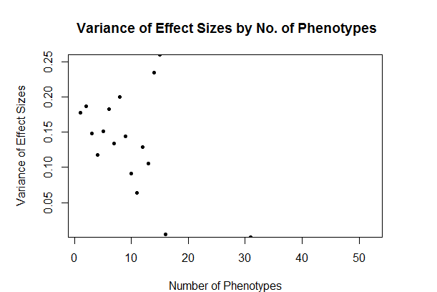

Figure S4: Variance of log₁₀(effect size) (y-axis) for all genes with a given number of phenotypes (x-axis) (p-value <5e-8).

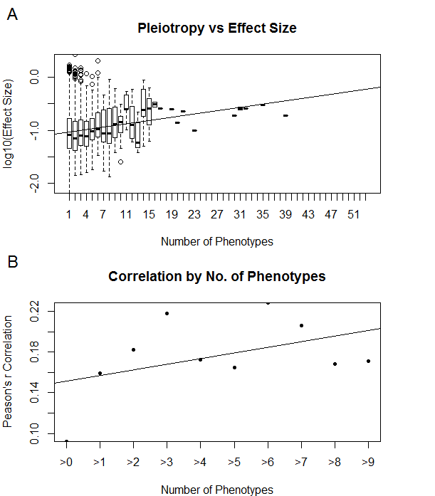
Figure S5: Relationship between Pleiotropy and effect size(p-value <5e-8). A) the number of phenotypes (x-axis) vs. the log₁₀(effect size) (y-axis). B) Pearson’s r correlation (number of phenotypes vs log₁₀(effect size)) (y-axis) for all genes with more than the number of phenotypes (>X) (x-axis).

