Supplementary Material

Fig. S1. Homology model of RPL3L binding to the ribosome.

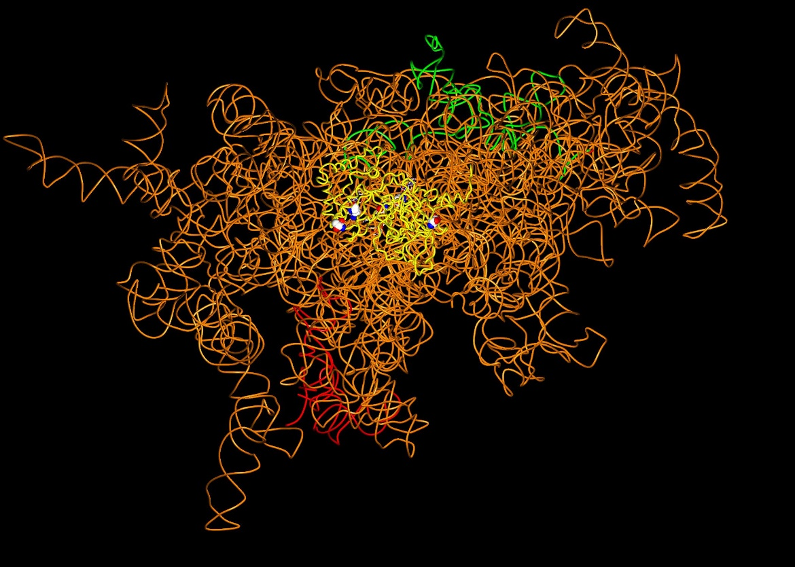

RPL3L and ribosomal RNA are shown in worm representation with RPL3L in yellow, the 28S RNA in orange, the 5S RNA in red, and the 5.8S RNA in green. Residues in RPL3L with significant variants are shown in sphere representation and colored by atom type.

Table S1. M-CAP scores and in silico prediction of the RPL3L variants identified in this study.
Family | Genomic location (hg19) | HGVS cDNA | HGVS protein | M-CAP scores | M-CAP prediction
1 | Chr16:1996654 | c.923A>T | p.(Asp308Val) | 0.061 | Possibly Pathogenic
1 | Chr16:1995856 | c.1027C>T | p.(Arg343Trp) | 0.054 | Possibly Pathogenic
2 | Chr16:1997317 | c.566C>T | p.(Thr189Met) | 0.03 | Possibly Pathogenic
2 | Chr16:1996655 | c.922G>A | p.(Asp308Asn) | 0.044 | Possibly Pathogenic
3 | Chr16:2000865 | c.481C>T | p.(Arg161Trp) | 0.064 | Possibly Pathogenic
3 | Chr16:2004073 | c.80G>A | p.(Gly27Asp) | 0.09 | Possibly Pathogenic

Table S2. MPC, MVP2 and PrimateAI prediction scores for the identified RPL3L missense variants.
Family | Genomic location (hg19) | HGVS cDNA | HGVS protein | MPC | MVP2 | PrimateAI
1 | Chr16:1996654 | c.923A>T | p.(Asp308Val) | 0.63 | 0.78 | 0.62
1 | Chr16:1995856 | c.1027C>T | p.(Arg343Trp) | 0.54 | 0.81 | 0.79
2 | Chr16:1997317 | c.566C>T | p.(Thr189Met) | 0.52 | 0.25 | 0.57
2 | Chr16:1996655 | c.922G>A | p.(Asp308Asn) | 0.43 | 0.65 | 0.67
3 | Chr16:2000865 | c.481C>T | p.(Arg161Trp) | 0.45 | 0.84 | 0.79
3 | Chr16:2004073 | c.80G>A | p.(Gly27Asp) | 0.55 | 0.79 | 0.81

