Supplementary Materials

Figure S1. Frequency distribution of continuous variables.
Figure S2. Within-Family and Population-based Polygenic Score Prediction in Metabolic Traits.
Figure S3. Estimates of shrinkage between population and within-sibship models with corresponding 95% CIs.
Figure S4. Estimates of shrinkage between population and within-sibship models after controlling for diet with corresponding 95% CIs.
Table S1. Data structure of the analytical design.
Table S2. Characteristics of the Study Population.
Table S3. Intraclass coefficients for siblings and parent-offspring trios.
Table S4. Within- and between-family prediction estimates of metabolic traits.
Table S5. Estimates of Indirect Genetic Effects of Diet on Metabolic Traits.
Table S6. Estimates of Indirect Genetic Effects of Diet on Metabolic Traits, after adjusting for SES.
Table S7. Within-sibship shrinkage estimates.
Table S8. Wilcoxon test comparing SNP estimates distribution.

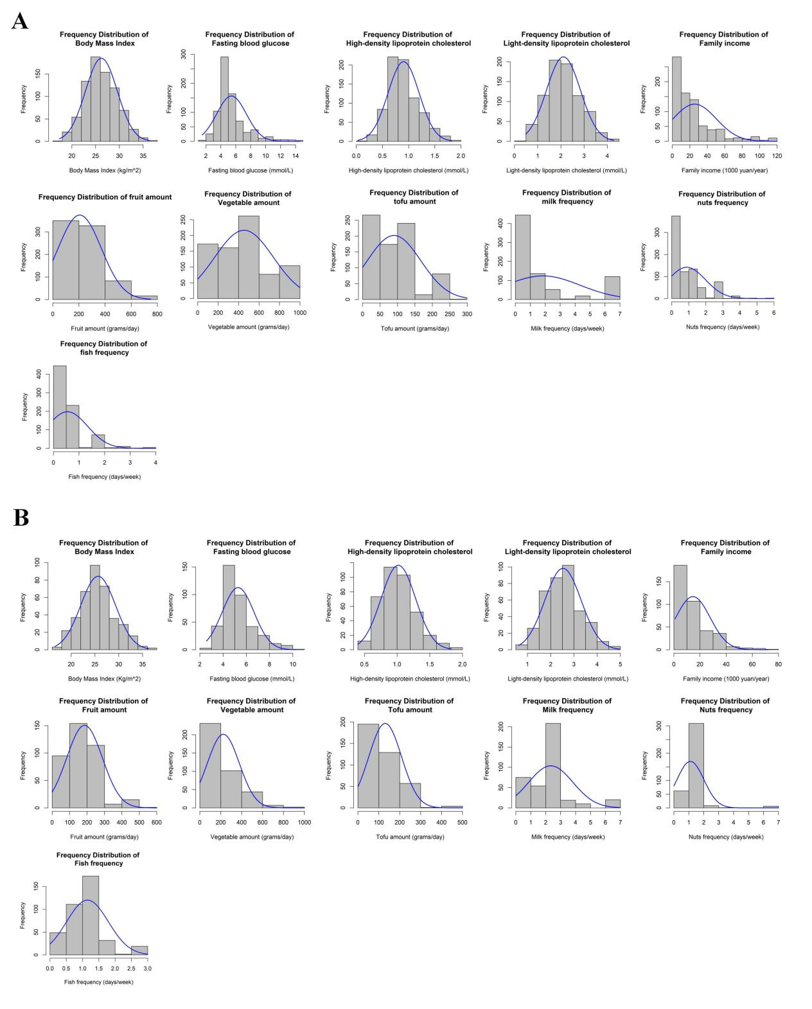
Figure S1. Frequency distribution of continuous variables.
- distribution of continuous variables in siblings study; (b) distribution of continuous variables in parent-offspring study.

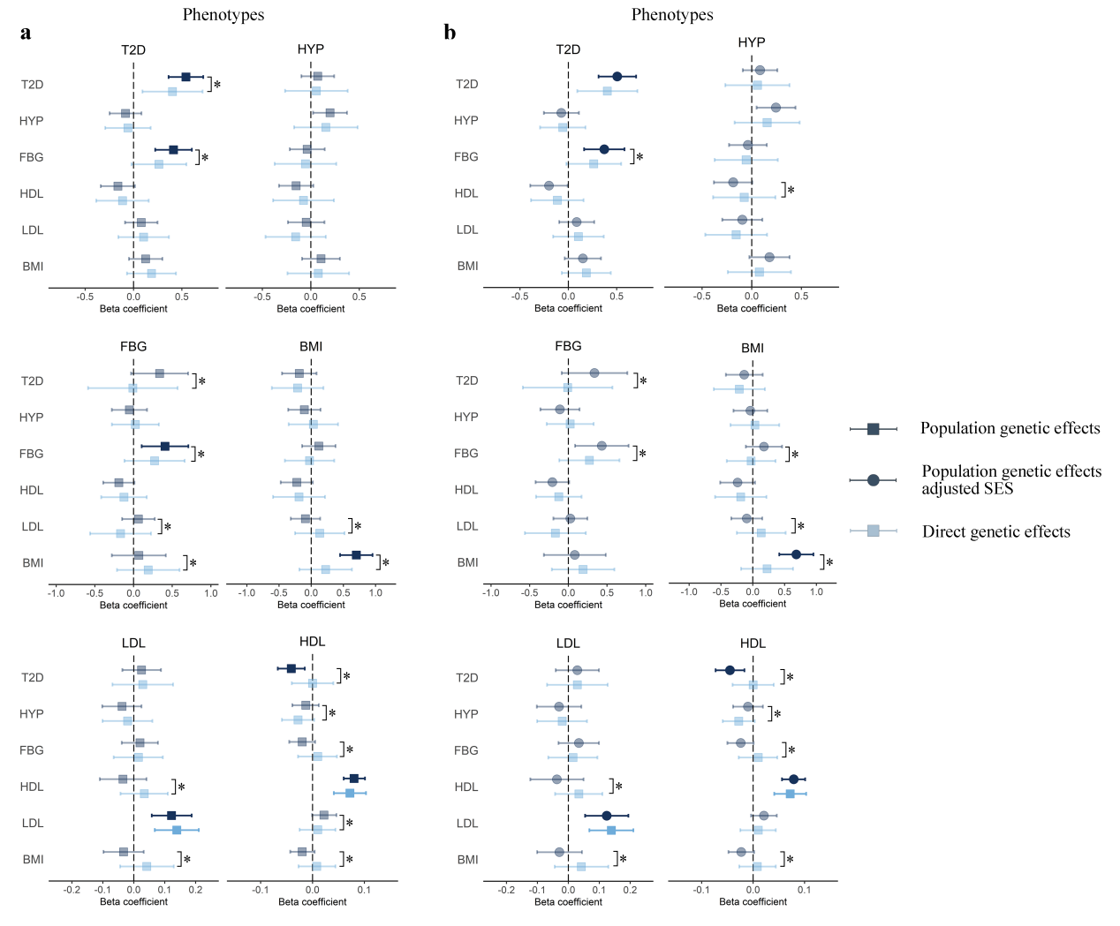

Figure S2. Within-Family and Population-based Polygenic Score Prediction in Metabolic Traits.
Findings before (a) and after (b) statistical correction for family SES. The PGSs are presented on the y-axis, predicting each of the six metabolic traits. Error bars represent 95% confidence percentile intervals. Opaque estimates indicate statistical significance at the false discovery rate corrected threshold of P < 0.05. * indicate a significant difference between population-based and within-family prediction estimates at the false discovery rate corrected threshold of P < 0.05. The dotted line represents a beta coefficient of zero. T2D, type 2 diabetes; HYP, hypertension; FBG, fasting blood glucose; HDL, high-density lipoprotein cholesterol; LDL, light-density lipoprotein cholesterol; BMI, body mass index.

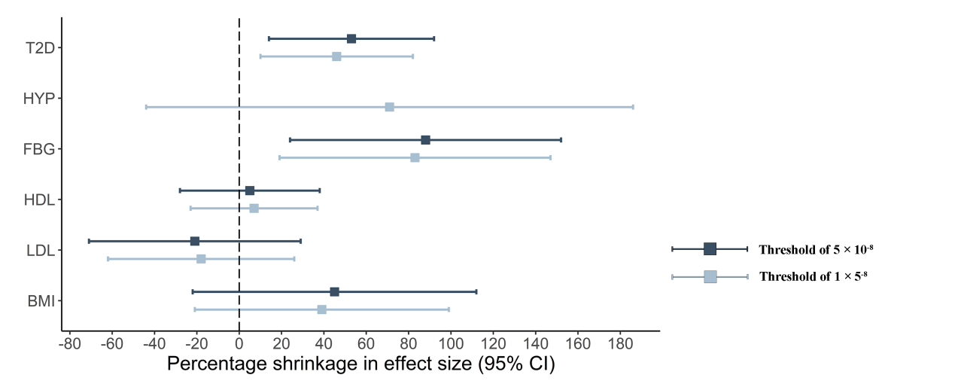Figure S3. Estimates of shrinkage between population and within-sibship models after controlling for with corresponding 95% CIs. Shrinkage is defined as the % decrease in association between the relevant weighted score and phenotype when comparing the population estimate with the within-sibship estimate. Shrinkage was computed as the ratio of two weighted score association estimates with standard errors derived using leave-one-out jackknifing.

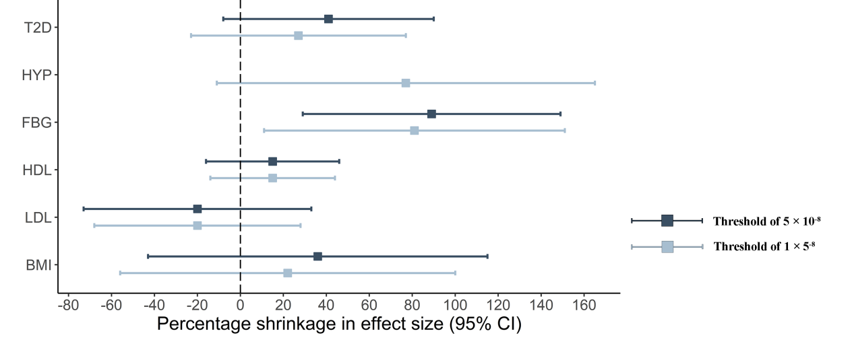
Figure S4. Estimates of shrinkage between population and within-sibship models after controlling for dietary patterns with corresponding 95% CIs. Shrinkage is defined as the % decrease in association between the relevant weighted score and phenotype when comparing the population estimate with the within-sibship estimate. Shrinkage was computed as the ratio of two weighted score association estimates with standard errors derived using leave-one-out jackknifing.

Table S1.Data structure of the analytical design
Study design | Number of offsprings/siblings within each family | Number of families | Total number of people
Trios design | 1 | 99 | 297
Trios design | ≥2 | 21 | 89
Sibling design | 2 | 267 | 534
Sibling design | 3 | 52 | 156
Sibling design | >3 | 20 | 87

Table S3. Intraclass coefficients for siblings and parent-offspring trios
Design | Sibling design |  |  |  | Trios design
Phenotype | ICC | ICC 95% CI L | ICC 95% CI U |  | ICC | ICC 95% CI L | ICC 95% CI U
Type 2 diabetes | 0.174 | 0.036 | 0.2 |  | 0.065 | 0 | 0.158
Hypertension | 0.04 | 0.011 | 0.061 |  | 0.087 | 0 | 0.179
Fasting blood glucose | 0.278 | 0.187 | 0.37 |  | 0.152 | 0.043 | 0.27
Body mass index | 0.247 | 0.15 | 0.338 |  | 0.269 | 0.163 | 0.372
High-density lipoprotein cholesterol | 0.408 | 0.319 | 0.491 |  | 0.345 | 0.235 | 0.456
Light-density lipoprotein cholesterol | 0.426 | 0.346 | 0.503 |  | 0.2 | 0.083 | 0.297
ICC = Intraclass coefficient; CI = Confidence Interval.

Table S11. Wilcoxon test comparing SNP estimates distribution
Phenotype | Population-based model vs Within-sibship model |  |  | Population-based model controlling for dietary patterns vs Within-sibship model
Phenotype | Q | P |  | Q | P
Type 2 diabetes | 5.49E+12 | <0.01 |  | 5.49E+12 | <0.01
Hypertension | 5.33E+12 | <0.01 |  | 5.26E+12 | <0.01
Fasting blood glucose | 2.16E+13 | <0.01 |  | 2.15E+13 | <0.01
High-density lipoprotein cholesterol | 5.50E+12 | <0.01 |  | 5.47E+12 | <0.01
Light-density lipoprotein cholesterol | 5.4935E+12 | <0.01 |  | 5.4563E+12 | <0.01
Body mass index | 5.45E+12 | <0.01 |  | 5.45E+12 | <0.01

