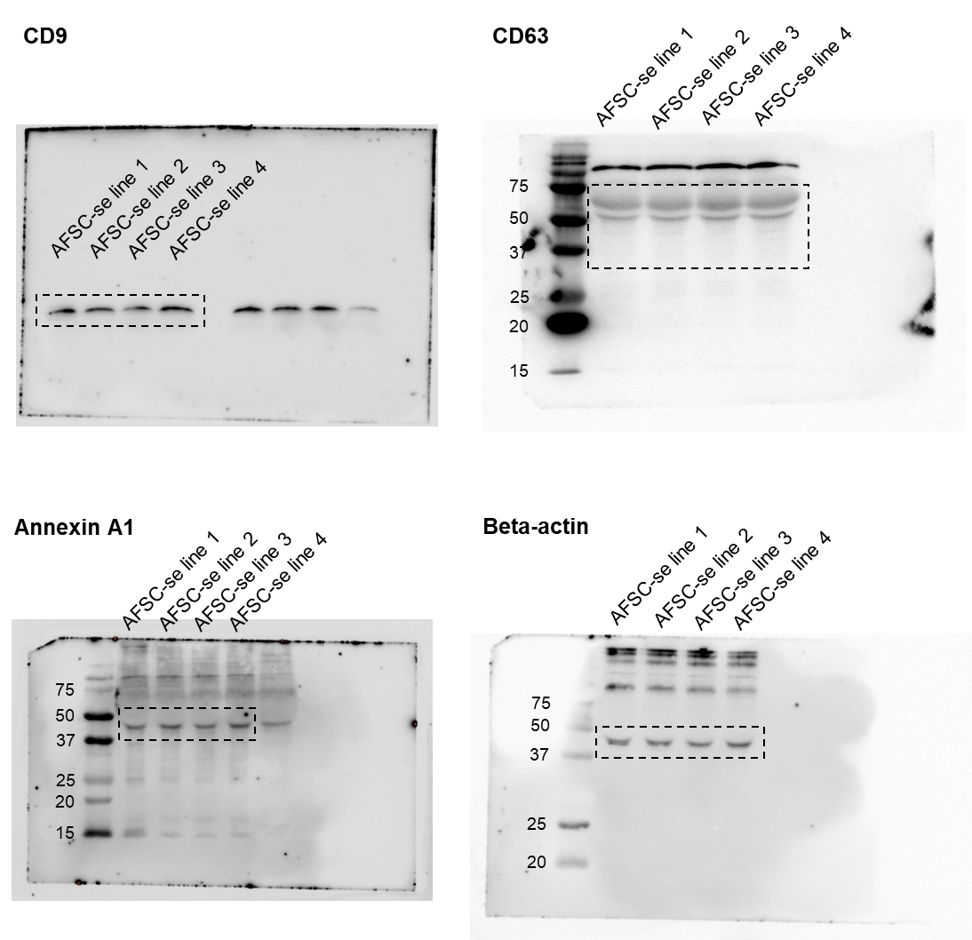
Supplementary Figure S1. Full length of Western blots in Fig. 1g. Dot boxes indicate the cropped blots shown in Fig. 1g.

