Quantifying consistent individual differences in habitat selection
Oecologia
Martin Leclerc, Eric Vander Wal, Andreas Zedrosser,
Jon E. Swenson, Jonas Kindberg and Fanie Pelletier

Corresponding author: Andreas Zedrosser, andreas.zedrosser@hit.no
Department of Environmental and Health Studies, Telemark University College, Norway

Supplementary material

Figure S1 How estimate of habitat selection repeatability can be biased by functional responses in habitat selection
Table S1 Random structures tested to assess the repeatability of habitat selection for cut blocks.
Table S2 Candidate models tested to assess the repeatability of habitat selection for cut blocks.
Table S3 Estimate and 95% C.I. of covariates in the model to assess the repeatability of habitat selection for cut blocks.
Appendix 1 R-script simulations of repeatability estimate with different habitat selection pattern.

Figure S1 Schematic representation showing that biased estimates of repeatability of habitat selection can be obtained if we do not account for functional responses in habitat selection. Results from the left panel (a, c, and e) do not account for functional response in habitat selection while panel on the right panel (b, d, and f) account for functional response in habitat selection. Note that different numbers refer to different individuals
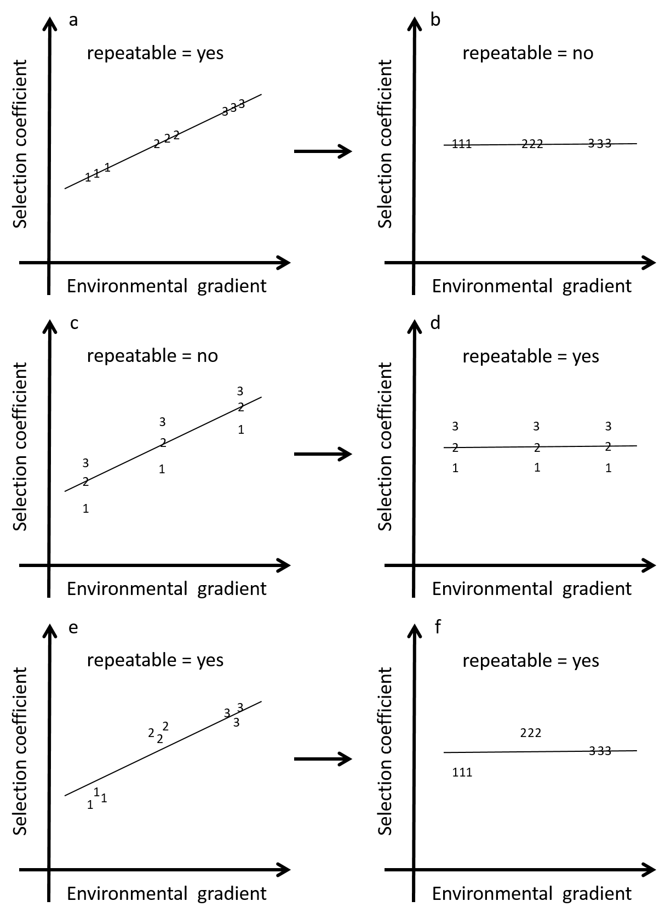
Table S1 Random structures tested to assess the repeatability of habitat selection of cut blocks by brown bears in Sweden between 2007 and 2012. Models are listed with their random intercepts, random coefficient, log likelihood (LL), differences in Akaike Information Criterion in relation to the best-supported model (Δ AIC), and Akaike weight (w_{i}).

MODEL | Random intercept | Random coefficient | LL | Δ AIC | w_{i}
A | Bear-year nested in BearID | – | -92170 | 1410 | 0
B | Bear-year nested in BearID | % cut blocks | -91462 | 0 | 1

Table S2 Candidate models tested to assess repeatability of habitat selection of cut blocks by brown bears in Sweden between 2007 and 2012. Models are listed with their fixed effects covariates, log likelihood (LL), differences in Akaike Information Criterion in relation to the best-supported model (Δ AIC), and Akaike weight (w_{i}). All models were tested with bear-year nested in BearID as a random intercept and % cut blocks as a random coefficient (model B from Table S1).

MODEL | VARIABLES INCLUDED | LL | ∆ AIC | w_{i}
Base | % cut blocks + % cut blocks in the annual home range + % cut blocks × % cut blocks in the annual home range | -98294 | 13652 | 0
Elevation | CONTROL + mean elevation + coefficient of variation of elevation | -96905 | 10877 | 0
Natural | ELEVATION + % water + % mixed–deciduous + % bog | -93384 | 3841 | 0
Full | NATURAL + % young forest + road density | -91462 | 0 | 1

Table S3 Coefficients (β) and 95% confidence intervals of the fixed effect covariates of the most parsimonious model to assess the repeatability of cut blocks habitat selection by brown bears in Sweden between 2007 and 2012. This model also included bear-year nested in BearID as a random intercept and % cut blocks as a random coefficient (model B from Table S1).

Variable | β | 95% Confidence Interval
 |  | Lower | Upper
Intercept | -0.070 | -0.115 | -0.026
% cut blocks | 0.264 | 0.194 | 0.334
% cut blocks within annual home range | -0.125 | -0.158 | -0.091
Mean elevation | -0.131 | -0.148 | -0.114
Coefficient of variation of elevation | 0.073 | 0.060 | 0.085
% water | -0.483 | -0.503 | -0.464
% mixed–deciduous | 0.022 | 0.011 | 0.033
% bog | -0.433 | -0.447 | -0.419
% young forest | 0.182 | 0.170 | 0.194
Roads length | -0.306 | -0.317 | -0.294
% cut blocks × % cut blocks within annual home range | 0.014 | -0.046 | 0.073

Appendix S1
# R-Script by Martin Leclerc
# For Leclerc et al. –Quantifying consistent individual differences in habitat selection–Oecologia

# Simulations of consistent individual variation in habitat selection
# Simulations of 5 individuals followed for 3 years
# Each individual-year exist in similar landscapes
# Habitat use differ between individual and individual-year

#######
# Simulation 1
# Habitat X non-significant at the population level
# but high among and low within individual variation

# Create the landscape
random=as.data.frame(cbind(bearID=c("a","b","c","d","e"),
year=c(rep(1,2500),rep(2,2500),rep(3,2500)),
y=0))
random$bearyear=paste(random$bearID,random$year,sep="")
random$value=rnorm(7500,mean=100,sd=30)

# Create habitat use pattern for each individual-year
# with high among and low within individual variation
inda1=rnorm(500,mean=60,sd=10)#individual1-year1
inda2=rnorm(500,mean=70,sd=10)#individual1-year2
inda3=rnorm(500,mean=80,sd=10)#individual1-year3
indb1=rnorm(500,mean=85,sd=10)#individual2-year1
indb2=rnorm(500,mean=88,sd=10)#individual2-year2
indb3=rnorm(500,mean=90,sd=10)#individual2-year3
indc1=rnorm(500,mean=90,sd=10)#individual3-year1
indc2=rnorm(500,mean=100,sd=10)#individual3-year2
indc3=rnorm(500,mean=110,sd=10)#individual3-year3
indd1=rnorm(500,mean=110,sd=10)#individual4-year1
indd2=rnorm(500,mean=112,sd=10)#individual4-year2
indd3=rnorm(500,mean=115,sd=10)#individual4-year3
inde1=rnorm(500,mean=120,sd=10)#individual5-year1
inde2=rnorm(500,mean=130,sd=10)#individual5-year2
inde3=rnorm(500,mean=140,sd=10)#individual5-year3
loc=as.data.frame(cbind(bearID=c(rep("a",1500),rep("b",1500),rep("c",1500),rep("d",1500),rep("e",1500)),
year=c(rep(1,500),rep(2,500),rep(3,500)),
y=1))
loc$bearyear=paste(loc$bearID,loc$year,sep="")
loc$value=c(inda1,inda2,inda3,indb1,indb2,indb3,indc1,indc2,indc3,indd1,indd2,indd3,inde1,inde2,inde3)

# Merging database and RSF model
str(loc)
str(random)
Final=rbind(random,loc)
library(lme4)
Sim1=glmer(y~value+(value|bearID/bearyear),family="binomial",Final)
summary(Sim1)

# Extract variances component and estimate repeatability
repSim1= VarCorr(Sim1)$bearID[4] / (VarCorr(Sim1)$bearID[4] + VarCorr(Sim1)$bearyear[4])
repSim1
################################################################
# Habitat type not selected nor avoided at the population level
# and highly repeatable (0.8-0.9 depending on rnorm values)
################################################################

#######
# Simulation 2
# Habitat X non-significant at the population level
# and low among and high within individual variation

# Create the landscape
random=as.data.frame(cbind(bearID=c("a","b","c","d","e"),
year=c(rep(1,2500),rep(2,2500),rep(3,2500)),
y=0))
random$bearyear=paste(random$bearID,random$year,sep="")
random$value=rnorm(7500,mean=100,sd=30)

# Create habitat use pattern for each individual-year
# with low among and high within individual variation
inda1=rnorm(500,mean=90,sd=30) #individual1-year1
inda2=rnorm(500,mean=100,sd=30)#individual1-year2
inda3=rnorm(500,mean=110,sd=30)#individual1-year3
indb1=rnorm(500,mean=90,sd=30 )#individual2-year1
indb2=rnorm(500,mean=100,sd=30)#individual2-year2
indb3=rnorm(500,mean=110,sd=30)#individual2-year3
indc1=rnorm(500,mean=90,sd=30 )#individual3-year1
indc2=rnorm(500,mean=100,sd=30)#individual3-year2
indc3=rnorm(500,mean=110,sd=30)#individual3-year3
indd1=rnorm(500,mean=90,sd=30) #individual4-year1
indd2=rnorm(500,mean=100,sd=30)#individual4-year2
indd3=rnorm(500,mean=110,sd=30)#individual4-year3
inde1=rnorm(500,mean=90,sd=30) #individual5-year1
inde2=rnorm(500,mean=100,sd=30)#individual5-year2
inde3=rnorm(500,mean=110,sd=30)#individual5-year3
loc=as.data.frame(cbind(bearID=c(rep("a",1500),rep("b",1500),rep("c",1500),rep("d",1500),rep("e",1500)),
year=c(rep(1,500),rep(2,500),rep(3,500)),
y=1))
loc$bearyear=paste(loc$bearID,loc$year,sep="")
loc$value=c(inda1,inda2,inda3,indb1,indb2,indb3,indc1,indc2,indc3,indd1,indd2,indd3,inde1,inde2,inde3)

# Merging database and RSF model
str(loc)
str(random)
Final=rbind(random,loc)
library(lme4)
Sim2=glmer(y~value+(value|bearID/bearyear),family="binomial",Final)
summary(Sim2)

# Extract variances component and estimate repeatability
repSim2=VarCorr(Sim2)$bearID[4] / (VarCorr(Sim2)$bearID[4] + VarCorr(Sim2)$bearyear[4])
repSim2
################################################################
# Habitat type not selected nor avoided at the population level#
# and low repeatability (>1.0e-5)
################################################################

#######
# Simulation 3
# Habitat X selected at the population level
# and low among and high within individual variation

# Create the landscape
random=as.data.frame(cbind(bearID=c("a","b","c","d","e"),
year=c(rep(1,2500),rep(2,2500),rep(3,2500)),
y=0))
random$bearyear=paste(random$bearID,random$year,sep="")
random$value=rnorm(7500,mean=100,sd=30)

# Create habitat use pattern for each individual-year
# with low among and high within individual variation
inda1=rnorm(500,mean=90+40,sd=30) #individual1-year1
inda2=rnorm(500,mean=100+40,sd=30)#individual1-year2
inda3=rnorm(500,mean=110+40,sd=30)#individual1-year3
indb1=rnorm(500,mean=90+40,sd=30) #individual2-year1
indb2=rnorm(500,mean=100+40,sd=30)#individual2-year2
indb3=rnorm(500,mean=110+40,sd=30)#individual2-year3
indc1=rnorm(500,mean=90+40,sd=30) #individual3-year1
indc2=rnorm(500,mean=100+40,sd=30)#individual3-year2
indc3=rnorm(500,mean=110+40,sd=30)#individual3-year3
indd1=rnorm(500,mean=90+40,sd=30) #individual4-year1
indd2=rnorm(500,mean=100+40,sd=30)#individual4-year2
indd3=rnorm(500,mean=110+40,sd=30)#individual4-year3
inde1=rnorm(500,mean=90+40,sd=30) #individual5-year1
inde2=rnorm(500,mean=100+40,sd=30)#individual5-year2
inde3=rnorm(500,mean=110+40,sd=30)#individual5-year3
loc=as.data.frame(cbind(bearID=c(rep("a",1500),rep("b",1500),rep("c",1500),rep("d",1500),rep("e",1500)),
year=c(rep(1,500),rep(2,500),rep(3,500)),
y=1))
loc$bearyear=paste(loc$bearID,loc$year,sep="")
loc$value=c(inda1,inda2,inda3,indb1,indb2,indb3,indc1,indc2,indc3,indd1,indd2,indd3,inde1,inde2,inde3)

# Merging database and RSF model
str(loc)
str(random)
Final=rbind(random,loc)
library(lme4)
Sim3=glmer(y~value+(value|bearID/bearyear),family="binomial",Final)
summary(Sim3)

# Extract variances component and estimate repeatability
repSim3=VarCorr(Sim3)$bearID[4] / (VarCorr(Sim3)$bearID[4] + VarCorr(Sim3)$bearyear[4])
repSim3
################################################################
# Habitat type selected at the population level
# and low repeatability (>1.0e-5)
################################################################

