Online Resource 1. Park map showing annual rainfall (left) and the study sites (right).

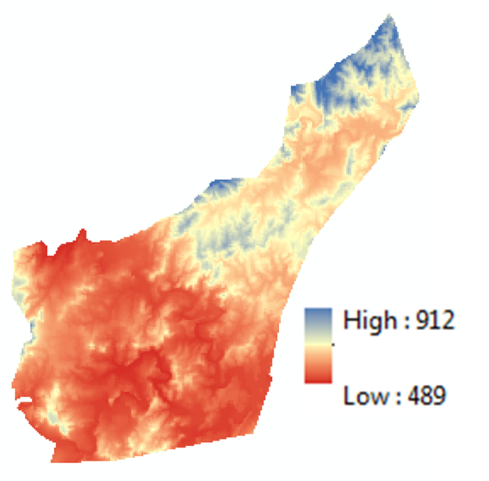
Online Resource 2. Seasonal variation in rainfall, aboveground primary production, nutritional quality and herbivore consumption for lawn and bunch grasses. Different lines indicate averages per site per period where colors represent annual amount of rainfall.

