Supplementary Information for:
“Resistance is futile: RNA-sequencing reveals differing responses to bat fungal pathogen in Nearctic Myotis lucifugus and Palearctic Myotis myotis
Including:
Figs. S1 to S4
Tables S1 to S3
Supplemental datasets 1 -4 as separate files.
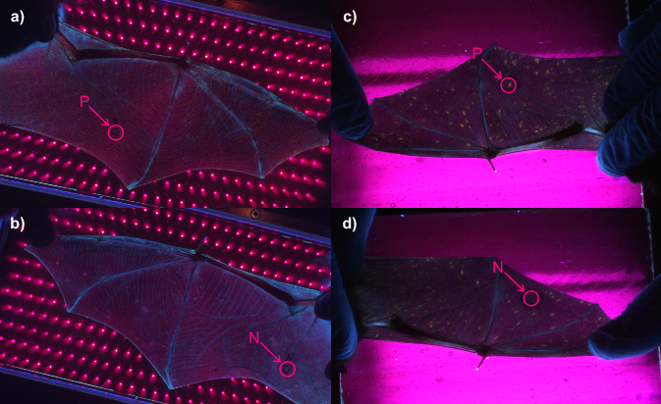

Fig. S1. Examples of sampling locations on bats: a) UV-positive M. myotis b) UV-negative M. myotis c) UV-positive M. lucifugus d) UV-negative M. lucifugus.

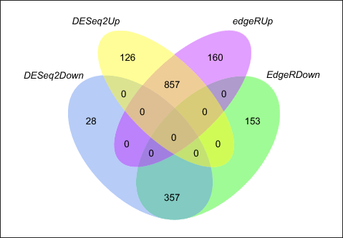

Fig. S2. Comparison of differential expression in M. lucifugus using DESeq2 and edgeR.

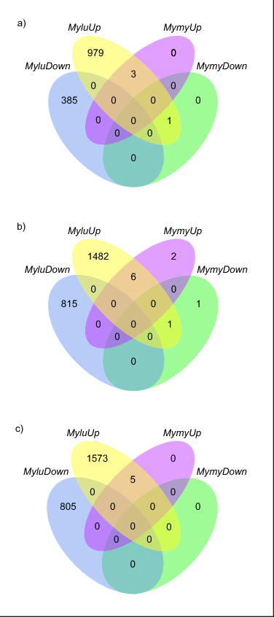

Fig. S3. Comparisons of differential expression using edgeR between M. lucifugus and M. myotis when transcripts are mapped to a) M. lucifugus genome, b) M. davidii genome, b) M. brandtii genome.

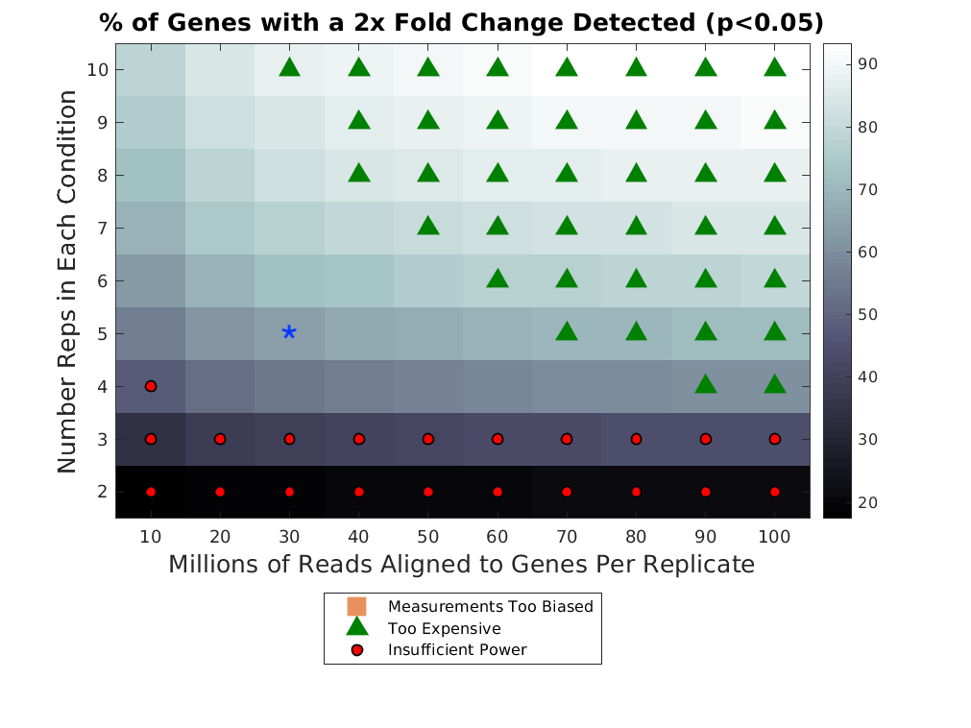

Fig. S4. Power analysis of differential gene expression showing the percent of genes with a 2-fold change in expression detected at p<0.05 for various study designs. The current study is indicated by an asterisk.

Table S1. The number of lesions, calculated from photographs at the time of sampling, were considerably lower in M. myotis compared to M. lucifugus.
M. lucifugus | Number of lesions |  | M. myotis | Number of lesions
ID | Right | Left | ID | Right | Left
8 | 3469 | 3018 | 2 | 8 | 11
11 | 1892 | 1642 | 9 | 247 | 89
16 | 1379 | 1529 | 13 | 21 | 18
21 | 1912 | 2947 | 17 | 127 | 48
23 | 1789 | 2137 | 18 | 73 | 192

Table S2. Mapping rates to M. lucifugus reference genome for the samples from M. lucifugus and M. myotis.

Sample | Reads | STAR uniquely mapped | Rate
Mylu08_UVneg | 28,227,304 | 24,258,895 | 85.94%
Mylu08_UVpos | 31,885,284 | 27,383,551 | 85.88%
Mylu11_UVneg | 36,076,494 | 30,863,508 | 85.55%
Mylu11_UVpos | 25,449,264 | 21,912,022 | 86.10%
Mylu16_UVneg | 29,569,913 | 25,511,454 | 86.28%
Mylu16_UVpos | 28,215,949 | 24,319,333 | 86.19%
Mylu21_UVneg | 22,909,267 | 19,639,759 | 85.73%
Mylu21_UVpos | 31,351,109 | 26,883,142 | 85.75%
Mylu23_UVneg | 32,993,452 | 28,096,045 | 85.16%
Mylu23_UVpos | 30,890,733 | 26,043,495 | 84.31%
Mymy02_UVneg | 34,290,736 | 26,448,603 | 77.13%
Mymy02_UVpos | 28,020,461 | 21,775,023 | 77.71%
Mymy09_UVneg | 28,040,967 | 21,667,504 | 77.27%
Mymy09_UVpos | 30,109,388 | 23,463,240 | 77.93%
Mymy13_UVneg | 32,855,251 | 25,328,644 | 77.09%
Mymy13_UVpos | 25,009,540 | 19,414,725 | 77.63%
Mymy17_UVneg | 29,149,471 | 22,377,246 | 76.77%
Mymy17_UVpos | 27,854,272 | 21,233,176 | 76.23%
Mymy18_UVneg | 31,672,563 | 24,068,775 | 75.99%
Mymy18_UVpos | 26,030,730 | 19,637,701 | 75.44%

Table S3. All of the M. myotis samples were obtained from the plagiopatagium (P), while three M. lucifugus biopsies were from the chiropatagium (C), all in the UV negative group.
Label | Individual | Group | Species | Location | Infection
Mylu08UV- | Mylu08 | MyluUVneg | Mylu | P | UV-negative
Mylu08UV+ | Mylu08 | MyluUVpos | Mylu | P | UV-positive
Mylu11UV- | Mylu11 | MyluUVneg | Mylu | C | UV-negative
Mylu11UV+ | Mylu11 | MyluUVpos | Mylu | P | IUV-positive
Mylu16UV- | Mylu16 | MyluUVneg | Mylu | C | UV-negative
Mylu16UV+ | Mylu16 | MyluUVpos | Mylu | P | UV-positive
Mylu21UV- | Mylu21 | MyluUVneg | Mylu | P | UV-negative
Mylu21UV+ | Mylu21 | MyluUVpos | Mylu | P | UV-positive
Mylu23UV- | Mylu23 | MyluUVneg | Mylu | C | UV-negative
Mylu23UV+ | Mylu23 | MyluUVpos | Mylu | P | UV-positive
Mymy02UV- | Mymy02 | MymyUVneg | Mymy | P | UV-negative
Mymy02UV+ | Mymy02 | MymyUVpos | Mymy | P | UV-positive
Mymy09UV- | Mymy09 | MymyUVneg | Mymy | P | UV-negative
Mymy09UV+ | Mymy09 | MymyUVpos | Mymy | P | UV-positive
Mymy13UV- | Mymy13 | MymyUVneg | Mymy | P | UV-negative
Mymy13UV+ | Mymy13 | MymyUVpos | Mymy | P | UV-positive
Mymy17UV- | Mymy17 | MymyUVneg | Mymy | P | UV-negative
Mymy17UV+ | Mymy17 | MymyUVpos | Mymy | P | UV-positive
Mymy18UV- | Mymy18 | MymyUVneg | Mymy | P | UV-negative
Mymy18UV+ | Mymy18 | MymyUVpos | Mymy | P | UV-positive

Supplemental Dataset 1(separate file)
Sorted and normalized differential expression of transcripts in M. lucifugus samples. See the second tab of the spreadsheet for the legend.
Dataset 2 (separate file)
All of the genes differentially expressed in these categories due to local infection in M. lucifugus showed lower fold-changes due to infection in M. myotis and were not differentially expressed in UV-positive tissue (Figure 3 and Dataset S3) or with respect to biopsy location (Supplemental Table 3). See the second tab of the spreadsheet for the legend.
Supplemental Dataset 3 (separate file)
Results for REVIGO analysis used to filter the gene ontology categories for redundancy.
Supplemental Dataset 4 (separate file)
When analyzing the M. lucifugus samples for differential expression based on biopsy location, we found strong enrichment of muscle development and function gene ontology categories. See the second tab of the spreadsheet for the legend.

