Bank vole alarm pheromone chemistry and effects in the field

Appendix 1

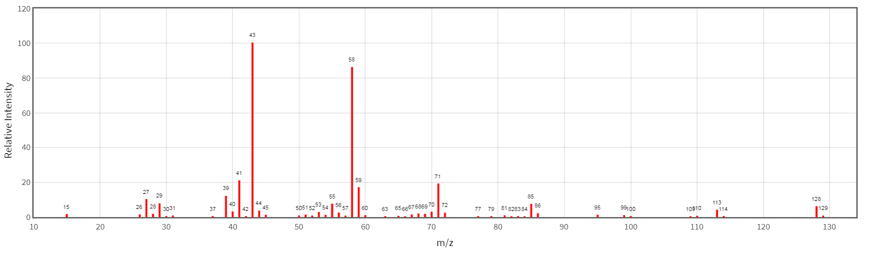
Figure S1: Theoretical mass spectrum for 2-octanol

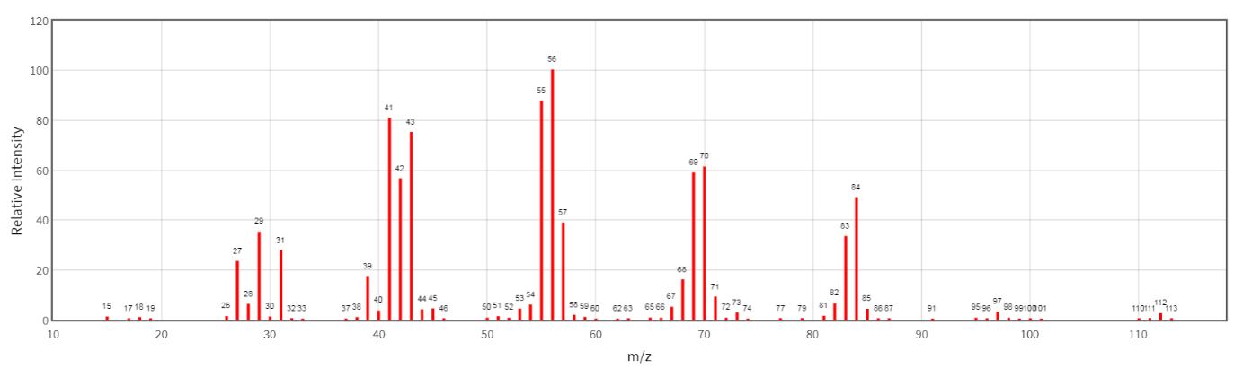
Figure S2: Theoretical mass spectrum of 1-octanol

