Electronic supplemental material

Positive effects of fast growth on locomotor performance in pelagic fish juveniles

Masahiro Nakamura^{1*}, Michio Yoneda¹, Taizo Morioka¹, Akinori Takasuka², Nozomi Nishiumi³

¹Fisheries Technology Institute, Japan Fisheries Research and Education Agency
Hakatajima Filed Station, Imabari, Ehime 794-2305, Japan
²Graduate School of Agricultural and Life Sciences, the University of Tokyo, Bunkyo, Tokyo 113-8657, Japan
³National Institute for Basic Biology, Higashiyama 5-1, Myodaiji, Okazaki, Aichi 444-8787, Japan

*Corresponding author: M. Nakamura
Tel: +81-897-72-0204, Fax: +81-897-72-2544
Email: mnakamura@affrc.go.jp

Table S1: Standard length (SL), days post hatch (dph) and rearing tanks for individuals used for analysis
ID | SL (mm) | dph | tank |  | ID | SL (mm) | dph | tank
1 | 21.51 | 20 | A |  | 40 | 16.46 | 27 | D
2 | 22.69 | 20 | A |  | 41 | 17.76 | 30 | A
3 | 17.13 | 20 | A |  | 42 | 16.97 | 30 | A
4 | 25.25 | 20 | B |  | 43 | 23.19 | 30 | A
5 | 23.07 | 20 | B |  | 44 | 20.14 | 30 | A
6 | 18.44 | 20 | B |  | 45 | 22.48 | 30 | A
7 | 15.95 | 20 | B |  | 46 | 23.27 | 30 | B
8 | 24.76 | 20 | C |  | 47 | 23.34 | 30 | B
9 | 21.66 | 20 | C |  | 48 | 21.83 | 30 | B
10 | 14.49 | 20 | C |  | 49 | 23.72 | 30 | B
11 | 15.21 | 20 | C |  | 50 | 21.67 | 30 | B
12 | 21.29 | 20 | D |  | 51 | 18.74 | 30 | C
13 | 20.73 | 20 | D |  | 52 | 16.53 | 30 | C
14 | 17.93 | 20 | D |  | 53 | 23.74 | 30 | C
15 | 17.30 | 20 | D |  | 54 | 18.35 | 30 | C
16 | 23.36 | 24 | A |  | 55 | 19.28 | 30 | D
17 | 19.25 | 24 | A |  | 56 | 20.41 | 30 | D
18 | 19.71 | 24 | A |  | 57 | 18.11 | 30 | D
19 | 21.12 | 24 | A
20 | 18.27 | 24 | B
21 | 18.73 | 24 | B
22 | 18.86 | 24 | B
23 | 17.78 | 24 | B
24 | 19.16 | 24 | B
25 | 21.73 | 27 | A
26 | 20.46 | 27 | A
27 | 21.97 | 27 | A
28 | 19.51 | 27 | A
29 | 20.64 | 27 | B
30 | 24.15 | 27 | B
31 | 23.10 | 27 | B
32 | 21.17 | 27 | B
33 | 19.60 | 27 | C
34 | 20.10 | 27 | C
35 | 14.50 | 27 | C
36 | 20.29 | 27 | C
37 | 18.29 | 27 | D
38 | 19.66 | 27 | D
39 | 19.18 | 27 | D

Fig. S1: Relationships between burst speed and standard length (SL) at each day post hatch (dph). Generalized linear model (GLM) was used to determine whether burst speed was significantly affected by dph, which contained mean burst speed of individuals as a response variable and SL and dph as explanatory variables. Dashed lines indicate generalized linear models fitted to the data at each dph-group. Individuals of 30 dph (slow growers) were estimated to show significantly low burst speed compared to the same-size individuals of 20 dph (P < 0.01). Significant effect of SL on burst speed was detected in this analysis (P < 0.01). The GLM was based on a Gamma distribution
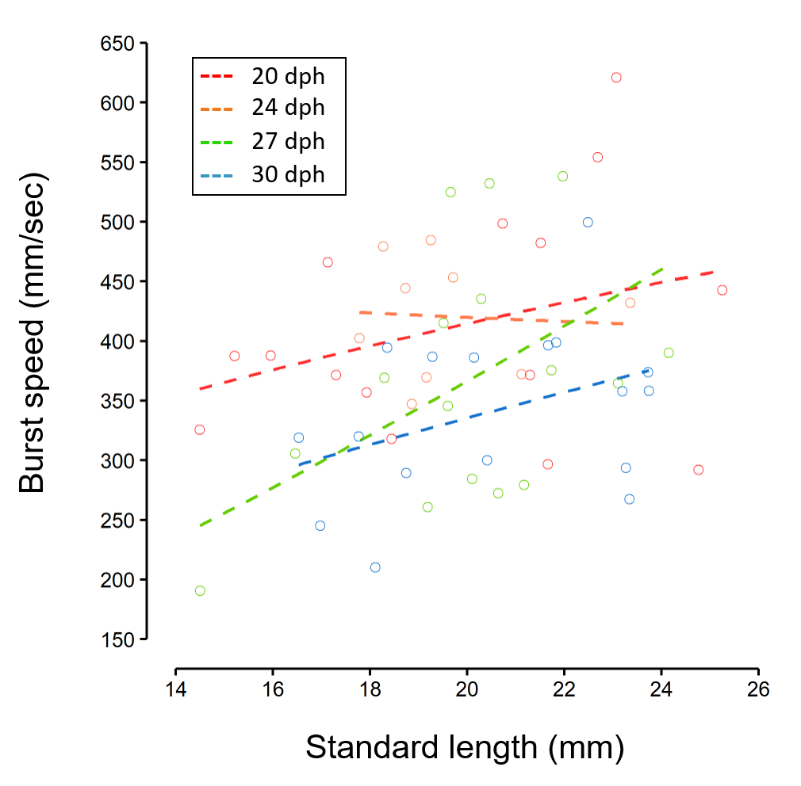

Table S2: Summary of results of a generalized linear mixed model (GLMM) and Wald’s test used to examine whether routine speed was significantly affected by standard length (SL), growth rate, and aliz arin complexone (ALC) marking. The GLMM was based on a Gamma distribution. It contained SL, growth rate, and ALC marking as explanatory variables and individual ID and rearing tank as random effects. VIF = variance inflation factor, SE = standard error

Explanatory variable | VIF | Estimate | SE | z value | P value
SL | 1.75 | 0.033 | 0.017 | 1.909 | 0.056
growth rate | 1.74 | -0.166 | 0.297 | -0.560 | 0.575
ALC marking | 1.01 | -0.039 | 0.067 | -0.573 | 0.567
Random effects | variance | SD
individual id | 0.05 | 0.23
rearing tank | < 0.01 | < 0.01

Table S3: Summary of results of a generalized linear mixed model (GLMM) and Wald’s test used to examine whether burst speed was significantly affected by standard length (SL), growth rate, and alizarin complexone (ALC) marking. The GLMM was based on a Gamma distribution. It contained SL, growth rate, and ALC marking as explanatory variables and individual ID and rearing tank as random effects. VIF = variance inflation factor, SE = standard error

Explanatory variables | VIF | Estimate | SE | z value | P value
SL | 1.70 | -0.012 | 0.014 | -0.859 | 0.390
growth rate | 1.66 | 0.729 | 0.238 | 3.063 | 0.002
ALC marking | 1.03 | 0.109 | 0.060 | 1.817 | 0.069
Random effects | variance | SD
indvidual id | 0.01 | 0.08
rearing tank | 0.01 | 0.08

Table S4: Details of modeling results of generalized linear mixed models (GLMMs) and Wald’s test to examine the relationship between burst speed and growth rate. The GLMMs were based on a Gamma distribution, and contained growth rate as an explanatory variable and individual ID and rearing tank as random effects. SE: standard error; SD: standard deviation

Model | Explanatory variable | Estimate | SE | z value | P value
Linear | Growth rate | 0.6395 | 0.1932 | 3.31 | 0.00093
Quadratic | Growth rate | 4.0419 | 1.4114 | 2.864 | 0.00419
 | Growth rate² | -2.2288 | 0.9178 | -2.428 | 0.01517
Cubic | Growth rate | 12.317 | 8.04 | 1.532 | 0.126
 | Growth rate² | -13.725 | 11.038 | -1.244 | 0.214
 | Growth rate³ | 5.106 | 4.886 | 1.045 | 0.296
Model | Random effects | Variance | SD
Linear | individual ID | 0.010312 | 0.10155
 | rearing tank | 0.003845 | 0.06201
Quadratic | individual ID | 0.00772 | 0.08786
 | rearing tank | 0.001724 | 0.04152
Cubic | individual ID | 0.006845 | 0.08274
 | rearing tank | 0.002291 | 0.04786
Akaike information criterion (AIC) values of the models; Linear: 2000.5, Quadratic: 1996.9, Cubic: 1997.9

