Appendices
Appendix A: Capture rate summary table

Common name | Species | PreCR | PostCR | PreOc | PostOc | Strata | Nocturnal | Mass_g | Diet
Armadillo sp. | Dasypus sp. | 0.89 | 2.37 | 0.3 | 0.5 | G | 1 | 3500 | Invertebrate
Brazilian rabbit | Sylvilagus brasiliensis | 0 | 0.66 | 0 | 0.06 | G | 1 | 950 | PlantSeed
Brown agouti | Dasyprocta punctata | 2.09 | 4.19 | 0.45 | 0.66 | G | 0 | 2675 | FruiNect
Bush dog | Speothos venaticus | 0 | 0.03 | 0 | 0.02 | G | 0 | 6000 | VertFishScav
Capybara | Hydrochoerus hydrochaeris | 0 | 0.03 | 0 | 0.02 | G | 0 | 48145 | PlantSeed
Coati | Nasua nasua | 0.09 | 0.63 | 0.05 | 0.29 | S | 0 | 3794 | FruiNect
Collared anteater | Tamandua tetradactyla | 0.09 | 0.3 | 0.05 | 0.18 | S | 1 | 5515 | Invertebrate
Collared peccary | Pecari tajacu | 1.14 | 6.39 | 0.45 | 0.76 | G | 1 | 21267 | PlantSeed
Common opossum | Didelphis marsupialis | 0.74 | 8.89 | 0.34 | 0.6 | S | 1 | 1091 | Omnivore
Crab-eating raccoon | Procyon cancrivorus | 0.14 | 0.1 | 0.09 | 0.02 | G | 1 | 6950 | Omnivore
Giant anteater | Myrmecophaga tridactyla | 0.26 | 0.88 | 0.14 | 0.27 | G | 1 | 22333 | Invertebrate
Giant armadillo | Priodontes maximus | 0.2 | 0.4 | 0.09 | 0.18 | G | 1 | 45360 | Invertebrate
Green acouchy | Myoprocta pratti | 1.2 | 0.88 | 0.25 | 0.16 | G | 0 | 967 | FruiNect
Grey brocket deer | Mazama nemorivaga | 1.63 | 8.59 | 0.23 | 0.73 | G | 0 | 17000 | PlantSeed
Jaguar | Panthera onca | 2.09 | 0.76 | 0.57 | 0.31 | G | 1 | 100000 | VertFishScav
Jaguarundi | Puma yagouaroundi | 0.06 | 0.03 | 0.04 | 0.02 | G | 0 | 6875 | VertFishScav
Margay | Leopardus wiedii | 0.83 | 0.68 | 0.36 | 0.32 | S | 1 | 3250 | VertFishScav
Ocelot | Leopardus pardalis | 1.2 | 2.55 | 0.41 | 0.5 | G | 1 | 11900 | VertFishScav
Paca | Cuniculus paca | 1.86 | 7.73 | 0.43 | 0.82 | G | 1 | 8173 | PlantSeed
Pacarana | Dinomys branickii | 0 | 0.03 | 0 | 0.02 | G | 1 | 12500 | PlantSeed
Pale-winged trumpeter | Psophia leucoptera | 4.72 | 7.6 | 0.7 | 0.74 | G | 0 | 1316 | FruiNect
Puma | Puma concolor | 0.69 | 1.59 | 0.27 | 0.37 | G | 1 | 51600 | VertFishScav
Razor-billed curassow | Mitu tuberosum | 0.94 | 1.41 | 0.38 | 0.4 | G | 0 | 2769 | FruiNect
Red brocket deer | Mazama americana | 1.17 | 3.66 | 0.38 | 0.63 | G | 1 | 22800 | PlantSeed
Short-eared dog | Atelocynus microtis | 0.31 | 2.17 | 0.16 | 0.4 | G | 1 | 7750 | VertFishScav
Southern naked-tailed armadillo | Cabassous unicinctus | 0 | 0.03 | 0 | 0.02 | G | 1 | 4800 | Invertebrate
Spix's guan | Penelope jacquacu | 0.69 | 3.21 | 0.27 | 0.68 | S | 0 | 1488 | FruiNect
Tapir | Tapirus terrestris | 3.55 | 10.48 | 0.7 | 0.92 | G | 1 | 207501 | PlantSeed
White-lipped peccary | Tayassu pecari | 5.63 | 0 | 0.77 | 0 | G | 1 | 32234 | PlantSeed

Appendix B: Temporal patterns in temperature and rainfall between the two survey periods shows the lack of overt changes in temperature (upper) and rainfall (lower) within the study region and period.
Data derived from Copernicus Climate Change Service (C3S) (2017): ERA5: Fifth generation of ECMWF atmospheric reanalyses of the global climate. Copernicus Climate Change Service Climate Data Store (CDS) https://cds.climate.copernicus.eu/cdsapp#!/home
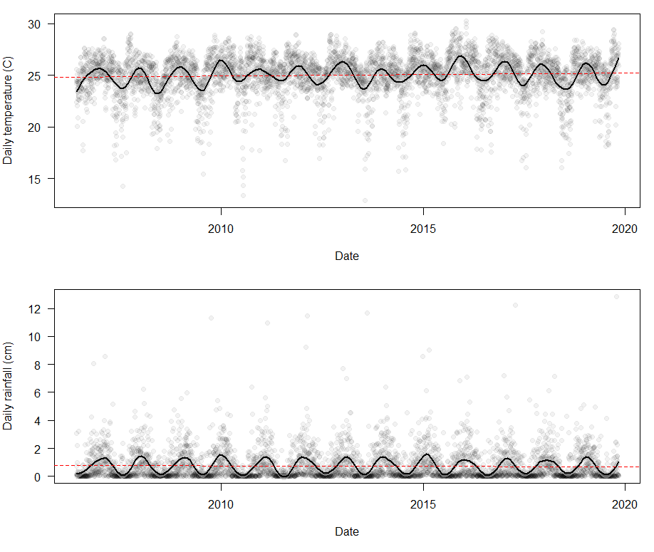
Appendix C: Forest cover loss within and surrounding the Los Amigos Conservation Concession (2000-2019).
The following image shows canopy cover loss (green) within and immediately around the Los Amigos Conservation Concession (black border), camera trap stations (Black points). It is important to note that loss can arise due to anthropogenic and natural causes. Within LACC, between 2000-2019 this represents a canopy cover loss of 0.12%.
Data derived from Hansen, M. C., P. V. Potapov, R. Moore, M. Hancher, S. A. Turubanova, A. Tyukavina, D. Thau, S. V. Stehman, S. J. Goetz, T. R. Loveland, A. Kommareddy, A. Egorov, L. Chini, C. O. Justice, and J. R. G. Townshend. 2013. “High-Resolution Global Maps of 21st-Century Forest Cover Change.” Science 342 (15 November): 850–53. Data available on-line at: https://earthenginepartners.appspot.com/science-2013-global-forest

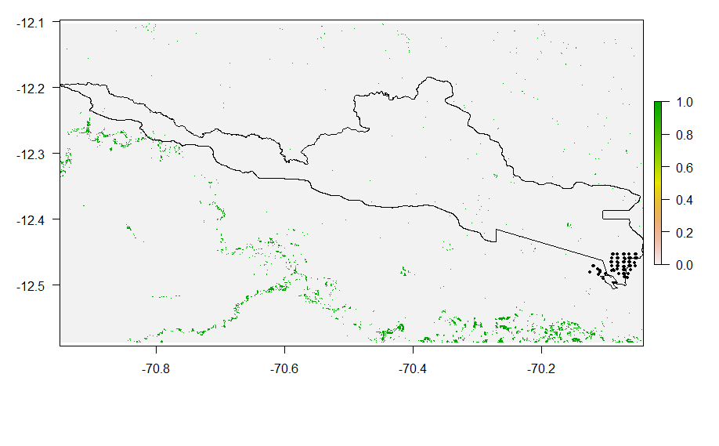

Appendix D: Variance explained by the multi-species model
Species-level ‘total’ pseudo-R²
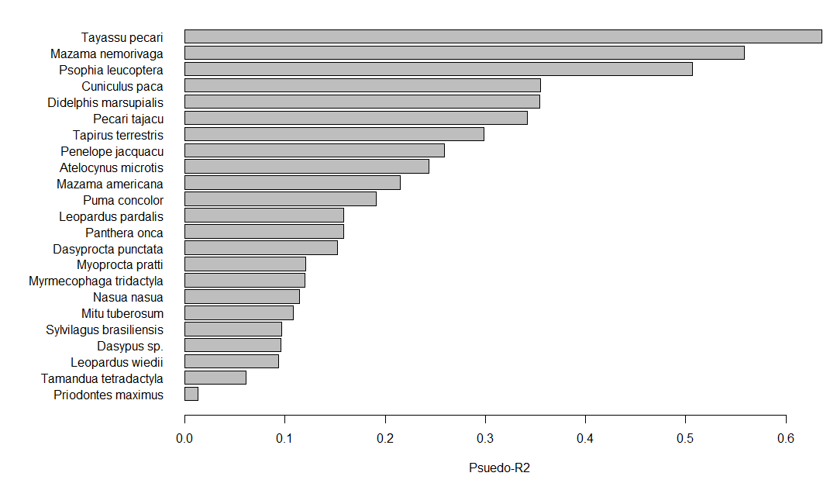
Partitioned R²
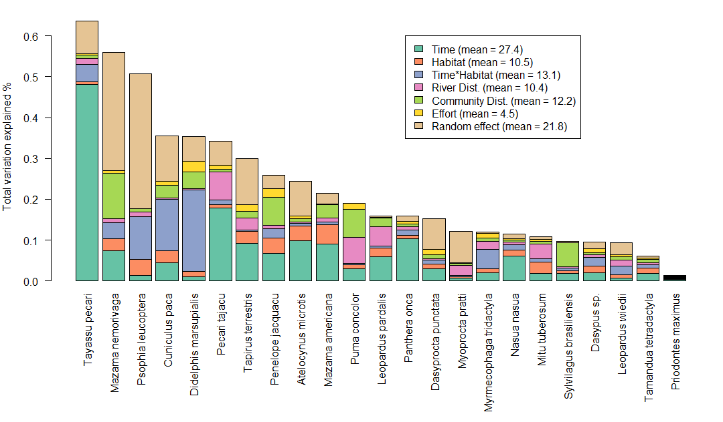

Appendix E: Full coefficients for the predictors of species-level counts
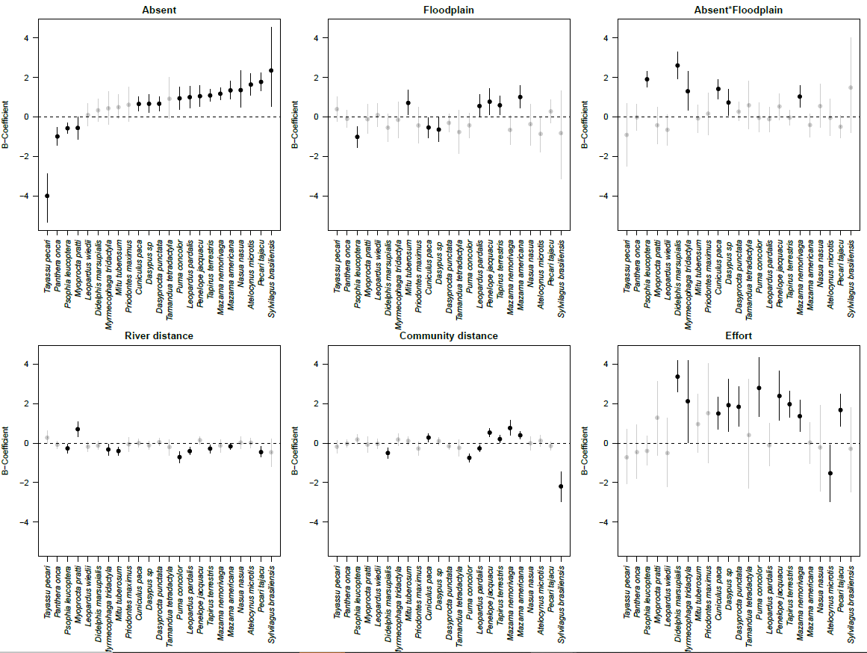

Appendix F: The relationship between community traits and predictor variables
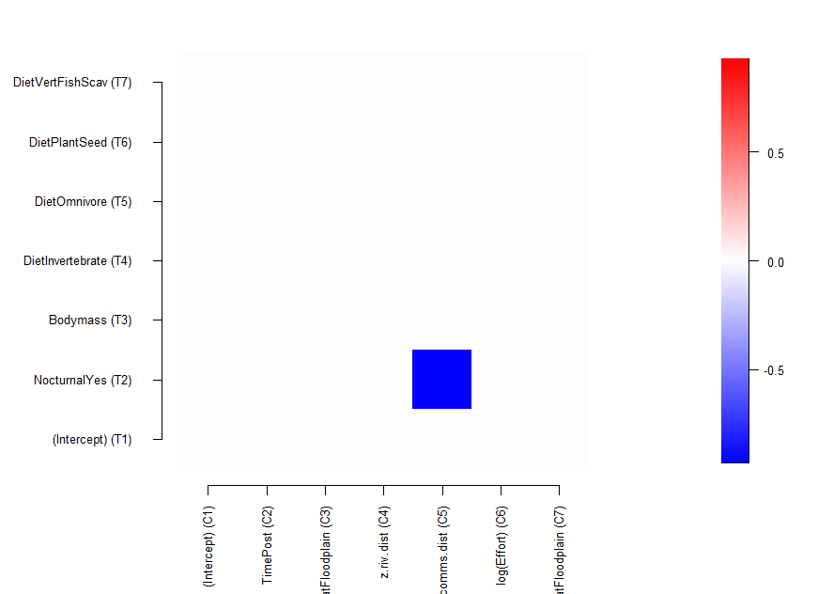
Appendix G: Anecdotal evidence of WLP decline in nearby locations

A near-parallel sudden population crash as that observed in LACC was directly observed by co-author JT in his field work spanning decades at Cocha Cashu (~160km to the NW of LACC). This field station lies directly within the well-protected and expansive Manu National Park, and while hunting by indigenous groups within the park is likely to deplete WLP populations locally around villages, these villages are many hours upriver from the field station, suggesting that a hunting-driven collapse in WLP populations is implausible (Ohl-Schacherer et al. 2007). Key visual anecdotal evidence is also noted by JT in his 2012 field season when bloated WLP corpses, covered in vultures, were observed floating down the Manu River, and the ‘stench of death’ emanated from parts of the forest along the river. Co-author AF also observed floating WLP corpses in the Río Los Amigos and the Río Piñi Piñi draining central Manu NP in 2012.

Ohl-Schacherer, J., G. H. Shepard, H. Kaplan, C. A. Peres, T. Levi, and D. W. Yu. 2007. The sustainability of subsistence hunting by Matsigenka native communities in Manu National Park, Peru. Conservation Biology 21:1174–1185.

