Supplementary Material

Title: Honeybees affect floral microbiome composition in a central food source for wild pollinators in boreal ecosystems
Authors: Elsi Hietaranta*, Heli Juottonen & Minna-Maarit Kytöviita

Department of Biological and Environmental Science, University of Jyväskylä,
P.O. Box 35, 40014 University of Jyväskylä, Finland
*corresponding author: elsi.h.hietaranta@student.jyu.fi

Table S1 The characteristics of the six study sites and the dates of bagging and sampling of the inflorescences. Number of beehives refers to the number of beehives in the nearest apiary
Study site | Coordinates | Honeybees | Number of beehives | Distance to the closest beehives | Net bags attached | Samples collected
A | 62°46' N : 25°18' E | No |  | > 3.5 km | 24-Apr-2019 | 28-Apr-2019
B | 61°54' N : 26°02' E | No |  | > 10 km | 16-Apr-2019 | 23-Apr-2019, 29-Apr-2019
C | 62°01' N : 26°17' E | No |  | > 10 km | 16-Apr-2019 | 25-Apr-2019, 29-Apr-2019
D | 62°46' N : 25°23' E | Yes | 7 | 100-200 m | 17-Apr-2019 | 28-Apr-2019
E | 62°03' N : 26°08' E | Yes | 4 | 50-100 m | 16-Apr-2019 | 23-Apr-2019
F | 61°49' N : 25°56' E | Yes | 6 | 10-200 m | 16-Apr-2019 | 23-Apr-2019, 25-Apr-2019

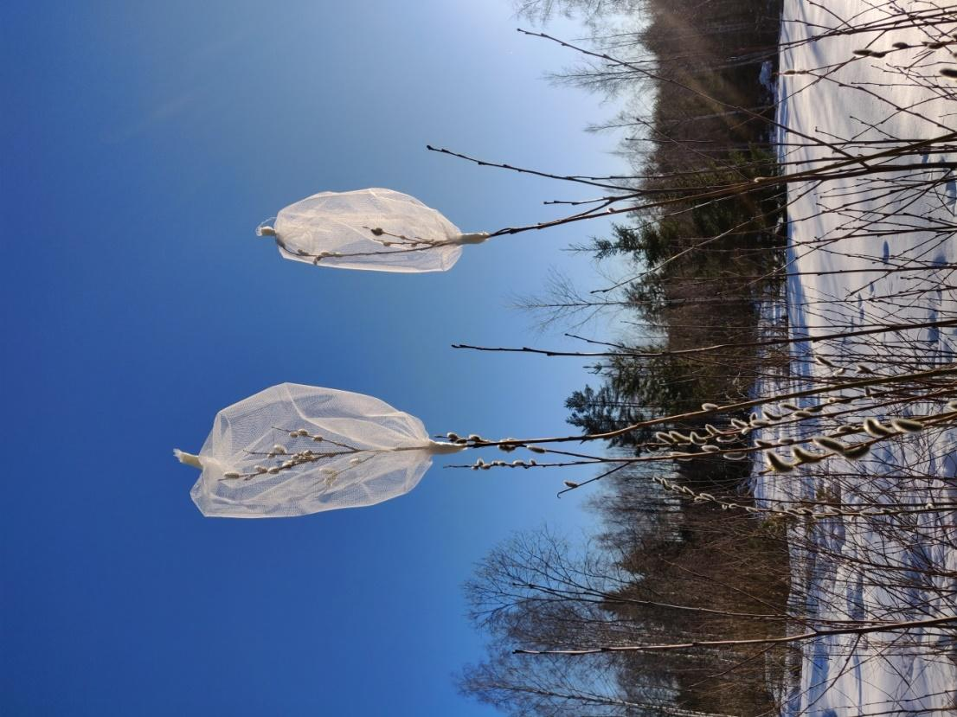
Fig. S1 Willow branches enclosed with a net bag to exclude insect visits on Salix phylicifolia inflorescences. Samples that were visited by insects were collected from inflorescences in branches next to net bags

Table S2 PERMANOVA statistics on effect of Salix phylicifolia individual (n = 4) on the structure of bacterial and fungal community composition in the inflorescences (N = 95). Significance codes are p ≤ 0.001 = ***, p ≤ 0.01 = **, p ≤ 0.05 = *
Site | Bacteria |  |  |  |  | Fungi
 | df | SS | R² | F | p | df | SS | R² | F | p
A | 3 | 1.22 | 0.55 | 4.96 | 0.002 ** | 3 | 1.33 | 0.37 | 2.40 | 0.001 ***
B | 3 | 1.08 | 0.24 | 1.29 | 0.167 | 3 | 0.88 | 0.35 | 2.14 | 0.004 **
C | 3 | 1.26 | 0.41 | 2.60 | 0.021 * | 3 | 0.86 | 0.34 | 1.91 | 0.002 **
D | 3 | 1.59 | 0.43 | 2.98 | 0.001 *** | 3 | 0.69 | 0.27 | 1.50 | 0.053
E | 3 | 1.00 | 0.32 | 1.91 | 0.033 * | 3 | 1.22 | 0.53 | 4.59 | 0.001 ***
F | 3 | 1.04 | 0.37 | 2.30 | 0.021 * | 3 | 0.61 | 0.36 | 2.23 | 0.009 **

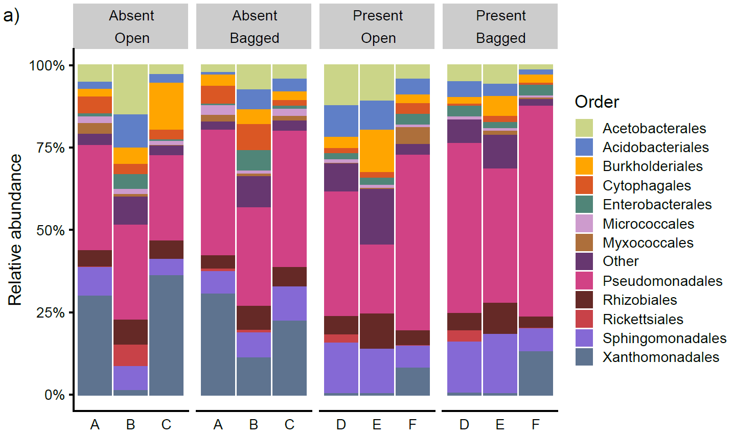
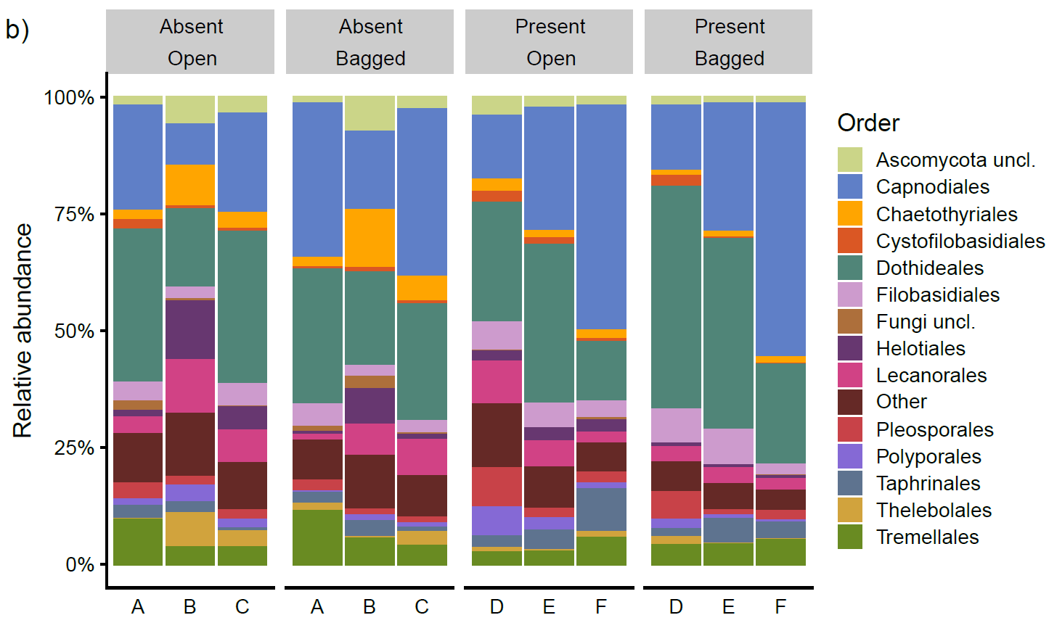
Fig. S2 The relative abundance of a bacterial orders and b fungal classes in the six study sites A–F (n = 15–16) divided by honeybees (absent/present) and treatment (open/bagged). Parallel samples from each site are pooled (N = 95). ‘Other’ represents bacterial orders and fungal classes which relative abundance is < 1%
Table S3 Bacterial and fungal operational taxonomic unit (OTU) richness by study site and treatment. Site affected significantly bacterial (df = 5, F = 6.789, p < 0.05) and fungal (df = 5, F = 8.103, p < 0.05) richness on inflorescences. ‘Site’ refers to the six study sites (see Table S1). ‘Treatment’ refers to the inflorescences that were either bagged with a mesh bag to exclude pollinators (n = 48) or left without the mesh bag (open) (n = 47). ‘Honeybees’ refers to the presence/absence of honeybees in the sites. SD means standard deviation
Site | Treatment | Honeybees | mean OTU richness |  |  |  | SD
 |  |  |  | bacteria | fungi | bacteria |  | fungi
A | open | no | 213 |  | 248 |  | 76 | 56
 | bagged |  | 144 |  | 166 |  | 51 | 47
B | open | no | 142 |  | 185 |  | 56 | 41
 | bagged |  | 104 |  | 140 |  | 39 | 27
C | open | no | 126 |  | 257 |  | 51 | 25
 | bagged |  | 134 |  | 193 |  | 63 | 51
D | open | yes | 218 |  | 222 |  | 56 | 48
 | bagged |  | 149 |  | 133 |  | 52 | 26
E | open | yes | 203 |  | 227 |  | 71 | 34
 | bagged |  | 153 |  | 155 |  | 84 | 24
F | open | yes | 117 |  | 194 |  | 61 | 41
 | bagged |  | 74 |  | 155 |  | 23 | 33

