Top-down and bottom-up forces explain patch utilization by two deer species and forest recruitment

J. Ignacio Ramirez^{1,2*}; Lourens Poorter²; Patrick A. Jansen^{3,4}; Jan den Ouden²; Matthias Siewert¹ & Johan Olofsson¹

Affiliations
¹Department of Ecology and Environmental Sciences, Umeå University, Umeå, Sweden.
²Forest Ecology and Forest Management Group, Wageningen University & Research, Wageningen, The Netherlands.
³Wildlife Ecology and Conservation Group, Wageningen University & Research, Wageningen, The Netherlands.
⁴Smithsonian Tropical Research Institute, Balboa, Ancon, Panama.
*Corresponding author: juanignacio.ramirez@icloud.com / +46 90 786 75 92

Electronic Supplemental Material
A1. Linear Mixed Model fits for the relationship between roe deer and red deer patch utilization. No significant (dashed line) relationship was found: R²marginal=0.05, R²conditional=0.06, β=0.009 & p value=0.68.

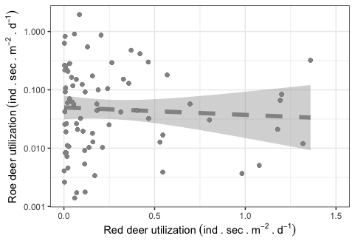

A2. Map depicting the average patch utilization by roe deer (A) and red deer (B) across the ten forest sites. The size of the bubble indicates the utilization level for the specific forest site. Name of sites are presented in Fig. 1.
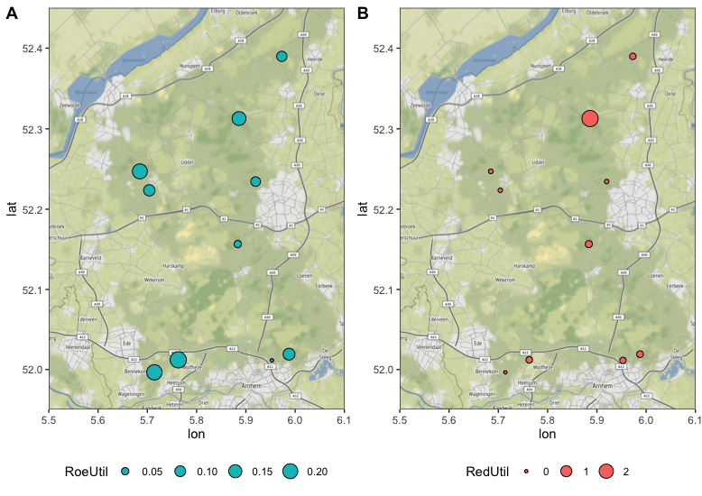

A3. Patch utilization by roe deer (A) and red deer (B) for camera placements in each of the ten forest sites. The x-axis is the longitude (lon) and the y-axis the latitude (lat). The size of the bubble indicates the utilization level for the camera placement. Names of sites are presented in Fig. 1.
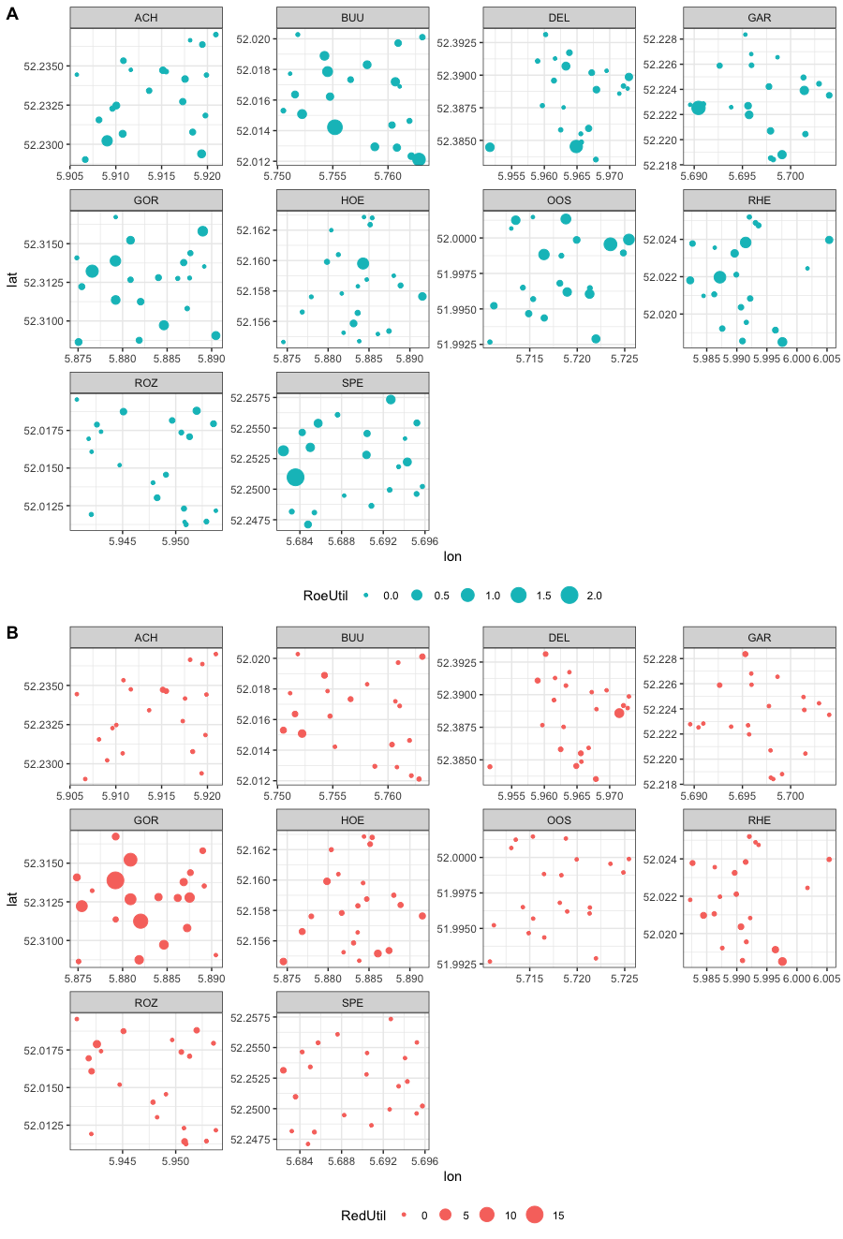

A4. Variables that are the most characteristic according to each PCA axis obtained by a Factorial Analysis.
Variable | Correlation | p value
Dim 1
S_aucuparia | 0.70 | 9.9E-31
R_frangula | 0.53 | 3.6E-16
P_serotina | 0.36 | 2.0E-07
Q_robur | 0.34 | 5.6E-07
A_lamarckii | 0.31 | 5.2E-06
P_sylvestris | -0.25 | 4.0E-04
L_kaempferi | -0.32 | 2.6E-06
F_sylvatica | -0.34 | 8.7E-07
P_menziesii | -0.52 | 1.1E-15
Dim 2
B_pendula | 0.55 | 2.2E-17
B_pubescens | 0.51 | 1.3E-14
Light | 0.49 | 2.4E-13
P_sylvestris | 0.42 | 4.2E-10
Q_rubra | 0.30 | 1.2E-05
P_menziesii | 0.20 | 4.5E-03
A_lamarckii | -0.15 | 3.7E-02
Deer_patch_u | -0.19 | 6.0E-03
F_sylvatica | -0.78 | 9.8E-42

A5. Linear Mixed Model fits related to forest recruitment as a response to light in the understory, patch utilization and herbivory by two deer species. Tree diversity (Shannon ‘H’) is set as response in panel A. Tree composition represents the values extracted from the PCA Dim1 and Dim2 and are set as responses in panels B & C. Models are accompanied by their standardized coefficients of the predictors, confidence intervals and p values represented by an asterisk (*). Significance levels: ∗∗∗(P<0.001), ∗∗(P<0.01) and ∗(P<0.05).

